Problems with generated cctor, op=:
- memory leaks
- dangling pointer

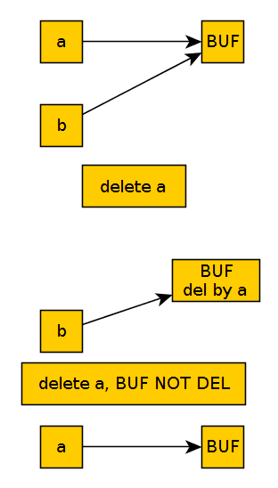

exceptions -
catch must follow try.

Void foo() try
{
….
}

catch
{
...
}

unwinding – when a function that down the line throw an exception, each stack on that line will be destroyed, plus, the dtor will be called

class myExcep: public std::excep
{
void what(char *);

}

catch(const std::excep&)
{

}

to take an advantage of polymorphism, we use const ref&

throw(by value)

catch(const std::excep&)

- re throw – a catch func that throw a throw to be catch by another catch function

- zombie object – a different way to notify that a ctor failed.

X x;
if(a.status == OK) … // checks that the ctor finished, by using a data member flag

if ctor failed, it his responsibly to handle the failure. Before throwing an excep, he needs to clean itself
exception calls dtor, but it cant be called if the exce is in the ctor function

an exce inside dtor is a problem, the unwinding mechanism cant be called

