Select API

TCP
7 = socket();
listen(7);

10 = accept
12 = accept
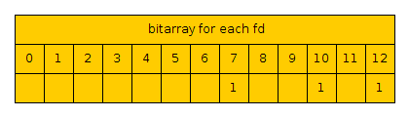
fd_set master, work
work = master;
select(12, work, …)

use 3 arrays for event input, event output, event error

open tcp socket, udp socket, and stdin
for each event that comes do ping pong

links:

