Casting
syntax ( 3 forms):
- (T)a
- T(a)
- static_cast, interpret_cast, const_cast

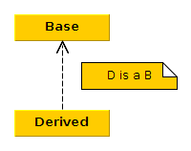

B* ptr = &d1; // upcasting

foo(B* a, int x)
{
D* ptr = static_cast<D*>(a); // no compiler intervention
D* ptr = dynamic_cast<D*>(a); // run time check, RTTI, return null if a is not type D
// has a run time price
}

