Design pattern

פתרון מוסכם לבעיה מוכרת

design pattern composite -

file/directory

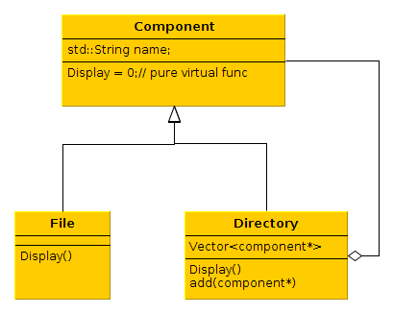

ex:
Tree( aka auto complete)
2 phases:
1. create in memory repository – scan the system file system
linux has : opendir, readdir, close
open the root dir and and read, we are building a tree. ( no need to start from root)

2. interactive read from stdin a path and call a Display function that shows it like a tree.

Maybe a Find function to parse the repository.

data member level indicates the depth

non blocking I/O not used here?
Scanf, getchar → based on read(0,...)

ioctl( ) → if there is no input , return

use recursion for dirs, remember to close the file descroptor ( there is a limited no of fd's)

