Const ref → extend the life time of a temp var
const String& a = concat(x, y);
concat() return a string object, a temp object on the stack, normally, it will be destroyed at the ;
but with the const Type& temp_var it will be destroyed only at the end of the scope.
U cannot change it, hence, the const

convert operator char*() → operator that convert an obj to char*

generated ctor – primitive type does not get initialized.

The = operator have to deal with self assignment
Self assignment in operator= implementation: 3 ways:
- if that checks the objects address
- copy & swap method
- coping the data before deleting

inheritance
key words:
- methods
- properties
- interface
- message
- override – redefination of implementation.
- non virtual – interface and implementation (no override to implementation)
- virtual – interface and optional implementation ( can override )
- pure virtual – interface only, no implementation. ( sons must implement themselves).

circle contains the class shape, but it cannot directly access the private section in shape, such as the data members. Only through getters and setters.

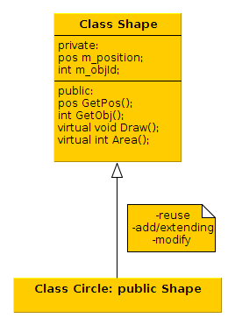
Override – a base class implementation that gets changed by its sub class to suit it own need.
We can use upcasting
Shape* c1 = new Circle; // Circle call the Ctor of Shape and then initialize its members

delete c1; // if the dtor of Shape is non virtual, it will only destruce only the Shape part

base class will always have the Dtor as virtual

case Base
{
public:
virtual ~Base();
};

pure virtual is a class that have at least one pure virtual function.
class X
{
public:
virtual void foo() = 0; // there can be an implementation of foo() , but the deraived call
// must implement the function foo() , it can use in its implementation the defaut implementation
};

X::foo();

use of protected -
class Base
{
public:

protected:
Base(); // ctor
}

class X: public Base
{
// has access to the protected section in the base class
}

all base class that has a virtual function, the first 8B is a pointer to a virual table.
Every derived class of base has a pointer to its own virtual table. The derived ctor, after the ctor of the base finishes will change the pointer to point to its virtual table.
There is an extra 8B for the pointer to the virtual table. No mater how many derived class, there will only one pointer to a virtual table, each class with its own virtual table.

