Pod – plain old data – all the primitive types( int, float , char...), if a class contains only pod, he is also pod

Udt –

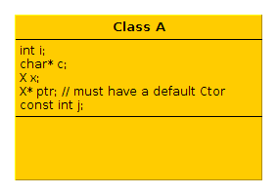
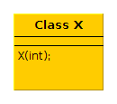
generated constructor will not know how to generate Ctor to A because no default Ctor for X,
and also because
the
const int j
and another case is reference.

The pod are garbeged valued.

String S1(“hello.......................................”);
String S2(S1);
S1 = S2;
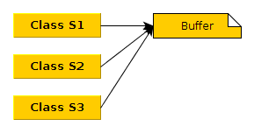

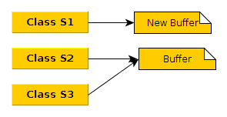

S1[3] = 'a';

reference count

- to read : flexable array ( c, not c++)

struct strData
{
size_t m_rc;
char m_str[1];
};
// take care of padding.
// may have to use the macro
// offsetoff
// offset(strData, m_str)

strData ptr = malloc( sizeof(strData) – 1 + strlen(str) + 1);
or
strData ptr = malloc(offsetof(strData, m_str) + strlen(str) + 1);

