<Title of the seminar paper>
< FIRSTNAME LASTNAME>
<Contact information>

Abstract
The purpose of the abstract is to give a complete, albeit small, picture of the whole article and its contents. About 15 to 20 rows should be enough. A short motivation, the used methods, and the most important results are typically included.
The abstract should provide clear information about the research and the results obtained, and should
not exceed 300 words. The abstract should not contain citations.
Key words: please provide key words or phrases to enable retrieval and indexing. Acronyms should be avoided. Acknowledgements and/or disclaimers, if any Names of funding organisations should be written in full.

Introduction
An introduction to your topic. A background/motivation, the purpose of the research, and the research questions/objectives are typically presented here. Describe also shortly the structure of paper.
Seminar papers should be written in Albanian.
Repetitive use of long sentences should be avoided. It is strongly recommended that the text be run through
computer spelling and grammar programs.
Articles should be divided into logically ordered and numbered sections.
Manuscripts should be 1.15 spaced with 2-cm margins on all sides of the page, in Times New Roman font (font size 12).
The entire seminar paper (including references, tables, and figures) must not be longer than 5pages.

Section 1
Start presenting your work here. Number all sections as you see it done here.
Refer to literature in the number format like this.
All authors should be included in reference lists unless there are 3 or more, in which case only the first 3 should be given, followed by ‘et al.’ Do not use individual sets of square brackets for citation numbers that appear together, e.g., [1, 3, 5–9], not [2], [3], [5]–[9].

Subsection 1
Remember to use subsections to keep your paper easy to read.
Other general guidelines:
- Make sure the title of the paper is in line with the text. Avoid repetition of matters in different parts of the paper, use cross-references instead.
- Use mathematical expressions, tables, figures and graphs to summarize and illustrate your point. Figures should also be understood without reading the text (e.g. name the variables used in figures). Remember also to interpret the tables/figures in the text.
- Every page of the seminar paper, including the title page, references, tables, etc., should be numbered.
- The resolution of images should not be less than 118 pixels/cm when width is set to 16 cm. Images
must be scanned at 1200 dpi resolution and submitted in jpeg or tiff format.
Graphs and diagrams must be drawn with a line weight between 0.5 and 1 point. Graphs and
diagrams with a line weight of less than 0.5 point or more than 1 point are not accepted. Scanned
or photocopied graphs and diagrams are not accepted.

Take a caption of the table and insert table name above the table.
Table 1: Classes and values
Class/Value | values 1 | values 2 | values3
class 1 | 1 | 2 | 3
class 2 | 1 | 2 | 3
class 3 | 1 | 2 | 3

Caption figures and graphs as well, the name this time under the figure.
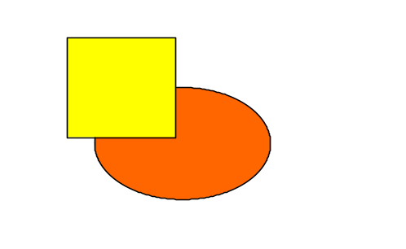
Figure 1 Orange and yellow

Conclusions
Could be also titled otherwise depending on contents, e.g. “Discussion”, “Summary”…
Summarize findings, present major conclusions, consider managerial relevance and further research….

References
Include at least the following information: Author, Title of the paper, Published where and when, possible www-address and quotation date, possible ISBN or ISSN number.
Examples:
- Wei C-P & Chiu I-T (2002). Turning telecommunications call details to churn prediction: a data mining approach. Expert Systems with Applications, Vol. 23 (August 2002), pp. 103-112.
- Ojala T., Hakanen T., Mäkinen T., Rivinoja V. (2005). Usage Analysis of a Large Public Wireless LAN. Proceedings of International Conference on Wireless Networks, Communications and Mobile Computing (IEEE WirelessCom 2005), June 13-16, 2005, Maui, Hawaii, USA.
- Google, Inc. web site [online]. Google Mobile, updated 2007 [accessed January 5, 2007]. Available in www-format: <URL: http://www.google.com/mobile/>.

Correspondence Address:
E-mail: qamil.kabashi@uni-pr.edu and
edon.gashi@uni-pr.edu

