DDQN Implementation
Since DQN was already implemented, we decided to first try to use DQN structure and adapt it for DDQN, because it was already suitable. I kept the overall code organization similar, but I modified the main parts of the algorithm so it follows the DDQN approach instead of the standard DQN one.
Changes I made
For the DDQN implementation, I created the files ddqn.py, train_ddqn_agent.py, and validation_agent_ddqn.py. I also added the necessary parts in main.py. Below, I describe only the main changes related to the DDQN implementation.
1. ddqn.py
First, I started with the ddqn.py.What I changed first were the class names from DQNNetwork and DQNAgent to DDQNNetwork and DDQNAgent. I kept the same neural network structure as in DQN because the main difference between DQN and DDQN is in the learning logic.
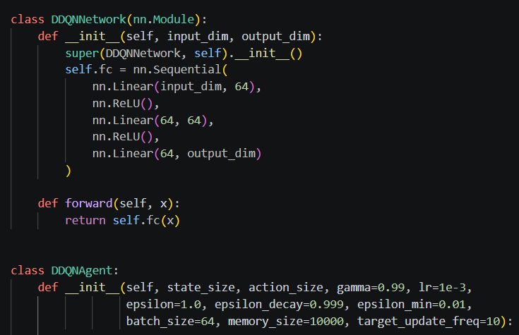
I changed the epsilon decay from 0.995 to 0.999. I changed this so exploration decreases more slowly during training. And the DDQN Agent can continue exploring the environment for a longer time before becoming more exploitative.
In the get_action function I only changed the way the state is converted before entering the network, so it is in the correct format for PyTorch.
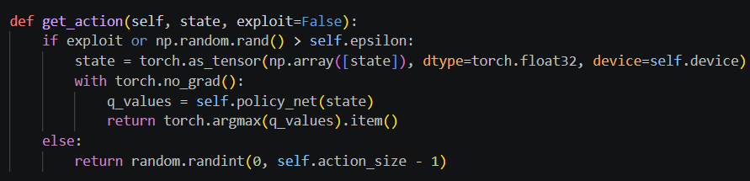

The main change I did was in the train_step() function. In this part, the next action is selected using the policy network, while the target network is used to evaluate that action. This is the main idea of DDQN.
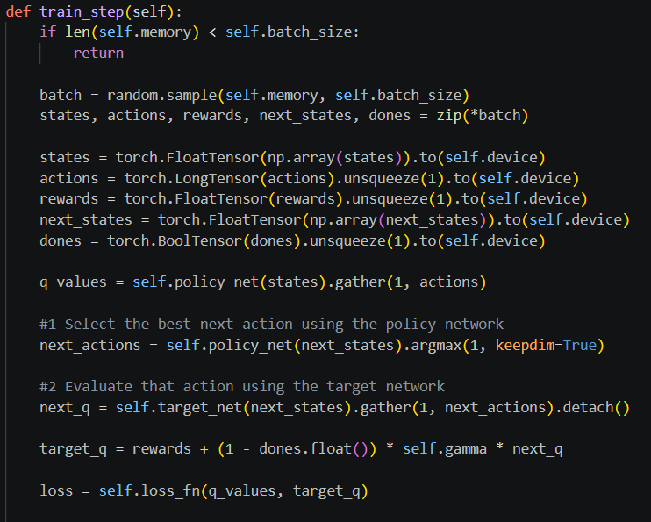

Other parts such as memory, optimizer, loss function, and target network update were kept similar to the DQN version, because they were already suitable for the implementation.
2. train_ddqn_agent.py
In this file, the main change was that I replaced the original DQNAgent with DDQNAgent, so the training process uses the DDQN implementation.
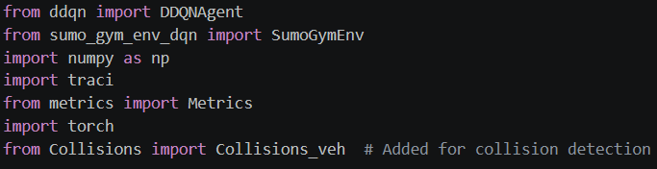
I renamed the training function from train_dqn to train_ddqn to make it consistent with the new DDQN implementation.

I created the DDQN agent.
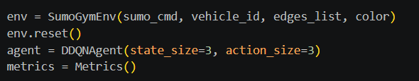

The metrics collection and model saving were also kept the same, so the DDQN results could be compared more easily with the DQN results.
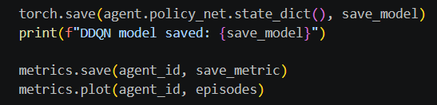

The rest of the training structure was kept almost the same, including the interaction with the SUMO environment, storing transitions, training at each step, epsilon decay and saving the metrics. I kept this structure because it was already suitable and the main algorithmic change was inside ddqn.py

3. validation_agent_ddqn.py
In the validation file, I mainly adapted the code from DQN to DDQN by changing the agent and function names. The overall validation logic stayed the same.

4. main.py
First, I added the necessary DDQN imports in main.py. This was needed so the project could recognize the new DDQN training and validation files.
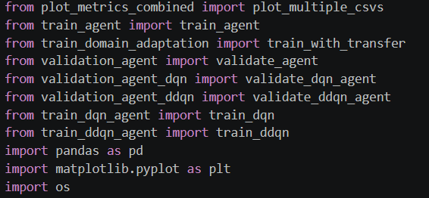

The role of main.py was mainly to connect my new DDQN files with the rest of the project. I used the same structure already present in the project, and I added the DDQN training and validation calls for both the Red agent and the Orange agent.
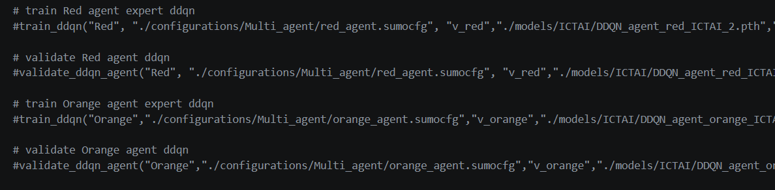

At the end, I also created a small Python file to verify that the saved DDQN_agent_red_ICTAI_2.pth and DDQN_agent_orange_ICTAI_2.pth were loading correctly.

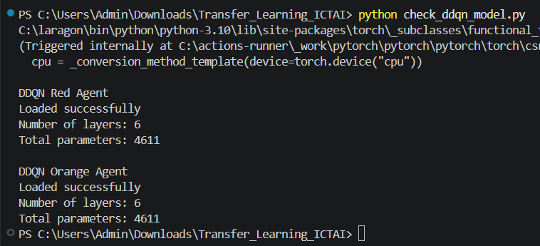
This confirmed that both DDQN models were saved correctly and were ready to be used for validation or later experiments.

