DDQN – Orange Agent - Training Results
I trained the DDQN Orange agent for 1000 episodes. The training metrics were saved successfully in CSV format and the plots were generated after training.

Main observations from the DDQN_training_metrics_agent_v_orange_2.csv
The reward is lower and more unstable at the beginning, but it improves later during training.
Travel time is high in the first episodes, then it drops and becomes more stable.
Most episodes are successful, but there are still some failed cases.
The average speed increases over time, which shows that the agent is learning better behavior.

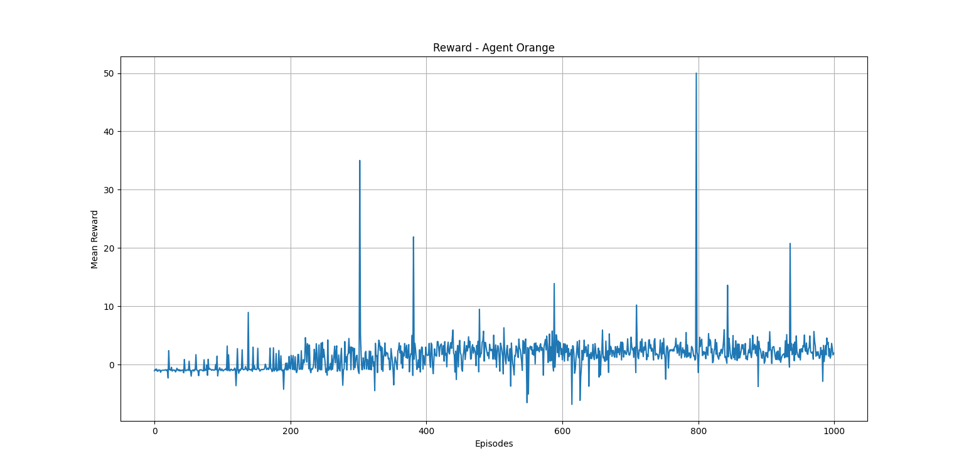
The reward is low and unstable at the beginning, but it becomes more positive later, which shows that the Orange agent improves during training.

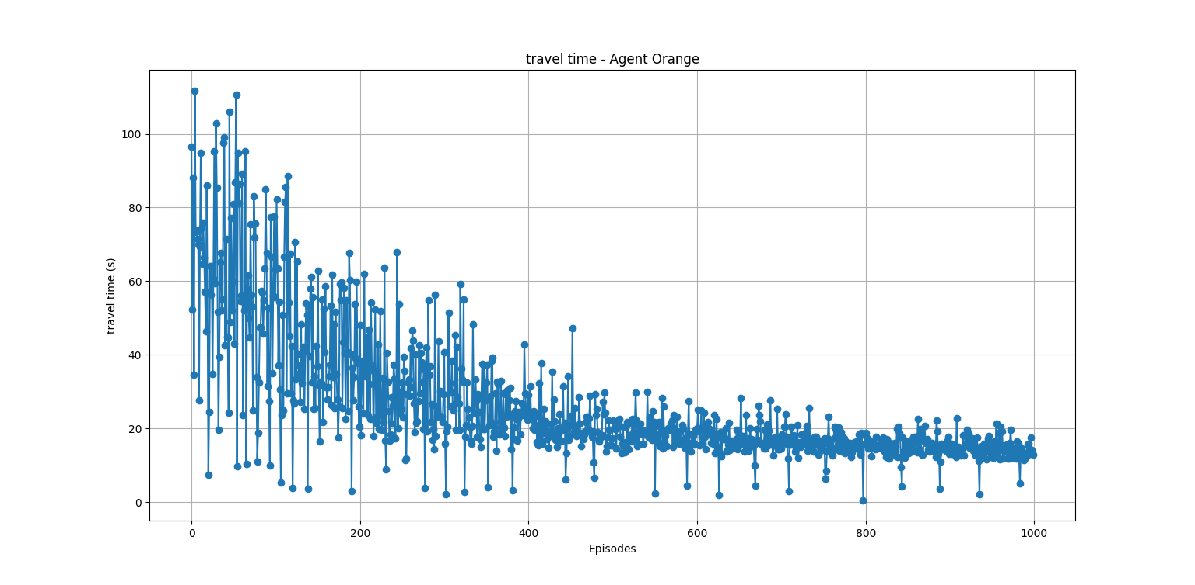

The travel time is very high in the early episodes, then it gradually decreases and becomes more stable, showing better performance over time.
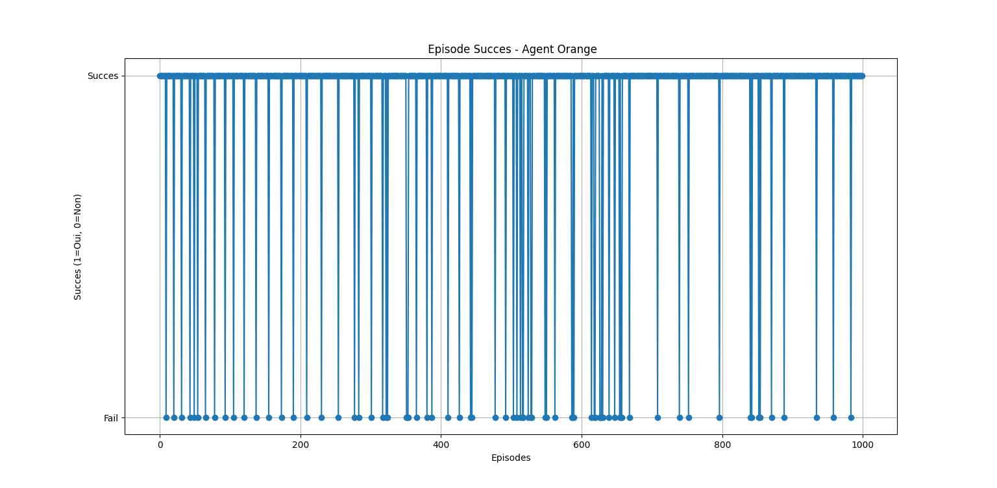

Most episodes are successful, but there are still some failed episodes during training.

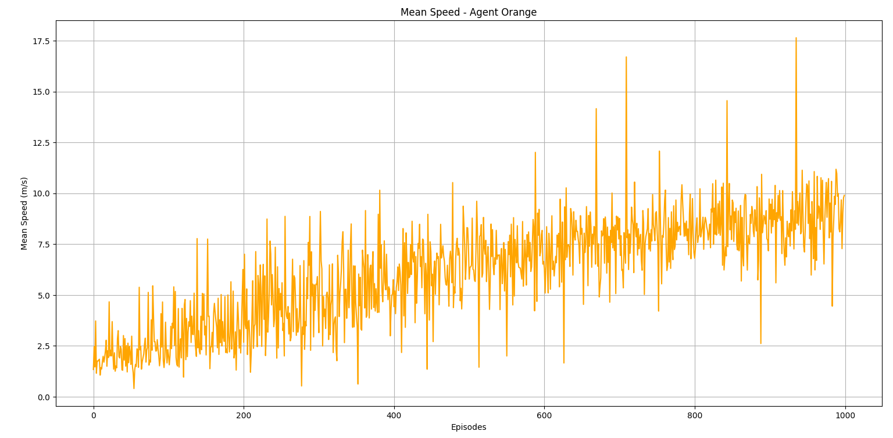

The average speed increases during training, which suggests that the Orange agent learns to move more efficiently.

DDQN - Orange Agent - Validation Results
The validation results are generally good. Most of the episodes were successful, the reward stayed mainly positive, and the travel time was mostly stable between 10 and 12 seconds. Even though some collisions and failed episodes were still present, the DDQN orange agent still achieved a good validation accuracy of 93.8%.

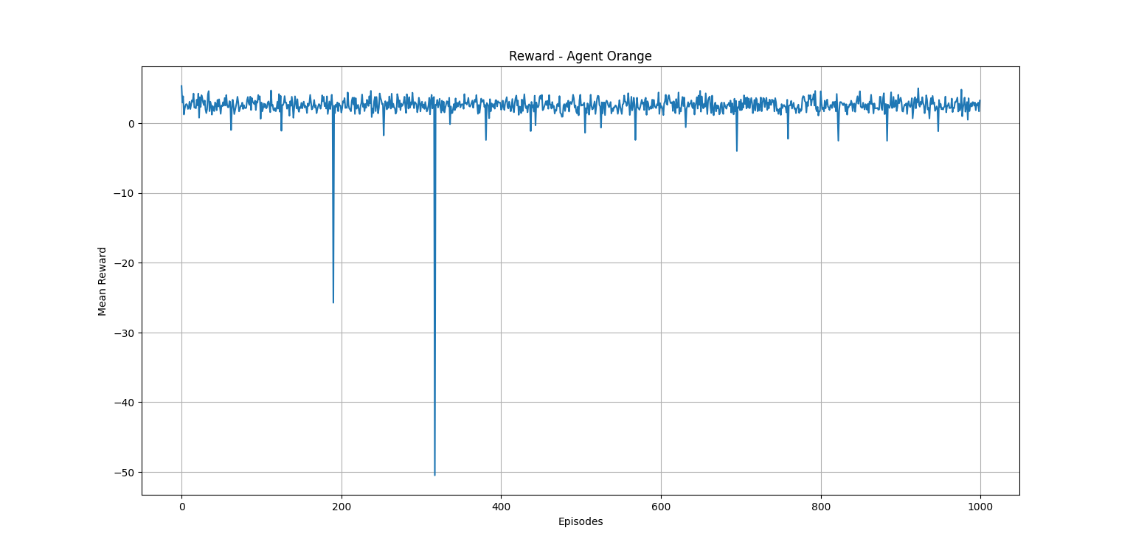

The reward stays mostly positive during validation, with only a few sharp drops in some failed episodes.

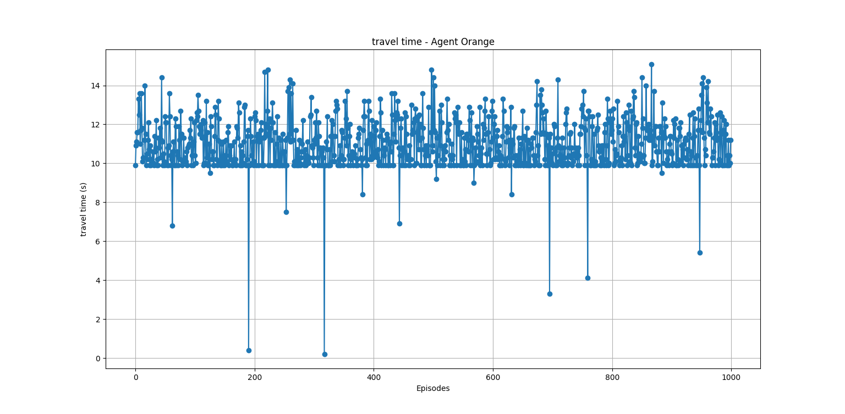
The travel time remains quite stable, mostly around 10 to 12 seconds, which shows consistent performance.

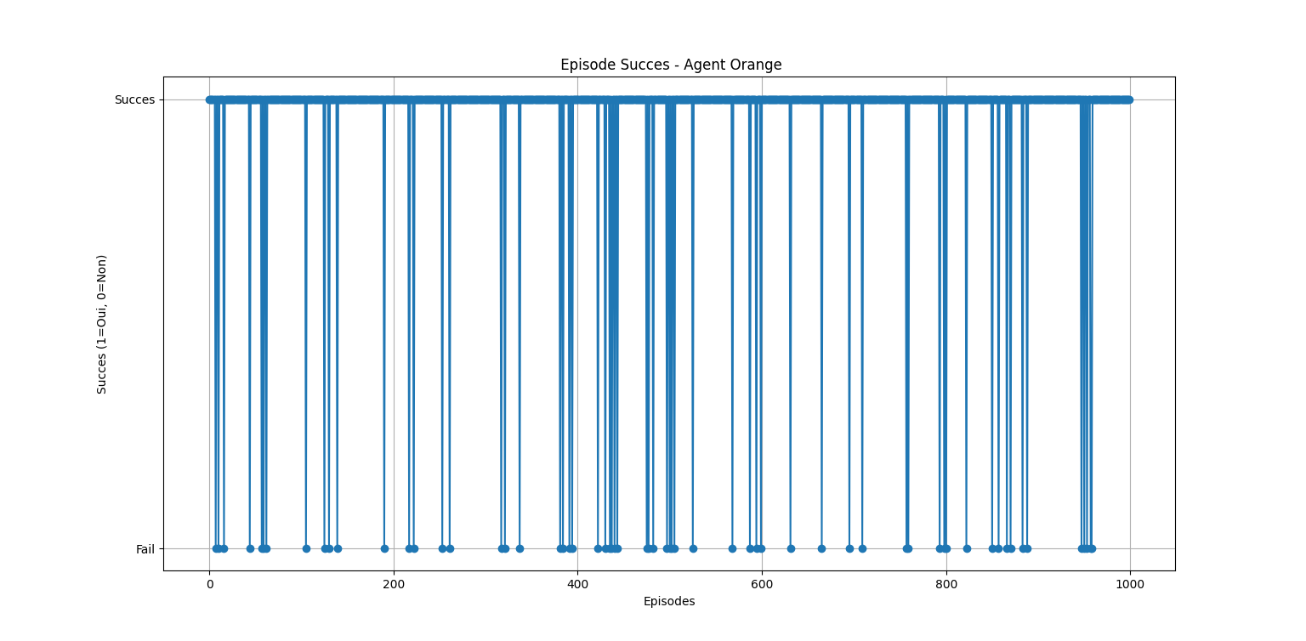
Most validation episodes were successful, although some failed episodes still appeared from time to time.

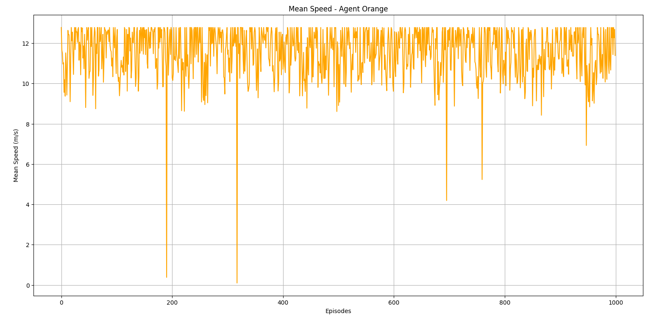
The mean speed stays generally high and stable during validation, which suggests efficient behavior of the agent.

Comparison of Red Agent and Orange Agent
Overall, both the Red agent and the Orange agent showed good performance during training and validation. In both cases, the agents learned to complete most episodes successfully and improved their behavior over time. The reward became more stable, the travel time stayed lower and more consistent, and the average speed showed that both agents were able to move more efficiently after learning.

When comparing them, the Red agent appears slightly more stable, while the Orange agent also performed well but had a few more fluctuations and failed episodes. Even so, the validation results show that both agents learned useful policies for their own scenarios. This means that DDQN worked well for both environments and was able to produce strong results for both agents.

