sumo_gym_env_ppo.py
For the PPO implementation, I first tried to use the existing sumo_gym_env.py environment. The main issue was related to the TraCI/SUMO connection. When PPO started a new episode, SUMO sometimes gave the error that the default TraCI connection was already active. Because of this, the environment could not always restart correctly between episodes.
Another problem was that the controlled vehicle sometimes did not move at the beginning of the episode. In the original environment, the reset function had a comment saying that the vehicle should be initialized with speed 10, but the actual code was setting the speed to 0. For PPO validation, this caused problems because the car could remain stuck and the episode could fail without the agent really being tested.
Because of these issues, I created a separate environment file called sumo_gym_env_ppo.py. This file keeps the same general structure as the original SUMO environment, but includes some changes needed for PPO
The first change was in the reset() function. So, before starting a new SUMO simulation, I added a safe check to close any previous TraCI connection if it was still active.
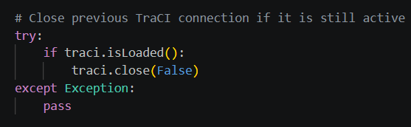
Here I check if the controlled vehicle exists in the simulation. If it exists, I set its color and give it an initial speed.

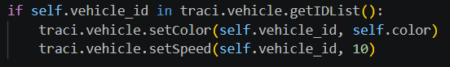
Without an initial speed, the vehicle could stay frozen at the beginning. By setting the speed to 10, the agent can actually interact with a moving vehicle during training or validation.
I added a safety check before applying any action to prevent errors if the vehicle has already left the simulation. Without this check, the code could try to apply acceleration or deceleration to a vehicle that no longer exists.
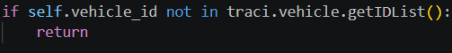
I made this change because if the vehicle finishes its route and leaves the simulation without collision, this should be considered a successful episode.

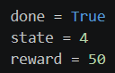
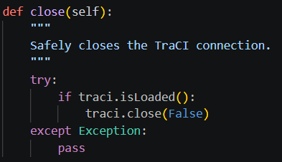
The close() function was also made safer to prevent the program from crashing if close() is called when there is no active TraCI connection.

main.py
In main.py, I added the PPO training and validation calls for both the Red and Orange agents.
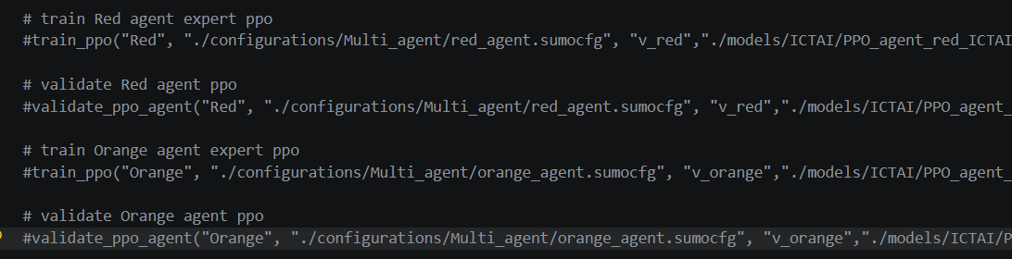

ppo.py
In ppo.py, I implemented the PPO agent using an Actor-Critic structure. The actor is responsible for choosing the action by giving action probabilities, while the critic estimates the value of the current state. This is important because PPO does not only learn which action to take, but also compares how good that action was compared to what the model expected.

The network first uses shared layers, and then separates into two parts: the actor and the critic.
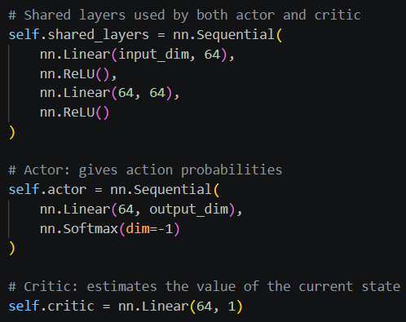

Since the environment uses discrete states, I converted the state into a one-hot vector before sending it to the neural network. This was needed because the neural network cannot learn properly from a single raw number like 0, 1, or 2; it needs the state in tensor/vector format.

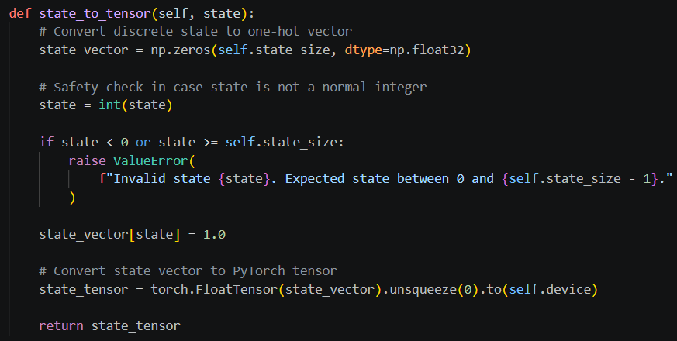

For action selection, I used two different behaviours. During training, the agent samples actions from the probability distribution so it can still explore. During validation, it chooses the action with the highest probability, because validation should test the learned policy without randomness.
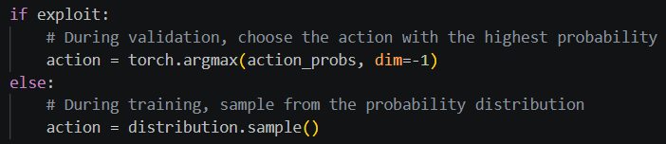

The most important PPO part is inside the update() function. Here, the new policy is compared with the old policy using the PPO ratio. Then the clipped objective is used to prevent the policy from changing too much in one update. This is the main idea of PPO.
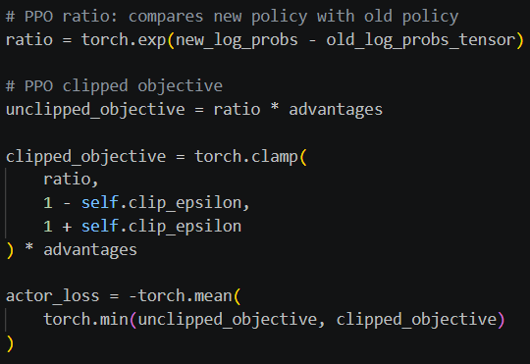
This part follows the PPO clipped objective idea:
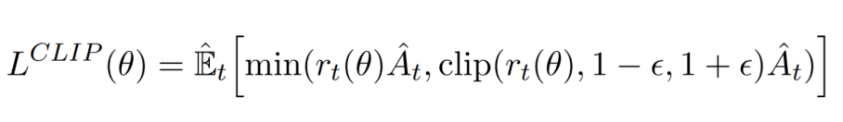
where the ratio checks how different the new policy is from the old one, and clipping keeps the update stable.
I also added the critic loss and entropy term to the total loss. The critic loss helps the value prediction improve, while entropy encourages the policy not to become too deterministic too early during training.

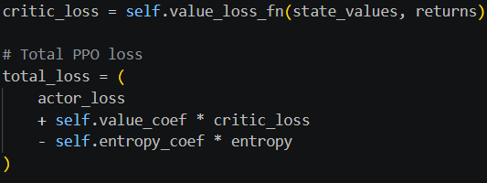
Finally, after each PPO update, I clear the memory because PPO uses the collected trajectory for one update cycle and then starts collecting new experience again.

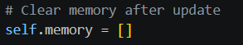

train_ppo_agent.py
First, I created the SUMO command configuration, similar to the other training files.
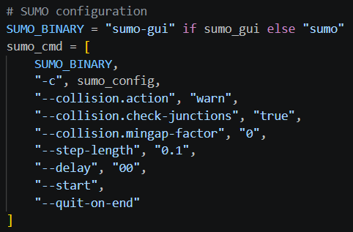

Then, I used the PPO-specific environment, sumo_gym_env_ppo.py, instead of the original SUMO environment.
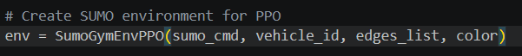

After that, I initialized the PPO agent using the observation space and action space from the environment. The state size comes from the 5 discrete traffic states, and the action size comes from the 3 possible actions: accelerate, do nothing, and decelerate.
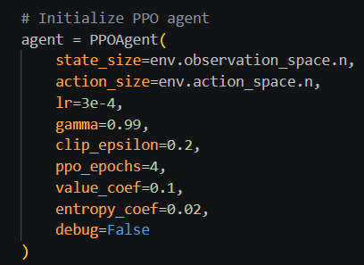
At the beginning of each episode, I close any previous TraCI connection and reset the environment. This was important because otherwise SUMO/TraCI could keep an old connection active and cause problems when starting a new episode.
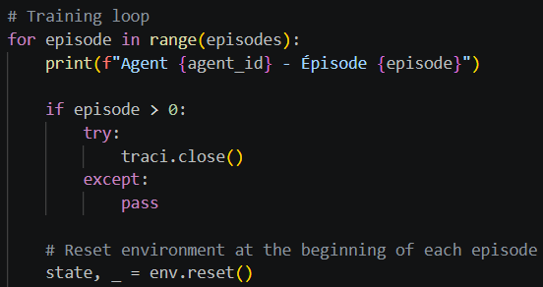

Inside the episode loop, the PPO agent selects an action based on the current state. Differently from DQN/DDQN, PPO also stores the log_prob and the estimated value, because these are needed later for the PPO update.
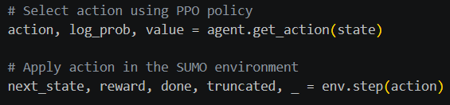

The file also records collision-related information and traffic impact metrics, similar to the previous agents.
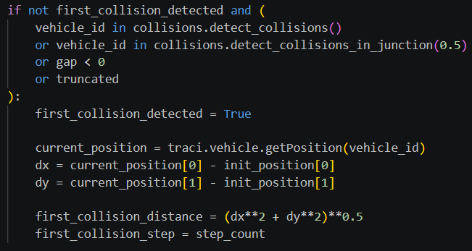
The most important PPO-specific part in the training file is the memory storage. For each step, the transition is saved in the PPO agent memory. This includes the state, action, reward, terminal flag, log probability, and critic value.
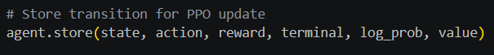
After one full episode is completed, the PPO agent is updated. So in this implementation, PPO learns from the trajectory collected during the episode, then clears the memory inside the update function.

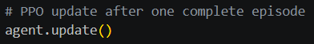

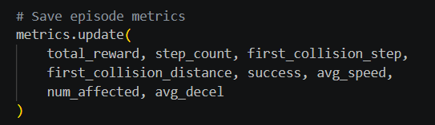
At the end of each episode, I save the metrics such as total reward, travel time, collision information, success, average speed, affected followers, and average deceleration.

I also added checkpoint saving every 50 episodes. This is useful because PPO training can take time, and checkpoints allow me to keep intermediate versions of the model instead of only saving the final one.
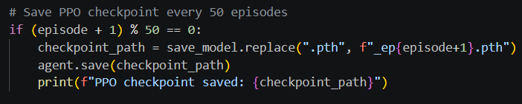

Finally, after training is finished, the final PPO model is saved, and the metrics are saved and plotted.
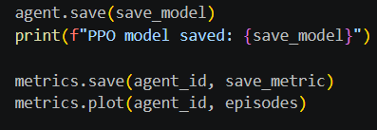

validation_agent_ppo.py
During validation, the agent uses the learned policy and selects the best action based on the trained model.
This part creates the SUMO environment used for PPO validation.
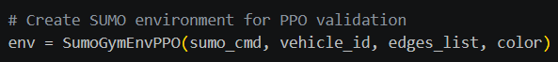

Here, the PPO agent is initialized with the same state and action spaces as during training. Then, the saved model is loaded from the .pth file so the agent can be tested using the learned policy.
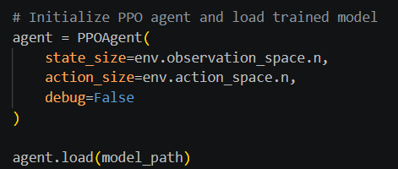

For every validation episode, the SUMO simulation is reset.
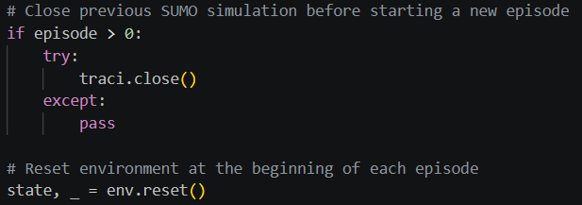

This is one of the most important parts of validation. During training, the PPO agent can sample actions, but during validation I used exploit=True so the agent chooses the action with the highest probability. This means the validation tests what the agent has actually learned.
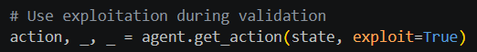

After the action is selected, it is applied in the SUMO environment. The environment then returns the next state, reward, and information about whether the episode finished.
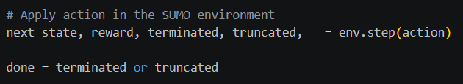

I added this check because SUMO can teleport a vehicle if it gets stuck for too long. In validation, this is treated as a failure because it means the agent did not complete the scenario normally.
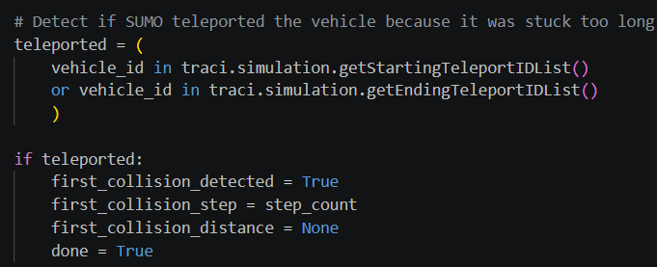

This part checks if the controlled vehicle is almost not moving for a long time. I added it to avoid counting frozen or stuck episodes as successful episodes.
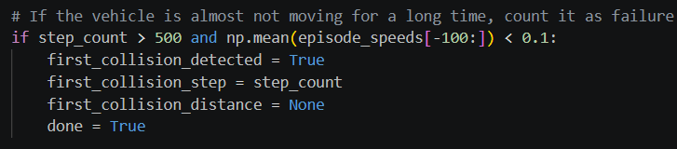

This part checks if the vehicle collided, had a dangerous gap with another vehicle, or if the episode was truncated. This is used to decide later if the episode was successful or not.
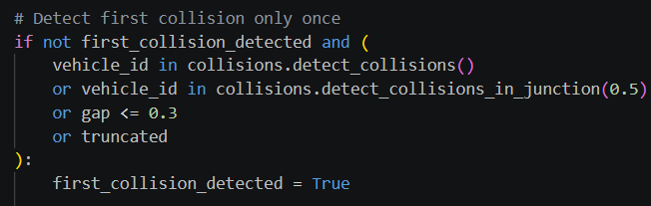

At the end of each episode, success is calculated based on three conditions: no collision was detected, the reward was not extremely negative, and the vehicle had a reasonable average speed.
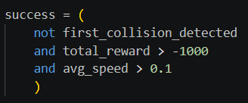

At the end of validation, the metrics are saved into a CSV file and plotted. This allows me to compare the PPO validation results with the training results and with the other models.
