DDQN - Red Agent - Training Results
I trained the DDQN Red agent for 1000 episodes. The training metrics were saved successfully in CSV format and the plots were generated after training.

Main observations from the DDQN_training_metrics_agent_v_red_2.csv
The average reward is mostly negative in the early episodes, but becomes more positive later in training.
Travel time decreases significantly from high values at the beginning to much lower and more stable values later.
Most episodes are successful, although some failed episodes still appear.
The average speed increases during training, which suggests better and more efficient behavior.

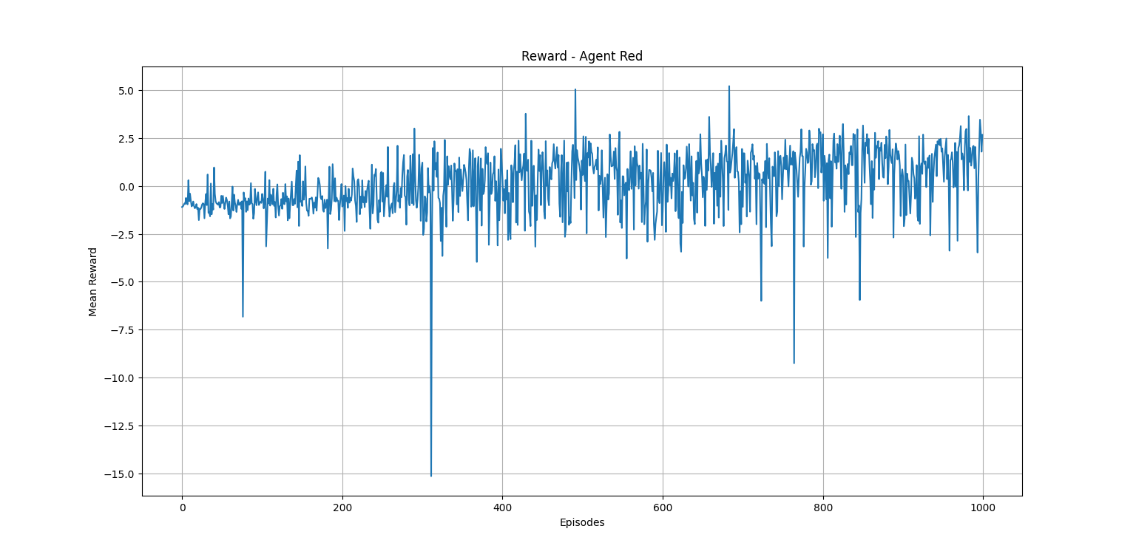
The reward becomes better overall during training, even if there are still some negative episodes.
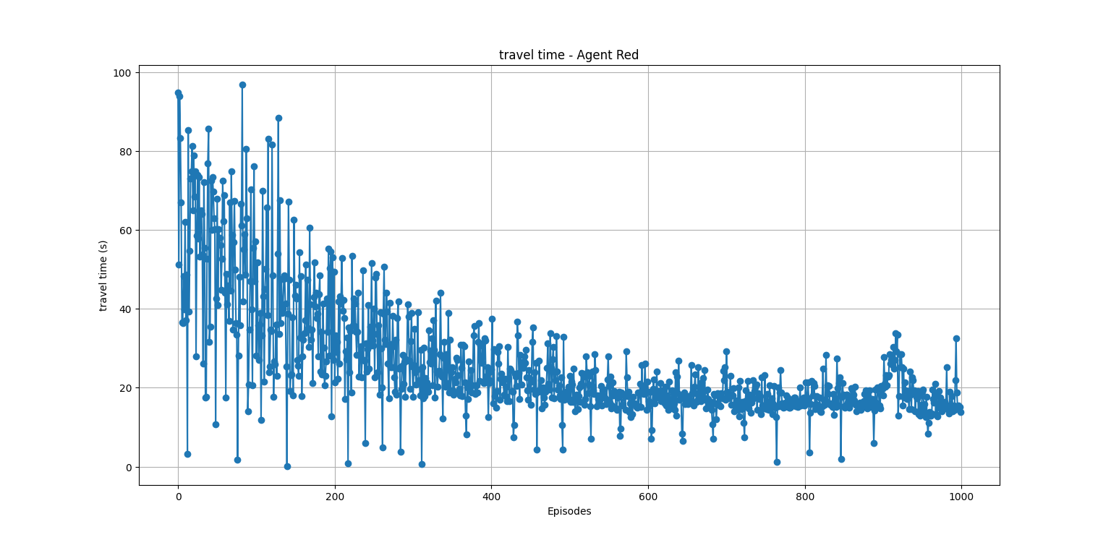

Travel time decreases compared to the beginning, so the agent becomes more efficient.

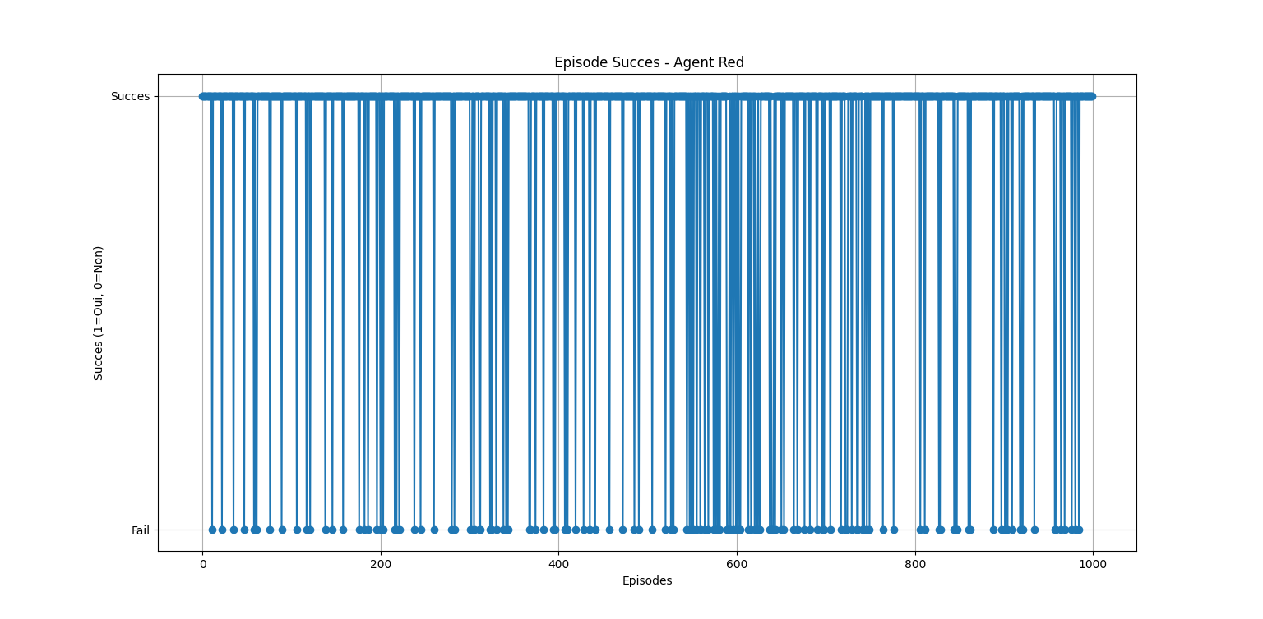
Most episodes are successful, although some failed episodes still appear during training. In general, the number of successful episodes stays high.
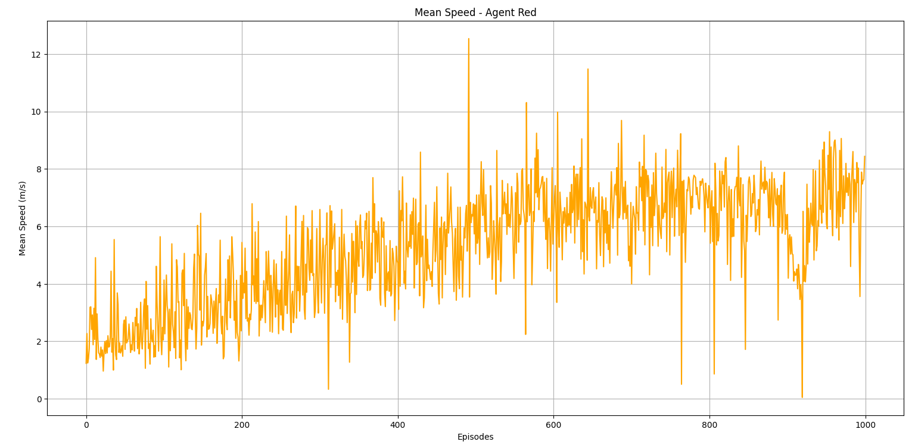
The mean speed increases over training, even if there are still some drops in a few episodes which shows that the agent becomes more efficient and confident in its behavior over time.

DDQN - Red Agent - Validation Results
The validation results are overall very good. Most episodes were successful, the reward stayed mostly positive, and the travel time remained stable around 9–12 seconds. The validation accuracy reached about 97.4%, which shows that the DDQN agent learned a strong policy for the red-agent scenario.
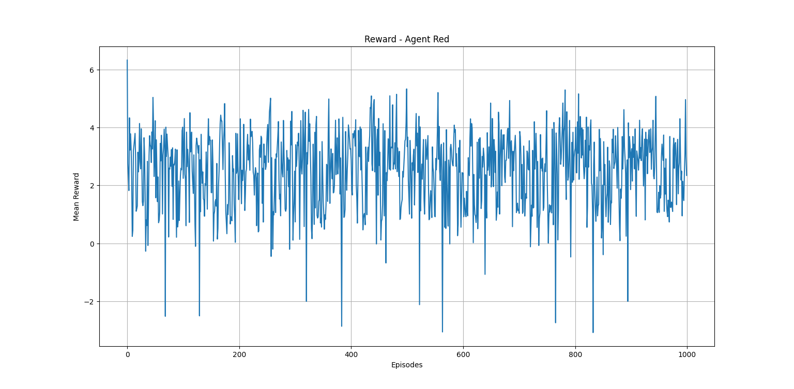

The reward is mostly positive during validation, with only a few drops in some episodes.

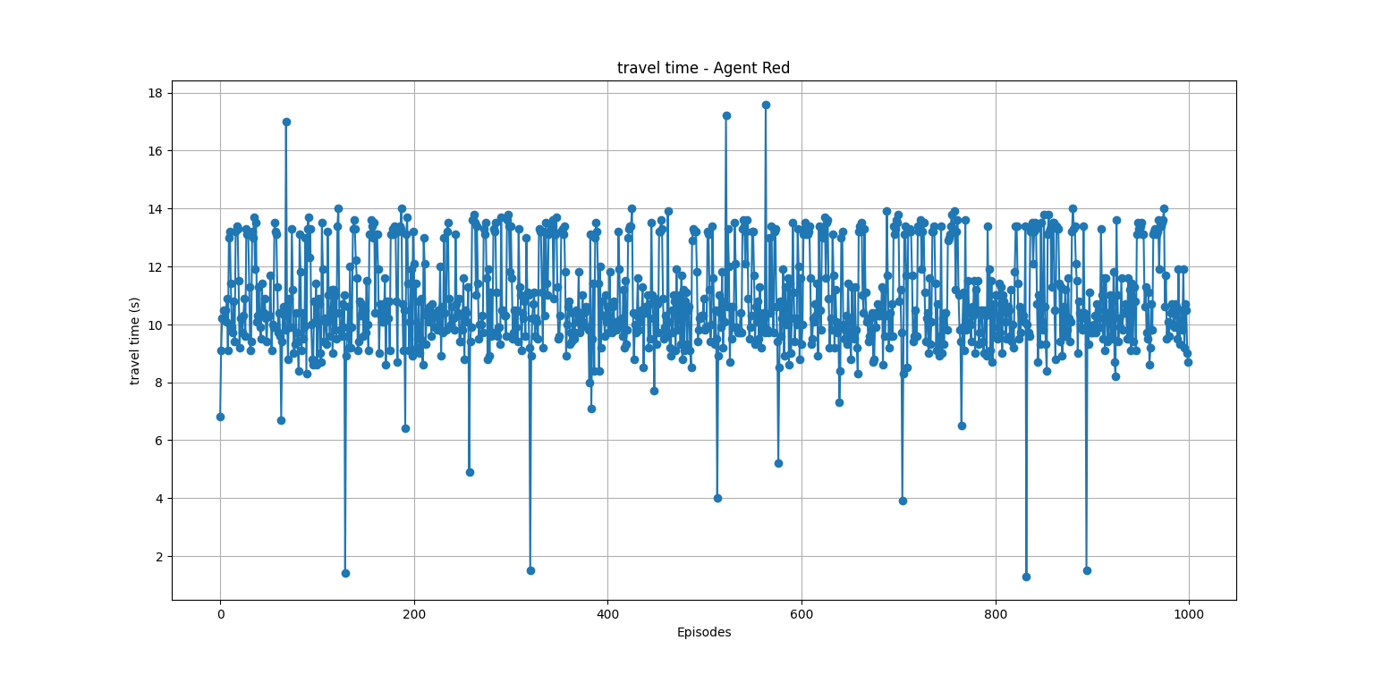
The travel time stays stable in most episodes, around a similar range.

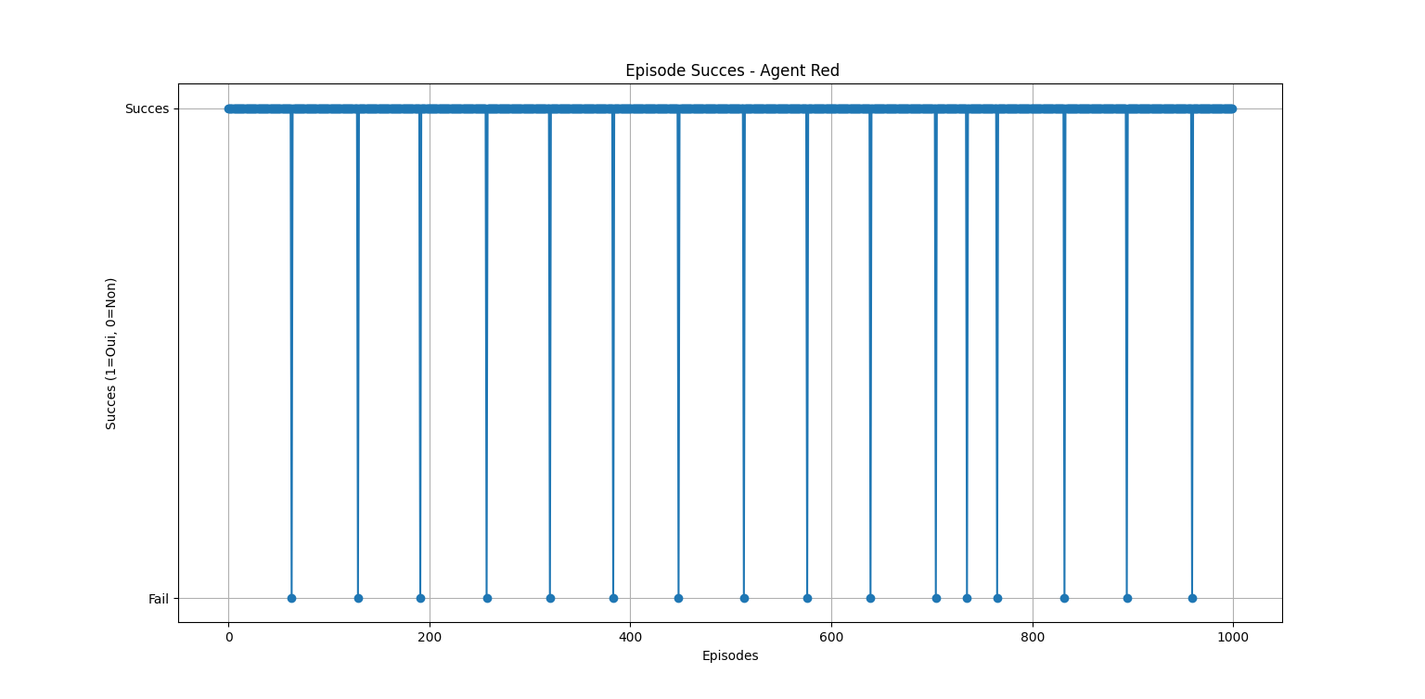
Most validation episodes are successful, with only a small number of failed cases. This indicates strong overall performance of the agent. The validation result is 97.4% accuracy, since there are 974 successful episodes out of 1000.

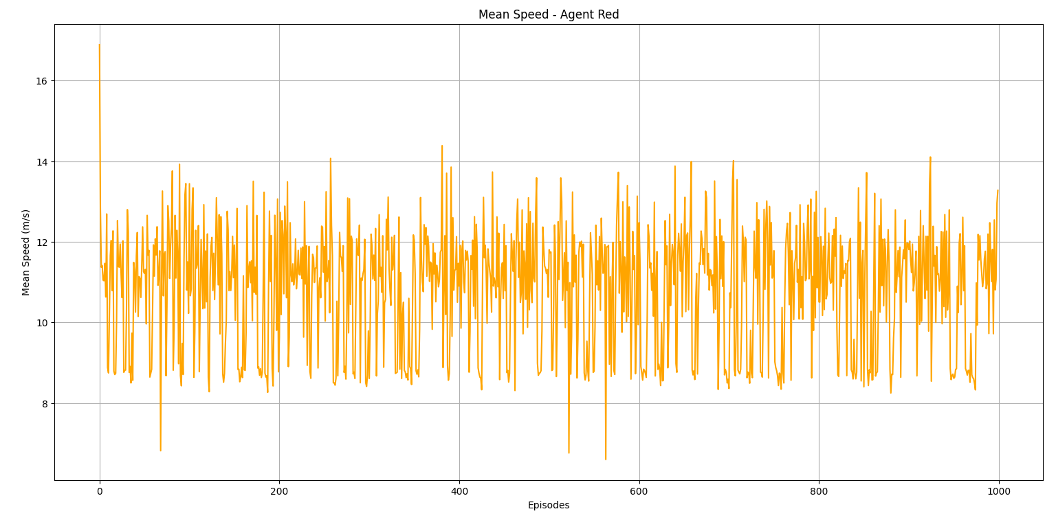
The mean speed remains relatively stable during validation, with some normal variations between episodes.

