Modeling and Simulation 101.455

**Emergency Call – Handout**

# **Task Description**

The task is to model Emergency Call case using AnyLogic.

The facts are as follows:

* In the operation center of an urgent medical help, an emergency call is given every 50 minutes.
* If the emergency vehicle with the doctor is on a mission or driving, incoming calls are collected in a waiting list.
* Immediately after completion of the treatment, the doctor then calls the center and if necessary receives the address (number of district) of the next patients.
* The selection from the waiting list is based on the FIFO (First In First Out) principle, with life–threatening emergencies having priority.
* For the treatment of “normal” patient, 10 to 20 minutes are estimated and for the “life-threatening” patient treatment, 30 to 90 minutes are estimated.
* If no further patient needs a treatment, the vehicle returns to the hospital, in the first district.
* The operational area of the doctor covers 10 districts.

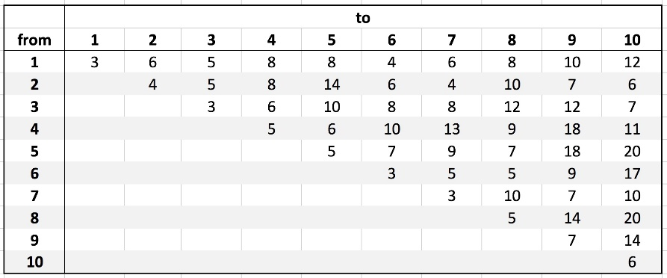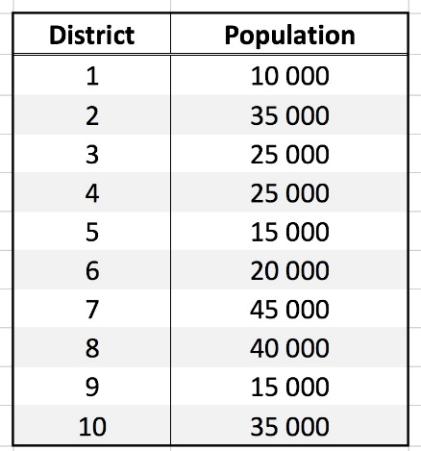

Average driving time from district to district in minutes

District’s population

# **Software Used**

For solving our project we have used AnyLogic, which is a simulation tool that supports all the most common simulation methodologies like System Dynamics, Agent-Based Approach and Discrete Events. (which of these one we have used, agent based + discrete event )

# **Implementation**

For the model creation we have used several AnyLogic components from different palettes.

The core elements of our model are the two queues connected to sources which generates patients. One queue and source are used for generating and storing not urgent patients and other ones are used for urgent patients. Another important part of our model is the state chart diagram which represents the states of the doctor. The model starts with the doctor being in hospital state. If a patient is in one of the queues, the doctor changes the state to driving to patient and then treating the patient. When he finishes treating the current patient, the doctor either drives to another patient or drives back to the hospital.

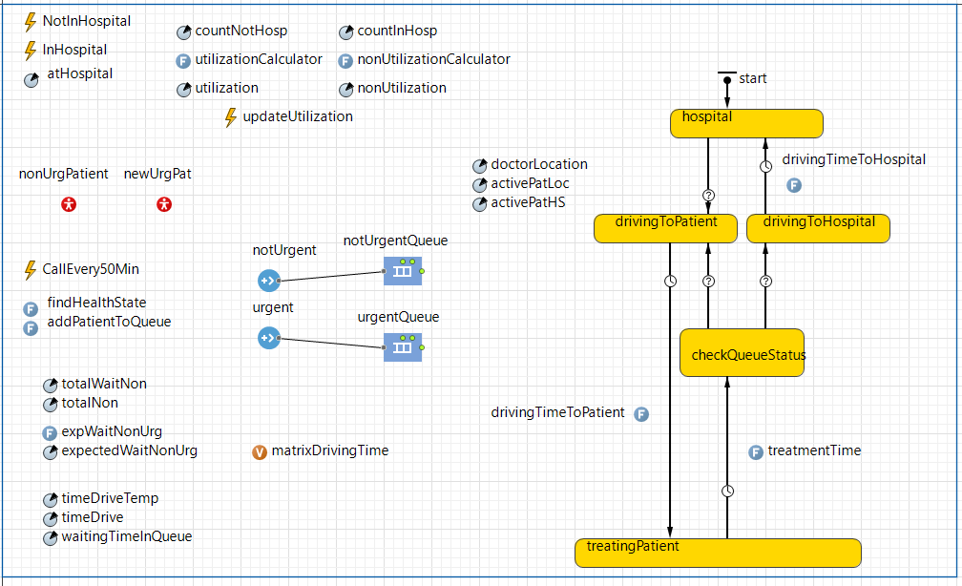

Emergency Call model screenshot

# **Statistics**

In this part we calculate and provide answers to the following questions:

1. Utilization of on-duty doctor: stored in the utilization parameter in the model
2. Expected waiting time of non-life threatening patient: stored in expectedWaitNonUrg parameter
3. Proportion of time spent by the doctor at the center: stored in nonUtilization parameter
4. Examination of other strategies: Agent Comparison and LIFO approaches

Group 14

Fanny Anna Andersson

David Zafirovski

Edon Jakupi