This is a Test

I am modifying content and Adding one Image

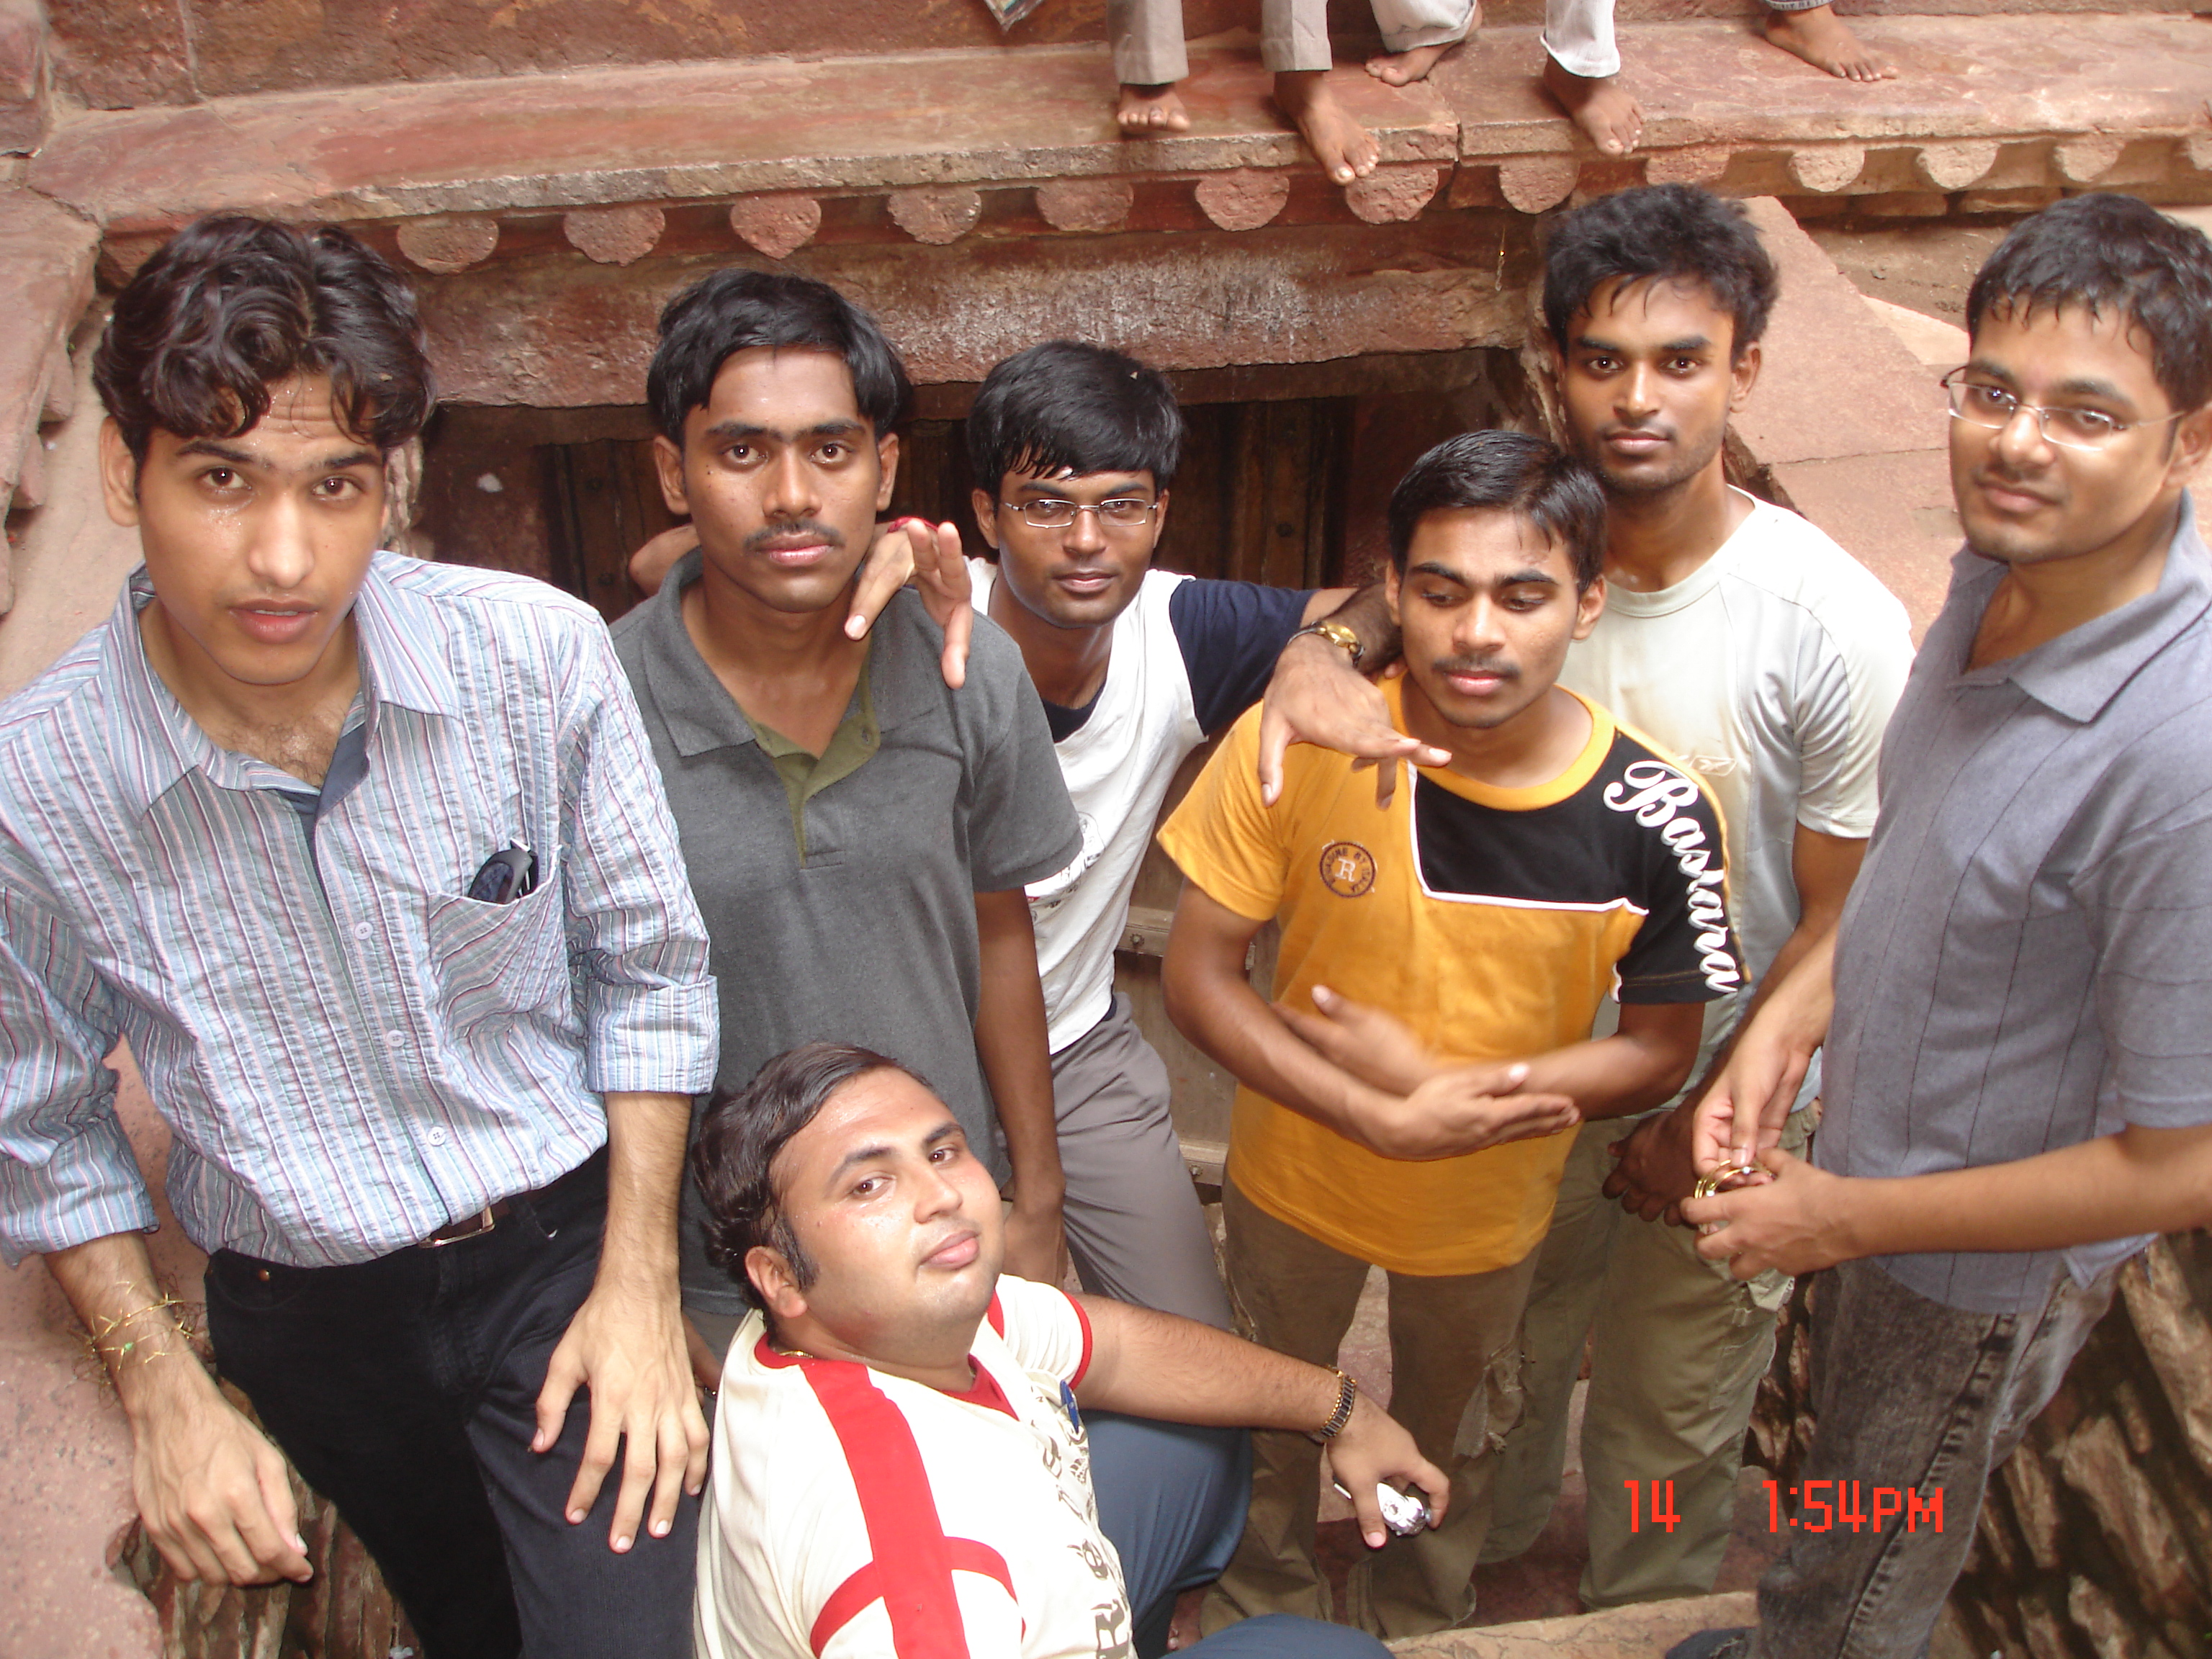

I have added this image, just for test !

