Bob | Alice
 | Hi Bob !
Hi Alice !
 | This software sure looks awesome.
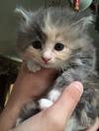
It sure does.
 | What a wonderful imaginary life we live ! No more Diffie Hellman, key exchanges or convuluted scenarios with Eve to sociopath, just cute pictures of small animals.
 | 