Report: Consumer Confidence and Social Transfers in Thailand, 2017-2024
This report interprets "customer confidence" as household consumer confidence. It combines official Thai fiscal and confidence data to study how social transfers in cash and in kind interacted with confidence between 2017 and 2024, with special attention to low-income households.

Executive Summary
- NESDC data show a large rise in Thailand's social-transfer envelope between 2017 and 2024. Total cash-like social benefits increased from THB 459.2 billion to THB 782.8 billion, while total social transfers in kind increased from THB 1.255 trillion to THB 1.628 trillion.
- The low-income-focused components grew even faster on the cash side. Cash social assistance almost doubled, from THB 104.0 billion in 2017 to THB 200.6 billion in 2024, a 92.8 percent increase.
- In-kind social assistance behaved differently. It was broadly stable before COVID, surged in 2021-2022 as health and cost-of-living support intensified, peaked at THB 344.9 billion in 2022, fell sharply in 2023 as pandemic-era health spending unwound, and partially rebounded in 2024.
- Confidence data tell a consistent macro story across sources. TPSO national consumer confidence averaged 48.4 in 2019, fell to 42.1 in 2020, recovered to 54.2 in 2023, and eased to 52.3 in 2024. FPO's regional RSI shows the same turning points and is highly correlated with TPSO confidence in the overlap sample.
- In monthly national change regressions, cash-transfer intensity is associated with a contemporaneous rise in TPSO consumer confidence of about 0.42 index points for a one-standard-deviation increase in the monthly cash proxy. In-kind support is more visible in the FPO sentiment measure, where the contemporaneous coefficient is about 1.56 points.
- In the occupation-level two-way fixed-effects panel, the story is more nuanced. High-transfer months did not eliminate the confidence gap between low-income-sensitive occupations and better-insulated groups. Cash-heavy months are associated with weaker relative confidence for exposed occupations, while in-kind support is mildly positive, especially for future expectations.
- Policy implication: cash transfers are useful for fast macro support, but durable confidence improvement for low-income households appears to rely more on predictable in-kind support, especially health, utilities, and essential living-cost relief.

Data, Scope, and Interpretation
- Fiscal anchor: NESDC annual national income tables, especially Table 61 in NI2024-Income.xlsx (https://www.nesdc.go.th/wordpress/wp-content/uploads/2025/12/NI2024-Income.xlsx).
- Consumer confidence: TPSO consumer confidence API, monthly national, regional, and occupational series, 2019M1-2024M12.
- Regional macro confidence: FPO regional RSI data catalog, monthly series, 2018M1-2024M12.
- BOT: used for timing and macro interpretation of stimulus effects, not as the core household confidence series.
- TCC: used as a complementary chamber-confidence benchmark from UTCC/CEBF archive releases, not as a direct substitute for household CCI.
The requested window is 2017-2024. The annual fiscal analysis fully covers 2017-2024. The monthly longitudinal econometrics begin later because the available TPSO monthly confidence panel starts in January 2019 and the available FPO monthly RSI starts in January 2018.

Fiscal Trend: What Happened to Social Transfers?
The official NESDC series separate total social transfers from the social-assistance components that are more directly relevant to low-income support. Both are worth tracking.
Year | Cash social assistance (THB bn) | YoY % | In-kind social assistance (THB bn) | YoY % | Main fiscal context
2017 | 104.0 | - | 220.7 | - | State Welfare Card rollout begins
2018 | 145.6 | 40.0 | 217.2 | -1.6 | Welfare-card phase 1-2 expansion
2019 | 161.3 | 10.7 | 222.0 | 2.2 | Welfare-card deepening, phase-2 quality-of-life measures
2020 | 176.5 | 9.4 | 228.8 | 3.0 | COVID emergency relief, cash top-ups, utility relief
2021 | 187.1 | 6.0 | 310.0 | 35.5 | Rao Chana, M33, vaccines, reopening support
2022 | 188.3 | 0.6 | 344.9 | 11.2 | Health spending remains high, welfare re-registration
2023 | 195.2 | 3.7 | 243.0 | -29.6 | COVID health spending unwinds, new welfare-card cycle
2024 | 200.6 | 2.7 | 260.8 | 7.3 | 10,000-baht vulnerable-group handout
Across the full 2017-2024 period:
- Total cash-like social benefits rose 70.5 percent.
- Cash social assistance rose 92.8 percent.
- Total social transfers in kind rose 29.8 percent.
- In-kind social assistance rose 18.2 percent, but with a pronounced pandemic hump.
The most important structural point is that cash support became larger and more permanent over time, while in-kind support became more cyclical and crisis-sensitive because of health expenditure.
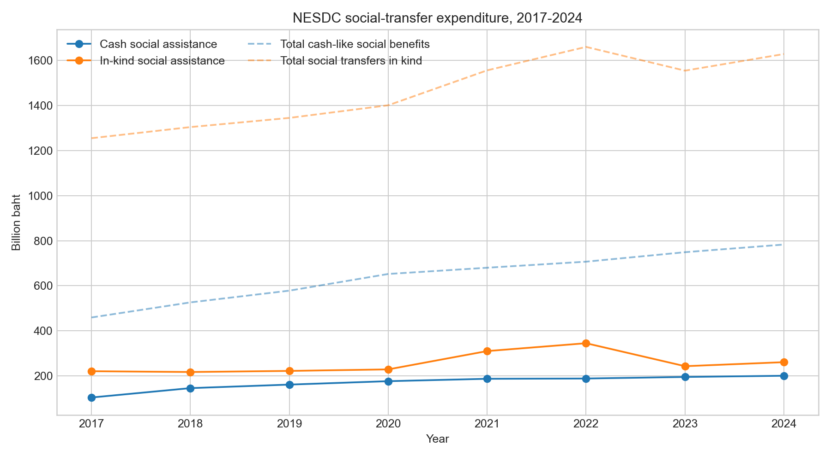
Annual Social Transfers

Confidence Trend: What Happened to Sentiment?
Confidence fell sharply in the pandemic and then recovered in 2022-2024, but the recovery was incomplete and uneven.
- TPSO national CCI annual averages:
  - 2019: 48.4
  - 2020: 42.1
  - 2021: 43.0
  - 2022: 46.2
  - 2023: 54.2
  - 2024: 52.3
- FPO mean regional RSI annual averages:
  - 2018: 78.4
  - 2019: 65.4
  - 2020: 52.8
  - 2021: 55.6
  - 2022: 66.4
  - 2023: 76.0
  - 2024: 74.3
The overlap correlation between TPSO national CCI and the FPO mean regional RSI is 0.94, so the two sources agree strongly on turning points even though their levels differ.
The TCC benchmark releases are consistent with the same turning points:
- April 2020 TCC-CI: 32.1
- October 2021 TCC-CI: 19.9
- October 2024 TCC-CI: 48.9
These TCC levels are lower than TPSO levels because the chamber-based index is not the same survey instrument, but the directional story is the same: collapse in the pandemic, partial recovery after reopening and renewed stimulus.
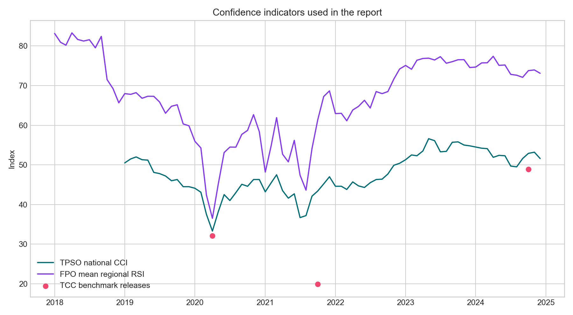
Confidence Indicators

Econometric Design
The econometric strategy uses a transparent mixed-frequency design:
1. NESDC annual social-assistance totals anchor the true fiscal magnitude.
2. A monthly policy-intensity calendar allocates those annual totals across months using the timing of major cash and in-kind stimulus programs.
3. Three empirical models are then estimated.
The core design problem is that the fiscal data are annual while the confidence data are monthly. The solution used here is to build a transparent monthly fiscal proxy that preserves the official annual totals exactly and only uses policy timing to distribute those totals within each year.

1. Construction of the Monthly Fiscal Proxy
Let:
- A_cash,y be NESDC annual cash social assistance in year y.
- A_inkind,y be NESDC annual in-kind social assistance in year y.
- w_cash,t be the monthly cash-intensity weight in month t.
- w_inkind,t be the monthly in-kind-intensity weight in month t.
All months start with a baseline weight of 1. A policy episode then adds extra weight to the months it covers. Within a year:
$${cash proxy}_{t} = \frac{A_{cash,y} × w_{cash,t}}{\sum_{m ∈ y}{w_{cash,m}}}$$
$${inkind proxy}_{t} = \frac{A_{inkind,y} × w_{inkind,t}}{\sum_{m ∈ y}{w_{inkind,m}}}$$
This guarantees that the 12 monthly proxies sum exactly to the official NESDC annual total in each year. The two proxies are then standardized across the full monthly sample:
$${cash z}_{t} = \frac{\left({cash proxy}_{t} - mean(cash proxy)\right)}{sd(cash proxy)}$$
$${inkind z}_{t} = \frac{\left({inkind proxy}_{t} - mean(inkind proxy)\right)}{sd(inkind proxy)}$$
As a result, all reported coefficients can be read as the confidence response to a one-standard-deviation increase in the relevant transfer-intensity proxy.

2. Policy-Intensity Calibration Used in the Proxy
The weight schedule used in the monthly allocation is:
Episode | Months | Cash weight add-on | In-kind weight add-on | Rationale
State Welfare Card launch | 2017-10 to 2018-03 | 1.4 | 0.8 | Initial rollout and top-up cycle
Welfare-card deepening | 2018-04 to 2019-12 | 0.7 | 0.5 | Phase-2 quality-of-life measures
COVID emergency cash | 2020-04 to 2020-06 | 4.8 | 0.8 | Rapid cash stabilization
COVID cost-of-living extension | 2020-07 to 2020-12 | 1.7 | 1.4 | Utility and living-cost relief
Rao Chana and M33 Rao Rak Kan | 2021-02 to 2021-05 | 5.6 | 1.1 | Strong cash-led support
Vaccination and reopening | 2021-06 to 2021-12 | 2.4 | 3.8 | Health purchases and reopening
2022 health and welfare support | 2022-01 to 2022-09 | 1.3 | 2.8 | Sustained health and welfare spending
New welfare-card cycle | 2023-04 to 2023-12 | 0.9 | 0.5 | New entitlement cycle
10,000-baht vulnerable-group transfer | 2024-09 to 2024-11 | 5.2 | 0.2 | Large one-off cash stimulus
These weights are not themselves econometric estimates. They are a calibration device used to map annual fiscal totals into monthly intensity while respecting policy timing.

3. Samples and Variable Definitions
National confidence sample:
- TPSO national CCI monthly series: 2019M1-2024M12.
- FPO mean regional RSI monthly series: 2018M1-2024M12.
- TCC is used only as a benchmark cross-check for selected dates, not as a direct dependent variable in the main regressions.
Occupation panel sample:
- 7 monthly TPSO occupation groups from 2019M1-2024M12.
- Outcomes:
  - cci_ot = overall occupation-level confidence index
  - future_ot = occupation-level future expectations index
- Low-income-sensitive exposure dummy:
  - LowInc_o = 1 for farmers, service labor / free service occupations, and not-working / pension groups
  - LowInc_o = 0 for government/state-enterprise employees, students, company employees, and business owners / traders
Effective estimation sample sizes:
- National TPSO change model: 70 monthly observations after differencing and lags.
- National FPO change model: 82 monthly observations after differencing and lags.
- Occupation TWFE on cci_ot: 504 observations, 72 months, 7 occupations.
- Occupation TWFE on future_ot: 336 observations, 48 months, 7 occupations.
- Local projections:
  - h=0: 497 observations
  - h=1: 490 observations
  - h=2: 483 observations
  - h=3: 476 observations

4. Model A: National Confidence Change Model
For the aggregate monthly models, the estimated equation is:
$${ΔY}_{t} = α + β_{0} {cash z}_{t} + β_{1} {inkind z}_{t} + β_{2} {cash z}_{t-1} + β_{3} {inkind z}_{t-1} + ρ {ΔY}_{t-1} + e_{t}$$
where:
- Y_t is either TPSO national CCI or the FPO mean regional RSI.
- Delta Y_t is the month-to-month change in that series.
- cash_z,t and inkind_z,t are the standardized monthly fiscal proxies.
- rho captures short-run persistence in monthly confidence changes.
Interpretation:
- beta_0 measures the contemporaneous aggregate confidence response to cash intensity.
- beta_1 measures the contemporaneous aggregate confidence response to in-kind intensity.
- beta_2 and beta_3 capture one-month delayed effects.
This model is intentionally parsimonious. It is designed to summarize the short-run macro association between transfer intensity and confidence, not to claim a fully structural causal estimate.

5. Model B: Occupation-Level Two-Way Fixed Effects
The main distributional model is:
$$Y_{o,t} = α_{o} + λ_{t} + θ_{cash} \left({LowInc}_{o} × {cash z}_{t}\right) + θ_{inkind} \left({LowInc}_{o} × {inkind z}_{t}\right) + u_{o,t}$$
where:
- alpha_o are occupation fixed effects.
- lambda_t are full date fixed effects, one for each monthly observation in the panel.
- Y_o,t is either cci_o,t or future_o,t.
Important identification point:
- Because lambda_t absorbs all common monthly shocks, the main effects of cash_z,t and inkind_z,t are fully absorbed.
- The model therefore identifies only the relative response of low-income-sensitive occupations compared with better-insulated occupations in high-transfer months.
Interpretation:
- theta_cash > 0 would mean cash-heavy months narrow the vulnerable-group confidence gap.
- theta_cash < 0 means cash-heavy months are associated with a wider gap or a weaker relative recovery for exposed groups.
- theta_inkind is interpreted the same way for in-kind support.

6. Model C: Local Projections
To trace the short-run dynamics, the report estimates a local-projection specification for horizons h = 0, 1, 2, 3:
$$Y_{o,t+h} - Y_{o,t-1} = α_{o,h} + λ_{t,h} + ψ_{cash,h} \left({LowInc}_{o} × {cash z}_{t}\right) + ψ_{inkind,h} \left({LowInc}_{o} × {inkind z}_{t}\right) + v_{o,t+h}$$
where:
- the left-hand side is the cumulative change from t-1 to t+h,
- alpha_o,h and lambda_t,h are horizon-specific occupation and time fixed effects.
Interpretation:
- psi_cash,h and psi_inkind,h show how the relative confidence response of vulnerable occupations evolves over the next 0 to 3 months after a high-transfer month.

7. Estimation and Variance Formulas
The occupation-panel models are estimated with ordinary least squares after exact two-way demeaning. Let X be the matrix of demeaned regressors and u the residual vector. The clustered variance estimator is:
$$V_{cluster} = s {\left(X'X\right)}^{-1} \left[\sum_{g}{\left({X'}_{g} u_{g} {u'}_{g} X_{g}\right)}\right] {\left(X'X\right)}^{-1}$$
where g indexes monthly clusters and:
$$s = \left(\frac{M}{M - 1}\right) \left(\frac{N - 1}{N - K}\right)$$
- M is the number of clusters
- N is the number of observations
- K is the number of regressors
Thus the occupation models use month-clustered robust standard errors with the small-sample correction above.
The national change models use a Newey-West style HAC estimator with Bartlett weights and lag length L = 3:
$$V_{HAC} = {\left(X'X\right)}^{-1} S {\left(X'X\right)}^{-1}$$
where:
$$S = Σₜ uₜ² xₜ xₜ' + Σl₌₁ᴸ (1 - l/(L+1)) Σₜ₌l₊₁ᵀ uₜ uₜ₋l (xₜ xₜ₋l' + xₜ₋l xₜ')$$
The report uses 90 percent confidence intervals, computed as coefficient plus or minus 1.645 standard errors.

8. Identification Assumptions and Limits
The key identifying assumption is not that transfers are exogenous. The design is more modest.
- In the national change models, the coefficients measure conditional short-run comovement after partial control for persistence.
- In the occupation TWFE and local-projection models, the identifying variation comes from whether exposed occupations move differently than non-exposed occupations in the same month when transfer intensity is high.
That is a stronger design than a pure before-after comparison, but it still has limits:
- The monthly fiscal proxy is modeled, not directly observed.
- Policy intensity is coded from rollout timing rather than from actual monthly disbursement ledgers.
- Some transfer programs may be endogenous to deteriorating conditions, especially in 2020-2021.
- The exposure dummy is deliberately simple and may understate heterogeneity within occupations.
- The occupation future-expectations model has fewer observations because the TPSO future series has missing values in part of the panel.
The main caveat is therefore unchanged: the report provides a serious longitudinal empirical framework, but it should be interpreted as a transparent mixed-frequency policy evaluation exercise rather than a definitive structural causal estimate.

Econometric Results

1. Aggregate confidence support
The national change models suggest that higher transfer intensity supported confidence at the macro level.
Outcome | Cash proxy coef. | 90% CI | In-kind proxy coef. | 90% CI
TPSO national CCI change | 0.42 | 0.15 to 0.69 | 0.15 | -0.47 to 0.78
FPO mean regional RSI change | 0.12 | -0.46 to 0.70 | 1.56 | 0.07 to 3.06
Interpretation:
- Cash transfers matter most for immediate macro demand support in the TPSO household confidence series.
- In-kind support matters more in the FPO regional macro-sentiment series, consistent with the role of health and cost-of-living support in stabilizing local economies.

2. Distributional result: vulnerable occupations still lag
The two-way fixed-effects panel gives a different answer from the aggregate model.
Outcome | Cash interaction | 90% CI | In-kind interaction | 90% CI
TPSO occupation CCI | -0.26 | -0.44 to -0.07 | 0.16 | -0.03 to 0.35
TPSO occupation future expectations | 0.12 | -0.19 to 0.43 | 0.32 | 0.03 to 0.61
Interpretation:
- High-cash-stimulus months did not close the confidence gap between vulnerable occupations and better-insulated groups.
- In-kind support is the more favorable channel for low-income-sensitive groups, especially when the outcome is expectations rather than current sentiment.
- A reasonable reading is that cash programs helped stabilize aggregate demand, but they were deployed in precisely the months when vulnerable groups were still suffering the deepest stress. In-kind programs appear more effective at improving relative expectations for those groups.

3. Dynamic response from local projections
The local projections reinforce that interpretation.
- Cash interaction:
  - h=0: -0.11
  - h=1: -0.12
  - h=2: -0.01
  - h=3: 0.01
- In-kind interaction:
  - h=0: 0.06
  - h=1: 0.09
  - h=2: 0.05
  - h=3: 0.06
So the relative drag from cash-heavy episodes fades quickly, while the relative support from in-kind programs is small but persistently positive.
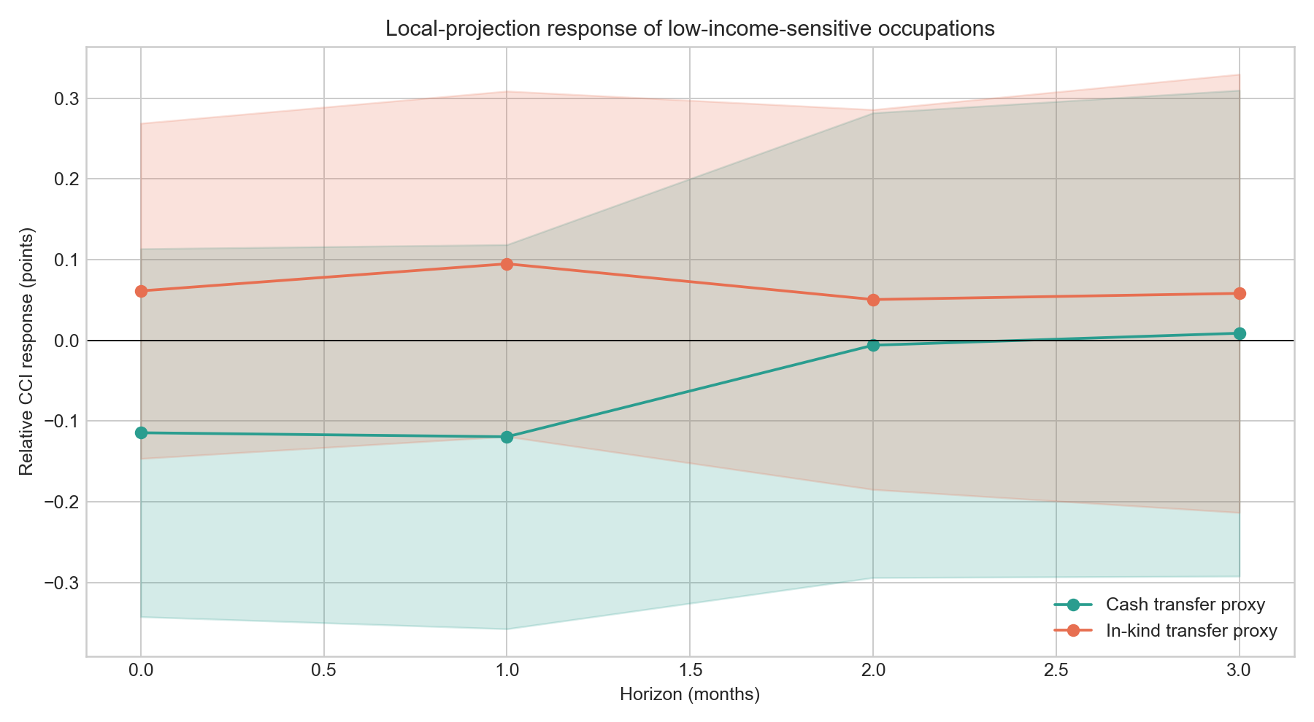
Local Projections
The occupation gap itself widened over time:
- Average treated-minus-control gap in 2019: -1.41 CCI points
- Average treated-minus-control gap in 2024: -3.68 CCI points
That is the most important distributional warning in the report. Thailand's post-pandemic confidence recovery was real, but it was not evenly shared.
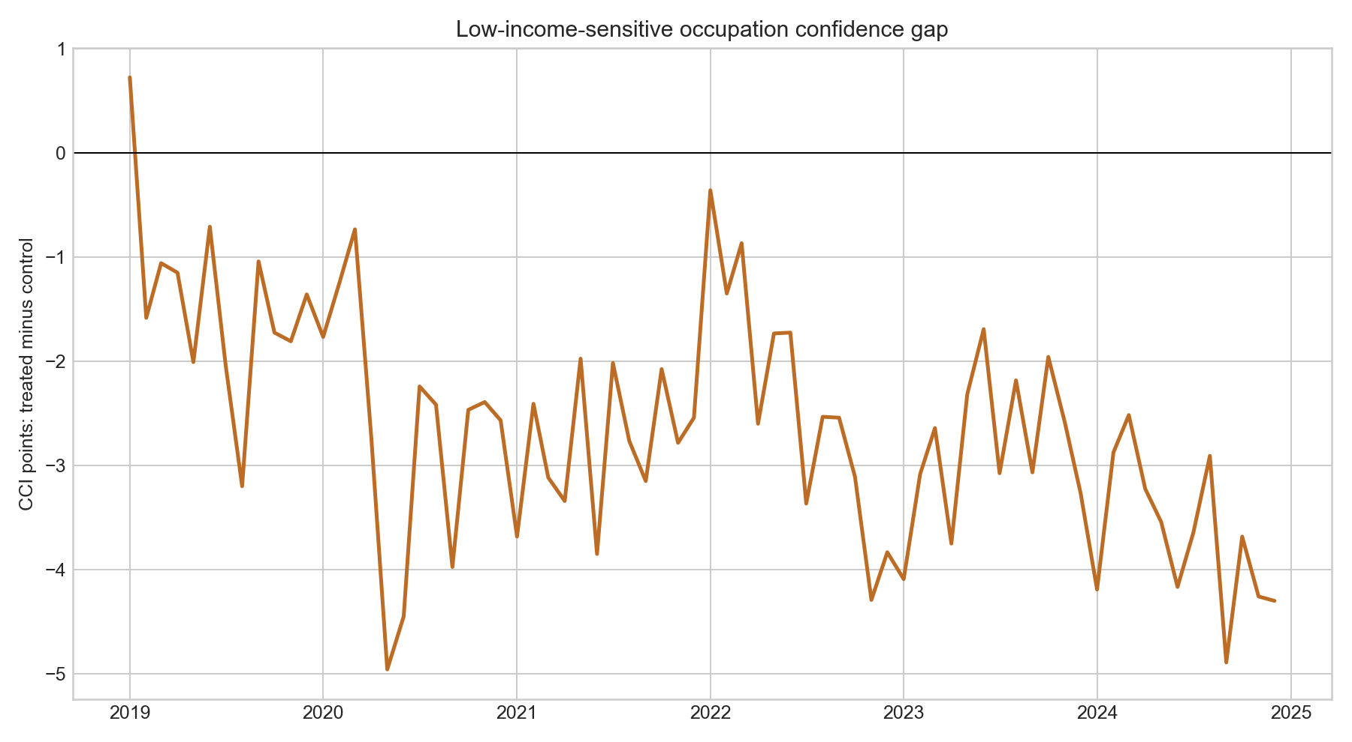
Occupation Gap

Important Policies Affecting Low-Income People
- 2017-2018: State Welfare Card phase 1 and 2 created a durable low-income transfer architecture combining cash, transport, LPG, utilities, and purchases through designated channels.
- 2019: Welfare-card phase-2 quality-of-life measures deepened the system and were explicitly framed around poverty reduction and income upgrading.
- 2020: COVID emergency cash relief, welfare-card top-ups, and electricity/water support prevented a deeper collapse in household purchasing power.
- 2021: Rao Chana and M33 Rao Rak Kan were the strongest cash-stimulus episodes in the sample. At the same time, health and vaccination expenditures lifted in-kind support sharply.
- 2022: Continued health support and the new welfare-card registration cycle sustained the in-kind peak.
- 2023: The 2022 welfare-card registration translated into a new entitlement cycle, while COVID health purchases normalized.
- 2024: The government approved a THB 10,000 transfer for about 14.55 million State Welfare Card holders and disabled persons, explicitly to relieve living costs and lift consumption quickly.

What This Means for Policy
Three conclusions follow from the evidence.
First, cash transfers are effective for fast economy-wide confidence support. That is what shows up most clearly in the aggregate TPSO change model and in BOT's October 2024 assessment of the 10,000-baht handout.
Second, in-kind support is more important for sustaining confidence among vulnerable groups. Health spending, utility support, and predictable subsidized access to essentials appear to matter more for relative expectations than one-off cash pulses.
Third, relying on temporary cash injections alone is not enough to close the confidence gap for low-income households. By 2024, national confidence had recovered far more than the confidence of the most exposed occupations.
The policy mix that best fits the evidence is:
- Maintain rapid cash support for acute downturns.
- Pair it with predictable monthly entitlements through the welfare-card system.
- Preserve strong in-kind protection in health and utilities during shocks.
- Use automatic triggers tied to labor-market weakness and confidence deterioration so support arrives earlier.

Source Notes
Primary sources used in the report:
- NESDC annual national income tables: NI2024-Income.xlsx (https://www.nesdc.go.th/wordpress/wp-content/uploads/2025/12/NI2024-Income.xlsx)
- NESDC 2023 English release page: National Income of Thailand 2023 (https://www.nesdc.go.th/en/?ddl=36312&p=36311)
- FPO regional RSI data catalog: Thailand Regional Economic Sentiment Index (https://catalog.fpo.go.th/dataset/thailand-regional-economic-sentiment-index-rsi)
- TPSO CCI API endpoint: CCI API (https://cci-survey-tpso.moc.go.th/cci-api/api/CCI/getcci)
- BOT February 2021 economic conditions: BOT Press Release No. 20/2021 (https://www.bot.or.th/en/news-and-media/news/news-20210331-1.html)
- BOT October 2021 economic conditions: BOT Press Release No. 88/2021 (https://www.bot.or.th/en/news-and-media/news/news-20211130.html)
- BOT October 2024 economic conditions: BOT Press Release No. 43/2024 (https://www.bot.or.th/en/news-and-media/news/news-20241129.html)
- FPO welfare-card phase 1 and 2 page: State Welfare Registration 2017 (https://www.fpo.go.th/main/General-information-public-service/%E0%B8%9B%E0%B8%A3%E0%B8%B0%E0%B8%8A%E0%B8%B2%E0%B8%8A%E0%B8%99%E0%B8%84%E0%B8%A7%E0%B8%A3%E0%B8%A3%E0%B8%B9%E0%B9%89/8198.aspx)
- FPO phase-2 quality-of-life infographic: State Welfare Card phase 2 (https://www.fpo.go.th/main/getattachment/News/Press-conference/10272/007-2562-info-%E0%B9%81%E0%B8%96%E0%B8%A5%E0%B8%87%E0%B8%82%E0%B9%88%E0%B8%B2%E0%B8%A7%E0%B8%A1%E0%B8%B2%E0%B8%95%E0%B8%A3%E0%B8%81%E0%B8%B2%E0%B8%A3%E0%B8%9E%E0%B8%B1%E0%B8%92%E0%B8%99%E0%B8%B2%E0%B8%84%E0%B8%B8%E0%B8%93%E0%B8%A0%E0%B8%B2%E0%B8%9E%E0%B8%8A%E0%B8%B5%E0%B8%A7%E0%B8%B4%E0%B8%95%E0%B8%9C%E0%B8%B9%E0%B9%89%E0%B8%A1%E0%B8%B5%E0%B8%9A%E0%B8%B1%E0%B8%95%E0%B8%A3%E0%B8%AA%E0%B8%A7%E0%B8%B1%E0%B8%AA%E0%B8%94%E0%B8%B4%E0%B8%81%E0%B8%B2%E0%B8%A3%E0%B9%81%E0%B8%AB%E0%B9%88%E0%B8%87%E0%B8%A3%E0%B8%B1%E0%B8%90-%E0%B8%A3%E0%B8%B0%E0%B8%A2%E0%B8%B0%E0%B8%97%E0%B8%B5%E0%B9%88-2.pdf.aspx)
- FPO Rao Chana press release: Press release 009/2564 (https://www.fpo.go.th/main/News/Press-conference/13953.aspx)
- FPO Khon La Khrueng phase 3 progress: Press release 192/2564 (https://www.fpo.go.th/main/getattachment/News/Press-conference/14992/%E0%B9%81%E0%B8%96%E0%B8%A5%E0%B8%87%E0%B8%82%E0%B9%88%E0%B8%B2%E0%B8%A7-%E0%B8%89%E0%B8%9A%E0%B8%B1%E0%B8%9A%E0%B8%97%E0%B8%B5%E0%B9%88-192-2564-%E0%B8%84%E0%B8%A7%E0%B8%B2%E0%B8%A1%E0%B8%84%E0%B8%B7%E0%B8%9A%E0%B8%AB%E0%B8%99%E0%B9%89%E0%B8%B2%E0%B9%82%E0%B8%84%E0%B8%A3%E0%B8%87%E0%B8%81%E0%B8%B2%E0%B8%A3%E0%B8%84%E0%B8%99%E0%B8%A5%E0%B8%B0%E0%B8%84%E0%B8%A3%E0%B8%B6%E0%B9%88%E0%B8%87-251064.pdf.aspx)
- FPO 2024 vulnerable-group handout: Press release 90/2567 (https://www.fpo.go.th/main/getattachment/News/Press-conference/19896/90-2567-%E0%B9%81%E0%B8%96%E0%B8%A5%E0%B8%87%E0%B8%82%E0%B9%88%E0%B8%B2%E0%B8%A7-%E0%B8%81%E0%B8%84-%E0%B9%82%E0%B8%84%E0%B8%A3%E0%B8%87%E0%B8%81%E0%B8%B2%E0%B8%A3%E0%B8%81%E0%B8%A3%E0%B8%B0%E0%B8%95%E0%B8%B8%E0%B9%89%E0%B8%99%E0%B9%80%E0%B8%A8%E0%B8%A3%E0%B8%A9%E0%B8%90%E0%B8%81%E0%B8%B4%E0%B8%88%E0%B8%9B%E0%B8%B5-67.pdf.aspx)
- FPO October 2024 fiscal conditions note: Monthly Economic Condition, October 2024 (https://www.fpo.go.th/main/getattachment/Economic-report/Monthly-economic-condition/20191/6-43_2567-Info-monthly-Oct-2024.pdf.aspx)
- UTCC/CEBF chamber-confidence archive: TCC archive page (https://cebf.utcc.ac.th/index_number.php?typeid=7)

