KeyGen.java

Note: The two files privkey.rsa and pubkey.rsa are created in the same directory where the KeyGen application is executed from.

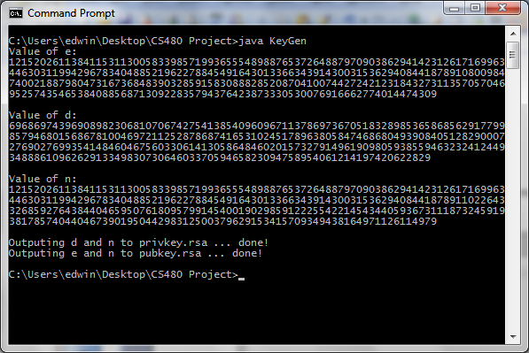

privkey.rsa
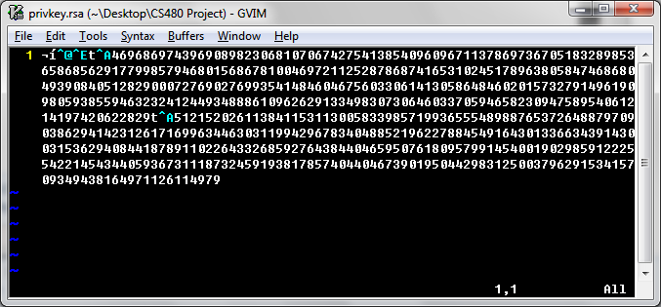

pubkey.rsa
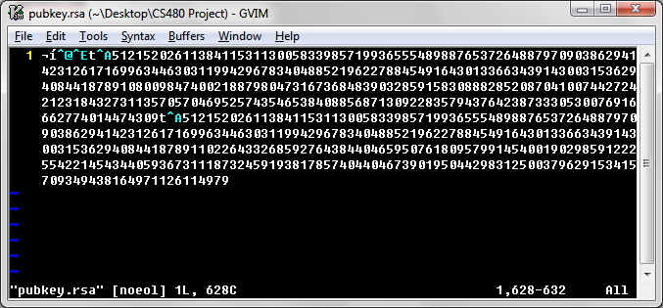

Sending “test.txt”
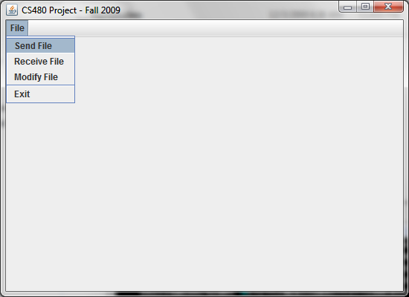

Click button to browse and select “test.txt”
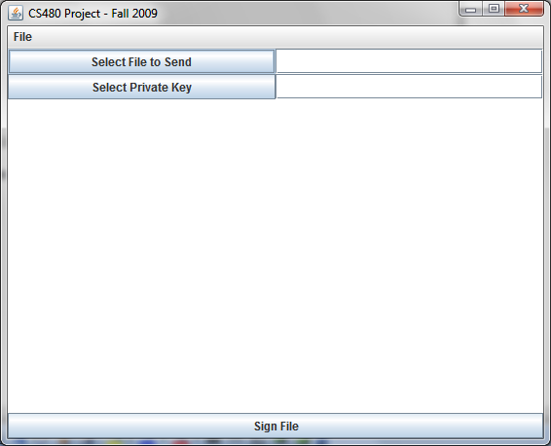

Browse to location of “test.txt”
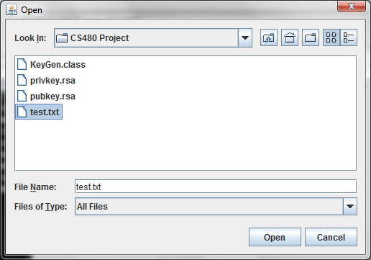

Select “privkey.rsa”
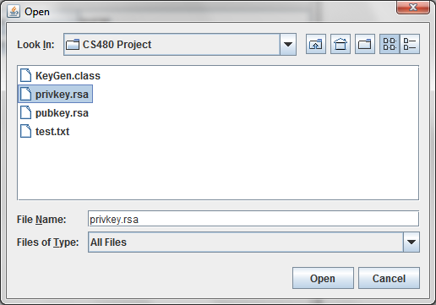
Click on sign file to generate signature, the signature and the message are then displayed for the user.
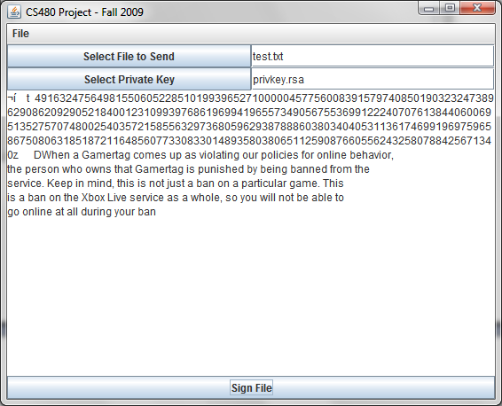

Receive Non-Modified File:
Select signed file and public key:
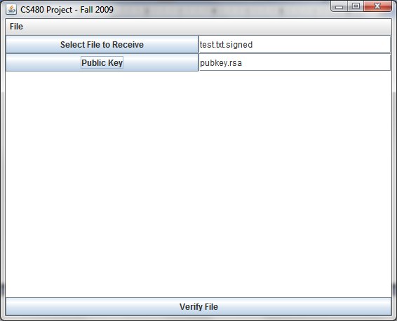

Verify file:
The following message box appears stating that the integrity of file has been verified:
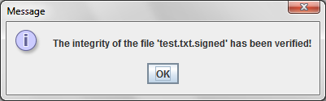

Afterwards, the user is able to see the message that was sent (without the signature):
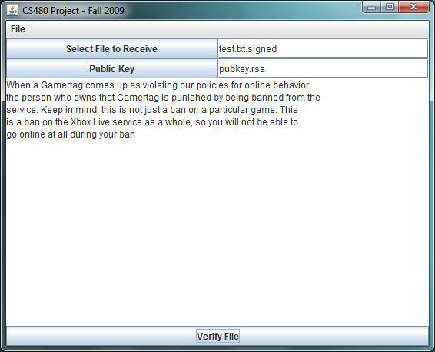
Modify File
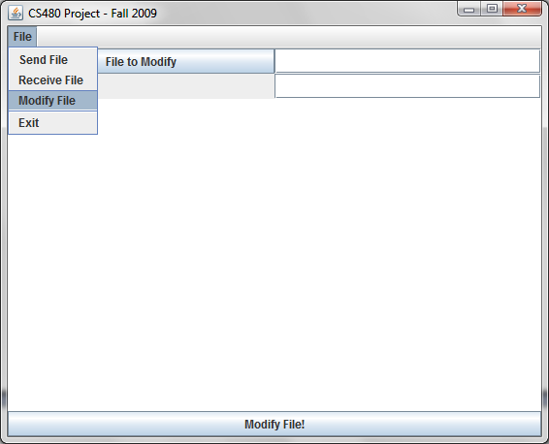

Select File to modify
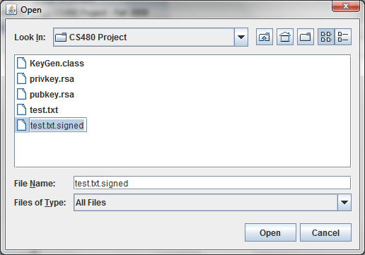

Type in index to modify in the selected file, then click on the “Modify File” button:
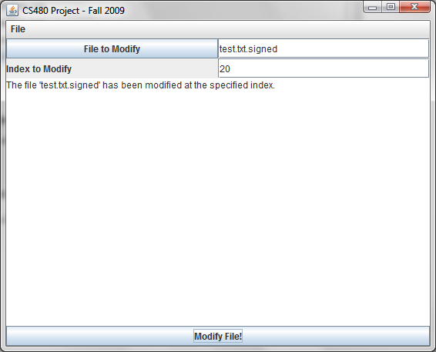

Receive Modified File:
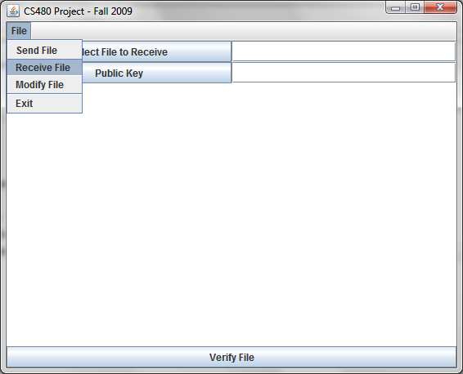

Select File to Receive and Public Key:
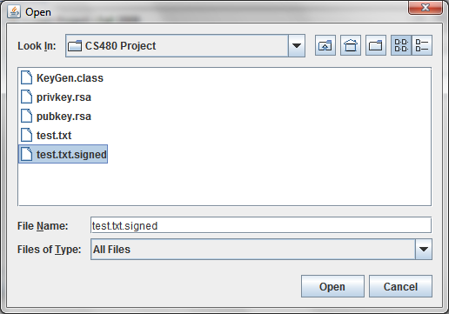

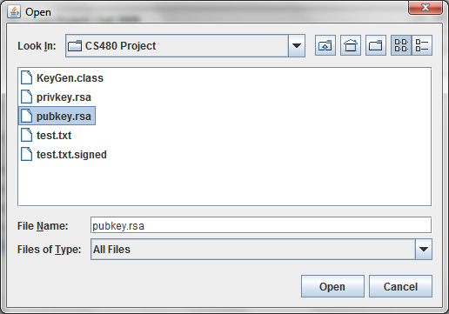

Verify File, if the file has been modified, the following message box appears.

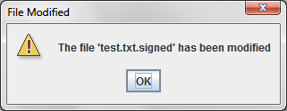

In addition, the following message shows up in the message box in the GUI:
