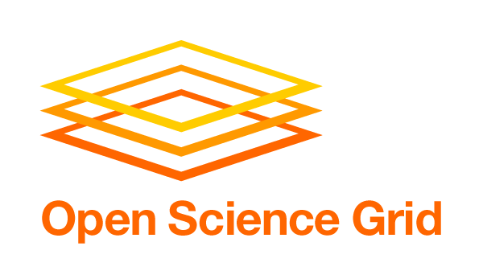

Deadline: June 15, 2010
Previous versions and input from other stakeholders are available at:
https://twiki.grid.iu.edu/bin/view/VirtualOrganizations/Stakeholder_PlansNeedsRequirements

Virtual Organization: NYSGrid

Stakeholder Scope: Science and Resource Provider

Mission Statement: Driving Force and Vision of VO

New York State Grid (NYSGrid) is a collaboration among New York institutions to create an advanced technological infrastructure that will strengthen research and education capabilities across the State.

Activity by VO: Quantitative Metrics

NYSGrid can still be considered in startup-mode as we are actively training and recruiting our membership.

VO’s Average OSG Utilization: 8 CPU Hours/day
VO’s Peak OSG Utilization: ? CPU Hours/day
VO’s Resource Provisioning to OSG: 2100 CPUs, 2000 GigaBytes

Activity by VO: Qualitative Science Value Output

Science Production: Current users are running community and commercial software for Computational Fluid Dynamics, Geophysical Mass Flow, and Computational Chemistry research. We do not have detailed metrics on these users at this time, however we do notice that the majority of our users are running licensed codes on NYS resources. Our work continues to be in recruiting users to run on their applications over the grid and assisting them with porting their codes and developing easy-to-use interfaces for scientists.

VO Direction and Plans: Short-term 6-12 months

NYSGrid is a regional grid that supports a wide variety of scientific disciplines and users across New York State. Over the next 12 months, we plan on focusing our efforts on implementing interfaces, through the HPC2 user portal (hpc2.org), for select users and applications.

Requirements (Needs & Expectations) from OSG: Short-term 6-12 months

We have no additional requirements at this time other than the current VDT software stack, VO management tools, and myOSG interface.

VO Direction and Plans: Long-term 1-4 years

We plan to help define the role of a regional grid within the OSG. This includes resource monitoring, job submission to the regional grid, and policy development. We also plan to continue adding users, institutions, and computational/storage resources as necessary to support the needs of our users. Some of these resources will be added through the HPC2 user portal while others may be added via Condor pools at various institutions, although security and political concerns at local campuses continue to prohibit this from happening today.

Requirements (Needs & Expectations) from OSG: Long-term 1-4 years

Working with OSG to develop policies as to how a regional grid interacts with the OSG.

Significant Milestones (i) Met in 2009-10 (ii) Planned in 2010-11

New York State has funded a High Performance Computing Consortium (HPC2) which will provide hands on assistance, through their scientists and engineers to the broader New York State user community, both to ease access to supercomputing resources at the institutions and to guide users in the utilization of HPC. As part of HPC2, a CCR-based computational scientist has been developing some of the infrastructure necessary for running applications remotely on grid resources. Hubzero has been selected as the portal platform that will be used to provide users with access to supported applications at NYS resources.

Miscellaneous

(Please feel free to include any other significant data.)

