PSACCT Probe Design Specification
Version 1.0
3/24/2006
Author: Tim Byrne
Abstract:
The purpose of this document is to provide a technical specification for a program that will parse PSACCT files into usage XML.

Table of Contents

Revision History 3
Overview 4
Model 4
Description 4
Process Flow 5
Model 5
Components 5
Configuration File 5
PSACCT File Repository 6
PSACCT File Backup Repository 6
PSACCT 6
Gratia.py 6
Processes 6
Read Configuration 6
Get PSACCT File Names 6
Get PSACCT Type Code 7
Loop through File Names 7
Read [Type] 8
Process [Type] 8
Can Backup File 8
Send Usage Record 9
Move PSACCT File to Backup 9
Garbage Collection 10

Revision History
Version | Date | Author | Notes
1.0 | 03/31/2006 | Tim Byrne | Initial Release

Overview

Model
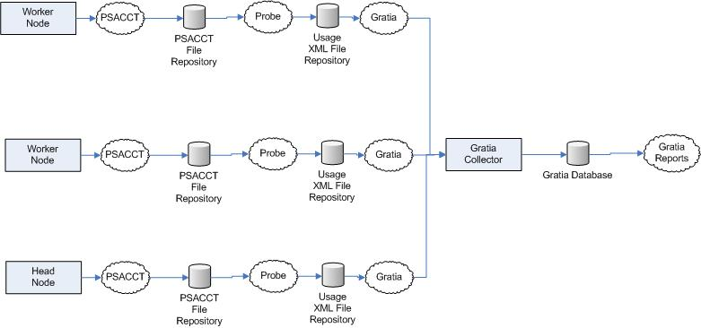

Description
PSACCT is a standard process running on each node that generates daily usage logs containing information on the jobs that ran and how many resources they consumed. This data can be used by Gratia for accounting purposes, and needs to be sent to the Gratia collector to be stored in a reporting database.
The purpose of the PSACCT probe is to read PSACCT generated files and convert them to usage records that the Gratia.py program can then send to the Gratia collector. The probe must be capable of parsing seven distinct versions of PSACCT files: AIX, IRIX, IRIX5, IRIX6, SunOS, OSF1 and Linux.

Process Flow

Model
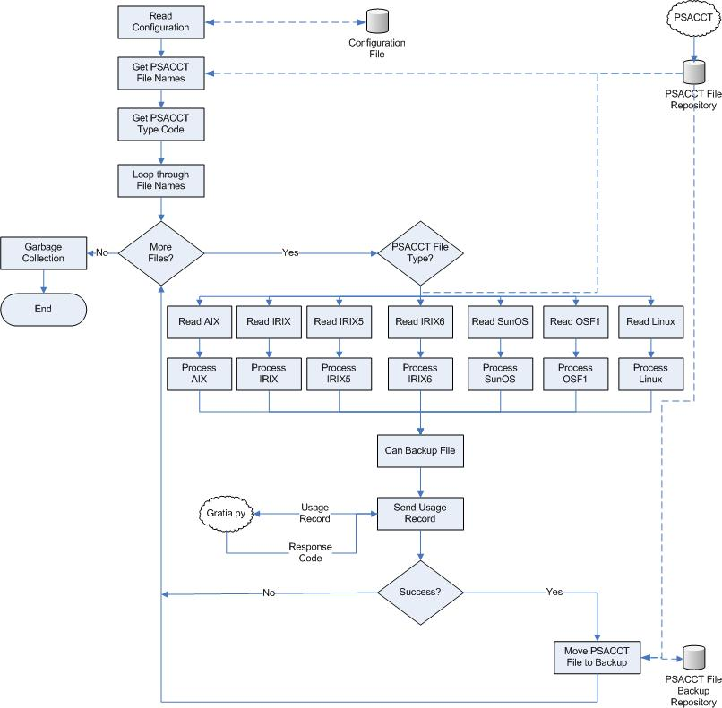

Components

Configuration File
A configuration file will reside in the same location as the probe and will contain any custom configuration settings. This file will be in xml format so that it is easy to extend and maintain. Configuration settings specific to the PSACCT probe include the PSACCT File Repository path and the PSACCT backup file repository path.

PSACCT File Repository
As PSACCT generates files, they will all be stored into one common place. Any files in this repository have not yet been processed and sent to the Gratia Collector.

PSACCT File Backup Repository
When the probe processes PSACCT files from the repository, they need to be moved out of the repository so they are not processed again. However, the files should not be deleted or their information will be permanently lost. Instead, they will be moved to a specified backup repository in case they are needed again.

PSACCT
PSACCT is a process assumed to be running on each node daily, generating usage files and storing them in the PSACCT file repository.

Gratia.py
Gratia.py is a Python script that can take Usage Records (A Python object) and send them to the Gratia Collector to be persisted in a database. The probe will interface with Gratia.py to prevent re-coding the send logic.

Processes

Read Configuration

Purpose
The ‘Read Configuration’ process reads the configuration file into a configuration object, which is then available for the rest of the program to reference. This process must validate the configuration file as well as ensure that the configuration file exists and is well-formed xml.

Inputs
None

Outputs
A ‘Probe Configuration’ object fully loaded with the configuration values from the ProbeConfig file.

Exceptions
ProbeConfig not found
ProbeConfig invalid xml

Get PSACCT File Names

Purpose
The ‘Get PSACCT File Names’ process will load a list with the full path and name of every PSACCT file that exists in the PSACCT file repository. This process must ensure that only daily usage files are included.

Inputs
Probe Configuration

Outputs
A list of full paths to PSACCT files that need to be processed.

Exceptions
PSACCT File Repository path does not exist.
Can’t access PSACCT File Repository path.

Get PSACCT Type Code

Purpose
Different systems generate different formats of PSACCT files. This function will determine the correct PSACCT type of the current system.
Note: The old system seemed to imply that one node could potentially generate several different PSACCT file types. This is based on the information found in the cpu_info_all table, where each CPU had a PSACCT type associated with it. This new system implies that all PSACCT files on a node will be of the same format, and this will be determined by ‘uname’.

Inputs
None

Outputs
A number code indicating whether the current file should be processed as any of the following types:
AIX = 0
IRIX = 1
IRIX5 = 2
IRIX6 = 3
SunOS = 4
OSF1 = 5
Linux = 6

Exceptions
Invalid PSACCT Type
Cannot determine PSACCT Type

Loop through File Names

Purpose
Start a loop through each file that is in the PSACCT file list, as collected in the ‘Get PSACCT File Names’ process. This will loop until there are no more files, any exceptions that occur while processing a file should not prevent other files from being processed.

Inputs

Outputs

Exceptions

Read [Type]

Purpose
Open the current PSACCT file in the loop, ensuring that it both exists and is readable. Since the PSACCT files are binary and may have different formats depending on PSACCT type, each type needs to have its own ‘read’ function.

Inputs
PSACCT File Name

Outputs
A list of each entities read from the PSACCT file

Exceptions
File does not exist
File cannot be read

Process [Type]

Purpose
Based on the type of PSACCT file, a Usage Record object will be created and have its values set to match the values of the entities read from the PSACCT file. Each type has different entities in a different order, so each type will have its own method.

Inputs
PSACCT Data

Outputs
Populated Usage Record

Exceptions
Invalid entity data

Can Backup File

Purpose
The purpose of the ‘Can Backup File’ method is to ensure that the pending PSACCT file will be able to be moved to the backup repository. It is important that this is verified BEFORE actually sending the file to Gratia, because if Gratia succeeds to process the file but the file is unable to be moved to the backup repository, then it will still be pending and will be processed again (resulting in a duplicate record).

Inputs
PSACCT File Name

Outputs
None

Exceptions
Cannot backup file

Send Usage Record

Purpose
At this point, a Usage Record object has been populated with all the data it could retrieve from the PSACCT file. Send the Usage Record to the Gratia.py process (via the ‘Send’ method) and accept the response code from Gratia.py. Only if the response code indicates that Gratia was unable to save the usage data to file should this function consider the collection a failure. [Determine what codes Gratia.py will return to indicate that the file was unable to be saved. If the file was unable to be sent, that is still considered a success by the probe, otherwise the PSACCT file will still be pending as will the usage xml file that Gratia.py saves]

Inputs
Populated Usage Record

Outputs
Response from the Collector

Exceptions

Move PSACCT File to Backup

Purpose
If the Response code indicated that Gratia.py successfully sent the usage record to the collector, then the original PSACCT file needs to be moved to the PSACCT file backup repository so it is not processed again.

Inputs
PSACCT File Path
Probe Configuration

Outputs

Exceptions
Can’t find file
Can’t move file to target

Garbage Collection

Purpose
In the ‘Garbage Collection’ process, destroy any variables and objects that were instantiated, they will no longer be needed as the entire process is over.

Inputs

Outputs

Exceptions

