An SRM Parallel Depot Storage Element
For the Open Science Grid

April 13, 2005

Activity co-Chairs:
Micah Beck (University of Tennessee)
Surya Pathak (Vanderbilt University)

TABLE OF CONTENTS

Motivation 3
Proposed Work Plan 5
Phase 1: Initial OSG Integration 5
Phase 2: Base Enstore Connectivity 5
SC 2005 Service Challenge 5
Phase 3: OSG Production Deployment 5
Phase 4: New architectural directions 5
Phase 5: Web based User Interface 6
Phase 6: PNFS-like File System 6
Personnel and Resources 6
Installation/Test Harness. 7
Service Challenges/Demos. 7
Integration/Deployment. 7
Appendix: Participants List 7

Motivation

Leadership in applying computing to science will necessarily require both world-class computing and world-class data management. An important gap in current approaches to managing the high volumes of data involved in ultrascale science stems from a lack of suitable infrastructure to work with data “in transit.” In this context, data is said to be “in transit” between the time at which it is generated at a source (e.g. a supercomputer simulation, an instrument or detector, an aggregated set of repositories) and the time it is either archived or thrown away, and during which it needs to be easily available to a (potentially large and distributed) research group for analysis, visualization, or some other form of processing. To meet the diverse and changing set of application needs that different research communities have, large amounts of non-archival storage are required for transitory buffering, and it needs to be widely dispersed, easily available, seamlessly integrated with archival resources, and configured to maximize flexibility of use.

Current approaches to this problem tend to be adaptations of solutions developed in an era when massive storage was mostly concentrated in data centers. Storage is allocated as if its usage were non-transitory and would, therefore, tend to make availability scarce. Consequently, under these traditional approaches, storage is available only to those with user accounts and membership in the appropriate virtual organizations, and it is encapsulated behind legacy interfaces that inhibit the flexibility of use and scheduling. This situation severely restricts the ability of application communities to access and schedule usable storage where and when they need to in order to make their workflow more productive. Investigating new strategies in this area would clearly be worthwhile.

The approach to this problem that we plan to explore is based on a new type of Open Science Grid (OSG) storage element, the SRM Parallel Depot (SPD) (Error: Reference source not foundFigure 1). The architecture of the SPD, described in detail below, integrates a familiar data management interface that is widely accepted in the OSG community – the Storage Resource Manager (SRM) – with a new technology for wide area data management – Logistical Networking (LN) – which is now being used by several important OSG application communities including Fusion Energy and Astrophysics. Logistical Networking technology builds on a highly generic storage service that uses the Internet Backplane Protocol (IBP), which it deploys on storage servers called “depots.” The strategy of combining SRM with IBP-based depots is designed to provide an interoperable foundation for wide area storage infrastructure that can address the problems of in-transit data management through a familiar interface, but with maximum flexibility and performance.

We believe that adding SPD storage elements to the OSG will achieve the following objectives:

- Enable OSG sites to provision with working storage as cost effectively as possible -- SPDs can use low cost commodity hardware, require low front-end investment, and involve minimal installation and management costs. This helps to maximize the opportunity of all OSG sites to provision with working storage to address chronic problems of data logistics.

- Provide a seamless interface between archival storage and wide area working storage – By combining SRM and IBP as a front end for tape-based archival resources, SPD’s will allow researchers to experiment with a wide range of caching, buffering, and prefetching strategies to optimize performance and reliability between long term and working storage.

- Facilitate widespread use of high performance data movement among all well connected OSG sites. – Available LN tools make high-performance data transfers a seamless part of the working environment. Spreading SPDs across OSG sites will accelerate the use of this capability dramatically.

- Open a smooth path for incorporating future innovation in storage technologies – The generic IBP storage service used by SPDs is designed to be easy to implement on virtually any type of storage resource. SPDs will use IBP with disk and tape resources, but it has also been implemented, for example, in RAM. Use of IBP guarantees that interoperability will be preserved as new innovation is incorporated.

- Expand the range of application communities using the OSG beyond its primary HEP community – LN technology is already widely used in application communities important to the OSG, including Fusion, Astrophysics, Medical Imaging, and Environmental Modeling. LN’s highly generic storage paradigm will allow OSG storage infrastructure to support all these communities equally well.

- Provide new opportunities for computational services for data in transit – For the purposes of managing data in transit, the workflow could often be made much more efficient if the data, while it is being buffered in transit, could easily be searched, reduced, reformatted, error encoded, encrypted, compressed, and so on. Prototype software already available will enable researchers to experiment with these capabilities using the shared, lightweight processing power available on SPDs.

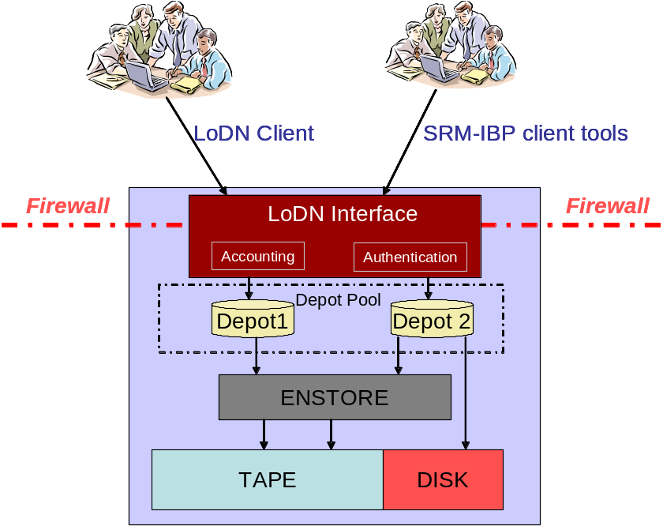
Figure 1: SRM Parallel Depot (SPD) Architecture

Proposed Work Plan

Our development and implementation of an Open Science Grid Storage Element based on SRM and LN will be accomplished in phases.

Phase 1: Initial OSG Integration
Primarily, the work in phase 1 will involve the development of an implementation of the SRM interface on top of a version of the Logistical Distribution Network adapted for the purpose. SRM will act as a bridge to dedicated IBP depots managing disk (and potentially tape) resources. Other important elements will include:
- a security framework imported from existing SRM implementations
- documentation of the SRM-to-IBP bridge, and
- a test harness (possibly leveraging the DRM-based validation code).
The resulting storage element will be added to and vetted in the integration test bed.

Phase 2: Base Enstore Connectivity
In parallel to Phase 1, we will develop an IBP depot that serves tape resources. The physical storage resources underlying this activity will be served by the Enstore tape library. This activity will include the development of a test harness and documentation.

SC 2005 Service Challenge
Once phase 1 and phase 2 are complete, we will demonstrate the performance and utility of our storage element via an appropriate service challenge to occur by August of 2005. We will also showcase SPDs in the ACCRE booth at Super Computing 2005. The focus of this service challenge and demonstration will be to show the flexibility of the SPD based SE to span an entire spectrum, ranging from very small SE consisting of single depot based system to very large ones that have multiple depots connected to big tape libraries.

Phase 3: OSG Production Deployment
- Bug fixes, support: Any implementation and deployment problems identified during the OSG integration and service challenge activities described above must be addressed before releasing the tools into active use. In addition, ongoing bug reporting, evaluation and resolution procedures must be in place spanning the organizations that are contributing to the SRM-IBP efforts.
- Packaging: One of the primary features of an SPD SE should be that it is easy to install and use. We will create a solid packaging and installation guide. Installation should be it as simple as doing a “configure, make, make-install”.

Phase 4: New architectural directions
While the deployment of an SRM-IBP Storage Element for the OSG is the first technical and organizational objective, there are additional goals that will be pursued to move the project toward higher levels of performance and functionality. These include
- Development of a shared storage backend that allows a pool of processors to balance the load of moving data from multiple tape libraries to a community of clients in the wide area.
- Imposition of space management policies, both dynamic (e.g. avoiding resource exhaustion) and static (e.g. policy-based quotas)
- Providing more direct control over tape-specific functionality to the IBP client, such as directing the migration of data between disk cache and tape.

Phase 5: Web based User Interface
The LoDN directory currently used by Logistical Networking clients to store publication metadata and manage storage resources will ultimately be extended to increase its expressiveness and power:
- Additional attributes will be a included to better model the OSG community’s information framework, and
- The authorization and authentication framework must be brought into line with OSG best practice.

Phase 6: PNFS-like File System
Developing a virtual file tree system with advanced features for managing metadata information for the IBP depots would be one of the final advanced features that we would develop. Essentially borrowing from the srm-dCache effort, we would like to build in a PNFS-like virtual file system that will make file metadata available.

Personnel and Resources

We anticipate that the majority of the above work will be carried out by Vanderbilt’s (VU) Kevin L. McCord, Bobby Brown, and Surya Pathak as well as the University of Tennessee’s (UT) Scott Atchley and Huadong Liu. Dan Engh (VU) will assist with the development of demonstration projects and service challenges. The initial VU effort will focus on creating the SRM/IBP interface, setting up a local LoDN server, and creating a prototype Storage Element (SE) that consists of two additional depots serving an EonStor RAID and Enstore tape archive. UT will initially assist with the packaging and setup of the LoDN server as well as providing technical details as needed for the SRM/IBP interface. OSG deployment will rely on VU and UT personnel with guidance from Rob Kennedy’s group at Fermilab.

In addition to personnel, hardware will be provided by ACCRE. The LoDN server will require a server capable of running Apache and executing Perl CGI scripts. If the LoDN Java client code is modified, it may also require a separate certificate. The prototype SE will need two machines for IBP depots with a minimum of dual CPUs, 2+ GB (ideally 4+ GB), Gigabit Ethernet, and ample (100s of GB or multiple TBs) of storage. The SE will also require an EonStor RAID and Enstore tape archive. For the demonstration or service challenge, similar SE hardware will need to be available at a minimum of one other site.

The primary requirement for the SC 2005 demonstration in November is additional hardware, installation and administration effort . This hardware will be defined in detail at a later date but will include a large-scale SE and a small-scale SEs. To perform the service challenge at Tier 2 centers, some hardware will need to be provisioned at the participating centers. We will show the different SEs to demonstrate that this solution will work for smaller work groups or individuals and scale up to handle large, data center class operations.

Installation/Test Harness.

SE Hardware Requirements: A minimum configuration will require a Unix machine in the role as SE server. The services provided by the server will be determined by available storage hardware, which can be a combination of unix file systems and tape systems.

SE Software Requirements: The OSG SE will require a subset of basic VDT-server tools, such as Globus, gsiftp, and pacman. The SE framework pacman installation will require root/privileged access. This service installation will include a test harness to verify the functionality and intercommunication of each of the SE components. This harness can be run manually or configured for automatic monitoring of SE health. Additional monitoring components will be included, providing hooks to the OSG information providers.

The storage client tools will primarily consist of SRM client tools. The SE client interface requires the basic VDT-client tools (including java and globus client tools) to be installed. The client will also come with a client test harness and monitoring tools. A user can configure their test harness and use their own grid credentials to test access to a SE. A small wide open OSG SE could be a useful testing resource for OSG users.

Integration/Deployment.

We will follow standard OSG procedures for integrating and deploying our SE, beginning with testing and vetting on the integration test bed. Service challenges and demonstration projects will be employed to demonstrate performance, functionality and stability.

Appendix: Participants List

The following personnel will contribute to this project. Rob Kennedy and Timur Perelmutov of Fermilab will contribute in an advisory capacity.

Who | Title | Institution
Scott Atchley | Research Leader, LoCI | University of Tennesse
Micah Beck | Associate Professor, Computer Science | University of Tennesse
Matt Binkley | Senior System Administrator, ACCRE | Vanderbilt University
Bobby Brown | Storage and Grid Administrator, ACCRE | Vanderbilt University
Dan Engh | Research Assistant Professor, Physics | Vanderbilt University
Huadong Liu | Graduate Student, Computer Science | University of Tennesse
Kevin McCord | Systems Analyst, ACCRE | Vanderbilt University
Terry Moore | Associate Director, LoCI | University of Tennesse
Surya Pathak | Postdoctoral Research Associate, ACCRE | Vanderbilt University
Paul Sheldon | Professor, Physics | Vanderbilt University
Alan Tackett | Technical Director, ACCRE | Vanderbilt University

