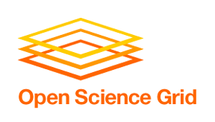
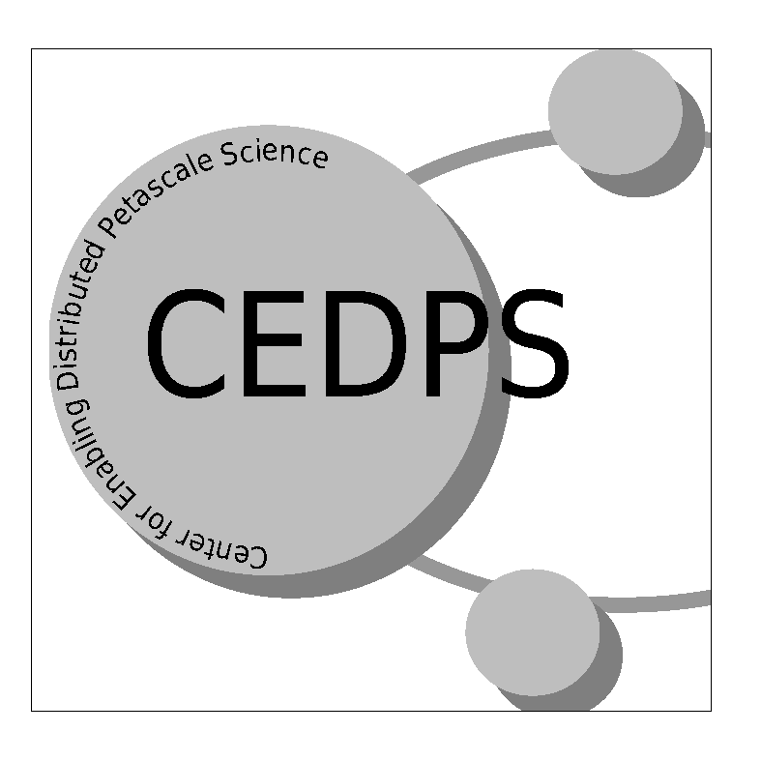

OSG Dependence on CEDPS
- Commitments and Expectations
DRAFT 3/29/07

Overview
The Open Science Grid (OSG) provides an integration and production level distributed facility supporting a broad and diverse set of researchers and scientific collaborations via an open Consortium of science researchers, software developers and computing, storage and network providers. The Open Science Grid Project is a five year program jointly funded by DOE SciDAC-2 and NSF. OSG does not include software development and we work with partners to provide the new software and services that we need. The software and services deployed on OSG are driven by our stakeholders.

When working with software suppliers for support or the development of new software, OSG will provide requirements, ongoing communication at the technical level, actively supports the use of the Integration Test Bed for bringing the new software to the level needed for production deployment and use, and is engaged throughout to ensure the new capabilities meet the needs of our communities,

The Center for Enabling Distributed Petascale Science (CEDPS) is a five year SciDAC-2 project that will produce technical innovations designed to allow for (a) rapid and dependable data placement within a distributed high-performance environment and (b) the convenient construction of scalable science services that provide for the reliable and high-performance processing of computation and data analysis requests from many remote clients. CEDPS will also address the important problem of troubleshooting these and other related ultra-high-performance distributed activities from the perspective of both performance and functionality. The CEDPS program of work is defined in close consultation with leading DOE application groups, and is deployed, applied, and evaluated in close collaboration with major DOE projects in climate, high energy and nuclear physics, combustion, astrophysics, fusion, biology, and other sciences.

CEDPS and OSG collaborate through a) attendance at each others technical, all hands, and collaboration meetings; b) CEDPS project director membership as an External Project on the OSG Executive Board; c) overlap of management personnel between the two projects.

Each of the projects has an overall five year roadmap and develops more detailed yearly plans and schedules. The research and development CEDPS does will in general take more than a year to develop to readiness for OSG deployment. Thus re-planning of jointly developed deliverables and milestones is expected.

Year 1-2 OSG Expectations and Commitments
CEDPS has three project areas: Data, Scalable Services, and Troubleshooting. OSG will work with these three areas towards the deliverables listed below. OSG will have ongoing discussion together with its stakeholders and CEDPS to ensure good communication of needs and requirements. OSG will actively engage and support the integration and deployment of CEDPS software into VDT after testing on the Validation and Integration Testbeds. OSG will work with CEDPS and the user and facility communities to ensure effective use of the new technologies and software.

Data Area:
1) Delivery of MOPS version 1.0 by the end of year 1 of CEDPS (October 2007), which will extend GridFTP to provide capabilities for automatic storage and network management. This work will integrate capabilities of the NeST system from the Condor project.

2) Delivery of a modified GridFTP client developed with the Fermi dCache team to be used for access to the new dCache GridFTP server. We plan to deliver this client by the end of year 1 of CEDPS (October 2007).

3) Delivery of a first-generation, higher-level data placement service, which is still in the design phase. The first version of the data placement service will likely manage replicated data by maintaining a certain number of replicas for each data item. We are working to identify OSG applications that would use placement services, and these applications will drive our design and the functionality of the placement service. A first version of the placement service will be delivered by the end of year 1 of CEDPS (October 2007).

TroubleshootingArea
For the 6 months time through Oct 2007, CEDPS plans to:

- Provide log parsers to convert existing logs for GridFTP, Globus Gatekeeper, and certain Condor logs to the format specified by the CEDPS Logging Best Practices guide (see: http://www.cedps.net/wiki/index.php/LoggingBestPractices )
- Provide a new version of Globus (v4.2) that contains more useful log messages as specified in the CEDPS logging best practices guide.
- Work with any OSG middleware or application developer to help implement the logging specified in the Logging Best Practices Document in any software/middleware component that OSG believes in important to have better troubleshooting capabilities.
- Develop a OSG Readiness plan for each of the following CEDPS recommended components:
  - syslog-ng (done, see https://twiki.grid.iu.edu/twiki/bin/view/Integration/SysLog)
  - Globus MDS4 Trigger service
  - CEDPS Log event database
  - CEDPS anomaly detection tool
- Work with the VTB/ITB team to test and deploy syslog-ng on the the OSG testbeds
- Work with OSG sites to deploy a Log event database at each site.

Deliverables suggested for the 6 months following Oct 2007, includes
- Work with the OSG Grid Operation Center to deploy a central log event database for OSG
- Work with the OSG Grid Operation Center to deploy anomaly detection and alert tools. These tools include new CEDPS tools for anomaly detection, and alert tools based on the MDS trigger service.

Scalable Services Area
- Continued support for Xen based Edge Service Framework activities within OSG, including CMS and ATLAS.
2) Discussion with VTB for deployment of STAR and ALICE applications using rpath images on ITB. Final deployment will depend on OSG timelines.

http://www.opensciencegrid.org
http://www.cedps.net/wiki/index.php/Main_Page

