OSG-ITB statistics
Last known jobs info

Experiment | Running Jobs | Idle Jobs | Held Jobs | Failed Jobs | Total Jobs
1. ATLAS | 0 | 0 | 0 | - | 0
2. BTeV | - | - | - | - | -
3. CDF | 0 | 0 | 0 | - | 0
4. CMS | 221 | 0 | 0 | - | 221
5. FMRI | 0 | 0 | 0 | - | 0
6. GADU | 0 | 0 | 0 | - | 0
7. GRASE | 0 | 0 | 0 | - | 0
8. GRIDEX | - | - | - | - | -
9. Grase | 0 | 0 | 0 | - | 0
10. LIGO | - | - | - | - | -
11. OSG | 0 | 0 | 0 | - | 0
12. SDSS | 0 | 0 | 0 | - | 0
13. cdf | - | - | - | - | -
14. fMRI | 0 | 0 | 0 | - | 0
15. iVDgL | 11 | 9 | 0 | - | 20
16. sdss | - | - | - | - | -
Total | 232 | 9 | 0 | 0 | 241

Farms statistics (last known values and last hour average values)

 | Master |  |  |  |  |  |  |  |  |  | Farm info
 | Load5 |  | Current CPU usage (%) |  |  |  | Average CPU usage (%) |  |  |  |  | No. of nodes
Farm | Last | Average | user | sys | nice | idle | user | sys | nice | idle | No. CPUs | Busy (last) | Busy (avg) | Idle (last) | Idle (avg)
1. BNL_OSG_Test1 | 2.07 | 2.424 | 33 | 6 | 0 | 61 | 18 | 10 | 0 | 72 | 198 | 83 | 82 | 16 | 17
2. DUKE-HEP | 0.16 | 0.254 | 3 | 1 | 0 | 96 | 2 | 1 | 0 | 97 | 4 | 0 | 0 | 1 | 1
3. FNAL_CMSOSG_TEST2 | 0.02 | 0.057 | 1 | 1 | 0 | 98 | 1 | 1 | 0 | 97 | - | - | - | - | -
4. FNAL_GPFARM | 0.12 | 0.201 | 1 | 1 | 0 | 98 | 2 | 1 | 0 | 97 | 341 | 83 | 83 | 65 | 65
5. FSU-OSGDEV | 0.35 | 0.398 | 16 | 3 | 0 | 81 | 15 | 3 | 0 | 82 | 6 | 0 | 0 | 5 | 5
6. GRASE-BINGHAMTON-ITB | 1.82 | 2.012 | 18 | 34 | 0 | 48 | 19 | 34 | 0 | 47 | - | - | - | - | -
7. JINR_LIT | 0 | 0.027 | 1 | 1 | 0 | 99 | 1 | 1 | 0 | 99 | - | - | - | - | -
8. LIGO-CIT-OSG | 0.11 | 0.17 | 0 | 0 | 0 | 99 | 1 | 0 | 0 | 99 | 24 | 0 | 0 | 9 | 9
9. OUHEP_ITB | 2.05 | 2.805 | 15 | 15 | 40 | 30 | 9 | 19 | 70 | 3 | 18 | 14 | 14 | 0 | 0
10. PROD_SLAC | 0.01 | 0.118 | 0 | 0 | 0 | 100 | 2 | 1 | 0 | 98 | - | - | - | - | -
11. TTU-TESTWULF | 3.16 | 3.345 | 7 | 2 | 91 | 0 | 6 | 2 | 91 | 0 | 8 | 1 | 1 | 3 | 3
12. UBuffalo-CCR-ITB | 0.81 | 0.508 | 4 | 2 | 0 | 94 | 6 | 2 | 1 | 91 | - | - | - | - | -
13. UC | 0.04 | 0.019 | 1 | 1 | 0 | 98 | 1 | 1 | 0 | 98 | - | - | - | - | -
14. UCSD-OSGINT | 0.05 | 0.054 | 0 | 0 | 0 | 100 | 1 | 0 | 0 | 99 | - | - | - | - | -
15. UC_grid03_OSG_ITB | 0.03 | 0.061 | 0 | 1 | 0 | 99 | 1 | 1 | 0 | 99 | 4 | 0 | 0 | 1 | 1
16. UF-HPC | 117.1 | 127.6 | 49 | 20 | 0 | 31 | 54 | 24 | 0 | 22 | 385 | 163 | 164 | 28 | 27
17. UFlorida-IGT | 0.19 | 0.351 | 10 | 2 | 0 | 88 | 10 | 4 | 0 | 86 | 4 | 0 | 0 | 2 | 2
18. UIOWA-ITB | 0.04 | 0.395 | 7 | 3 | 0 | 90 | 9 | 3 | 0 | 89 | 10 | 0 | 0 | 10 | 10
19. UM_ATLAS | 1.47 | 1.628 | 36 | 3 | 0 | 61 | 31 | 4 | 0 | 66 | 28 | 1 | 1 | 9 | 9
20. atlas10.hep.anl.gov | 0.26 | 0.161 | 1 | 1 | 0 | 99 | 4 | 2 | 0 | 94 | 1 | 0 | 0 | 1 | 1
21. citgrid3.cacr.caltech.edu | 0.03 | 0.607 | 1 | 1 | 0 | 99 | 1 | 2 | 0 | 97 | 24 | 1 | 0 | 5 | 6
22. fnpcg.fnal.gov | 0.09 | 0.171 | 1 | 1 | 0 | 98 | 1 | 1 | 0 | 98 | 46 | 1 | 1 | 17 | 17
Total |  |  |  |  |  |  |  |  |  |  | 1101 | 347 | 346 | 172 | 173
Average | 5.906 | 6.516 | 9 | 5 | 6 | 80 | 9 | 5 | 7 | 79 | 73 | 23 | 23 | 11 | 12
Min | 0 | 0.019 | 0 | 0 | 0 | 0 | 1 | 0 | 0 | 0 | 1 | 0 | 0 | 0 | 0
Max | 117.1 | 127.6 | 49 | 34 | 91 | 100 | 54 | 34 | 91 | 99 | 385 | 163 | 164 | 65 | 65

Traffic statistics (instant and last hour average: Mbps; total in the last hour: MB)

 | "Master" traffic ( sum(ethX) ) |  |  |  |  |  | Farm traffic ( sum(nodes' traffic) )
 | Instant |  | Average |  | Total |  | Instant |  | Average |  | Total
Farm | IN | OUT | IN | OUT | IN | OUT | IN | OUT | IN | OUT | IN | OUT
1. BNL_OSG_Test1 | 0.135 | 0.047 | 0.199 | 0.062 | 89.34 M | 28.09 M | 270.4 | 233.5 | 127.8 | 125.8 | 56.17 G | 55.27 G
2. DUKE-HEP | 0.021 | 0.029 | 0.036 | 0.028 | 16.15 M | 12.79 M | 0.007 | 0.015 | 0.04 | 0.029 | 17.91 M | 13.17 M
3. FNAL_CMSOSG_TEST2 | 0.038 | 0.014 | 0.027 | 0.014 | 12.06 M | 6.225 M | - | - | - | - | - | -
4. FNAL_GPFARM | 0.051 | 0.045 | 0.055 | 0.053 | 24.63 M | 23.71 M | 2.79 | 0.679 | 6.271 | 2.978 | 2.756 G | 1.309 G
5. FSU-OSGDEV | 0.028 | 0.035 | 0.04 | 0.032 | 18.22 M | 14.52 M | 0.03 | 0.039 | 0.048 | 0.039 | 21.44 M | 17.66 M
6. GRASE-BINGHAMTON-ITB | 0.17 | 0.307 | 0.545 | 0.511 | 245.3 M | 230 M | - | - | - | - | - | -
7. JINR_LIT | 0.007 | 0.012 | 0.025 | 0.014 | 11.42 M | 6.22 M | - | - | - | - | - | -
8. LIGO-CIT-OSG | 0.063 | 0.021 | 0.032 | 0.019 | 14.54 M | 8.65 M | 0.021 | 0.052 | 0.023 | 0.056 | 10.32 M | 25.07 M
9. OUHEP_ITB | 4.221 | 4.138 | 3.754 | 4.253 | 1.65 G | 1.869 G | 8.704 | 8.634 | 11.44 | 10.22 | 5.026 G | 4.492 G
10. PROD_SLAC | 0.023 | 0.022 | 2.628 | 0.13 | 1.155 G | 58.58 M | - | - | - | - | - | -
11. TTU-TESTWULF | 0.067 | 0.029 | 0.029 | 0.027 | 13.19 M | 12.37 M | 0.011 | 0.029 | 0.033 | 0.029 | 15.07 M | 13.27 M
12. UBuffalo-CCR-ITB | 0.02 | 0.029 | 0.032 | 0.024 | 14.61 M | 10.66 M | - | - | - | - | - | -
13. UC | 0.007 | 0.015 | 0.026 | 0.017 | 11.92 M | 7.588 M | - | - | - | - | - | -
14. UCSD-OSGINT | 0.016 | 0.015 | 0.034 | 0.018 | 15.39 M | 8.229 M | - | - | - | - | - | -
15. UC_grid03_OSG_ITB | 0.006 | 0.012 | 0.028 | 0.016 | 12.55 M | 7.13 M | 0.047 | 0.013 | 0.032 | 0.015 | 14.27 M | 6.568 M
16. UF-HPC | 0.371 | 0.542 | 0.598 | 0.611 | 269.2 M | 274.9 M | 652.1 | 63.07 | 179.9 | 69.12 | 79.05 G | 30.38 G
17. UFlorida-IGT | 0.113 | 0.051 | 0.307 | 0.146 | 138 M | 65.81 M | 0.242 | 0.071 | 0.387 | 0.148 | 174.2 M | 66.7 M
18. UIOWA-ITB | 0.086 | 0.021 | 0.048 | 0.022 | 21.58 M | 9.821 M | 0.051 | 0.024 | 0.069 | 0.03 | 31.04 M | 13.32 M
19. UM_ATLAS | 1.052 | 4.68 | 1.597 | 4.618 | 718.9 M | 2.029 G | 2.022 | 5.546 | 1.804 | 4.853 | 811.6 M | 2.133 G
20. atlas10.hep.anl.gov | 0.01 | 0.021 | 0.029 | 0.03 | 12.99 M | 13.49 M | 0.051 | 0.033 | 0.03 | 0.03 | 13.39 M | 13.48 M
21. citgrid3.cacr.caltech.edu | 0.066 | 0.039 | 0.046 | 0.044 | 20.55 M | 19.96 M | 0.058 | 0.049 | 0.078 | 0.056 | 35.17 M | 25.42 M
22. fnpcg.fnal.gov | 0.011 | 0.023 | 0.031 | 0.025 | 13.78 M | 11.17 M | 1.875 | 0.363 | 1.992 | 0.453 | 896.3 M | 203.9 M
Total |  |  |  |  | 4.459 G | 4.709 G |  |  |  |  | 145 G | 93.96 G

Top of Form
Sites :
ATLAS BTeV CDF cdf CMS FMRI fMRI GADU GRASE Grase GRIDEX iVDgL LIGO OSG SDSS sdss | 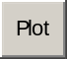
(check all | uncheck all) | Quick interval: Interval selection : -

Graphs :
Running Jobs | Idle Jobs
(check all | uncheck all)

Bottom of Form
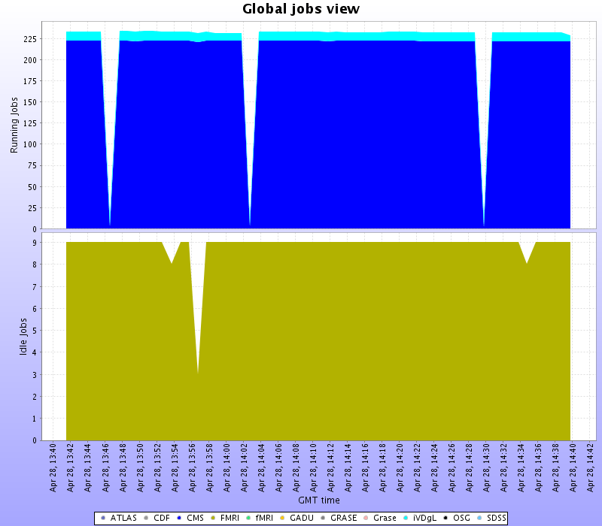

Running Jobs
Farm | Last value | Min | Avg | Max
ATLAS | 0 | 0 | 0 | 0
CDF | 0 | 0 | 0 | 0
CMS | 221 | 2 | 210.5 | 222
FMRI | 0 | 0 | 0 | 0
fMRI | 0 | 0 | 0 | 0
GADU | 0 | 0 | 0 | 0
GRASE | 0 | 0 | 0 | 0
Grase | 0 | 0 | 0 | 0
iVDgL | 7 | 7 | 10.76 | 12
OSG | 0 | 0 | 0 | 0
SDSS | 0 | 0 | 0 | 0
Total | 228 | 9 | 221.3 | 234

Idle Jobs
Farm | Last value | Min | Avg | Max
ATLAS | 0 | 0 | 0 | 0
CDF | 0 | 0 | 0 | 0
CMS | 0 | 0 | 0 | 0
FMRI | 0 | 0 | 0 | 0
fMRI | 0 | 0 | 0 | 0
GADU | 0 | 0 | 0 | 0
GRASE | 0 | 0 | 0 | 0
Grase | 0 | 0 | 0 | 0
iVDgL | 9 | 3 | 8.864 | 9
OSG | 0 | 0 | 0 | 0
SDSS | 0 | 0 | 0 | 0
Total | 9 | 3 | 8.864 | 9

OSB-ITB status
Farms status

 | Online | Master | PN | VO_JOBS | VO_IO | ABPing | ML Version
1. ASCC_OSG |  |  |  |  |  |  | 1.2.32
2. BNL_OSG_Test1 |  |  |  |  |  |  | 1.2.32
3. DUKE-HEP |  |  |  |  |  |  | 1.2.26
4. FNAL_CMSOSG_TEST2 |  |  |  |  |  |  | 1.2.26
5. FNAL_CMST1_TEST |  |  |  |  |  |  | 1.2.32
6. FNAL_GPFARM |  |  |  |  |  |  | 1.2.32
7. FSU-OSGDEV |  |  |  |  |  |  | 1.2.32
8. GRASE-BINGHAMTON-ITB |  |  |  |  |  |  | 1.2.32
9. IU_WALLABY |  |  |  |  |  |  | 1.2.32
10. IU_iuatlas |  |  |  |  |  |  | 1.2.32
11. JINR_LIT |  |  |  |  |  |  | 1.2.32
12. LIGO-CIT-OSG |  |  |  |  |  |  | 1.2.32
13. OUHEP_ITB |  |  |  |  |  |  | 1.2.32
14. PROD_SLAC |  |  |  |  |  |  | 1.2.32
15. PROD_SLAC_STANFORD_EDU |  |  |  |  |  |  | 1.2.26
16. TTU-TESTWULF |  |  |  |  |  |  | 1.2.32
17. UBuffalo-CCR-ITB |  |  |  |  |  |  | 1.2.32
18. UC |  |  |  |  |  |  | 1.2.26
19. UCSD-OSGINT |  |  |  |  |  |  | 1.2.26
20. UC_Teraport_OSG_ITB |  |  |  |  |  |  | 1.2.26
21. UC_grid03_OSG_ITB |  |  |  |  |  |  | 1.2.32
22. UC_grid05_OSG_ITB |  |  |  |  |  |  | 1.2.26
23. UF-HPC |  |  |  |  |  |  | 1.2.32
24. UFlorida-IGT |  |  |  |  |  |  | 1.2.32
25. UIOWA-ITB |  |  |  |  |  |  | 1.2.32
26. UM_ATLAS |  |  |  |  |  |  | 1.2.32
27. atlas10.hep.anl.gov |  |  |  |  |  |  | 1.2.32
28. citgrid3.cacr.caltech.edu |  |  |  |  |  |  | 1.2.32
29. fnpcg.fnal.gov |  |  |  |  |  |  | 1.2.32
30. sdsslnx10.fnal.gov |  |  |  |  |  |  | 1.2.32
Total | 22 | 22 | 15 | 18 | 17 | 21

