Miron -
What are the fundamentals of ID management?
I don't understand what ppl are doing
What is diffc between difft concepts?
We struggle w/ trust relationships
like between CA
Have trust issues never thot about before
Who tells us who to trust & how
Want to have more thoro discussion about risk assessment (not just about scale but how easy to get into /out of messes)
What happens if 2 guys w/ Kalashnikov take over CA
Very embarrassing if we have to take down infrastructure for a security incident
What are vulnerabilities, risks associated w/ id management
I understand scheduling &c
What are the approaches to ID management?
The components are the result of the approach we take
Bill: This is exactly what you said at Berkeley
PPl who "do trust" start at origin & move forward
Maybe better to start at point of trust decision & move back up transaction chain
DL example
Use analogously in some other system to explain trust decision
VW:
All id mgmt systems you go thru same processes
Take place in difft orgs
What sociologically is the community willing to accept?
We'll use X.509 from 1970 from standards when we didn't have
an internet
Mh: What do you want from id system
ML: Getout of way!
Well, need to capture needs of community
Much less concerned about something bad, DOE upset oh well
Vulnerability exposed, need to shut down OSG
I want to understand technology
What are the common components of what is underneath
Let's leave out any mention of technology
Usability - what we are trading off
Q: How broad - we will discuss all the tools &c a scientst uses?
Wld like to but focus on subset, like data management, just to make sure we can make some progress
Ok,but Grid cmty evolved into a corner about id tools
Wiki is just important
I need a comprehensive view
Need same identity for everything
Ok will try
ML: I use same pw to get on wireless & everything else
The experts throw the problem between authN & authZ
Think it is outrageous we are running jobs w/ same id we read our mail
We have to be prepared for our id's to be stolen
VW: The individual should be in charge
COnstrain to discussion of identifiers
What does identity provider do?
Enrollment
"Vetting"
Tracking, contact, &c
Revocation
Ongoing management of user pool, but....
Incident Response
Tends to be afterthot, tied to revocation
protocols mapped onto it
SP Level
validation
binding to a local context
consumers
audit
who used it
do we have diversity &c
authz
debugging
ML
The interface is between validation & assertion
How I at the validation pt get an assertion about identity
Is this uni=directional or bi-directional trust between OP & SP
RA: Some providers have concept of LOA
Time is useful but what is the real foundation for it?
ML: it is useful somehow
eg "time" is a powerful revocation tool
JB: Also about strength of crypto material
RA: Where is the user?
What is the role of federation
What does it mean?
Mean just signed an agreement? Or inherent policy?
I want to come & audit that federation
how coordinated are you in case of an incident response
DO: Reputation of federation is important individual providers depend on this
ML: If I am an idp,I may have to connect my service (like IR)
Q: What if an IDP is a member of a 1000 federations?
Mike trying to find out how ML can trust a federation (he seems to have
identified certain internal services/qualities it must provide, like IR)
ML If you have 2 id providers &c how does your IR communicate?
ML: I don't want to send my proxy to a site that trusts all these bad CAs
Discontinuities between what issuers local sites trust
Q: Are there any protocols that ask who you trust?
A: TLS
Notion of trust is not a 1st class citizen in our vocabulary
Not fully following revocation/IR discussion drawing - seems to be about info flow both inside & outside federation -
not sure what is asserted here
ML: We don't take our assertions seriously. Eg So-and-so exists for 24 hrs, then we allow them in indefinitely
Risk, truth management
But these probs run str into scalability probs & into usability issues we have dealt w/ for years
A problem is that id time limit constraints are mapped to Operating System id's, which generally do not have time limit constraints
Discussion about renewal (missed some due to discussion about tandberg problm)
Ok, now we are talking just about assertions (even if it's say a driver's license)
What is the meaning of "assertion expired"
Anything I made a decision on I hve to undo it
VW: application dependent (generally)
VW: Most Idps cannot provide realtime updates on their info
How do we deal with quality? of identity information?
When UNIX was designed, when you are removed from p/w file, your jobs shld be killed
Confusion about what "identity" is required & what attributes mean
Enrollment & vetting
I have a certain sense of ownership based on identity - I don't want to have re-enrollment disrupt my ownership
ML: Whenever you do something, if you bring in LIGO, you have an exception
DK: YOu as service provider must figure out how you manage the authZ assertions
VW: ML is saying, you have a credential, but things can happen, a job is running but underlying
assertions permitting are revoked &c.
epistemological catastrophe!
VW: We don't have tools to go back & check validity state "in flite" so to speak
Q: Was this useful so far
federation / idp inter-relationship - something about federations at all levels
Shouldn't your id be same everywhere?
If we worry about how we create assertions from others (also that we never propagate assertions)
All you need to know is who you got the assertion from (this is like the AK/MS model - it's a responsibility model)
discussion from ML has moved towards discussing delegation of (whatever) & how to attentuate/control/clean up after messes &c
lunch break now
1135/1335 CT - restarting
How should we march down the technology
Talk about specific technologies
Mine enumerates the agenda
ML I don't want to hear nuances eg all these difft flavors of X.509
Is InCommon & X.509 closely together
JB will review IGTF (I think - can't really read board bt sounds like that)
Discussion about proxy & delegation
teragrid doesn't use proxies
VW: A lot of what we are talking about has to do w/ OSG's use of eg VOMS
VW: Shibboleth has no concept of delegation
VW: You can't use an individual certificate to delegate/mitm because you don't have the private key matching it
(trying to summarize more complicated argument)
Ugh! Missing this stuff
from Stiegler's "dynamic sharing" - it's
the same as delegation problem
Dynamic
Attenuated
chained
accountable
Cross domain
Recomposable
Where we break down & miss pieces then system has to struggle....
MH: there is no diffc in vetting
VW: ok ... what the difference is, is who is doing the vetting
SAML - XML format &c
assertion restricted to particular SP
openid
Can't hear Rachana very well but material that I can hear sounds very good
How are assertions about IDPs done?
JB: SAML metadata corresponds to X.509 self-signed lists &c
ML: Why do we care about authentication/identity?
Can we just say so-&-so is a member of LIGO
Is it true that the only way to deal with misbehavior is either ban <X
or IDP <Y>? Aren't there other choices?
Whee! I've just been spun around!
VW: Shibboleth doesn't have concept of 3rd party attribute source
[Note: NOTHING does - it's a bolt-on in Grids eg VOMS]
SAML: do SPs have to be part of federation
VW: Well, idps vary widely in what they release
openid: ESG vs general ways openid is used
government - JV
reviewing HSPD-12 & PIV-1 & PIV-2
piv-i - non govt card
piv-c - compatible, but non-trusted card
Should we use OCSP?
CRLs are a significant problem.
Mike says CRLs are useless
JV: I have 3 certs
part of the market is for encryption
result is multiple certs so enterprise can hold an escrowed copy of private key
h.w token based service
directory service behind it
[can't read this column well] | X.509 IGTF | SAML InCommon Federation | OpenID ESG (only browserbased access)
vetting | IGTF: F2F govt ID / RA Network IDMS  CAs run by nat'l grid projects | Basic: Universities just tell us what to do  Silver: F2F govt id  IDPs run by Universiteis | ESG MoU Each site agress to basic registration (Firstname, Lastname, institution)
assertion? | X.509 End Entity certificates RSA keys / proxy | SAML authentication "Bearer credential" | Assertion over SSL back to browser
revocation? | CRL | ? short lived assertions | ? short lived association w/ portal [actually - no - this is the universal logout problem imho - mwh]
validation | SSL/digital sig | digital sig/ SAML metadata | IDP whitelist / assertion over mutually authenticated channel
federation | IGTF: International O(50) mbr | InCommon: National O(150) members | "ESG"  [This is a particular application domain's implementation - many openid providers & consumers ==mwh]
naming? | CAs have unique namespace; managed by IGTF ; Recl? name in certificate | eppn: Jbasney@illinois.edu  etid: x9738y7@illinois.edu | openid in context of idp  [industry: more complexity / in flux]
 | proxy certs RFC 3820 [not much used in industry if at all] | ? some proposals | Not used, can be used with OAuth  [see iiwix & WRAP WG]
  delegation?
lifetime | 1 yr or 1 wk | minutes | [indef/undef]

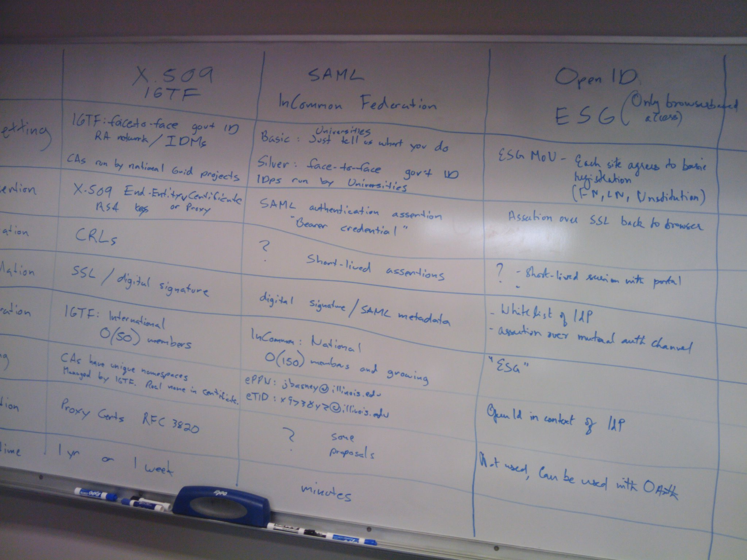
DK talking about IGTF & EUGridPMA things
Now describing TERENA Infrastructure
ML: EU has more cert "demand" in marketplace than US? Yes.
Now we are discussing the cost of the infrastructure? Why or how is this in scope?
Miron Livny asks again & again, what is the weakest point in the trust structure. THis is a really
good question to keep in mind at all times, a test that has to be applied repeatedly.
How do we get a good trusted list & recover from compromise of "trusted list archive"
(I think - think this is IS's question)
Need to look at services for reliability
DK We have had lots of incidents where it would have been nice torevoke ssh keys ... too bad we can't, unlike what we have in x.509
ML VOMS missed completetly what was needed for managing a VO & now we are suffering the consequences
How do we operate in a heterogenous env?
Is it useful to do SSO?
How to pick the rite IDP for the particular service
user will go to rite IDP
user will go to real rather than phished idp endpoint
biggest problem is SAML Is browser based not commandline
The reason we are concerned about SAML is that we have the marketing machine pushing adoption gettiung universities' IDM's available.
intricacies of delegation
VW: the world is web based = will we in Grids jump to it?
ML: we are only worried about identity at moment of initiation, then we pass something else downstream
VW: You have to fit in w/ auth systems everywehre else in world. Define use cases you have to solve,
& how they fit in w/ what's in rest of world.
ML: Key issue is interactive vs dedicated? execution (maybe delegated?)
ML: I found the day very useful!

