
VOBOX
Security and Operations Questionnaires
14 January 2006
ALICE experiment v-0.5

Table of contents
1 The ALICE Baseline Requirements 2
1.1 VOBOX general requirements 2
1.2 LCG configuration 3
1.3 AliEn configuration 3
1.4 Backup 4
1.5 Example of port assignment for the ports with inbound connectivity 4
2 VOBOX functional description 4
2.1 Interaction between the VOBOX services 4
2.1.1 File registration 4
2.1.2 File retrieval 5
2.1.3 Workload management 5
2.1.4 proofd services 6
2.1.5 Local tactical buffer management 7
3 Security assessment questionnaire for VOs 8
3.1 Network and Services Table 9
3.2 Information Monitoring and Publication Table 10
3.3 VOMS 10
4 An Operational assessment questionnaire for VOs 10

The ALICE Baseline Requirements
ALICE has the following requirements:
BS 1 ALICE requires a single VO operating across all flavours of Grid, along with the possibility to specify roles and groups via VOMS.
BS 2 A dedicated VO node (known as VOBOX), on which to deploy and manage ALICE-specific long-lived agents, is required at each site. The ALICE-specific agents and services deployment and support on the VOBOX is under the VO responsibility. The general requirements for the VO node agents and the description of the services are given below.
BS 3 ALICE expects a standard interface to the various types of Storage Elements (SE). This must be SRM and each SE shall present a single, SURL namespace. ALICE has a central file catalogue containing the LFN, GUID, SI and the corresponding metadata for each file.
BS 4 ALICE requires a local site service (most likely LFC) that maps the LFN and GUID to a SURL.
BS 5 ALICE expects a reliable file transfer service for data replication (FTS) provided and deployed by the LCG project.
BS 6 The LCG-UI functionality, including access to the LFC and the FTS services, must be available from the VOBOX.
BS 7 ALICE needs outbound network connection from the Worker Nodes, or appropriate tunnelling mechanism.

VOBOX general requirements
The general requirements for the VOBOX are the following:
VB 1 Linux kernel 2.4 or higher, any Linux flavour on i386, ia64 or Opteron;
VB 2 Hardware: at least a PIII 2GHz with 1024 MB RAM;
VB 3 At least one normal user account (no super-user privileges) with access via ssh or gsissh. Optimal configuration is two accounts, belonging to the same group;
VB 4 A VOBOX local directory, not shared among the WNs ‘alicesgm’ with read/write access by user ‘alicesgm’ with at least 10 GB disk space. This directory will be used for the log files of the agents/services running on the VOBOX. A $VO_ALICE_SW_DIR with read/write access by user ‘alicesgm’, shared among the WNs, with at least 5 GB disk space. This directory will be used for the application software installation;
VB 5 Outbound connectivity;
VB 6 Inbound connectivity from CERN on two fixed network port (see table below);
VB 7 Inbound connectivity from World on four fixed network ports: 1093, 1094 plus two more at arbitrary address (see table below);
VB 8 Local tactical data buffer: This can be a local disk on the VOBOX (for small sites) or xrootd managed disk buffer (for larger sites) for intermediate input and output data storage of jobs. This buffer is not necessary if xrootd is centrally managed on the site storage element. The buffer size is at least <number of ALICE jobs slots on the site> * 3 GB.

LCG configuration
The following LCG functionality is required to properly operate the VOBOX:
LC 1 full standard LCG User Interface;
LC 2 FTS Client, including the Perl APIs, to be used for data transfers;
LC 3 lcg-infosites suite.

AliEn configuration
AliEn and monitoring agents and services running on the VO node:
AL 1 Storage Adapter (SA) – interface to local storage (via SRM or directly);
AL 2 File Transfer Daemon (FTD) – scheduled file transfers agent (using FTS implementation);
AL 3 xrootd – application file access;
AL 4 Site Proxy (SP) – local queue monitoring;
AL 5 MonALISA – general monitoring agent;
AL 6 PackMan (PM) – application software distribution and management;
AL 7 Site Computing Agent (SCA) – interface to local scheduler or LCG RB;
AL 8 Agents Monitoring (AMON) – VOBOX agents and services status monitoring;
AL 9 proofd daemon for interactive distributed analysis with PROOF.

Backup
Backup is required for:
- the local directory (see section 1.1 d) of the alicesgm user on the VOBOX node;
- the /opt/vobox directory.

Example of port assignment for the ports with inbound connectivity

Port | Access from | Used by
8082 | inbound from World | SA
8084 | inbound from CERN | SCA
9991 | inbound from CERN | PM
1094 | inbound from World | xrootd
1093 | inbound from World | proofd
8884 | (UDP) inbound from WNs | MonALISA
8888 | inbound from WNs | proofd registration
Please note that the port assignment for xrootd and proofd are fixed and cannot be changed.

Interaction between the VOBOX services
This chapter describes the way the services running in the VOBOX communicate among themselves and with the rest of the system. We will start with the components used in the data management, both during file registration and file retrieval. After that, we will describe the workload management and finally the tactical data buffer management.
The following sequence diagrams follow the same colour convention:
- Green: ALICE services running on the VOBOX
- Yellow: ALICE central services
- Gray: services provided by LCG needed by ALICE.

File registration
Fig. 1 shows the registration path for a file through the Storage Adapter (SA) running on a VOBOX. As a first step, the client code will make sure that the user has the necessary privileges to register the lfn. Then, it will contact the SA, asking for permission to put the file. The SA creates the surl where the file will be kept. The SA will also create the guid (unless the user has already specified one). Finally, the SA will register the entry in the LFC, and give back to the client the xrootd endpoint to which the file can be uploaded.
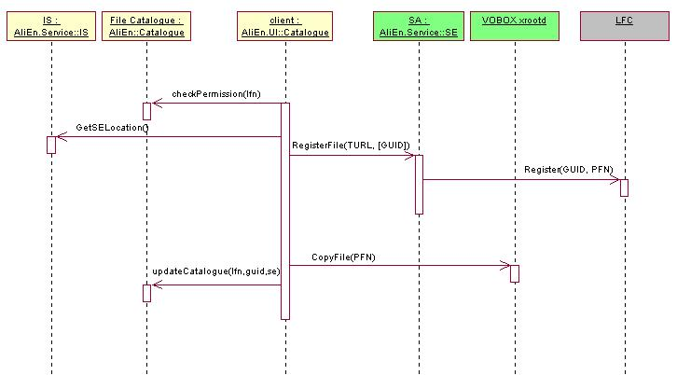
Figure 1: File registration

File retrieval
Retrieving a file from the catalogue follows a similar path, as shown in Fig.2. First, the client will contact the central AliEn Catalogue to translate the lfn into a guid and retrieve a list of SE. The Information Service (IS) will give the endpoint of the SA. After that, the SA will translate the guid into a turl that the application can access. For this translation, the SA retrieves the information from the LFC. Finally, the client retrieves the turl, which will point to the xrootd running on the VOBOX.
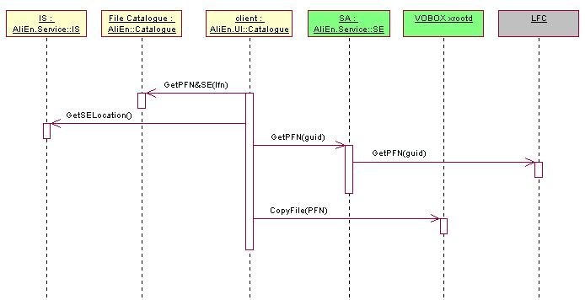
Figure 2: File retrieval

Workload management
The workload management full sequence diagram is shown in Fig.3.
As a first step, the Site Computing Agent (SCA) running on the VOBOX collects information about the number of jobs that the VO is allowed to run by querying the LCG Information System directly or through the “lcg-infosites” package, the application software that is already installed, and the applications that could be installed. It sends this information to the AliEn central services through the Site Proxy (SP).
The AliEn Broker checks the AliEn Task Queue (TQ) for jobs that can be executed on a given site and returns the list of job agents that the SCA should start. The SCA sends the job agents to the LCG resource broker, who will start them on the worker nodes (WN).
The job agent running on the WN contacts the AliEn TQ to retrieve a user job. As in the previous case, the communication between the job agent and the AliEn TQ is done through the SP. Once a matching job is found, the job agents contacts the PackMan (PM) to set-up and install the application packages required by the job, and finally starts the job execution. After the execution of the job and the registration of the output, the job agent will try again to fetch another matching task from the AliEn TQ.
During all its life, the job agent also sends asynchronously messages to the local MonALISA (ML) service, which monitors the progress of all jobs running on a site, aggregates the collected monitoring information and sends it to the central ML repository.

proofd services
The interactive analysis services on the VOBOX consist of a proofd running as a PROOF submaster and a proofd-registration service. A proofd on a WN (started as normal job) is registered through the proofd-registration service. The registration service writes a configuration file, which includes information on all proofd’s running on the WNs to be used by the proofd running on the VOBOX. The proofd on the VO- Box accepts connections from the PROOF supermasters (which are running elsewhere) and contacts the proofd running on the WN.
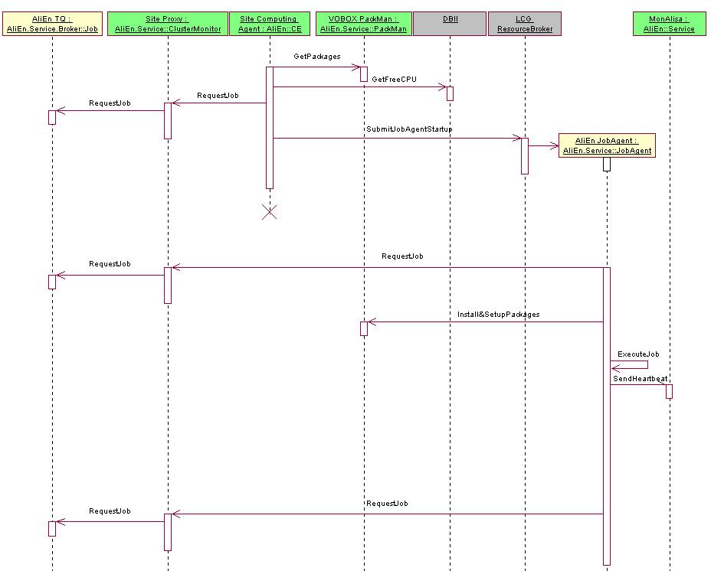
Figure 3: Workload management

Local tactical buffer management
The local tactical data buffer on a site is managed through the xrootd running on the VOBOX, with the following use cases:
- For a small site (up to 30 job slots) the buffer can be directly attached to the VOBOX, for example in the form of a local disk. In this case, the VOBOX will route all network traffic associated with the jobs running on the WNs.
- For a larger site and for sites offering large disk caches, the xrootd should run directly on the disk servers as disk management software. In this case, the xrootd running on the VOBOX will run as master and the ones running on the disk caches in worker mode. The traffic will be routed directly through the disk servers.
In both cases, the SA running on the VOBOX provides the configuration for the xrootd master and workers. The underlying MSS (if applicable) is accessed through the SRM interface either directly from the VOBOX in case of (1) or from the disk cache (2). ALICE prefers that the bulk of the disk-based storage allocated to the ALICE VO at the computing centres is considered as ‘tactical’ and managed through the schema described above and shown schematically in Fig.4. To that extent, the necessary buffer storage to the MSS should be kept to the minimum necessary for efficient operation of the taping system.
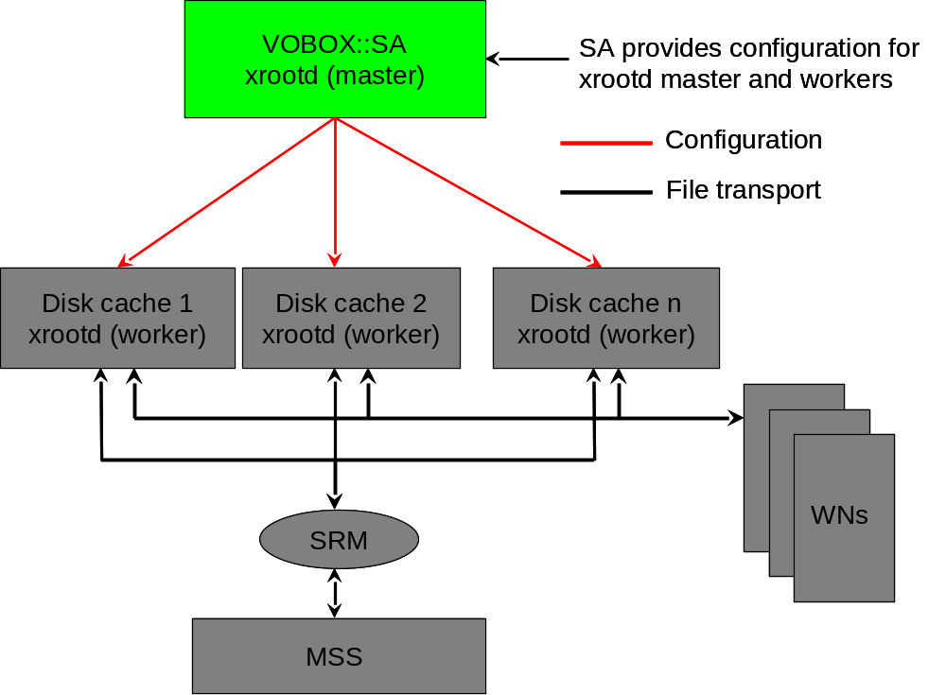

Figure 4: Tactical data buffer management

Security assessment questionnaire for VOs
The answers to this questionnaire must be available to the Site Managers and the Site Security Officers at all times. The information provided here MAY be stored in an on-line repository, accessible to all site managers. Specific Sites MAY require the information below and (at their discretion any additional information) to be sent explicitly to them.
By submitting this questionnaire or by using any service provided by an VOBOX, the VO maintainer and the VO security responsible agree that their personal information will be shared with all Sites and shall be used for administrative, operational and security purposes only.
- Name of the Virtual Organisation
ALICE
- Name and contact details of the maintainer:
Name: Federico Carminati
Email address: Federico.Carminati@cern.ch
Phone number(s): +41227674959, +41764874843
- Name and contact details of the VO security responsible
Name: Federico Carminati
Email address: Federico.Carminati@cern.ch
Phone number(s): +41227674959, +41764874843
- Out-of-office hours phone number:
See above
We, the VO maintainer and the VO security responsible, take responsibility for all services running on the VO box running under the VO’s system credentials, and for all actions, events and incidents resulting directly or indirectly from the programmes running on the VO Box under the VO’s user or group system identity.

Network and Services Table

Service | Protocol and ports | Targets (choose):  - specific range  - local site  - WNs only | Description | Logging location(s)
gsissh | 1975/tcp  security: GSI | Inbound from 137.138.0.0/16 and 192.16.186.192/26 | Interactive login service secured via GSI | Via syslog at level authpriv.notice
xrootd | 1094/tcp  security: signed SSH | Inbound from World | Application File Access | localdir/log/alien-logs/xrootd.default.log*
Storage Adapter (SA) | 8082/tcp  security:SSL | Inbound From World | Interface to local storage (via SRM or directly) | localdir/alien-logs/SE.log*
File Transfer Deamon (FTD) | No Port | Outbound Connectivity | Scheduled file transfer agents (using FTS implementation) | localdir/log/alien-logs/FTD.log*
Site Proxy (SP) | 8084/tcp  security:SSL | Inbound from World and WN | Local queue monitoring | localdir/log/alien-logs/ClusterMonitor.log*
PackMan (PM) | 9991/tcp  security:SSL | Inbound from 137.138.0.0/16, inbound from WN | Application software distribution and management | localdir/log/alien-logs/PackMan.log*
Site Computing Agent (SCA) | No Port | It talks through the Cluster Monitor | Interface to local scheduler or LCG RB | localdir/log/alien-logs/CE.log*
proofd | 1093/tcp  security: (optional) kerberos | Inbound from World;  Outbound to WNs Port 1093/1094 | PROOF submaster for interactive ROOT analysis | localdir/log/proof/master-*
proofd | 8888/tcp | Inbound from WNs | Registration of cluster proofd | localdir/log/alien-logs/ProofdReg.log*
MonAlisa | 8884/udp | Inbound from WN; outbound to World |  | localdir/log/alien-logs/Monalisa.log*

Explanation of table entries:
Service – short name of the service
Protocol and ports – protocol (TCP/UDP) and the port number. A reference to the protocol description should be supplied if it’s not a “standard” protocol (i.e. one that can be found in the IETF RFC of GGF GWD).
Indicate the “security level” of the protocol: plain-text, encrypted via a pre-shared secret, client or server authentication encrypted re-useable tokens, ibidem via client-authenticated TLS or GSI, one-time tokens.
Targets – how will the port/protocol be accessed? Is it outbound from the VOBOX or inbound into the VOBOX? What network(s) will contact the box/be contacted by the box? Specify at least one (or more) of “world”, “specific range” (and indicate the range. The standard CERN fixed networks are 137.138.0.0/16, “local site” (i.e. all machines into the LCG-related network segments inside the site hosting the box), or “WNs only” (only worker node machines inside the site’s network).
Description – A short description of the service, including the foreseen network access pattern (so that anomalies can be detected by the site and local IDS systems tailored to monitor the traffic).
Logging destinations – a description of the logging by the service (a must in case of a service providing a service to the world or specific network ranges), and the destination of the logging entries (syslog, file,)

Information Monitoring and Publication Table

Monitored Item | Storage | Publication | Security
MonALISA | Small cache (several KB) | Published by the ALICE’s central MonALISA repository.

VOMS
All members of the ALICE VO will be registered in VOMS (through the VOMS Registration Service) and for any work on the Grid will obtain an extended proxy from the VOMS server (through voms-proxy-init). This proxy certificate includes the member's groups and roles as additional attributes. At present, the following roles are foreseen in the ALICE VO:
- user – ordinary ALICE user
- admin – VO administrator with unlimited privileges
- aliprod – production, maintenance of official application software
- alicesgm – VOBOX maintainer
The membership in the ALICE VO, the creation of roles and assignment of user to these roles is managed by the VO administrators, appointed by the ALICE Offline group leader.

An Operational assessment questionnaire for VOs
The answers to this questionnaire must be available to the Site Managers at all times. The information provided here MAY be stored in an on-line repository, accessible to all site managers. Specific Sites MAY require the information below and (at their discretion any additional information) to be sent explicitly to them.
By submitting this questionnaire or by using any service provided by a VO box service system, the VO maintainer agree that their personal information will be shared with all Sites and shall be used for administrative and operational purposes only.
- Name of the Virtual Organisation:
ALICE
- Name and contact details of the maintainer:
Name: Federico Carminati
Email address: Federico.Carminati@cern.ch
Phone number(s): +41227674959, +41764874843
- What are the hardware requirements for your VO Box?
  - Linux kernel 2.4 or higher, any Linux flavour on i386, ia64 or Opteron
  - Hardware: min. PIII 2GHz, 1024 MB RAM
  - Local tactical data buffer: This can be a local disk on the VOBOX (for small sites) or xrootd managed disk buffer (for larger sites) for intermediate input and output data storage of jobs. This buffer is not necessary if xrootd is centrally managed on the site storage element. The buffer size is at least the number of ALICE jobs slots on the site * 3 GB.
For additional software requirements see section 1.
- What operating system is preferred or would be acceptable?
ALICE can use any flavour of SL3 and any platform, compatible with LCG UI
- What certification has been performed of the VO services?
Before the ALICE production begins, all the services that are installed in the VOBOXes are fully tested in the “development site” in Torino. The full LCG configuration of the site, containing as well a LCG VOBOX for ALICE use only, allows checking the status of the software before releasing it and installing it in the rest of the sites. Several checks and tests are performed at CERN as well before the ALICE software deployment.
- Can the VOBOX for your VO be co-located on the same physical hardware as another VO’s VO Box?
A dedicated VOBOX is required to all sites (*). A co-location can be considered if the agents/services of the VOs do not interfere with each other.
(*) Note: During the PDC05, ALICE runs the production only on SC3 sites.
- Can one VO box be shared across multiple sites to be used by the VO?
The ALICE VOBOX cannot be shared among different sites, since ALICE accesses the shared software area from the VOBOX and this is not typically available over WAN.
Moreover ALICE collects aggregated output of several services that are running in each site. For these reasons a dedicated VOBOX in each site is mandatory for the ALICE production.
- Should any VO services be monitored by the site? If so please provide technical details of how this can be achieved. In the case where incidents are triggered please provide details of the action required?
ALICE does not currently require service monitoring by the site. However it could be useful for the site and for the experiment to have standard mechanisms allowing them to monitor the status of the services that are running on the VOBOX. ALICE proposes to develop GridIce based sensors. The site could always be aware of possible problems (and therefore of lacks of jobs at the site). No emergency actions are required in these cases: announce it to the VO responsible via email would be enough.
- How should the VOBOX be recovered after a complete loss? If more than a return of the vanilla VOBOX service is required please include a list of directories to be backed up and if any provision should be made for preserving and restoring consistent databases. Once the service is restored to previous state are any subsequent actions required by a site such as synchronisation with job outputs that completed during the downtime?
A reinstallation of a vanilla VOBOX for ALICE is acceptable, as described in section 1.1 and 1.2, followed by a restore of the log files in the ‘alicesgm/alien-logs’ local VOBOX directory.
- What is the time period in which the VO can restore a production service?
One working day (in average)
- Are there any special requirements for the service that might influence the VOBOXes initial deployment? For instance are there special network requirements of the VOBOX? Please provide details of how a VO service fits in to the overall workflow for the experiment.
Connectivity details are explained in section 1 of this document. Moreover ALICE requires that the software area is visible on the WNs (for example it is NFS mounted) and accessible from the VOBOX
- What is the business impact for the failure of VOBOX?
Several ALICE services (necessary to run the jobs) need inbound connectivity (see section 2). In case of network problems, the ALICE production will be stopped at the site. If the WNs have no outbound connectivity, new jobs will not arrive to the site and those that are already running will fail. If the WNs have outbound connectivity, no new jobs will be launched at the site, however the already running jobs will complete.
- How should the VO be contacted for service interventions?
Via email to the alice-lcg-task-force list (alice-lcg-task-force@cern.ch)
- Are any steps required before or after the service outage?
Full backup of the service before and after the service outage

