CPU Usage Accounting
Version 1.0
3/21/2006
Author: Tim Byrne
Abstract:
The purpose of this document is to layout the existing data transfer processes and provide recommendations for new short and long-term processes that eliminate or reduce manual procedures.

Table of Contents
Table of Contents 2
Revision History 4
Current Process 5
Model 5
Nodes 5
PSACCT 5
Collection 5
CPU Info 5
User Info 6
Usage Reports 6
E-mail 6
Manual entry 6
Reports 6
Recommended Near-Term Process 7
Model 7
Nodes 7
PSACCT 7
Translator 7
Gratia (Probe) 7
Gratia Collector 8
Gratia Reports 8
CPU Info Maintenance 8
User Info Maintenance 8
Head Node Process 9
Model 9
Nodes 9
PSACCT 9
Pull Worker Usage Files 9
Translator 10
Gratia 10
Collector, Reports, CPU Info and User Info 10
Recommended Long-term Process 11
Model 11
PSACCT 11
Pull Worker Usage Files 11
Pull Glue CPU Info 11
Translator 12
Add Group Info 12
Gratia 12
Gratia Collector 12
Gratia Reports 12
Data Mappings 13
Glue to CPU Info Mapping 13
PSACCT to ur-wg Mapping 13
User Info to XXX Mapping 14
Usage Report Columns to ur-wg Mapping 14

Revision History
Version | Date | Author | Notes
1.0 | 03/21/2006 | Tim Byrne | Initial Release

Current Process

Model
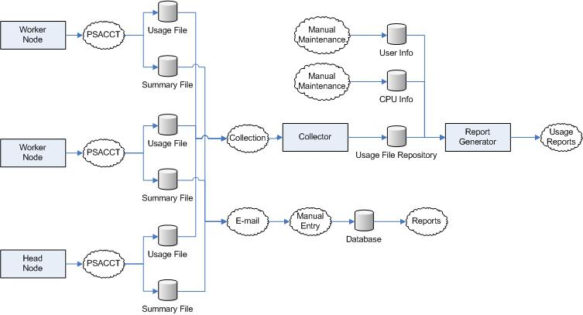

Nodes
The current process does not make any distinction between worker nodes and head nodes, as each of them perform the same function for the purpose of usage accounting.

PSACCT
PSACCT is a Linux utility used to gather usage information into both daily usage files and weekly or monthly summary usage files. This process is scheduled on all nodes to run daily and generate these files to a standard path on the node.

Collection
A collection process is scheduled to run daily and pull the daily usage files from each registered node and store them in a common area on a ‘collector’ machine. There is currently only one ‘Collector’ machine gathering and storing these files. The files are stored in such a way so that their location on the machine denotes the node that they were collected from. The file names themselves are not unique, only their path. Each usage file can potentially be one of many different formats, as each vendor has their own specific usage file format. [How does the collector know which nodes to gather from? Is the cpu info table used for this, or some other config file?]

CPU Info
CPU info is kept in a file on the collector and consists of CPU data such as benchmark speeds, processor type, etc. by node for every registered node. As nodes are added or updated, this file is manually updated to reflect the changes. Some benchmarking values in this file are gathered from a tool called ‘Tiny’, which is manually run on each node to benchmark the CPU, and the results of ‘Tiny’ are manually entered into the CPU info file.

User Info
User info is kept in a file on the collector and is essentially a mapping between user Ids and their associated groups, so it is possible to report on group totals or user activity by group. This file is a necessity because there currently is not any group associated with a user’s credentials, and it is possible that one user id may be associated with many groups, therefore making it difficult to determine for which group a user was running a process. Maintaining this file is a complicated and time-consuming manual process where the administrator needs to account for all new users and user group changes.

Usage Reports
Usage reports are generated using the individual usage, CPU info and User info files. [Are these reports generated on demand, or static reports generated on a schedule?]

E-mail
Usage summary files are e-mailed to Jeff Mack. [Is this an automated e-mail process? Are the summary files or usage summary reports e-mailed to Jeff?]

Manual entry
Jeff Mack must manually enter in the data files received via e-mail into a database.

Reports
There are several custom Crystal Reports that run off of the database maintained by Jeff Mack.

Recommended Near-Term Process

Model
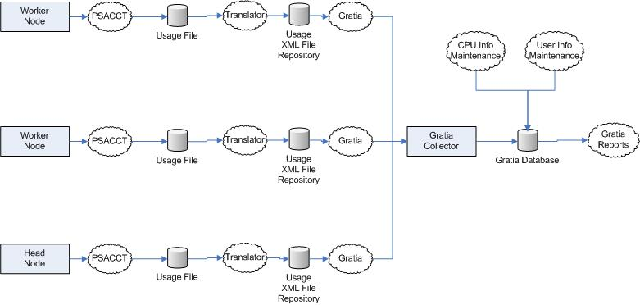

Nodes
As in the current process, the recommended near-term process does not make any distinction between worker nodes and head nodes.

PSACCT
PSACCT will remain as is, generating usage files daily. The summary files will no longer be needed, but continuing to generate them will not disrupt the process.

Translator
A translator script will be scheduled to run daily after the PSACCT service finishes generating the daily usage file. The purpose of the translator script is to read the daily usage file generated by PSACCT and convert it to the ur-wg XML schema that is used by Gratia. The functionality of this script will be similar to the ‘condor_meter’ script in the current prototype but will use the PSACCT data files as a source instead of the condor data files. A translator for each specific vendor format of the PSACCT usage files will need to be developed.

Gratia (Probe)
The Gratia probe logic will be a common component on all nodes and incorporates the logic for pushing usage data in a common format (ur-wg XML schema) to the Gratia collector for storage. The translator will invoke the Gratia probe script when it finishes translating the current day’s PSACCT usage file to a ur-wg XML file. This model assumes that every node will be capable of communicating directly with the Collector. An ‘End-node’ process will be described further in this document for scenarios where not all nodes have access to the Collector.

Gratia Collector
The Gratia Collector will function as a web service and accept usage data in the ur-wg XML schema format and add it to a Gratia data source.

Gratia Reports
A powerful reporting interface will be available using the Gratia database as a data source. All reports currently developed by Jeff Mack will either be reproduced in the Gratia Reporting project or redirected to the Gratia database. The CPU info and User info files will be added to the database as new tables, so the files will no longer be necessary. The Reporting Engine used to generate usage reports will also no longer be necessary, as an authorized user will be able to use the Gratia Reporting web interface to generate usage reports on demand, and e-mail notifications can be sent regularly to reviews of certain reports.

CPU Info Maintenance
A short-term solution requires that an administrator maintain the CPU info table much in the same fashion that an administrator maintained the CPU info file in the old process. A simple interface will be developed to allow the user to perform this task easily without manually modifying the database. The recommended long-term process section will define some other changes to the grid system that may need to take place before CPU info can be accurately reported on without manual maintenance.

User Info Maintenance
A short-term solution requires that an administrator maintain the user info table much in the same fashion that an administrator maintained the user info file in the old process. A simple interface will be developed to allow the user to perform this task easily without manually modifying the database. The recommended long-term process section will define some other changes to the grid system that may need to take place before user group relationships can accurately be reported on without manual maintenance.

Head Node Process

Model
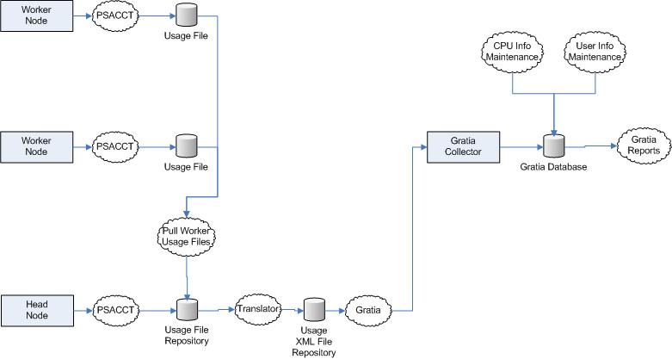

Nodes
Unlike the current and recommended processes, the ‘Head Node’ process treats worker nodes and head nodes differently. Worker nodes will not have any additional functionality, they will simply generate PSACCT usage files while all of the new functionality is delegated to the head node. The head nodes will pull the usage files from all of their worker nodes and process them on their own. While an additional layer of complexity is introduced using this method (The ‘Pull Worker Usage Files’ process), this extra layer is balanced by having the other new processes located on only one node, thereby keeping the worker nodes as simple and error-free as possible and not requiring them to have their own security certificates (which would be necessary if jclarens were used to communicate with the Collector). [Is this methodology better than having each node push their data to the Collector on their own?]

PSACCT
The PSACCT functionality will remain as defined in the ‘Recommended Near-Term Process’.

Pull Worker Usage Files
A new process will be developed for the head nodes to collect the usage files from the worker nodes on a regular basis and store them on the head node before processing them.

Translator
The translator process will remain as defined in the ‘Recommended Near-Term Process’ save for the fact that it will be translating usage files from all nodes on the cluster whose usage files have been pulled by the ‘Pull Worker Usage Files’ process. This should not require a change in logic to the translator, as the initial design will have it process all usage files in the repository regardless of which node the usage file belongs to.

Gratia
The Gratia process will remain as defined in the ‘Recommended Near-Term Process’. As with the translator process, the Gratia process will be sending the usage xml for all nodes on the cluster but this should be transparent to the Gratia logic, as its initial design will have it process all usage xml in the repository regardless of which node the xml belongs to.

Collector, Reports, CPU Info and User Info
The rest of the process will remain as defined in the ‘Recommended Near-Term Process’.

Recommended Long-term Process

Model
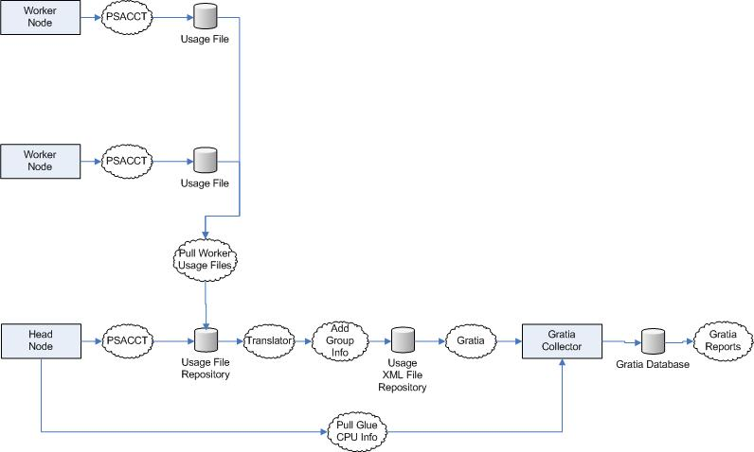

PSACCT
The PSACCT process of generating daily usage files will remain as defined in the ‘Head Node Process’.

Pull Worker Usage Files
The pull worker usage files process will remain as defined in the ‘Head Node Process’.

Pull Glue CPU Info
The ‘Glue’ schema is a standard VDT component that includes much of the data from the CPU info table. The Glue schema is stored in an LDAP data source and uses the ‘Generic Information Provider’ (GIP) to expose this data via MDS. Instructions at the bottom of the following VDT installation page describe GIP and how to install it: http://vdt.cs.wisc.edu/releases/1.3.9/installation_post.html#gip.
The long-term goal is to automatically populate the CPU info table from the Glue schema data on each of the nodes. To do this, a new process will be developed that will nightly analyze the usage xml received by the collector that day. For each unique node that was used, a ‘pull’ process will retrieve that node’s CPU Info from the head node’s GIP and store it into the Gratia database’s CPU Info table. This would involve a change from the ‘Tiny’ number benchmark to one of the two benchmark ratings included in the Glue schema, but a change of this nature is already planned.

Translator
The translator will remain as defined in the ‘Head Node Process’, though the next new process, ‘Add Group Info’ might be incorporated into it as all nodes will need to include this new process.

Add Group Info
In order to eliminate the manual process of mapping users to groups, it is imperative that the associated group be included with this user’s log on credentials, so no mapping needs to take place. There has been some discussion of this taking place, but more details on when and how will be required. The recommended long term process would be to include the group information along with the user id in the usage xml file sent to the collector. [How will user group data be captured and stored? How will we access it? Should this be a daily pull process like pulling the glue CPU Info?]

Gratia
The Gratia process will remain as defined in the ‘Recommended Near-term Process’.

Gratia Collector
The ‘Collect Usage Xml’ service would need to be updated to allow the group field to be collected and persisted to the database. The ur-wg schema already has a place for group in each usage record, so any change here would be minimal or even non-existant.
A new method would need to be added to the collector to collect CPU Info data in the ‘Glue’ schema and persist it to the CPU info table, using that day’s node usage to determine which node’s CPU info to collect.

Gratia Reports
The Gratia report definitions will remain the same as in the ‘Recommended Near-term Process’ save for any reports using the ‘User Info’ table. The ‘User Info’ table will be removed, because including the group along with the usage data will render any other user to group mappings (such as the ‘User Info’ table) obsolete.

Data Mappings

Glue to CPU Info Mapping
The CPU Info table is currently used to generate several usage reports. As such, if the solution recommends capturing CPU Info data from the ‘Glue’ schema (instead of manual maintenance) than all the fields in the CPU Info table need to exist in some fashion within the Glue schema. This chart maps all of the CPU Info fields and their corresponding Glue schema fields, highlighting any that either do not appear or have questionable mappings.

Glue Field | CPU Info Field
Mds-Host-hn=[host].Mds-Host-hn | Node Name
GlueClusterUniqueID=[host]  GlueSubClusterUniqueID=[host]  GlueHostBenchmarkSI00 | Tiny Factor
GlueClusterUniqueID=[host]  GlueSubClusterUniqueID=[host]  GlueHostBenchmarkSI00 | VUP Factor
Mds-Host-hn=[host].Mds-Cpu-Total-count | Number of CPUs
Mds-Host-hn=[host].Mds-Os-name | OS
Mds-Host-hn=[host].Mds-Os-version | OS Version
Mds-Host-hn=[host].Mds-Cpu-model | CPU Type
 | CPU System

PSACCT to ur-wg Mapping
The ur-wg schema will be used as a basis for all usage reports, so all required fields within it must be populated. If PSACCT becomes the source for all of the data to be stored in the ur-wg schema, then it is important that the PSACCT files contain data for the fields required by the ur-wg schema. The following table lists all of the required ur-wg fields and their corresponding PSACCT field and highlights any fields that do not appear or have questionable mappings. [Need to know job name, status, host, machine name]

PSACCT Field | Ur-wg Field
Ta_uid (user-ID) | Local User Id
Ta_name (login name) | Global User Name
Ta_cpu (cum. CPU time, p/np (mins)) | CPU User Duration
Ta_kcore (cum. kcore-mins, p/np) | CPU System Duration
Ta_io (cum. chars xferred (512s))
Ta_rw (cum. blocks read/written)
Ta_con (cum. connect time, p/np, mins)
Ta_du (cum. disk usage)
Ta_qsys (queuing sys charges (pgs))
Ta_fee (fee for special services)
Ta_pc (count of processes)
Ta_sc (count of login sessions)
Ta_dc (count of disk samples)

User Info to XXX Mapping
The information currently residing in the User Info table will need to be captured elsewhere and persisted to the database. It is unknown at this time where this information will come from, ideally from the log in credentials of the user that started the job.

XXX | User Info Field
 | Group Name
 | UID
 | GID
 | User Name
 | User Info from Password file

Usage Report Columns to ur-wg Mapping
The current usage reports use fields from the CPU Info, User Info and PSACCT files to generate their data and calculations. As an additional cross-reference to the PSACCT to ur-wg mapping table, this table will specify where each usage report column header (and their underlying calculations) will come from in the new ur-wg schema. Any fields that do not exist or have questionable mappings will be highlighted.

Usage Report Column Header | Ur-wg Field
CPU Name | CPU Info table
CPU System | CPU Info table
CPU Type | CPU Info table
Fermi Rating | CPU Info table (Tiny Number)
Group Name | Have to come from user info table
CPU Minutes Used | CPU User Duration
VUPS Rating | CPU Info table (VUP Factor)
Total CPU Minutes | Calculated
User Id | Local User Id
Days | User Entered – Daily (1) Weekly (7) or monthly (28,30,31)
Number of minutes in period | Calculated – based on Days
Used < 95% | Calculated - The field remains blank if this user or group consumes 95% or more of this nodes total cpu usage. If this user or group uses less than 95% of the total cpu used this field will report the usage percentage this user consumed.

