OSG-ESNet Joint Identity Management Workshop,

9-10 Nov. 2009, Madison, Wisconsin
M. Altunay, M. Helm, D. Olson, and Dhiva

Executive Summary: Steps Forward
Executive Summary: Steps Forward
Our workshop had two goals: analyzing identity management from a computer science perspective and then gathering user feedback on the current security infrastructure. We designed a separate day-session for each goal with a different set of attendees. Although the scope of each session was different, the findings from each nicely complemented one another.
A striking conclusion from day one was that interactive vs. non-interactive computing models need significantly different access control models, and the emerging web-based identity management systems are built for the interactive computing environments. The grid computing model on the other hand is built for non-interactive batch jobs. Grid credential delegation is implemented in an off-line mode with no interaction necessary with the user; this is not existing in the web-based domain and it is not clear if it ever be needed. In web-based computing, user is available and in fact user interaction is desirable and profitable. The new identity management systems built for the web computing may not meet the access requirements of the grid computing. However, because web-based computing is utilized by a much larger fraction of users, adopting a similar access control model would be more beneficial for grid computing's overall longevity and success. Our conclusion is to understand whether/how we can merge this two access control models.
Usability is found to be an afterthought and hence a challenge in our infrastructure. This lack not only demonstrated itself in technical discussions, but also brought up by VO representatives'. All of the VOs identified lack of certificate management tools on the desktop as a problem in terms of end user experience. After a user is approved for a certificate, she has no means to manage the certificate life cycle: exporting/importing certificates from browser, renewing, porting certificate to the unix shell, porting certificates to a different computer, importing CA trust roots, requesting revocation, and so on. The difficulties in this area found to be the most frustrating to the user, especially during bootstrapping. Technically each of these problems are very solvable; however, the damage is great in that they paint the certificate experience in a very negative light. We found this area to be most open for any improvement. Although technical solutions are within reach, the great challenge remains to be the usability of the proposed solution.
Furthermore, even the grid users are adopting web-based tools for different styles of collaboration; all of the VOs in OSG reports to use a web-based tool. The grid job submissions are still the most necessary, but new collaborative tools also become important. Switching back and forth between different identities (web vs. grid) burden and confuse the user. Moreover, popular web applications shape a user's expectations on access control models; thus, grid access model may appear too complex or unusable because it is different from a typical user experience.
Along the same lines, the need for diverse collaboration tools (so far web-based) seems to delineate two sets of VO communities: a set of VOs (CMS, Atlas, CDF) that are largely satisfied with the status quo; another set of VOs (SBGrid, LIGO, CompBioGrid) that heavily use diverse collaboration tools and are not satisfied with the status quo. The unsatisfied VOs do not complain over the grid security infrastructure. Instead, they complain because there is not a unifying security infrastructure that ties grid access model with web-based access control models. In other words, they complain because their users need to switch identities across different collaborative tools. (We lump all of the collaborative tools into a web-based category, but we recognize this is a gross generalization that needs further understanding.) The trend among the unsatisfied VOs is to design an upper layer, home-grown identity management system that can unify access for all of their collaborative tools including grid-based tools. This is a significant undertaking for the VOs and consequences should be understood by OSG, ESnet and VOs all together.
OSG and Esnet has so far focused on grid security middle-ware. Other types of collaborative tools are mostly treated as out-of-the-scope. Now is a good time for both organizations to evaluate this statement. As part of these meetings, ESNet is planning to hold one last workshop to gather requirements from ESNet stakeholders. This workshop would be helpful in evaluating the scope and future plans.
Moreover, OSG and ESNet should more thoroughly understand the reasons driving VOs unsatisfied with the current infrastructure. It is possible that currently-satisfied VOs may also become unsatisfied in future due to the same reasons. On the other hand, the reasons may found to be without standing or may not stand the test of time. The user frustration with certificates (i.e. desktop problem) seems to be the driver for moving away from PKI based systems. ESNet and OSG infrastructures are an implementation of PKI among many other possible implementations, and they are responsible for low user satisfaction. It is crucial to distinguish shortcomings of the current infrastructure from shortcomings of the PKI. As there is no magic system that can be all to all users, understanding what is successful in each system (web or grid based) would enable to combine best of the both worlds. It is very important that OSG, ESNet and VOs should continue the dialog until all problems fully understood before making grand architectural changes.
CMS and Atlas report no major problems in terms of user experience (except for calling them minor annoyances). Even when they need a web-based tool, they continue to employ certificates for access control. We must understand what causes such a major difference between the user communities.
We conclude that existing grid security infrastructure is mostly satisfactory. There is more room for improvement in the desktop and usability areas. This is natural given our efforts, both at Esnet and OSG, have very much focused on grid-based collaborative tools. The challenge now is to understand whether/how non-grid based collaborative tools can be supported by our infrastructures.

Living in an Evolving Identity World
The goal of the first day session was to lay out a conceptual identity management diagram that all of the attendees could agree on. Later, based on the diagram (Fig 1.), we discussed and compared different technologies.

A Conceptual Diagram of Identity Management

We agreed to use the term “assertions” instead of certificates, credentials, etc. An assertion is a unique statement about a person's identity. An X.509 certificate, for example, is implementation of an assertion.
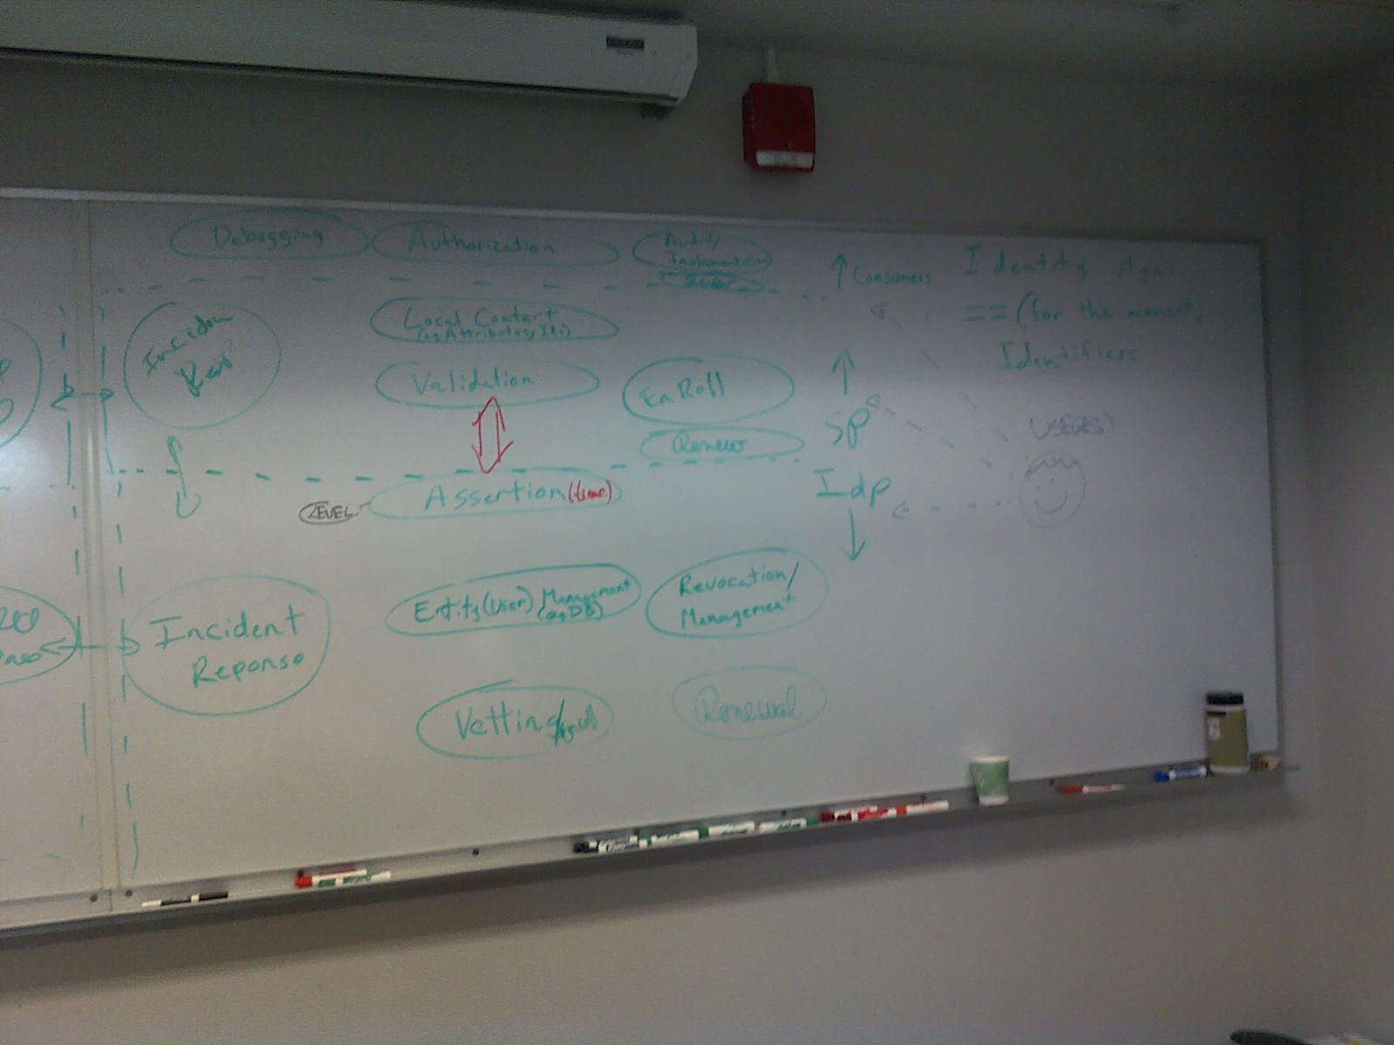Figure 1. A Conceptual Diagram of Identity Management1
- The incident response is a common element that is repeated at SP and IdP layers. Moreover, it is used between separate IdPs as well. We sought for any other common elements between IdP, user, SP or federation. Our argument did not include much in detail how this diagram changes when we add separate federations.
- We identified that revocation in the authorization layer (top layer in Fig. 1) is necessary. The revocation here means negating/changing/re-evaluating the authorization decision once the assertions used to make that decision may no longer be valid. Assertions and the authorization decisions tied to those assertions can be treated as two separate control channels. It is a policy decision how to treat them when one of them expires. When an assertion expires, should one leave the authorization decision as is, or re-evaluate the decision, or negate the decision and undo all past actions allowed by that decision, and so on.
- Propagation of assertions in the middle-ware and the infrastructure is needed. Would propagation of an assertion be equal to creating a new assertion? We have not reached a conclusion.
- Users' ability to scope their assertions is a needed piece in the identity management. A user can pick and choose the assertions about herself.
- We agreed that users are often an after-thought in the security systems, and usability is not a driving concern for the security architectures.

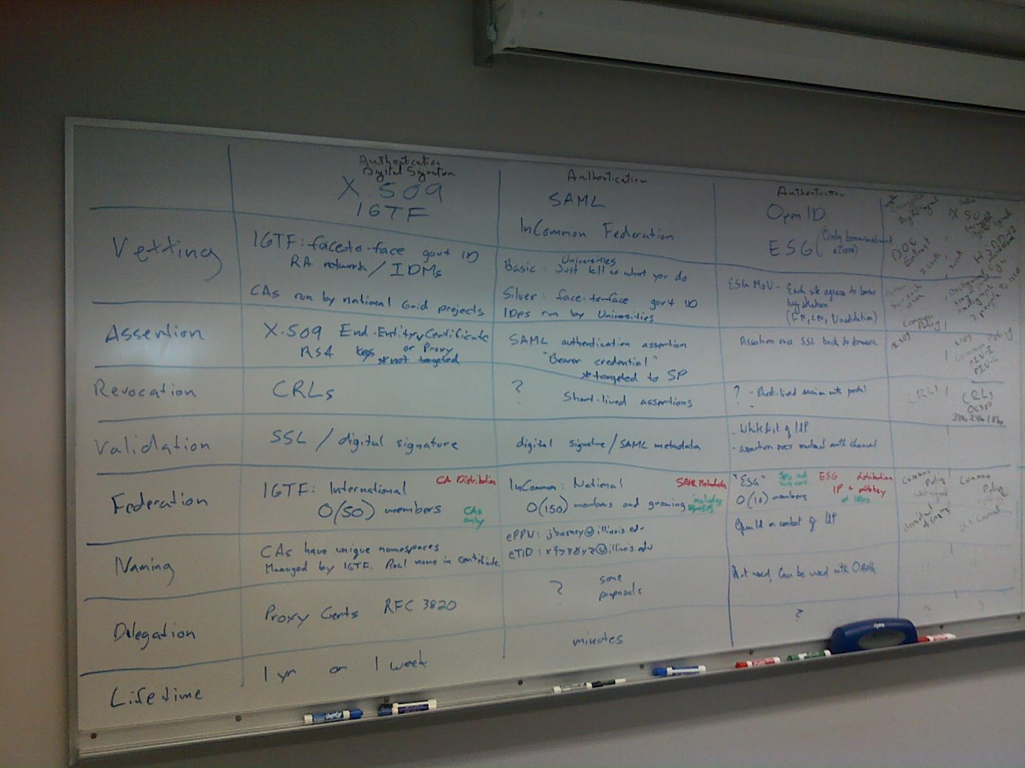
Discussion of Existing Technologies against the Conceptual Identity Diagram

Figure 2. A table of existing technologies against the conceptual identity diagram
Delegation
- X.509 provides offline delegation; necessary for non-interactive long-termed batch jobs to run.
- SAML and OpenID protocols do not provide delegation. This is a huge drawback for their usage in the non-interactive grid world. But any technology can enhance the protocols and/or implement the delegation. Current SAML work on delegation is not scalable, and, designed for interactive online systems. The delegation request always goes back to the IdP
- Oauth is an authorization protocol for the web applications.
Interactive vs. non-interactive work environment
- The web world is build on the assumption of interactive usage model; grid is built on the no-interactive usage model. Grid jobs are long-termed batch jobs with no expectation of user interaction. Web world needs and desires user interaction because the application lifetimes are much shorter and the service providers desire to keep the customer on their web site actively.
- Most solutions like SAML and OpenID are designed for web and will not meet grid world's needs. Should grid world abandon its access model and follow the rest of the world? What would grid infrastructure look like if we assume it is purely made by web protocols?
- Would the web world eventually evolve into the grid world direction and require non-interactive usage models?
Privacy
- The disclosure of user DN's are required by IGTF and the compute elements. Would there be any consequences in terms privacy, especially in trust federations?
Usability
- The user interface of Shibboleth is identical to the interface of a phishing attack; the user goes to a central web site and then clicks on a link to log onto their home organization. An attacker uses the same scenario, except she would not forward the user to the real home organization's web site and steals the user's username/password. It is alarming to get grid users accustomed to being forwarded to their home web sites for login.
- In order to eliminate MITM and phishing attacks, the end user and the providers should use SLL, hence certificates. Importing the CA trust roots and paying attention to ssl connection would be a burden on the user.
- In order to join a trust federation, providers should also present certificates. Thus, trust roots in a trust federation like InCommon is essentially the Certificate Authorities.

OSG User Communities' Requirements from Identity Management
USAtlas, USCMS, LIGO, Alice-USA, OSG-Engage, Fermilab, and STAR VOs attended the requirement gathering workshop. A questionnaire of identity management issues have been sent to all OSG VOs. The results of the survey is available at http://spreadsheets.google.com/pub?key=t429dxm3_5SJyRexugOsBNA&output=html.

Usage of DOEGrids CA certificates: User Experience in Certificate Life Cycle.
- DOEGrids CA infrastructure mostly suffices for the needs of VOs whose usage model is non-interactive grid jobs, namely CMS, Atlas, Dzero, CDF, and Star. There are areas of improvements to DOEgrids CA infrastructure, but the basic functionality is working well.
- VOs that rely on web tools, non-grid based production mechanisms, or tools with diverse authentication mechanisms are significantly unsatisfied with the DOEGRids CA infrastructure, namely SBGrid, LIGO and CompBioGrid.
- It is not clear whether unsatisfied VOs' needs can be fully met by a PKI infrastructure; or whether the problem is due to the particulars of the DOEgrids CA infrastructure.
- All of the VOs, satisfied and unsatisfied with the current infrastructure, suffers from the lack of credential management over the desktop. We identified user desktop as the no-man's-land because neither OSG nor DOEGrids CA serves any tools for managing certificates over the desktop. Once a user is issued a certificate, she is responsible for importing/exporting the certificate, converting certificate format, importing trust roots, renewing, porting the certificate to a new machine. Switching computers is a big problem for end user. The bootstrapping the certificate usage is heavy for the user and user is left without tools. Diversity of browsers and OSes also exacerbates the problem.
- Although all VOs complain about certificate bootstrapping/desktop management, some does more than others: this was a sufficient reason for LIGO to switch to a system where end user is completely isolated from certificate handling, whereas CMS and Atlas users have not felt the need for such a drastic change. It is unclear how much of LIGO's transition is propelled by their dependence on web-based tools. LIGO security contacts rated wiki tools as much as if not more important than grid job submission tools. A unified authentication method across diverse applications, such as wikis, software repositories, etc, was rated as a significant driver for the change in LIGO. Similarly, an average SBGrid user have 4-5 different identities, and SBGrid is interested in having their own CA to maintain (similar to LIGO plan). Atlas and CMS on the other hand does not use applications with diverse authentication methods, and currently has no further requirement from OSG on identity management.
- However, we have not yet fully understood the differences between satisfied and unsatisfied VOs: whether the cause of frustration is related to usage models, user profiles, expectations, or a mix of many other elements.
- We recognized that a side effect of each VO operating their own CA is that each VO becomes an IdP. This could be cumbersome because a person with multiple VO memberships will get as many identities. The identity as we operate now is not tied to a group membership, but to an individual's legal name and a key pair.
- Fermilab VO had similar problems too, but they solved them mostly. It ties a single user identity to multiple assertions. It uses a desktop client to generate certificates and manage them on the desktop. It issues multiple certificates for the VO members. The fermilab KCA can continue functioning even if Fermilab is off the network. Similar architecture is designed for CDF with Fermilab support.
VO's experience with DOEgrids CA and PKI infrastructure
- Each VO has to participate in the identity vetting process actively. DOEgrids Registration Authority relies on VO members (sponsors) to vouch for a requester's identity. This is a time-costly manual process, often executed via emails. Because sponsors are drawn from different institutions, it is complicated for large VOs. CMS has a worldwide certificate team specially designated to act as sponsors. Furthermore, a VO needs to manage the users memberships actively; removing inactive users from membership list. All of this efforts resemble a Virtual HR for a VO. Every brick-mortar organization has an HR, thus should a virtual organization have a virtual HR?
Projected VO Growth, Worst-Case Scenarios (what keeps you awake at night) and Risk Analysis (what can't you live without)
- Ligo expects 10% growth in community and more diversity. Chinese researchers recently joined LIGO. Which Cas are going to be used by Chinese is open for discussion. Ligo is considering IGTF approval of their own CAs. Ligo is gearing to open up its data. External collaborations with gamma-ray researchers are developing. This means restricted sharing of data and joint co-analysis. Thus, finer-granularity data access controls may be needed. Getting their colllaborators up to speed is a concern for Ligo.
- CMS expects a factor of 2 user growth. Computing model is not changing. Tier 3 is a bit more dedicated effort.
- For Ligo, the biggest threat is an insider job, a disgruntled student. For Atlas, grid-targeted attacks are the biggest threat, small scale attacks intrusions. For SBGrid data and process privacy is very important. If VOMS compromised, that is a failure scenario. For CMS, hadoop would be a central failure point. All worker nodes would be lost.

VOs are asked to think through their worst-case scenarios and risk analysis. All VO representatives agreed to send such a report after the meeting.
- Not the intrusion itself, but the time to clean up and bring the machine back up again are the main worries. This should be better understood.
Sites' experience with DOEGrids CA and PKI infrastructure
- Shortage of CRL lifetimes is causing a headache for the site admins. CMS estimates 1 hour compute time is wasted each day on average due to CRL failures. All resources suffer from this regardless of which CA they use.
- The root-cause of this problem is that our middle-ware implements of a common unwritten IGTF policy without giving the other parties an alternative. It suggested to update CRLs every month, but a CA or a resource may increase or decrease the accepted CRL lifetimes based on their own policies.
Small Dynamic VO Groups
- Quickly forming small VO groups is requested by SBGrid and LIGO VOs (and SNSS VO although it is not an OSG member). SBgrid needs dynamic groups for data access, rather than computing access as they are sharing http passwords currently. Delegation or assignment of VO management attributes, dynamic creation and propagation of newly-formed VOs, and dissolution of VOs need understanding. Currently there is not a ready solution.
Pilot Jobs
- Does pilot jobs need special access requirements? Do we need authenticate/authorize pilots any differently than other jobs?
- Site view on the topic (Keith Chadwick) is no; pilots do not need any special access requirements than any other jobs.
- Whether in future each user will run their own pilot jobs?
Storage Access Control Model
- Privacy vs. integrity needs.
- Atlas needs data integrity, whereas SBGrid and CMS requires data privacy. SBGrid is on the hook for scientific privacy needs. They need data and process privacy; the need is valid for non-HIPPA bound scientists as well.
- There is a real need for data access to be managed at group level. Data and computing access models are different: data needs groups, jobs do not need groups. uid is currently used for data access. (cms data is read available.)
Recommended/Sanctioned Activities
- Both VOs and sites need a list of recommended sanctioned activities in OSG.
- Sanctioned activities, ten commandments of grid security. For example, how often renew a proxy, or how to use a service certificate
- There is a need for having processes for the users to inquire about sanctions, recommendations, challenging earlier decision. Currently a VO or site can contact OSG security team for a recommendation. OSG should advertise the processes more widely.

http://hueniverse.com/2007/10/beginners-guide-to-oauth-part-i-overview/

