OSG Change Control Request and Agreement

Sequence Number 06 Date 05/09/2007

TYPE OF CHANGE: [ x ] SCHEDULE [ ] BUDGET [ ] SCOPE [ ] SOW

If Funding Change:
Current Annual Funding Amount:
Requested Change to Annual Funding Amount:

DESCRIPTION OF CHANGE

- An update to the WBS has been proposed by Don Petravick in the last WBS status update cycle. This is driven by the late hiring of the security expert at Fermilab. This took more time than original estimate but finally it is done; the new person will start in July 2007.

REQUIRED SIGNATURES:

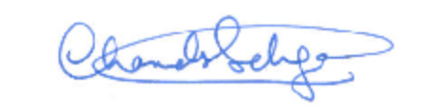
ORIGINATOR (name) _______________________________________ DATE: _05/09/07
Chander Sehgal


WBS Level 3 Coordinator __________________________________ DATE: _05/09/2007
Don Petravick

REVIEW / APPROVAL MECHANISM

[ ] Reviewed / approved at OSG Executive Team Meeting:

[ ] APPROVED VIA SIGNATURES (as shown below)

- Resources Managers (Paul Avery, Kent Blackburn)
- Executive Director (Ruth Pordes)
- OSG PI (Miron Livny)

List of Year 1 Milestones Under Change Control

- WBS 1.1.4.9; First audit of OSG asset; InCharge = Don Petravick; Old Start Date = 5/1/07; Old Finish Date = 5/1/07

Change: New Start date = 9/1/07 New Finish Date = 9/1/07

