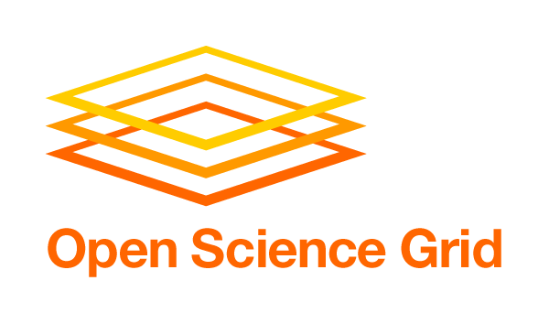
Previous versions and input from other stakeholders are available at:
https://twiki.grid.iu.edu/bin/view/VirtualOrganizations/Stakeholder_PlansNeedsRequirements

Virtual Organization: ALICE

Stakeholder Scope: High-Energy Physics VO

Mission Statement: Driving Force and Vision of VO
The ALICE Collaboration is building and operating a dedicated heavy-ion detector to exploit the unique physics potential of nucleus-nucleus interactions at LHC energies. Our aim is to study the physics of strongly interacting matter at extreme energy densities, where the formation of a new phase of matter, the quark-gluon plasma, is expected.

Activity by VO: Quantitative Metrics

This VO has been in existence for over 5 years and is in it’s initial phase with OSG. The overall goal is to integrate the US OSG resources within the existing ALICE Grid thus assuring full access of all ALICE physicists to the US computing resources and allowing all US physicists efficient access to the ALICE data processing Grid framework. Resource targets for 2010 of about 15 kHEPSPEC06 cpu capacity, 1 PB of disk storage and 0.6 PB of tape storage are scheduled for deployment at the ALICE-US Tier-2 facility to be located jointly at NERSC/PDSF and LLNL. The numbers are expected to double over the next two years and hardware procurements are being planned in order to meet such expectations.

Activity by VO: Qualitative Science Value Output

Science Production: The VO enables researchers to keep pace with current data production and analysis needed to contribute significantly to the scientific mission of the ALICE collaboration as noted above. Such contributions are measured by peer-reviewed publications and presentations at major scientific conferences by which physics discoveries by ALICE researchers are made available to the larger scientific community.

VO Direction and Plans: Short-term 3-9 months

The ALICE experiment is currently taking data during the proton+proton running at the LHC, and preparation is underway for the upcoming heavy-ion (Pb+Pb) running planned for November 2010. It is expected that ALICE will acquire several peta bytes of raw and first pass reconstructed data during this period. Approximately 10% of that data will be sent to the US facilities as secondary storage and as input to further processing and analysis. The heavy-ion community will be extremely active analyzing these data, with large efforts geared toward preparation for the Quark Matter conference in May of 2011.

In order to provide compute and storage resources to support the expected computing needs of ALICE during this next year and beyond, the US ALICE computing project is currently establishing facilities at both NERSC/PDSF and LLNL. New hardware purchased by the project has been installed at PDSF and is providing the ALICE VO ~10k cpu-hours daily with grid-enabled disk and tape storage elements. Additional hardware will be deployed at PDSF later in 2010 or early 2011, doubling the cpu resources available to the ALICE VO. The LLNL facility is under construction and should be operational by October 2010. LLNL will be of comparable size as the facility at NERSC/PDSF.

ALICE grid jobs run at NERSC/PDSF are processed through the OSG gateway, allowing resource utilization to be recorded through OSG accounting procedures and eventually registered with the WLCG. The current planning at the LLNL site includes setting up an OSG gateway for processing ALICE grid jobs run on that facility, providing a common accounting structure for these two main ALICE US facilities.

Members of the ALICE Computing project have been involved in evaluating use of Cloud resources for ALICE grid activities. Such activities in the US include use of the Magellan experimental facility at NERSC. The US ALICE project is interested in advancing OSG integration into Magellan for use by ALICE VO grid efforts. The goal of such activity is to preview models for next generation facilities supported by NERSC for groups such as ALICE and to make use of a modest amount of CPU resources available on the Magellan systems, particularly at NERSC where ALICE VO data will already be resident.

VO Direction and Plans: Long-term 1-4 years

The ALICE VO will continue to operate ALICE grid activities as the LHC running progresses. It is expected that ALICE computing needs will steadily increase over the coming several years to meet the physics goals of the collaboration.

Needs and Expectations from OSG Consortium: Short-term 3-9 months

The primary expectation from OSG is supporting the seamless integration of the OSG gateway with ALICE grid activities. Successes at NERSC/PDSF suggest that this activity will be productive. The next step will be to include and verify the mechanism for reporting ALICE grid use on OSG facilities to the WLCG.

One item that the ALICE grid team has identified interest in is the CREAM CE, now widely used by the ALICE VO. ALICE grid sites rely on the CREAM CE almost exclusively and have found it to be quite stable and easy to maintain and monitor. The team believes that support of the CREAM CE by the OSG would make future work with OSG more easily adaptable in the ALICE grid environment. Any effort to incorporate the CREAM CE in OSG would be encouraged by the ALICE VO and supported where possible by ALICE US participants.

Needs and Expectations from OSG Consortium: Long-term 1-4 years

During a later phase of work with OSG, the ALICE VO will proceed to test use of opportunistic resources across OSG sites. The ALICE-US participants will attempt to develop and test methods for accessing remote OSG resources. Such activities help ensure software compatibilities (e.g. participation in OSG’s software validation process) and provide opportunities to expand the resource pool available to ALICE. The level and conditions for such opportunistic computing will be determined at a later date, by mutual agreement with ALICE, the computing sites, and their sponsors.

Significant Milestones (i) Met in 2010 (ii) Planned in 2011
(use milestones from spreadsheet)

During the past year, the ALICE VO and OSG have continued to interact while the ALICE US facilities were being designed and constructed. The primary significant milestone achieved has been the testing of the OSG infrastructure at the scale necessary for a large ALICE T2 facility operation. This work has been undertaken at NERSC/PDSF with support from OSG.

Miscellaneous

We list here some major points of interest in the relationship between ALICE VO and OSG.

- ALICE purchased resources at PDSF are currently available and being used by OSG member VOs and new hardware supplied by ALICE at both PDSF and LLNL will be made accessible to OSG for opportunistic use.
- ALICE is opening doors for GRID work at both NERSC and LLNL facilities which have historically been restrictive in allowing access through grid interfaces.
- OSG has already done the work of providing reporting to WLCG for it’s major stakeholders, ATLAS and CMS. ALICE-US will benefit greatly by leveraging this work to meet our needs in this regards.

