CEMON Troubleshooting Guide

(VDT 1.10.0 i.e. OSG v1.0)
T.Levshina

VERY QUICK CHECKLIST:

- To verify that your CEMon is successfully reporting to ReSS issue the following command from the node where condor is installed:

condor_status -pool osg-ress-1.fnal.gov -l -constraint "GlueCEInfoHostName == \"<YOUR HOST_NAME>\""

for example:

condor_status -pool osg-ress-1.fnal.gov -l -constraint "GlueCEInfoHostName == \"tier2-02.uchicago.edu\""

it should report back something like the following:

MyType = "Machine"
TargetType = "Job"
Name = "tier2-02.uchicago.edu:2119/jobmanager-condor-atlas.1231388458"
GlueCEInfoContactString = "tier2-02.uchicago.edu:2119/jobmanager-condor"
CurMatches = 0
Requirements = (CurMatches < 10)
WantAdRevaluate = TRUE
ReSSVersion = "1.0.6"
GlueCEInfoApplicationDir = "/share/app"
GlueHostProcessorModel = "Intel(R) Xeon(TM) CPU 3.00GHz"
GlueCEName = "atlas"
GlueCEHostingCluster = "tier2-02.uchicago.edu"
GlueCEPolicyPriority = 0
GlueHostProcessorVendor = "GenuineIntel"
GlueHostProcessorClockSpeed = 1000
GlueSiteUniqueID = "tier2-02.uchicago.edu"
….

If this command returns no output, then ReSS is NOT receiving your site information from CEMon. In this case, do the following:

- Check permission on the service certificate and key. Verify that service certificate in apache $VDT_LOCATION/apache/conf/extra/httpd-ssl.conf exists and is owned by “daemon” (or whatever daemon is running apache and tomcat) and have a right permission (httpkey.pem should be readable only by user “daemon”)
SSLCertificateFile /etc/grid-security/http/httpcert.pem
SSLCertificateKeyFile /etc/grid-security/http/httpkey.pem
After changing permissions restart apache and tomcat.

Check the permission of a gridmap file (It should be set to readable to world
644). The file location is defined in $VDT_LOCATION/glite/etc/glite-ce-monitor/authconfig.xml

After changing permissions restart apache and tomcat.
Check that the certificate is not expired by executing command:
openssl x509 -dates -in /etc/grid-security/http/httpcert.pem -noout

- Check that apache and tomcat are running (use ps command, for example “ps -efw | grep tomcat”) and if you have a certificate uploaded to your browser check if you can access CEMon by this link:

https://<YOUR-HOST-NAME>:8443/ce-monitor/TopicList

(for example:
https://cms-xen1.fnal.gov:8443/ce-monitor/TopicList )

If you have your DN listed in /etc/grid-security/grid-mapfile you will get back the following:

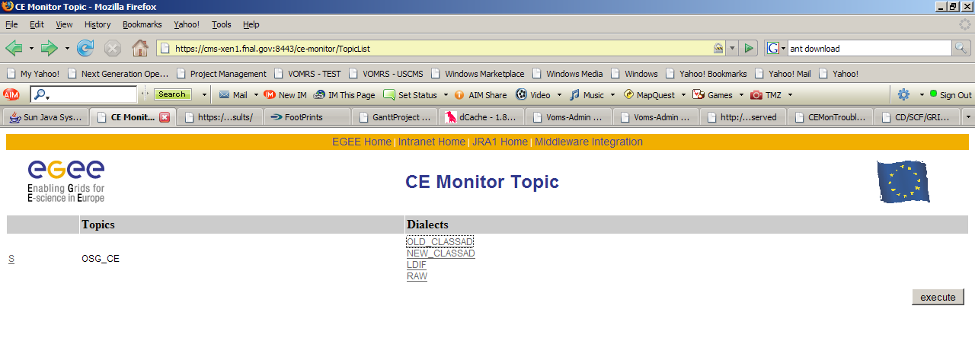

Click on “OLD_CLASSAD” and “RAW” links you should be able to see the last event that CEMON sent to ReSS and BDII Consumer respectively.

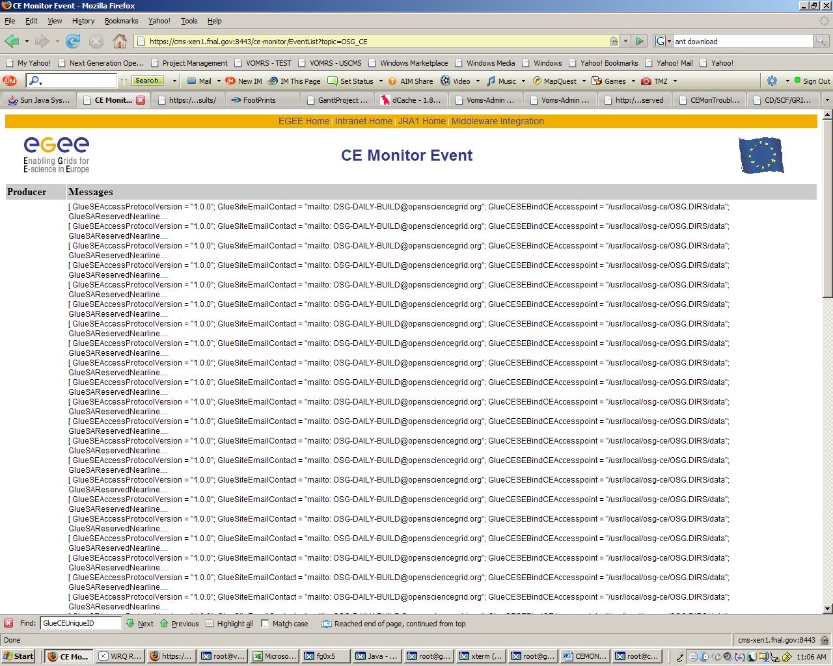

If your DN is not listed you should get something like this:
User DC=org,DC=doegrids,OU=People,CN=Name LastName …. not authorized for {http://glite.org/ce/monitor}BrowseTopicList
.

- Verify that your GIP configuration is correct.
  - Run GIP wrapper script manually and save its std output and error e.g. in /tmp/out and /tmp/err:
$VDT_LOCATION/gip/libexec/osg-info-wrapper >/tmp/out 2>/tmp/err
  - Check that you do not have any errors in /tmp/err.
  - cd $VDT_LOCATION
  - . setup.sh
  - cd verify-gip-for-cemon
  - run the following script, so that it processes the gip output saved in point a. above
./verify-gip-for-cemon-wrapper /tmp/out
The script will either print out the valid gip configuration
formatted for CEMon OR generate an error that would help you with
the diagnostic of GIP configuration problems.
- Check firewall settings on your local computer
- Increase level of debugging.
  - Modify $VDT_LOCATION/tomcat/v55/webapps/ce-monitor/WEB-INF/classes/log4j.properties:
log4j.logger.org.glite=debug, fileout
#log4j.logger.org.glite.ce.monitor.holder.NotificationHolder=debug, fileout

# log4j.logger.org.glite=info, fileout
log4j.appender.fileout=org.apache.log4j.RollingFileAppender
log4j.appender.fileout.File=/usr/local/osg-ce/glite/var/log/glite-ce-monitor.log
log4j.appender.fileout.MaxFileSize=2MB
log4j.appender.fileout.MaxBackupIndex=20
log4j.appender.fileout.layout=org.apache.log4j.PatternLayout
log4j.appender.fileout.layout.ConversionPattern=%d{dd MMM yyyy HH:mm:ss,SSS} %c - %m%n

  - Restart tomcat

- If everything mentioned above does not expose any problem, contact expert support and provide the following information:
  - catalina log ($VDT_LOCATION/tomcat/v55/logs/catalina.out)
  - cemonitor log ($VDT_LOCATION/glite/var/log/glite-ce-monitor.log)
  - output of the wrapper script ($VDT_LOCATION/gip/libexec/osg-info-wrapper)
  - configuration files located in ($VDT_LOCATION/glite/etc/glite-ce-monitor/)

