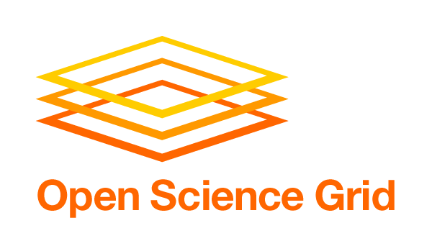

Previous versions and input from other stakeholders are available at:
https://twiki.grid.iu.edu/bin/view/VirtualOrganizations/Stakeholder_PlansNeedsRequirements

Virtual Organization: CHARMM Group in OSG VO

Stakeholder Scope: Science production

Mission Statement: Driving Force and Vision of VO

Molecular simulation has become an increasingly important tool for elucidating the relationship between the structure, chemical properties, and biological function of macromolecules such as proteins, nucleic acids, lipids, and carbohydrates. CHARMM is a program that is designed to conduct simulation of these biomolecules. The purpose of our work is to provide a stable environment for running CHARMM on the Open Science Grid (OSG).

Activity by VO: Quantitative Metrics

Currently, our primary project is to run simulations of various mutants of the E. Coli AraC protein, which regulates genes that synthesize proteins necessary for the uptake an catabolism of the sugar Arabinose by that microorganism. Currently, four mutants are running with three more ready to be started.

Numbers given below are very approximate:

VO’s Average OSG Utilization: ~ 1300 CPU-Hours/day: , Average 2000 MB/Day
VO’s Peak OSG Utilization: ~ 1360 CPU-Hours/day, 2800 MB/day

Activity by VO: Qualitative Science Value Output

The results of the simulations will help determine the effect of mutations on the behavior of the AraC protein. In particular, there are several key residues that seem to affect the overall behavior of the protein system, and our simulations will elucidate the effect of various mutations on these residues. The idea behind these simulations is to get a very quick snapshot of how each mutation changes the energy profile of the system. Since we are only running single CPU jobs, we cannot determine long time scale dynamics, but we can look at the initial, short-term effect of the mutations on the system's behavior.

The results of the simulations we are conducting now will be used to drive experimental work to be done at John Hopkins University. The short time-scale simulations of the type we are running now have been shown to predict well the behavior of E. Coli in the presence of Arabinose. The idea is that our simulations will be used to identify potentially interesting mutants. Our experimental collaborators will then actually make these E. Coli mutants and observe them. In doing so we will be able to check the in vivo effects of these mutations against the results of our computer simulations.

VO Direction and Plans: Short-term 6-12 months

We are in production and intend to increase our production over the next two months. We intend to finish the current project by the end of October, 2010. We would like to be able to increase our production roughly three-fold over the amount we are getting now. We expect production to peak from early September until late October.

Requirements (Needs & Expectations) from OSG: Short-term 6-12 months

Our model of operation is based around opportunistic computing, i.e. the use of spare cycles that are not dedicated to other projects. Therefore, we do not have any specific types of short-term resources that we need. The main priority is, instead, to locate sites where we can submit our pilots to run our jobs in an opportunistic fashion. Collaboration is ongoing with Jose Caballero at BNL and others to identify these sites so that we can ramp up our production.

VO Direction and Plans: Long-term 1-4 years

Our goal is to show that useful biomolecular simulations can be done in the OSG environment using CHARMM and to complete the AraC project by mid-2011 (see below). If there is interest from the scientists at JHU, follow-up projects and broader engagement efforts can be considered.

Requirements (Needs & Expectations) from OSG: Long-term 1-4 years

The ability to connect better with other groups using the OSG to do computational biology and simulation in particular would be helpful in finding other people who would be potentially interested in building on the tools that we have developed. In addition, we are limited by our ability to run single-thread jobs. At the last all-hands meeting, ideas were discussed for a common, unified, method of running MPI jobs on the grid. This would be extremely useful for our science and we'd potentially be interested in helping to test MPI jobs (we've done limiting testing, but it has all been very site-specific whereas our goal would be to run MPI jobs in volume across many sites). Ultimately, however, future needs for this effort will be determined by how many scientists are interested in using the tools that we have developed.

Significant Milestones (i) Met in 2009-10 (ii) Planned in 2010-11

(ii) Publication of the AraC project is expected by mid-2011 after our experimental collaborators have finished their work.

Miscellaneous

N/A.

