OSG Change Control Request and Agreement

Sequence Number 7 Date 06/20/2007

TYPE OF CHANGE: [ x ] SCHEDULE [ ] BUDGET [ ] SCOPE [ ] SOW

If Funding Change:
Current Annual Funding Amount:
Requested Change to Annual Funding Amount:

DESCRIPTION OF CHANGE

An update to the WBS has been proposed by Ruth Pordes and Gene Oleynik. The specific proposal is to delete item 1.3.2.2.12. The reason is that work on FTS is outside the scope of OSG and was not part of the requested services from the stakeholders. The task came out of an out of band Blueprint discussion at which the area coordinator was not present.

REQUIRED SIGNATURES:

ORIGINATOR (name) _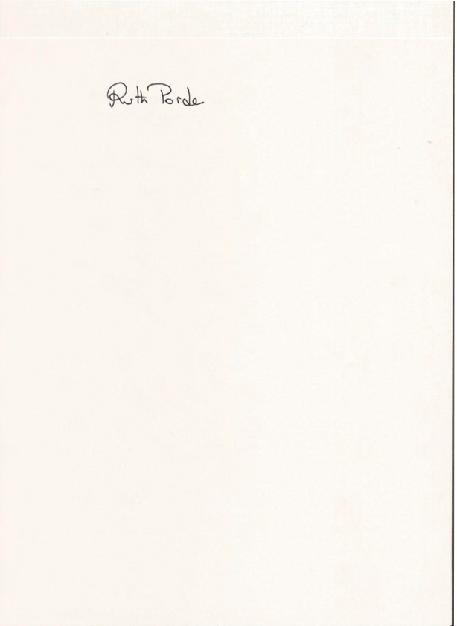______________________________________ DATE: 21 June 2007

WBS Level 3 Coordinator __________________________________ DATE:

REVIEW / APPROVAL MECHANISM

[ x ] Reviewed / approved at OSG Executive Team Meeting:

[ ] APPROVED VIA SIGNATURES (as shown below)

- Resources Managers (Paul Avery, Kent Blackburn)
- Executive Director (Ruth Pordes)
- OSG PI (Miron Livny)

List of Year 1 Milestones Under Change Control

- WBS 1.3.2.2.12; Evaluate FTS Client and FTS functionality support for US CMS Tier-3s; Gene Oleynik; Old Start Date = 04/02/07; Old Finish Date = 06/01/07

Change: Delete this item

