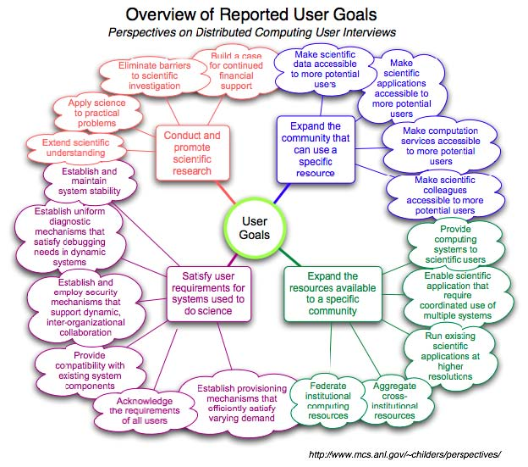

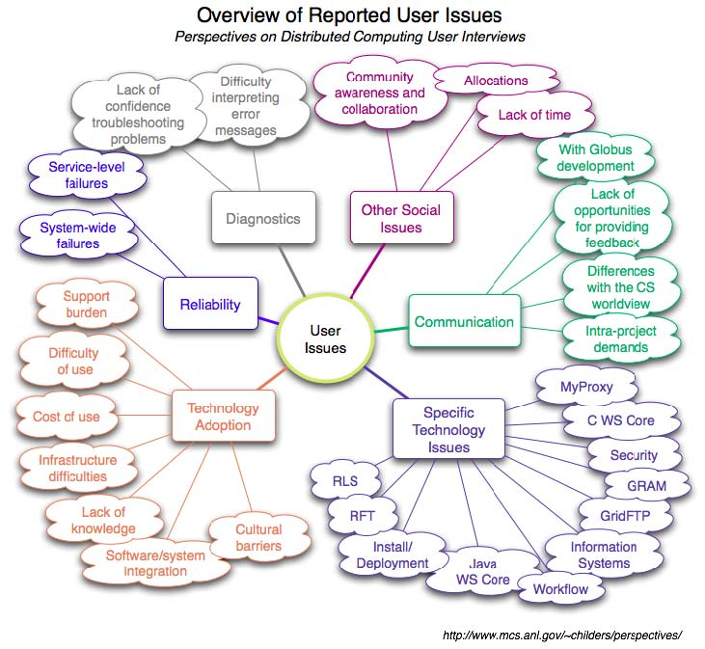

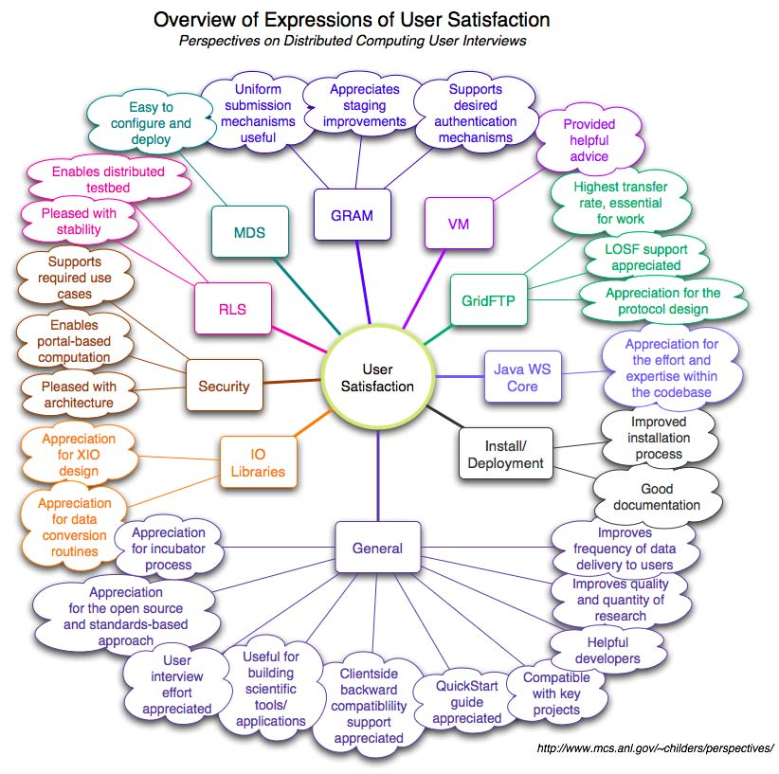

5.1 For Developers of Distributed Computing Technology
As the profiles in Section 4 show, the goals of distributed computing technology users extend well beyond the bounds of any single technology. Yet Grid middleware development is organized around providing users with functional components¹⁴². Developers specify, implement, and make components available for later assembly into products that satisfy specific use cases. A key advantage of the component approach is that it facilitates code reuse: a component can be combined with domain-specific code and other components to create higher-level products that perform large tasks. We see many examples of this in the interviews, with components such as RLS, GridFTP, and GRAM employed in a wide variety of domain-specific applications. Yet the developer who works solely inside a component-centric bubble runs the risk of missing key user requirements.
Recommendation 1: Broaden the focus of component-centric development
The crux of this recommendation (and all that follow) is that understanding the broader context of component usage is essential to building useful, usable components. We recommend that component developers address five key needs, highlighted in bold italics.
Product requirements are derived from the users’ needs: a goal or set of goals that users of the product are trying to realize. Understanding component usage in relation to the larger product requirements will help the developer write better tests for the component, based on realistic use cases; write better documentation, using terminology and concepts familiar to the user; and refine component requirements, using concrete ideas to augment the usual abstractions.
Note that a single set of product requirements can be satisfied by multiple system designs, as multiple implementations can provide similar results. Therefore, product requirements alone are insufficient to understand component-level requirements. Component developers must also work to understand the end-to-end system design of the product. This understanding will yield requirements related to the component’s public interface, such as interoperability, fault handling, and logging.
Component developers should actively manage the contexts in which the components are employed. If conflicting requirements exist, the developers will need to devise a strategy for supporting them. One such approach is to design the component in such a way that incompatible functionality is encapsulated in pluggable modules. Another approach is to provide specialized versions of the component for each requirement set. Still another is to explicitly and noisily declare one or more requirement sets to be unsupported.
The component developer should also ensure that dependent elements in the system are readily available. Developers should track the dependencies of each product on components from other sources and should monitor the availability of those components, for example by negotiating agreements with other development teams or contributing to other development products.
Component developers should fully document the types of products in which the component is intended to work. Developers should not leave it to the user to infer the component’s intended use or the intended context for applying it. Useful descriptive information includes a description of the product’s users, a summary of the user needs met by the product, a list of use cases and the
¹⁴² Many example components can be found at http://www.globus.org/toolkit/docs/4.2/4.2.0/
48

role the component plays in each use case, and an overview of an example system design and the key requirements provided by the component.
Recommendation 2: Develop unique approaches for engaging different user types
Figure 4 shows considerable diversity in what each of the thirty people interviewed aims to do using distributed computing tools. Clearly, a single approach to outreach, training, and user support will not serve all of these kinds of people equally well. Within each user type, however, we can take similar approaches to outreach, training, and support. The reason is that the user types are defined by the way members interact with technology. Technology developers should choose types of users to work with and devise unique approaches for the engagements.
Elaborating on this general recommendation, we discuss four specific recommendations, one for each user type: (1) provide a data movement product for HPC scientists who routinely move data;
(2) enlist the aid of HPC domain-specific developers to translate generic technology concepts into domain-specific concepts; (3) partner with general-purpose infrastructure providers to refine requirements for reliability and multiple-use deployments; and (4) partner with other general-purpose technology developers to build and document interesting multicomponent examples. Again, we use bold italics to highlight points.
1. Provide a data movement product for HPC scientists who routinely move data
Section 4.2 profiles the three HPC scientists we interviewed. The primary application they see for distributed computing tools is to move data between the systems where they perform simulation tasks, data analysis tasks, and the rest of their work. The HPC scientists are first and foremost scientists, not information technology specialists. Of the four user types identified in this report, the HPC scientists had the narrowest scope of interest in distributed computing capabilities.
Data movement is a task that many HPC scientists need to perform routinely. The scientists we interviewed were adamant that it is a time-consuming source of frustration for them. They feel that they need to “baby-sit” file transfer tools to ensure that data movement failures – which are frequent enough to become routine – are dealt with without losing valuable time. The scientists use various manual techniques to reduce the impact of failures and to assure themselves that the data has been transferred accurately. It is not only fault recovery that is a challenge. Diagnosing the cause of errors is also reported as a time-consuming issue.
An end-to-end product aimed at these users must move large volumes of data of varying numbers of files and varying file sizes. The solution must automatically restart in the event of transient failure. The solution must be able to diagnose common configuration issues at either end of the transfer (e.g., security misconfigurations, expired certificates) and provide diagnostics in layman’s terms. Most important, the product must reliably work with the installed systems at a wide range of HPC centers – multiagency, multi-institutional, international. The HPC scientist should not need to install, configure, or tune the solution: it should be ready to use. Nor should the HPC scientist need to tell the HPC center when the solution is not working: it should be monitored by center staff and kept working at all times. Consider the case where the GridFTP deployments at two centers do not recognize a common certificate authority. The scientists expect the performance of the solution to be high, utilizing networks and I/O interfaces to their capacity, but this is a secondary concern relative to reliability and automation: slower, foolproof transfers are preferable to faster, unreliable ones. A well-documented guarantee of data consistency and the method used to assure it is a critical requirement.
49

Training materials for the HPC scientist must be practical and focused on things that the scientist can and should be doing himself, not things that the IT support staff should be doing for him. A primary issue reported by HPC scientists is the need to move data from system to system because no single system meets all of their needs. Training materials for these scientists should clearly address how to use an end-to-end data movement solution, rather than how to build and deploy the solution, unless it is trivial to deploy. Additional issues that HPC scientists reported include having to personally deal with failures (e.g., restarting failed file transfers) and having to debug security issues (e.g., expired certificates). Training materials for this user type should provide practical suggestions for how to employ automated fault recovery mechanisms such as RFT and how to quickly interpret the nature of a security error and who to talk to in order to resolve each kind of error. Effective training materials depend, of course, on having in place a robust, reliable, easy-to-use, end-to-end data movement product on the major HPC systems used by HPC scientists.
2. Enlist the aid of HPC domain-specific developers to translate generic technology concepts into domain-specific concepts
Section 4.3 profiles HPC domain-specific developers. These are people who both use and integrate general-purpose HPC technologies and also develop and integrate domain-specific technologies. Because of their role as mediators between scientists and technology, their goals are often of the form “Use [x technology] to facilitate [y scientific goal].” They mention social issues, but technological issues dominated among those we interviewed.
Component developers should seek out domain-specific developers as both a source of knowledge about the domain’s needs and an entry point or gateway to the users within the domain. Convincing the domain-specific developers of the value of a technology is likely to be an important step toward being given the chance to serve that domain’s needs. We found that two of the common activities pursued by HPC domain-specific developers are translating domain goals into technological concepts and translating concepts into practice. Domain-specific developers are the people who marshal information technologies to meet the needs of domain practitioners. They have feet in both the science domain and the domain of general-purpose technology, and translating between them is a key part of their job. The presence or absence of such domain-specific developers typically indicates the readiness of a domain for distributed systems technologies. Without such experts, the general-purpose technology developers will have to assume the translation burden normally shouldered by the domain-specific developers.
HPC domain-specific developers are interested in technology components that they can easily integrate with domain-specific systems to make those systems more powerful, easier to maintain, more flexible, or more robust. Distributions should be in the form of software developer kits or modular packages rather than preintegrated applications or suites. Components should offer the ability to customize behavior even at the expense of being complex, because the developer will take advantage of the configurability and hide the complexity from users.
Documentation and training for these users should emphasize application programmer interfaces and service interfaces for these components rather than direct user interfaces such as command line or graphical user interfaces. Included in such documentation should be examples of how the component has been integrated in other scientific systems and the benefits provided to those systems – robustness, performance, improved flexibility.
HPC domain-specific developers should be provided diagnostic and status data from many layers of their systems, including components provided by others, in a central location for debugging purposes. Error reports should be machine-readable and easy to decode.
50
HPC domain-specific developers should be able to configure components to respond in specific ways to faults, hiding low-level faults from the user of the systems they develop, and reporting problems only when the system cannot automatically recover. The recovery strategies may vary widely from application to application, however, based on the application-level requirements. Component suppliers should work closely with HPC domain-specific developers to understand how the developers believe that faults should be handled and provide ways for the developers to configure the components accordingly.
3. Partner with general-purpose infrastructure providers to refine requirements for reliability and multiple-use deployments
Section 4.4 profiles general-purpose HPC infrastructure providers. These are people who use, integrate, and develop general-purpose technologies and who integrate – but neither develop nor use – domain-specific technologies. Operational and technical matters dominate their goals and issues, with considerable emphasis on providing stable, usable, and reliable technological capabilities to their users. Social elements do arise, however, because of the integration function the infrastructure providers perform for others.
General-purpose infrastructure is of key concern because it is one of the two places where scientific end-users encounter distributed systems technology. Domain-specific infrastructure is the other, and domain-specific infrastructure may also leverage general-purpose infrastructure. Infrastructure providers are also a source of stringent reliability requirements because they – and their users – highly value service reliability. General-purpose infrastructure must support multiple uses and users, which leads to another set of interesting requirements.
General-purpose infrastructure providers typically do not use the technologies they provide to scientists, so they are not likely to have firsthand knowledge of their users’ requirements. Instead, they are interested in technology components that they can integrate to make their general-purpose systems more powerful, easier to maintain, more flexible, or more robust. It is not uncommon for them to have limited development resources, in which case they seek out third-party products. They value products that are configurable and flexible enough to adapt to their existing systems; a modular design is considered an advantage. They want components that can be customized both at deployment time by the infrastructure provider and at runtime by the end user. Runtime configurability is particularly important because the system will be used by a diverse set of end-users with unique needs. General-purpose infrastructure providers also develop general-purpose technologies, so they may avoid other implementations of components that they have developed themselves. See the “Develop” column of Table 7 for a list of these components.
Documentation and training targeted at infrastructure providers should emphasize end-toend use scenarios that illustrate the benefits of the products to both end-users and infrastructure providers. Include examples of how the component has been integrated in other scientific systems and the benefits provided to those systems (robustness, performance, improved flexibility, etc.). Deployment and configuration details are of equal importance, particularly the host system technical requirements and scaling limitations. Direct user interfaces (command line or graphical user interfaces) and service interfaces must be documented, but this information will most likely be passed directly on to end-users rather than used by the infrastructure providers themselves.
Special attention should be given to diagnostics for general-purpose infrastructure providers. Local log files should be well organized. The data relevant to a given failure must be straightforward to find, ideally in a single location. Error messages must be clear and accurately identify any related system problems. Temporary files that may have contributed to failures must be preserved. The infrastructure providers noted that they often do not have control over the clients their users are using and noted that client version mismatches or configuration issues,
51
including security configuration, account for a nontrivial number of the issues. An easier means of flagging the use of “bad” clients would be an obvious way to help.
Infrastructure providers also find that their systems become elements of larger application networks and that failures at other sites in such networks or along the communication links may cause real or apparent failures in their local system. As in the client case, providers do not have control over these peer systems or the software used on them. Therefore, a means of flagging interactions with misconfigured or “known-to-be-bad” systems should be provided for diagnosing failures. Infrastructure providers also note that simply detecting failures in their deployed services can be difficult. Usage reports that record failures, log failure data, and notify infrastructure providers would be helpful.
4. Partner with other general-purpose technology developers to build and document interesting multicomponent examples
Section 4.5 profiles general-purpose HPC technology developers. These are people who use, integrate, and develop general-purpose technologies but who do not work with domain-specific technologies. The goals expressed by these developers are a mixture of technical development, with a strong focus on new or improved features, and social operations, such as encouraging user adoption and helping users to meet their goals. Interesting is the notable absence of technical operations goals, such as maintaining deployed systems, and of social development goals, such as identifying new types of users. Issues expressed by the general-purpose technology developers mainly involved integrating technologies developed by others, but there was a strong element of social and organizational issues, such as difficulties obtaining information from deployments and heavy demands for communication with users and for user support.
General-purpose technology developers should conduct joint demonstrations of their components used together to accomplish end-to-end user scenarios. This type of engagement yields two benefits. First, the demonstration gives infrastructure providers and HPC scientists a clear example of using the components to resolve problems familiar to them. Second, it provides an opportunity to expose more people to each of the partners’ components, as presumably each partner has different (though most likely overlapping) user bases.
General-purpose technology developers are interested in technology components that provide functionality complementary to their own components and can be used with their own components to build end-to-end capabilities for users. General-purpose technology developers look for modular components; and they want such components to be available with specific versions so that once they demonstrate an integrated solution, they can be sure that the integration with the original version will continue to be available to their users. Components should offer the ability to customize behavior, even at the expense of being complex, because the general-purpose technology developer will take advantage of the configurability and hide the complexity from users. Nevertheless, the default behavior should both work and be simple.
Documentation and training for general-purpose technology developers should emphasize application programmer interfaces and service interfaces for these components rather than direct user interfaces. Examples of how the component has been integrated in scientific systems will help other developers formulate possible integration strategies.
The integration issues reported by general-purpose technology developers include dependency conflicts between components that require different versions of the same third-party code, language mismatches, and frequent changes in other components. General-purpose technology developers chafe at being reliant on others for responses to issues (e.g., bugs, feature requests, performance issues), so to retain their interest and trust, one must be responsive to their requests. General-purpose technology developers also want to intercept and handle faults from components
52

they are integrated with. Recovery strategies may vary widely from component to component, however, based on the requirements of the component itself. Component suppliers should work closely with other general-purpose developers to understand how they believe that faults should be handled and to provide ways to configure the components accordingly.
Diagnostic features that assist in distributed debugging are important for general-purpose technology developers. Since it is difficult to obtain good information from deployments, remote monitoring and error tracking should be made available.

