Probing the Perfect Liquid with the STAR Grid
x
z
y
p_{x}
p_{y}
y
x
Figure 1: Left: Schematic of the collision zone between two incoming nuclei. Right: Initial-state spatial anisotropy converting into final-state anisotropy in momentum.

When the universe was just microseconds old, it consisted of a soup of free quarks and gluons. Experiments at the Relativistic Heavy Ion Collider (RHIC) at Brookhaven National Laboratory seek to reproduce matter under these conditions and study it in the laboratory by creating "little bangs" from high-energy collisions of heavy nuclei. Recent findings from these experiments indicate that the matter created in these conditions behaves like an extraordinarily "perfect" liquid, one which flows with little resistance much like superfluid helium.

To determine the properties of this perfect liquid, physicists around the world must sift through the ashes from millions of these little bangs. One measure sensitive to these properties is the “elliptic flow” of particles in the detector. As shown in the top figure, the initial shape of the collision zone is usually elliptical. Pressure in the liquid seeks to make the matter round, and so makes the liquid flow faster in the shorter than in the longer direction. This elliptic flow is preserved in the velocity of particles as they reach the detector. At the highest multiplicities at RHIC this flow is large, and approaches the limit of the maximal amount of flow predicted in pure hydrodynamic calculations that assume the matter flows with zero viscosity.

An incisive test of this is the pattern of elliptic flow for a range of identified final-state particles. At low transverse momentum the pattern of elliptic flow is well reproduced by such calculations. While this discovery is extremely exciting, it remains a challenge to determine the viscosity of the liquid, which needs to be an order of magnitude smaller than that of superfluid helium, with high precision. The viscosity is in principle calculable from first principle Lattice Quantum Chromodynamics, and so a precise measurement serves as a crucial test of our understanding of that theory.
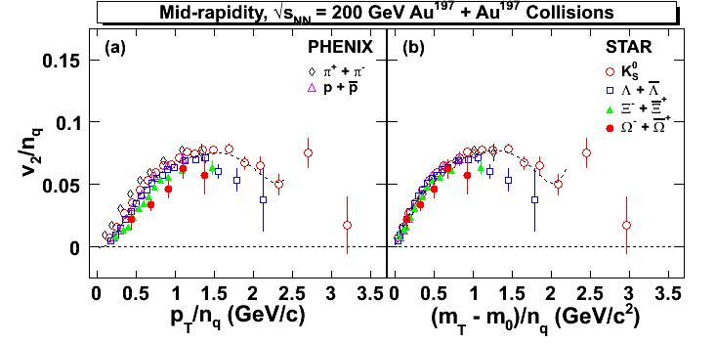
Figure 2: v₂ divided by the number of quarks (2 for mesons, 3 for baryons) versus transverse mass – rest mass (m_{T} – m₀) or transverse momentum p_{T}, again divided by the number of quarks. Preliminary result shown at Hard Probes 2006 by Y. Lu (IOPP) based on analysis of events transferred to China over the Grid.

This challenge requires the analysis of large event samples. The STAR collaboration currently relies on the OSG software stack to federate its facilities into a uniform computational pool which is then used to run heavy simulations. The SRM/DataMover, running on the OSG infrastructure is making STAR's data available to remote sites. This tool, provided by STAR's collaborators from the SDM center at LBL, has been a tremendous enabler in these analyses. The data set needed for important upcoming conferences, 20 TB (110 million events), has been transferred from BNL to PDSF at NERSC in near-real time at a peak rate of 35 MB/sec, and beyond that to collaborating sites in China.
Efficient data movement has allowed STAR to spread user data analysis over a computing pool of 3000 kSI2k which has in turn led to timely analysis of the patterns of elliptic flow in the data. A preliminary example is shown in Figure 2. In certain regions of transverse momentum, STAR has found that elliptic flow scales with the number of quarks in the final state hadron, thus bringing to light the partonic dynamics in the early stages of the collision.
Further results on elliptic flow and other related phenomena will be presented at the largest international conference in the field, Quark Matter 2006, in Shanghai this November.

