RENCI PI Report for OSG
July 27-2007

- Enhancements to the Engage VO hosted infrastructure in support of users
  - By working with OSG site administrators, the GOC, and the user support groups, we have increased the number of sites that are servicing jobs for the Engage VO. The number of sites supporting this VO is critical, as it enables rapid turnaround for peak processing. The typical Engage usage profile is shown in Figure 2 with a recent graph of jobs being processed for a Rosetta user in the Kuhlman lab. Having access to more sites provides significantly better turnaround for this peak oriented workload profile.
  - The matchmaking services have been refined in close collaboration with Gabriele Garzoglio and Chris Green, and a demonstration of these services is under development for presentation at the CHEP 2007 conference.

- User Engagements
  - Kuhlman Lab: continued usage, though with a summer lull. We have had very little contact with this group in recent months, which shows that they are successfully running on OSG w/o much effort from the Engage team.
  - iFold: we continue to work closely with this team, and are preparing them for the kind of usage that will lead to a research highlight.
  - WRF for Brian Etherton: we have successfully run a significant number WRF ensemble runs for this researcher, resulting in a presentation at a American Meteorological Society scientific conference – Probabilistic QPF using a multi-physics WRF ensemble:
    - http://ams.confex.com/ams/22WAF18NWP/techprogram/paper_123875.htm
  - WRF for UC Davis: we have begun the process of WRF runs with this user.

- Examination of MPI and WRF capabilities on OSG: During our interactions with potential users, one recurring question was whether OSG supports MPI jobs. As the Engagement VO has had great success getting new users running serial jobs, it was decided that we would explore the current state of support for parallel jobs on OSG resources, especially within the context of the Weather Research and Forecasting model (WRF). A detailed account of our activities and findings can be found in the following report: http://osg-engage.renci.org/papers/OSG_MPI.pdf

- Campus CI Days workshop planning and presentations
  - We continue to participate in the Campus CI days planning process, including presentations at Educause and Internet2 meetings. Discussions are underway for the next two Campus CI Days events in New Mexico and at Elizabeth City State University.

- Early planning and preparation for the March 2008 OSG Consortium meeting, to be held in Chapel Hill, NC.

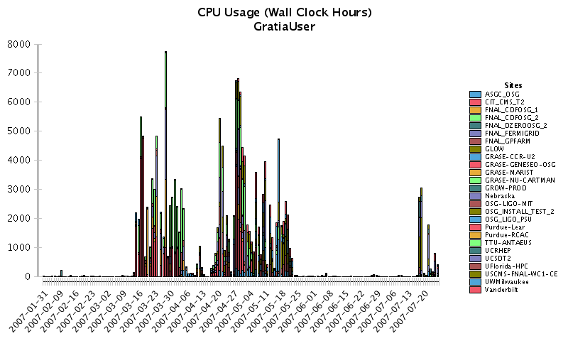
Figure 1.

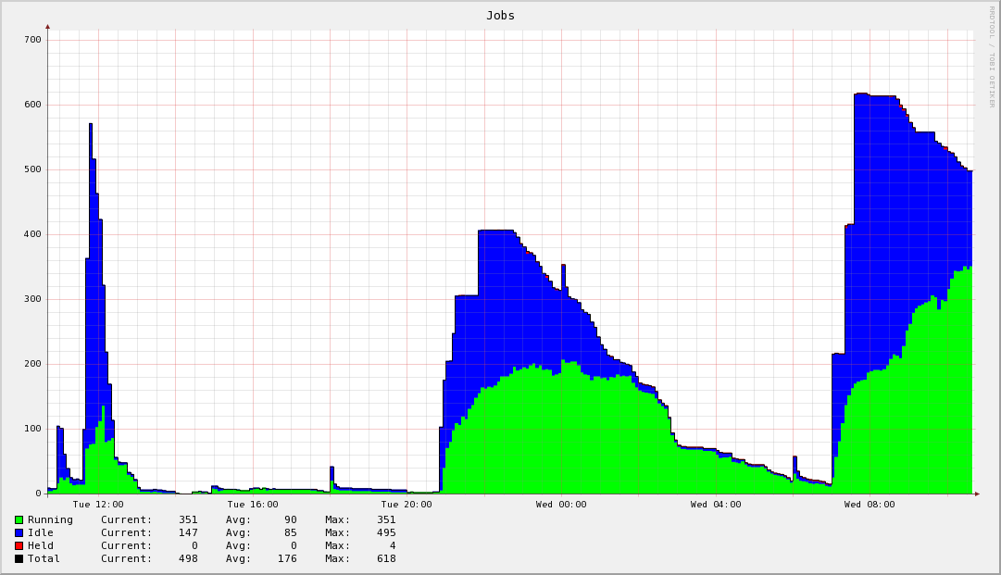
Figure 2.
