OSG VO Registration Workflow (Current)

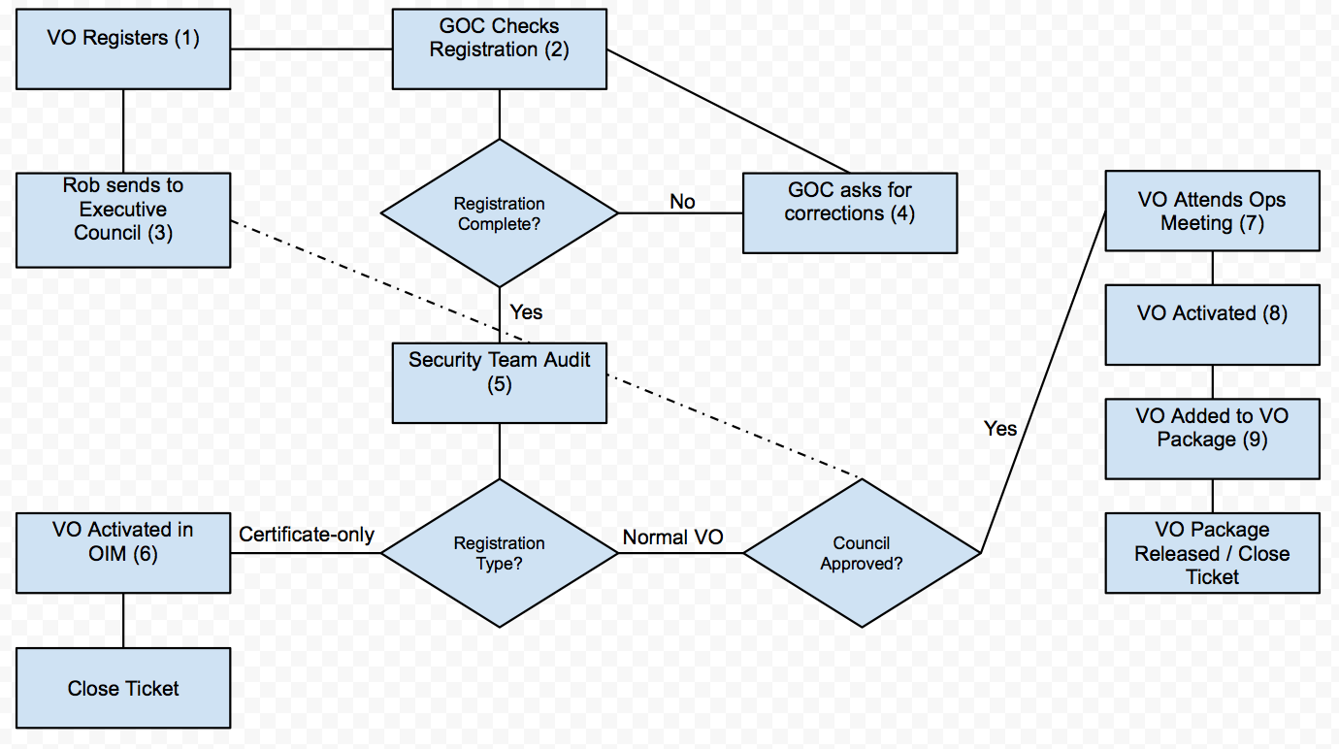

1. Registration begins by visiting <http://oim.opensciencegrid.org/oim/vo>. The registration instructions can be seen at <https://twiki.grid.iu.edu/bin/view/Operations/OIMRegistrationInstructions>.
2. Registration is checked for completeness and valid contact information.
3. This Email is composed manually and sent to [osg-council@opensciencegrid.org](mailto:osg-council@opensciencegrid.org). This step happens concurrently with steps 2, 4 and 5.
4. If registration is incomplete the registrant is contacted and asked to complete or update any information that is necessary to complete the registration.
5. The security team audits contact information and contacts the VO Security Contact and any Registered Authorities for an introduction and training session.
6. If a VO is only interested in certificate services it is activated and the registration is considered completed.
7. This is not mandatory, but recommended for all new VOs it is a chance to introduce their work and resources to the OSG Operations group.
8. This is done by OSG Operations staff upon confirmation the VO is accepted by the council and introduced to OSG Operations at the weekly operations meeting.
9. Done monthly and released to the ITB on the first Tuesday of each month and to Production on the second Tuesday of each month.

Proposed Additions and Changes

The proposal from the OSG Council chair is to gather more information during registration to help the OSG Council make a more informed recommendation about accepting or rejecting new VO registrations. This includes asking for detailed descriptions of what resources the new VO hopes to utilize (what they want from OSG membership) along with the resources they plan on offering to the OSG community (what they bring to the OSG that will make it better).

To meet these council needs the following additions will be added to the OSG VO Registration process:

“Please provide a detailed description on how you plan to utilize the Open Science Grid to further your research goals. This includes any resource utilization estimates, application requirements, or other useful details that might help OSG better serve your VO.“

“Please provide a detailed description of resources you will bring to the Open Science Grid. This should include, but not be limited to, hardware resources. Such as, any application or service development that may be of interest to OSG, any connections to other ongoing research projects or endeavors that may further the goals of OSG to provide a high throughput infrastructure to the national science community”

While the OSG Operations team will concentrate on the entire registration, the OSG Council will primarily evaluate these two responses to determine if the VO should be accepted.

Proposed Workflow

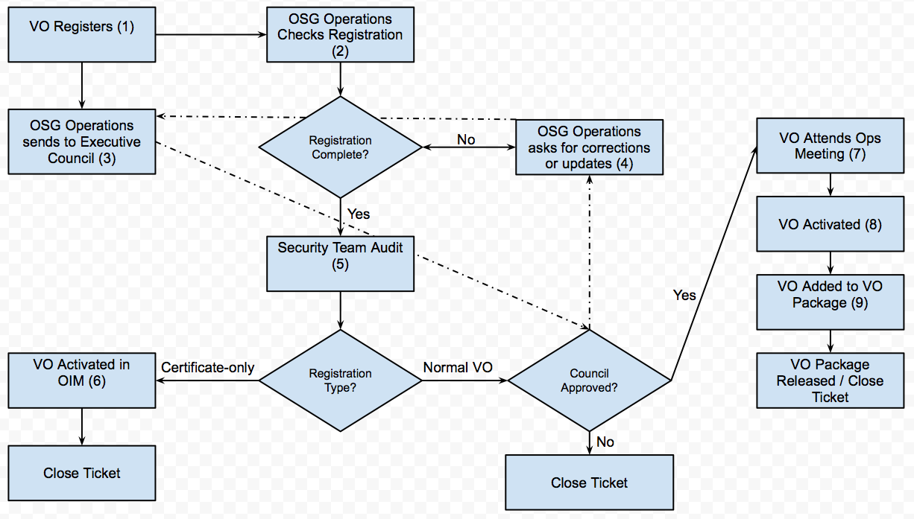

The primary difference captured in this new workflow is the OSG Council approval flow, which now loops and allows for additional information to be requested before approval is granted.