The following four are plots from the Gratia reporting that display the comparison of running jobs and idle glideins as reported by the Frontend service and the Glidein Factory Service

Reported Running Jobs

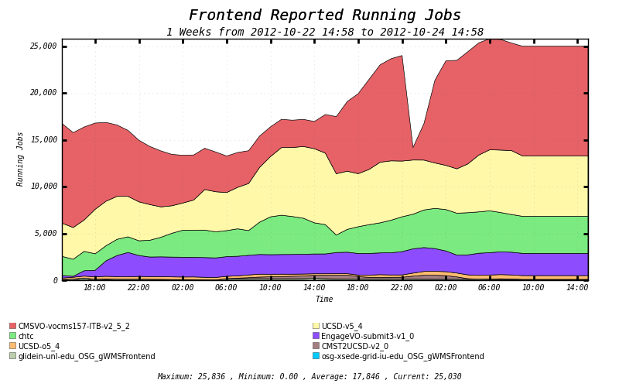

Ref: [http://t2.unl.edu:8100/gratia/xml/status_vo?excludefacility=None&span=3600&facility=FrontendReports&excludevo=NONE&vo=.*&host=.*&excludehost=NONE&title=Frontend%20Reported%20Running%20Jobs](http://t2.unl.edu:8100/gratia/xml/status_vo?excludefacility=None&span=3600&facility=FrontendReports&excludevo=NONE&vo=.*&host=.*&excludehost=NONE&title=Frontend%20Reported%20Running%20Jobs)

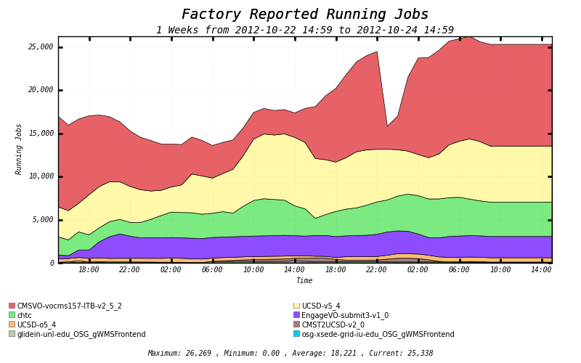

Ref: [http://t2.unl.edu:8100/gratia/xml/status_vo?excludefacility=None&span=3600&facility=FactoryReports&excludevo=NONE&vo=.*&host=.*&excludehost=NONE&title=Factory%20Reported%20Running%20Jobs](http://t2.unl.edu:8100/gratia/xml/status_vo?excludefacility=None&span=3600&facility=FactoryReports&excludevo=NONE&vo=.*&host=.*&excludehost=NONE&title=Factory%20Reported%20Running%20Jobs)

Reported Idle Glideins

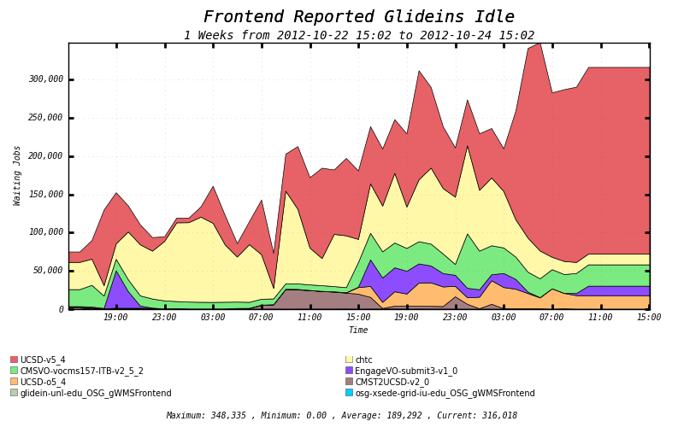

Ref:

[http://t2.unl.edu:8100/gratia/xml/status_vo_waiting?excludefacility=None&span=3600&facility=FrontendReports&excludevo=NONE&vo=.*&host=.*&excludehost=NONE&title=Frontend%20Reported%20Glideins%20Idle](http://t2.unl.edu:8100/gratia/xml/status_vo_waiting?excludefacility=None&span=3600&facility=FrontendReports&excludevo=NONE&vo=.*&host=.*&excludehost=NONE&title=Frontend%20Reported%20Glideins%20Idle)

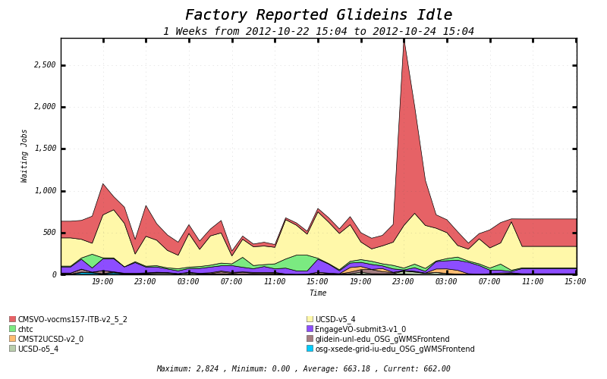

Ref:

[http://t2.unl.edu:8100/gratia/xml/status_vo_waiting?excludefacility=None&span=3600&facility=FactoryReports&excludevo=NONE&vo=.*&host=.*&excludehost=NONE&title=Factory%20Reported%20Glideins%20Idle](http://t2.unl.edu:8100/gratia/xml/status_vo_waiting?excludefacility=None&span=3600&facility=FactoryReports&excludevo=NONE&vo=.*&host=.*&excludehost=NONE&title=Factory%20Reported%20Glideins%20Idle)

List of Variables Used from both Factory and Frontend

* GlideinMonitorClientMonitorJobsRunHere
* GlideinMonitorClientMonitorJobsRunning
* GlideinMonitorClientMonitorGlideRunning
* GlideinMonitorStatusRunning
* GlideinMonitorStatusIdle
* GlideinMonitorRequestedIdle
* GlideinMonitorClientMonitorJobsIdle
* GlideinMonitorClientMonitorGlideIdle
* ReqClientName
* ReqFactoryName
* GlideinMonitorRequestedMaxRun
* GlideinMonitorClientMonitorJobsRunning
* GlideinMonitorClientMonitorGlideTotal