**Effective service delivery for all XSEDE Users of OSG (Rynge – Ongoing)**

* 1. OSG continues to provide stable/reliable DHTC compute resources to XSEDE users; but submit host is showing limits of performance (temporary solutions applied: added memory, bonding 3 NICs)
  2. Usage for the OSG-XSEDE system in last 30 days is approx. 100K hours per day

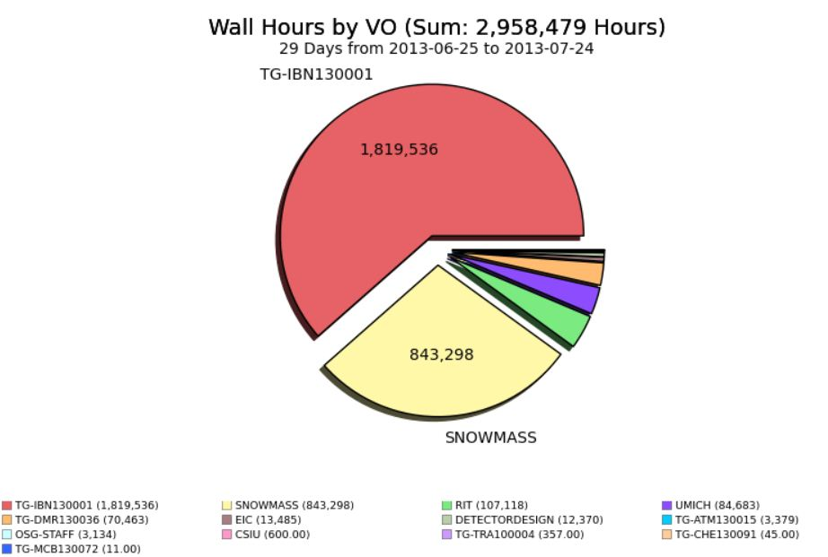

* 1. Number of active users is still modest but likely to grow with retirement of Purdue Condor pool

## OSG-XD Report for 2013-07-15 - 2013-07-22

|  |  |  |  |  |
| --- | --- | --- | --- | --- |
| Project Name | PI | University | Science Domain | Hours |
| TG-ATM130015 | Phillip Anderson | University of Texas at Dallas | Atmospheric Sciences | 837 |
| TG-DMR130036 | Emanuel Gull | University of Michigan | Materials Research | 7,740 |
| TG-IBN130001 | Donald Krieger | University of Pittsburgh | Integrative Biology and Neuroscience | 231,343 |
| TG-MCB130072 | Robert Quick | Indiana University | Molecular Biosciences | 11 |
| TG-CHE130091 | Paul Siders | University of Minnesota, Duluth | Chemistry | 39 |
| XD Total |  |  |  | 239,970 |

* 1. System continues to be used successfully by several non-XSEDE OSG users

## OSG-VO Report for 2013-07-15 - 2013-07-22

|  |  |  |  |  |
| --- | --- | --- | --- | --- |
| Project Name | PI | University | Science Domain | Hours |
| CSIU | Samy Meroueh | Indiana University School of Medicine | Chemical Genomics and Drug Discovery | 316 |
| RIT | Alexander Arlange | Rochester Institute of Technology | Ramsey Numbers R(C4,Km) | 18,089 |
| OSG-Staff | OSG Staff | Various | Testing & Integration | 2,821 |
| Snowmass | Meenakshi Narain | Brown University | LPC group | 262,976 |
| UMich | Paul Wolberg | University of Michigan | Microbiology | 20,374 |
| EIC | Thomas Ullrich | Brookhaven National Lab | Particle Physics | 3,085 |
| OSG-VO Total |  |  |  | 307,660 |

* *For more info contact Mats Rynge*

**Assist Gratia Project in Implementing better Science Type accounting**

1. Leverage “ProjectName” work done for OSG-XSEDE; design requirements and use scenarios being documented
2. Also attempting to clean-up gratia probe configurations at Campus submit nodes that send jobs to OSG production fabric. Completed: UCSD, BakerLab, UC3, RENCI, VT; Pending: GLOW (Where do we find the complete list?)
3. **WE NEED FEEDBACK** from area coordinators on draft plan at <https://twiki.grid.iu.edu/bin/view/Accounting/FOSAccounting>
   1. How to gain wide adoption of ProjectName use by multi-science VOs?
   2. What other reports may be useful from Gratia?
   3. Other??

**Community Support**

1. Belle/PNNL – CeMon publishing problem resolved (Marco Mambelli)
2. UMD-IGS - site strategy and goals being clarified (Marko Slyz)
3. Snowmass – wrap-up plan being discussed with project (Marko Slyz and Chander Sehgal)
4. NOvA – assisting project in running at sites outside Fermilab (Chander Sehgal & Marko Slyz)
5. FIFE – working with Fermilab Intensity frontier experiments to have them adopt OSG glide-in factories rather than build their own at Fermilab

**Planning upgrades of OSG-XSEDE and OSG-iRODS hardware platforms**

1. Mats will work with GOC staff on defining OSG-XSEDE upgrade
2. Tanya will work with GOC staff on defining iRODS public storage server

**Top Concerns**

1. Progress on Fermilab intensity frontier experiments (e.g. NOVA) is slow due to customer priorities
2. Need clarity on campus grids & BOSCO accounting principles and architecture; need to build in hooks for science type accounting
3. Must get new hardware upgrades installed before customers experience degraded service

**Recent Accomplishements**

1. Snowmass LPC project goals enabled; good positive feedback
2. Several new XSEDE users enabled on OSG; should see ramp-up of usage “soon”
3. Support Campus Grids team in defining OSG Connect service

**User Support Team**

|  |  |  |
| --- | --- | --- |
| Name | Institution | %FTE |
| Mats Rynge | ISI | 50% |
| Marko Slyz | FNAL | 50% |
| Tanya Levshina | FNAL | 25% |
| Alex Zaytsev | BNL | 10% |
| Chander Sehgal | FNAL | 30% |