# User Support

## Year1 Findings and Lessons

1. We delivered high quality production DHTC to XD via the OSG-XSEDE interface; built effective relationships and teamwork with XSEDE counterparts
2. Supported 15 researchers (communities) with 21M hours (10M to XD; 11M to vo=osg customers)
3. No observed shortage of opportunistic cycles (last quarter we averaged 1M per week); peak day was >380K hours (constrained by resource limits at OSG-XSEDE front-end)
4. We do a good job of assisting new communities in leveraging OSG DHTC computing (they recognize and appreciate us, with their sponsors, for enabling their science); but they mostly do not transform into vibrant new VOs who effectively contribute to and promote OSG
5. gWMS is great for accessing lots of cycles at many sites; but this layer makes it even harder to understand performance issues in a distributed fabric
6. Public storage using iRODS has been useful for research communities with large data (2-30GB) using vo=osg; but no general demand from other VOs. Thus we propose to continue this service for vo=osg opportunistic customers

# Year2 Proposed Work Plan

1. Effective service delivery for all XSEDE Users of OSG
2. Achieve production grade use of OSG by at least 2 additional communities
3. Improve current services
4. Grow OSG-XSEDE front-end hardware to avoid current resource exhausts
5. New iRODS server to be hosted by GOC; operated by OSG user support for benefit of vo=osg users
6. Design & Deploy “OSG Connect” services for Campus Researcher to send DHTC work to the production fabric
   1. In partnership with Campus Grids & Operations
   2. Enable “*bulk*” connections from Campus Grids (flocking, BOSCO, etc.)
   3. Hosted at GOC (similar to OSG-XSEDE host; run under vo=osg)
   4. Provide integration support for campus grids who wants to leverage the OSG Connect service
7. Provide tutorials and documentation for new capabilities; current candidates are
   1. How to structure jobs for use in OSG (2-4 sessions)
   2. How to use OSG Connect (2-4 sessions)
8. Partner with site support to provide technical guidance and support for communities who want to setup new sites
9. Provide technical support for Users in resolving obstacles to effective use of OSG
10. Arrange to provide newsletter articles about new communities and sites; at least 1 per quarter
11. Provide OSG overview presentations and integration guidance to new communities interested in joining OSG

**Metrics**

1. Number of new community outreach presentations
2. Number of technology tutorials delivered
3. Number of new researchers/communities enabled to use DHTC
4. Number of hours served to XD customers
5. Number of hours served to vo=osg customers

## The User Support Team in Year1

*Gabriele Garzoglio – 20%*

*Tanya Levshina – 25%*

*Mats Rynge – 50%*

*Marko Slyz – 35%*

*Alex Zaytsev- 10%*

*Chander Sehgal- 30%*

*Total = 1.7 FTE*

OSG XSEDE Usage

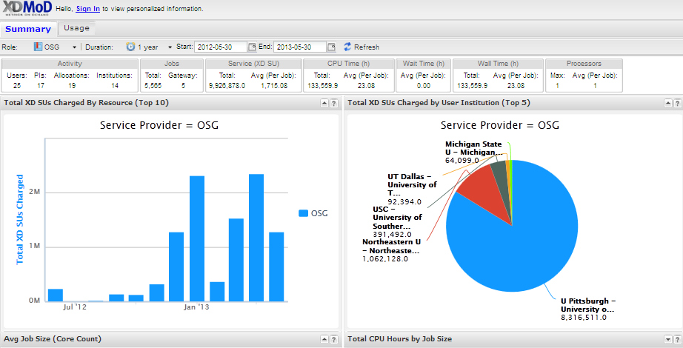

~9.9M hours delivered

~5 active users

## Opportunistic Availability for vo=osg

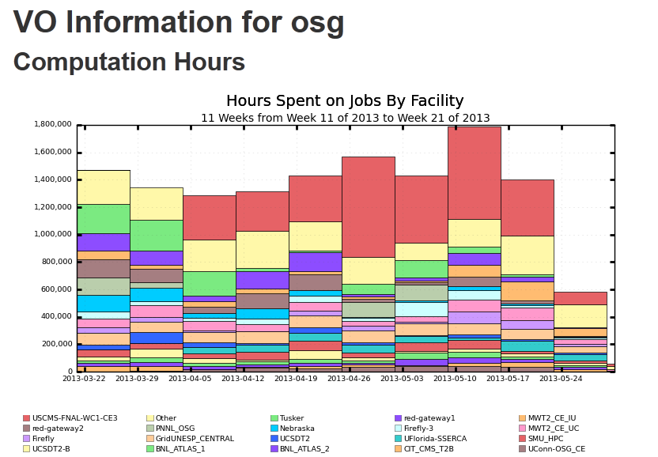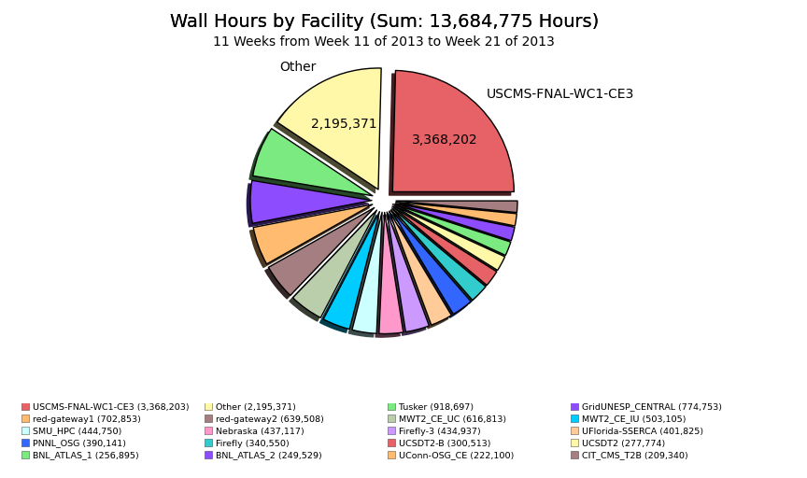

## >200K hours per day of opportunistic cycles is accessible by a single VO

## Public Storage using iRODS – Year1 Experience

1. EIC / test run:

1. prestaged data using iRODS from osg-xsede node to various Classic_SEs (OSG_DATA)
2. ran jobs and accessed this data directly

2. SAGA / test run:

1. prestaged data using iRODS from osg-xsede node to various Classic_SEs (OSG_DATA)
2. ran jobs and accessed this data directly
3. used iRODS meta data catalog, registered files

3. Snowmass / limited production run:

1. prestaged big files (20 - 40 GB) from osg-xsede to SEs
2. from a worker node access file directly if exists or query irods for file location and copy it from local storage to a worker node.

4. Pheno / test run:

1. queries iRODS from  a worker node to find a SE, upload files to a SE , register a file with iRODS
2. download files from the SEs to a user's laptop using iRODS

5. DetectorDesign / limited production run:

1. queries iRODS from  a worker node to find a SE, upload files to a SE , register a file with iRODS
2. download files from the SEs to a user's laptop using iRODS

## 15 Researchers Enabled via User Support in year1

|  |  |  |  |  |  |  |  |
| --- | --- | --- | --- | --- | --- | --- | --- |
| Science | Sub-Category | Researcher | Affiliation | Project Title (and URL, if available) | Usage (Hours) | Team | OSG Contact |
| Physics | Accelerator Modeling | Armando Fella | SuperB experiment; CNRS–Orsay | Test jobs in preparation for designing SuperB accelerator, http://superb.infn.it/home | 23,239 | User-Support | Marko Slyz |
| Physics | Accelerator Modeling | Tobias Toll | Brookhaven National Lab | Electron Ion Collider (EIC) at BNL, https://wiki.bnl.gov/eic/index.php/Main_Page | 612,896 | User-Support | Alexandr Zaytsev |
| Physics | Astronomy | Don Petravick, Brian Yanny | NCSA & FNAL | [Basic processing of DES exposures, https://cosmology.illinois.edu](https://cosmology.illinois.edu/) | 129,308 | User-Support | Gabriele Garzoglio |
| Physics | Astronomy | John Peterson | Purdue | [Software development for LSST telescope, http://www.lsst.org/lsst/](http://www.lsst.org/lsst/) | 393,597 | User-Support | Gabriele Garzoglio |
| Medicine | Biomedical Imaging | Martin Purschke | Brookhaven National Lab | Positron Emission Tomography (PET) at BNL, http://www.bnl.gov/pet/ | 1,628 | User-Support | Alexandr Zaytsev |
| Physics | HEP | Meenakshi Narain for Snowmass LPC Group | Brown University | LHC Modeling | 6,144,337 | User-Support | Marko Slyz |
| Biology | Cell Biology | Paul Wolberg | University of Michigan | Multi-scale Computational Models to study the Human Immune Response to infection with M. tuberculosis | 116,346 | User-Support | Mats Rynge |
| Mathematics | Combinatorics | Alexander Arlange | Rochester Institute of Technology | Ramsey Numbers R(C4,Km) | 655,314 | User-Support | Mats Rynge |
| Civil Engineering | Earthquake Engineering | Andre Barbosa, Patricia Clayton | Oregon State University, University of Washington | [Simulation of structures' responses to earthquakes, http://nees.org/](http://nees.org/) | 3,410 | User-Support | Marko Slyz |
| Physics | Phenomenology | Stefan Hoeche | SLAC | Validation and use of software for particle physics phenomenology, http://www.freacafe.de/physics/index.php | 199,536 | User-Support | Marko Slyz |
| Astronomy | Extrasolar planet astronomy | Ewa Deelman, Bruce Berriman | USC ISI / NASA IPAC | Atlas of Periodicities present in the time-series data sets released by the Kepler satellite | 391,492 | OSG-XSEDE | Mats Rynge |
| Biology | Integrative Biology and Neuroscience | Don Krieger | University of Pittsburgh | Very high resolution functional brain mapping | 8,316,511 | OSG-XSEDE | Mats Rynge |
| Physics | Magnetospheric Physics | Robert McIntosh | University of Texas at Dallas | Global Distribution of Characteristics of Auroral Particles | 92,394 | OSG-XSEDE | Mats Rynge |
| Physics | Theoretical Physics | Pran Nath | Northeastern University | Search for Beyond the Standard Model Physics at the LHC | 1,062,158 | OSG-XSEDE | Mats Rynge |
| Medicine | Chemical Genomics and Drug Discovery | Samy Meroueh | Indiana University School of Medicine | [Structural Protein-Ligand Interactome (SPLINTER) - http://www.biodrugscreen.org/](http://www.biodrugscreen.org/) | 3,160,813 | CSIU | Rob Quick |
|  |  |  |  |  |  |  |  |
|  |  |  |  | Total = | 21,302,979 |  |  |