**OSG Year6 Operations Work Plan**

# Strategy

“Operations transforms resource or data inputs into desired goods, services, or results, and create and deliver value to the customers.” –Business Dictionary

Operations will continue to provide the core OSG infrastructure and service desk services to the OSG Collaboration. These services will retain their mature service expectation while adapting to changing user needs. OSG Operations will continue to take stakeholder driven requirements and produce a valuable set of operational tools focusing on ease of use, accuracy and freshness of data, and proactive problem solving. Distributed (IU, Fermilab, UCSD, etc.) operational staff and resources will continue to provide the highest level of service and maintain strict accountability via Service Level Agreements for delivering these services. A Continual Service Improvement (CSI) model will be used to keep services consistent with evolving needs of the OSG Users. OSG Service Desk Operators will continue to work directly with customers to efficiently resolve issues via the trouble ticketing mechanisms. Overall OSG Operations will strive for transparency, reliability, and accountability in all aspects of working with OSG Stakeholders.

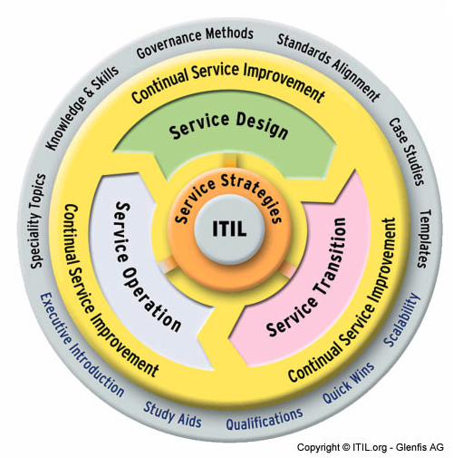

# Requirements

This functional area gets it requirements from OSG Stakeholders VOs, OSG management, and OSG staff.

# Tactics and Changes in our Methods

There are no major changes to our Methods in Year 6. We will revisit lessons learned to harden our policy and procedures for services. We will also work to have a better-trained staff for Operational triage of issues reported by OSG Users. We will continue to adhere to well defined Change Management policies and evolve our HA capabilities to use the latest advances in virtualization and load-balancing technologies. Along with hosting several mature services, newly defined services will be smoothly transitioned from development to testbed to production.

# High-level Goals

## Projects (with Date targets)

1. Upgrade BDII v4 to v5 – Oct 2011
2. Deploy WLCG Top-Level BDII - Dec 2011
3. Deploy Glide-In Factories at IU and CERN - Aug 2011 and Feb 2012 respectively
4. Evolve HA Technologies - Apr 2012
5. Consolidate Public Documentation (WebPages, Wiki, Documentation DataBase) – Aug 2012

## Ongoing Tasks

1. Support LCH
2. Routine Process Execution
3. Improving Operational Processes
4. Help Regional Grids with Operational Infrastructure
5. Interaction with External Projects
6. VDT/GOC Infoshare/Training

# Staffing Plan

* Rob Quick (50% Operations, 40% Production, 10% IU)
* Scott Teige (100% Operations Engineering Lead)
* Kyle Gross (100% Operational Service Lead)
* Soichi Hayashi (80% Service Maintenance)
* Tom Lee (100% System Adminsitrator)
* Elizabeth Chism (100% Operations Support)
* Alain Deximo (100% Service Desk, CA, Operations Support)
* Chirs Pipes (100% Operations Support)
* Igor Sfiligoi (10% Glide-In Factory)
* Jeff Dost (60% Glide-In Factory)
* Terrence Martin (5% Glide-In Factory)
* Keith Chadwick (25% Fermigrid Operations)

# Risks and Concerns

1. New services are coming quickly. Glide-In Factory, Top Level BDII, JIRA, Planet Blog, CMS, Pakiti, mirrored VDT Cache, to name a few. No additional effort or deprecation of services offset this load. This will eventually lead to service problems.
2. Staff used for ticketing is mostly untrained in the OSG software realm. This leads to smart people not being able to contribute to their utmost to the project.
3. We are using dated pseudo-HA methods, these have worked, but with Virtualization and HA, we can use our experience and extent it to provide a more robust service.