NEXHRIS: A SMART AND NEXT-GENERATION HUMAN RESOURCE
INFORMATION SYSTEM FOR ILOCOS SUR POLYTECHNIC
STATE COLLEGE
A Capstone Project
Presented to the Faculty of the College of Arts and Sciences
Ilocos Sur Polytechnic State College
Tagudin Campus, Tagudin, Ilocos Sur
In Partial Fulfillment
of the Requirements for the Degree
Bachelor of Science in Information Technology
by
EIDREF JAKE S. MANALANSAN
DIANA SOFIA L. STA. ANA
SHERAN S. LEAL
YURI BIB P. SOMERA
ARVIE KEITH M. MANZANO

Month 2026

APPROVAL SHEET
This capstone project entitled “NexHRIS: A Smart and Next-Generation Human Resource Information System for Ilocos Sur Polytechnic State College,” prepared and submitted by Eidref Jake S. Manalansan, Diana Sofia L. Sta. Ana, Sheran S. Leal, Yuri Bib P. Somera, and Arvie Keith M. Manzano, in partial fulfillment of the requirements for the degree Bachelor of Science in Information Technology, has been examined and is hereby recommended for acceptance and approval for oral examination.

NAME OF ADVISER
Adviser
PANEL OF EXAMINERS
Approved by the Panel of Examiners on Oral Examination with a grade of ____.

NAME OF CHAIRPERSON
Chairperson
NAME OF MEMBER | NAME OF MEMBER
Member | Member

Accepted and approved in partial fulfillment of the requirements for the degree Bachelor of Science in Information Technology.

NAME OF DEAN | NAME OF CAMPUS DIRECTOR
Dean, College of Arts and Sciences | Campus Director

Date: ________

ACKNOWLEDGMENT
Write the acknowledgment of the researchers here: the adviser, the panel, the HR Office of ISPSC Tagudin Campus, the respondents, families, and others who supported the study.

ABSTRACT
The Human Resource (HR) Office of Ilocos Sur Polytechnic State College (ISPSC) Tagudin Campus maintained its employee records on paper and in Excel workbooks, keeping a Personal Data Sheet (PDS) for every employee, a separate form for every leave application, and two handwritten ledger cards per person, while leave approval required a printed form to be carried between three offices for signature. This study developed NexHRIS: A Smart and Next-Generation Human Resource Information System for Ilocos Sur Polytechnic State College, a web-based system that moves these transactions online while preserving the Civil Service forms exactly as the campus uses them. The study employed a descriptive developmental research design and followed the Rapid Application Development (RAD) model. The system was built with the Laravel 12 framework, a MariaDB relational database, and Blade templates with Tailwind CSS and Alpine.js, and was deployed on a virtual private server running Nginx and LibreOffice. NexHRIS provides the management of employee accounts, colleges, and departments; versioned publication of the official blank forms; Personal Data Sheet submission with a review-and-return cycle; leave applications routed through an approval chain derived from the rank of the applicant; leave and service credit ledger cards with running balances; HR policies with acknowledgment tracking; announcements and notifications; a digital identification card with QR code verification; role-based dashboards; printable management reports; and an audit trail. Official documents are produced by converting the workbook that the employee actually uploaded rather than by rebuilding the form from stored values, so that the printed output retains the exact format of the campus's Civil Service forms. Access is governed by four roles—HR Administrator, Campus Director, Dean, and Employee—whose data boundaries are enforced at the query level, and the accounts that carry approval authority are further protected by a one-time verification code sent by email. The acceptability of the system was evaluated using the Technology Acceptance Model (TAM) in terms of Perceived Usefulness and Perceived Ease of Use, and the Wilcoxon Signed-Rank Test was used to determine whether a significant difference existed between the manual process and the developed system. State the overall mean and interpretation for each TAM construct and the result of the Wilcoxon Signed-Rank Test here once the data have been analyzed.

Keywords: Human Resource Information System, Personal Data Sheet, Leave Management, Role-Based Access Control, Technology Acceptance Model, ISPSC

TABLE OF CONTENTS

APPROVAL SHEET ii
ACKNOWLEDGMENT iii
ABSTRACT iv
LIST OF TABLES viii
LIST OF FIGURES ix
LIST OF PLATES x
INTRODUCTION 1
Background of the Study 1
Conceptual Framework of the Study 6
Objectives of the Study 8
Hypothesis 8
Scope and Limitation of the Study 8
Importance of the Study 11
Definition of Terms 12
METHODOLOGY 15
Research Design 15
Software Model 16
Project Plan 18
Project Assignment 19
Population and Locale of the Study 20
Research Instruments 21
Data Analysis 22
RESULTS AND DISCUSSION 25
Current Process of Employee Records and HR Data Handling 25
System Requirements of NexHRIS 26
Functional Requirements 26
Non-Functional Requirements 27
Hardware and Software Requirements 28
System Design 28
Features of the Developed System 29
Authentication and Role-Based Access 29
Dashboards 32
Employee Accounts, Colleges, and Departments 34
Publication of the Official Forms 36
Personal Data Sheet 37
Leave Application and Approval Chain 39
Leave Calendar 42
Leave and Service Credit Ledger Cards 43
Management Reports 46
HR Policies 47
Announcements and Notifications 48
Digital Identification Card 50
Activity Log 51
Data Security 51
Acceptability of the Developed System 52
Comparison Between the Manual Process and NexHRIS 53
REFERENCES 54
APPENDICES 55
Appendix A. Letter of Permission to Conduct the Study 56
Appendix B. Technology Acceptance Model Questionnaire 57
Appendix C. Flow Chart of the Manual Process 59
Appendix D. Use Case Diagram 60
Appendix E. Context Diagram (Level 0) 61
Appendix F. Data Flow Diagram (Level 1) 62
Appendix G. Entity Relationship Diagram 63
Appendix H. Flow Chart of the Developed System 64
Appendix I. Input-Process-Output Chart 65
CURRICULUM VITAE 66

LIST OF TABLES

Table 1. Project Assignment 19
Table 2. Distribution of Respondents 21
Table 3. Likert Scale for the TAM Evaluation of NexHRIS 23
Table 4. Mean Range Interpretation for the TAM Evaluation of NexHRIS 24
Table 5. Functional Requirements of NexHRIS 26
Table 6. Non-Functional Requirements of NexHRIS 27
Table 7. Hardware and Software Requirements of NexHRIS 28
Table 8. Perceived Usefulness of NexHRIS 52
Table 9. Perceived Ease of Use of NexHRIS 52
Table 10. Wilcoxon Signed-Rank Test Results 53

LIST OF FIGURES

Figure 1. Research Paradigm 7
Figure 2. Rapid Application Development 16
Figure 3. Project Schedule 19

LIST OF PLATES

Chapter 1

INTRODUCTION

Background of the Study
The rapid advancement of technology has fundamentally transformed the way organizations manage their human resources. Across the globe, institutions are shifting away from manual, paper-based administrative processes toward integrated digital platforms that offer efficiency, accuracy, and accessibility. In government higher education institutions, Human Resource (HR) offices are primarily responsible for maintaining, organizing, and safeguarding the employment records of all personnel. These records, collectively known as the 201 files, contain the complete employment history of an employee, including personal information, appointment papers, service records, certificates of eligibility, and other official employment documents. The proper management and accessibility of these records are critical to the effective administration of human resources within any institution.
Internationally, several studies confirm the urgent need for digital employee document management systems in organizations. Wahdaniah et al. (2023) demonstrated that human resource management transformation in the digital age results in more organized recordkeeping, reduced document retrieval time, and improved overall HR operational efficiency across diverse institutional settings. Similarly, Abaci and Medeni (2022) conducted a case study on the efficiency of electronic document management systems and established that digitizing employee records reduces retrieval time, minimizes physical storage requirements, and enhances organizational transparency. Orioque et al. (2024) further affirmed that an online contextualized document management system aligned with the operational environment of an organization significantly enhances information access and reduces misplaced documentation. Dres and Rabut (2025) developed eDOCS, a web-based file management system, and found it to be highly effective in improving document organization, accessibility, and retrieval speed compared with traditional manual filing methods. Furthermore, Panfilova et al. (2024) noted that the integration of automated document management systems into institutional workflows facilitates diagnostic monitoring, reduces human error, and improves documentation lifecycle management, all of which are directly relevant to the employee file management needs of human resource offices in academic institutions.
In the Philippines, the digitalization of employee and institutional records has similarly gained traction among higher education institutions. Purcia and Velarde (2022) conducted a study on student registration and records management in private universities and found that the majority of institutions still rely on paper-based processes, highlighting a persistent gap in digital adoption and the urgent need for electronic records systems. Pagayonan (2022) developed an Electronic Document Management System (eDMS) for a higher education institution and found that the system improved the organization, storage, and retrieval of institutional records while reducing dependency on physical filing systems. Encarnacion et al. (2024) developed a web-based document management system for an educational office in Pagadian City that streamlined the dissemination, submission, and collection of pertinent documents, addressing challenges typically experienced by office employees in managing paper-based records. More recently, Rabulan and Glina (2025) developed a web-based file management system for the Office of the National Service Training Program at Sorsogon State University, which effectively centralized student information and office records, resulting in a more secure, accurate, and faster file management process that directly reduced the burden on office personnel.
At the regional and provincial level, the need for digital records management has been consistently identified, particularly at ISPSC Tagudin Campus itself. Angala et al. (2023) developed and implemented a web-based Document Management System (DMS) at ISPSC Tagudin Campus and found that respondents were generally very satisfied with how the system was used to arrange, store, track, and manage documents within the campus, affirming that digital document systems are well received at the institution. Bulong et al. (2025) similarly focused on ISPSC Tagudin Campus and developed DocuTrack, a web-based document management system featuring role-based access control, cloud storage integration, and an activity log, confirming that paper-based document management remains a critical challenge for the institution as it continues to grow in terms of personnel, programs, and administrative responsibilities. Beyond ISPSC, Sebucao-Orias (2023) examined the records management practices of a state university in the Philippines and identified significant deficiencies in documentation processes, while Taguiam (2024) established that non-compliance with proper records management protocols in state universities leads to operational inefficiencies, both underscoring the need for structured digital records management systems in similar institutions. The Ilocos Regional Development Plan 2023–2028 further identifies the enhancement of institutional efficiency and the adoption of digital governance tools as priority directions for all government agencies and institutions in the region (Regional Development Council, 2023). The Data Privacy Act of 2012 (Republic Act No. 10173) likewise mandates that all government institutions, including state colleges in Ilocos Sur, ensure the confidentiality, integrity, and availability of the personal data in their custody, which directly necessitates the adoption of secure digital systems for managing sensitive employee records. Furthermore, the national directive on digital transformation articulated in the Philippine Development Plan 2023–2028 reinforces the importance of transitioning from paper-based to digital HR records management in institutions such as ISPSC (Department of Information and Communications Technology, 2023).
The implementation of NexHRIS at Ilocos Sur Polytechnic State College, Tagudin Campus is particularly justified by the current state of HR document management in the institution. The ISPSC HR Office maintains all employee 201 files on paper and in Excel workbooks, keeping a Personal Data Sheet per employee, a separate form per leave application, and two handwritten ledger cards per person. Leave approval requires a printed form to be physically routed between three offices for signature. These manual systems are prone to document loss, physical deterioration, unauthorized access, and delays in document retrieval. As the institution continues to grow in terms of personnel and administrative responsibilities, the volume of employee records that must be managed likewise increases, making traditional paper-based processes increasingly inefficient and difficult to sustain. The absence of a centralized digital repository for employee files requires HR personnel to spend considerable time locating, reproducing, and verifying documents that could otherwise be accessed instantly through a secure electronic system. Employees, on their part, must still visit the HR Office to update their Personal Data Sheet, to check their leave credits, and to file a leave application, adding to the workload of HR personnel who have to retrieve records and compute balances manually for every request.
A review of the systems cited above reveals a consistent limitation: all of them are document management systems, not human resource systems. The eDMS of Pagayonan (2022), eDOCS of Dres and Rabut (2025), the contextualized system of Orioque et al. (2024), the web-based system of Encarnacion et al. (2024), and the file management system of Rabulan and Glina (2025) are each designed to store, categorize, track, and retrieve files. The same is true of the two systems developed for ISPSC Tagudin Campus itself: the DMS of Angala et al. (2023) and DocuTrack by Bulong et al. (2025) both centralize institutional documents, and DocuTrack adds role-based access and activity logging, but both stop at document handling. In every one of these systems, a document is treated as a file to be uploaded and retrieved, and none of them processes the transaction that the document represents.
NexHRIS differs from all of them in four specific ways. First, none of the reviewed systems handles the Personal Data Sheet as a governed submission with a review-and-return cycle and retained versions; each would treat a PDS as one more uploaded file. Second, none of them routes a document through a multi-level approval chain in which the route is determined by the rank of the applicant, nor records which approvals were skipped and why. Third, none of them maintains a running-balance record such as the leave and service credit ledger cards of the campus, where correcting one entry must recompute every balance below it. Fourth, none of them is concerned with preserving the exact printed format of an official government form, because a document management system stores the file that the user uploaded and never has to regenerate it. These are precisely the day-to-day HR transactions that ISPSC employees still complete manually, even though the campus already has a working document management system. The gap, therefore, is not the digitization of storage, which the literature has addressed thoroughly, but the digitization of the HR transactions themselves, which NexHRIS is designed to fill.
Recognizing this gap, NexHRIS: A Smart and Next-Generation Human Resource Information System for Ilocos Sur Polytechnic State College was conceptualized to go beyond the storage-and-retrieval model demonstrated by existing systems. Rather than covering the entire employee 201 file, the study focuses specifically on the components with which employees interact most directly and repeatedly—the Personal Data Sheet, leave records, personal information, and HR policies and guidelines—allowing employees to take part in managing their own HR transactions and to stay informed of institutional policies, instead of relying solely on manual, HR-mediated processes. Through the development of NexHRIS, the study seeks to address the limitations of existing manual practices, strengthen records security and accessibility, improve operational efficiency, and support compliance with government policies on digital transformation and data privacy. Ultimately, the study aims to contribute to the modernization of human resource management practices in ISPSC and to provide a model for the implementation of HR-focused information systems in higher education institutions.

Conceptual Framework of the Study
The conceptual framework of this study is anchored on the Input–Process–Output (IPO) model, which provides a systematic representation of how data are transformed into meaningful outputs through the developed system.
The Input consists of the employee 201 files, specifically the Personal Data Sheet (CS Form No. 212) and leave records, together with the personal information of employees, the HR policies and guidelines maintained by the HR Office, and the official blank Civil Service forms that the HR Office issues. These constitute the primary data required for managing employee records and facilitating HR-related transactions within the system.
The Process involves the design, development, and implementation of NexHRIS following the Rapid Application Development model. During this stage, the system validates and updates employee information, routes leave applications through a role-derived approval chain, records approved leave on the appropriate ledger card, organizes employee data, and manages HR policies and guidelines through a centralized digital platform. These processes transform the input data into accurate, organized, and readily accessible information.
The Output consists of a centralized digital employee records repository, online Personal Data Sheet management, digital leave application and leave records management, maintained leave and service credit ledger cards, a digital employee identification card, and accessible HR policies and guidelines. Collectively, these outputs enhance the security, accessibility, and efficiency of employee records management while improving the delivery of HR services.
Overall, the IPO model illustrates how NexHRIS transforms manually managed employee records and HR information into an integrated digital system that supports efficient records management, facilitates HR transactions, and promotes effective human resource administration at Ilocos Sur Polytechnic State College.
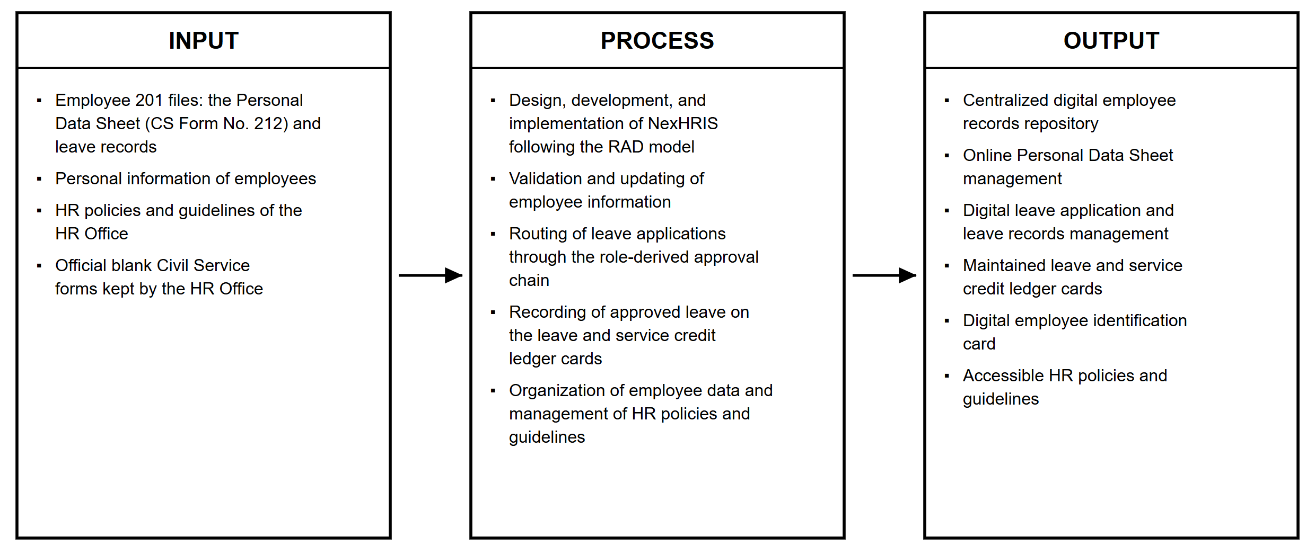
Figure 1. Research Paradigm

Objectives of the Study
The main objective of this study is to develop NexHRIS: A Smart and Next-Generation Human Resource Information System for Ilocos Sur Polytechnic State College to support the secure and efficient digital management of employee Personal Data Sheets (PDS) and leave records at ISPSC Tagudin Campus. Specifically, this study aims:
1. to analyze the current employee file management processes of the ISPSC HR Office to serve as the basis for system design and development;
2. to determine the system requirements for the development of NexHRIS, a web-based Human Resource Information System for the secure management of employee Personal Data Sheets, leave records, and personal information at ISPSC Tagudin Campus;
3. to evaluate the level of acceptability of NexHRIS using the Technology Acceptance Model (TAM); and
4. to determine whether there is a significant difference between the existing manual employee file management process and the developed NexHRIS system in terms of perceived usefulness and perceived ease of use.

Hypothesis
H₀: There is no significant difference between the existing manual employee file management process and the developed NexHRIS system in terms of perceived usefulness and perceived ease of use.

Scope and Limitation of the Study
This study covers the design, development, and implementation of NexHRIS for ISPSC Tagudin Campus, focusing on four components of the employee 201 file: the Personal Data Sheet, leave records, personal information, and HR policies. The HR Administrator publishes the official blank forms—the Personal Data Sheet (CS Form No. 212), the Application for Leave (CS Form No. 6), and the leave ledger card—as numbered versions. Employees download these forms, fill them in, and upload the completed files. The HR Administrator reviews each Personal Data Sheet submission and either approves it or returns it with remarks, and every submitted version is retained.
Leave applications are routed through an approval chain determined by the rank of the applicant, since no user signs his or her own leave: the application of an employee passes from the Dean of the employee's college, to the HR Administrator, to the Campus Director; the application of a Dean skips the Dean stage; and the application of the Campus Director is decided by the HR Administrator alone, as no role outranks the Campus Director. Skipped stages still appear on the printed approval sheet, marked not applicable. Once an application is fully approved, the HR Administrator records the days on either the leave ledger card or the service credit ledger card.
The system serves four roles—HR Administrator, Campus Director, Dean, and Employee—whose data boundaries are enforced at the query level rather than only in the interface, so that a user cannot reach records outside his or her authority by modifying a web address. It also provides each employee with a digital identification card bearing a QR code that resolves to a public verification page; published HR policies with acknowledgment tracking; announcements with email and in-system notifications; role-based dashboards; a leave calendar; printable management reports; and an audit trail. Signing in requires acceptance of the Terms and Conditions of the system, and the accounts of the HR Administrator, the Deans, and the Campus Director are further protected by a six-digit verification code sent to the registered email address. NexHRIS is web-based and is accessible through a web browser on any internet-connected device.
The study is limited in the following respects. It does not digitize the rest of the 201 file; appointment papers, service records, performance ratings, and similar documents remain in the manual custody of the HR Office. The system does not perform optical character recognition, does not extract data from the uploaded forms, and does not verify the accuracy or authenticity of what an employee encodes, which remains the responsibility of the HR Administrator upon review. Leave applications filed through the system are limited to vacation leave and sick leave; other types of leave continue to be processed manually. Leave credits and ledger balances are encoded and maintained by the HR Administrator; the system neither computes credits from attendance or biometric data nor decides on which of the two ledger cards an approved leave is recorded, although it allows the monthly leave credits of all personnel to be posted in a single action. The HR Administrator account serves as the administrator of the system and does not file its own leave or Personal Data Sheet through the system.
The official forms must be completed in a desktop spreadsheet application, namely Microsoft Excel or LibreOffice Calc, because web-based and mobile spreadsheet applications remove the check boxes of the form when saving it. Official documents are converted to PDF on the server by LibreOffice; should the converter be unavailable, the system uses a built-in renderer, and where a form cannot be reproduced completely, it issues the original workbook instead of an incomplete PDF. The policies module supports reading and acknowledgment only, without a facility for employees to comment on or request revisions to a policy. The digital identification card is viewable and printable within the system and carries no RFID functionality. NexHRIS does not integrate with external government systems such as those of the Civil Service Commission, the Government Service Insurance System, or the Department of Budget and Management; is intended for ISPSC Tagudin Campus alone and does not support multi-campus deployment; has no dedicated mobile application, although its interface adapts to the screens of mobile browsers; and requires an internet connection, with no offline operation.

Importance of the Study
The development of NexHRIS is expected to provide significant benefits to various stakeholders by improving the management, accessibility, and security of employee records. The beneficiaries of this study are discussed as follows:
To the HR Office of ISPSC Tagudin Campus. NexHRIS provides a centralized and secure platform for managing employee 201 files and personnel records. It reduces the time and effort required to store, retrieve, and verify employee documents, and it automates the routing of leave applications and the maintenance of ledger cards, thereby improving operational efficiency and supporting more effective human resource management.
To the Employees of ISPSC Tagudin Campus. The system provides employees with a transparent and accessible platform where they can submit and print their own Personal Data Sheet, file and monitor their leave applications, view their own ledger cards, and view their own personal information, reducing the need for repeated visits to the HR Office for these routine transactions.
To the Deans and the Campus Director. The system presents the leave applications awaiting their decision in one place, with the form readable in the browser, and gives them a view of leave within their scope of authority, so that approvals no longer depend on a printed form reaching their offices.
To Ilocos Sur Polytechnic State College (ISPSC). The institution benefits from improved records security, reduced risk of document loss or damage, and a more organized employee records management process. The system also supports compliance with the Data Privacy Act of 2012 and the digital transformation initiatives of the institution.
To the Researchers. The study provides practical experience in designing, developing, and implementing a web-based information system that addresses an actual institutional need, and it enhances the knowledge and skills of the researchers in system development, document processing, and system evaluation.
To Future Researchers. This study may serve as a reference for future researchers who intend to develop similar human resource information systems or employee records management solutions. The findings and methodologies presented may contribute to further research and innovation in the field of HR technology.

Definition of Terms
The following terms are defined operationally as they are used in this study:
201 File – the personnel file of an employee kept by the HR Office, containing records such as the Personal Data Sheet, leave records, and appointment papers.
Approval Chain – the sequence of reviewers—the Dean, the HR Administrator, and the Campus Director—through which a leave application passes, derived from the role of the applicant.
Audit Trail – the activity log of NexHRIS, which records sign-ins, decisions, and changes to records together with the account, date, time, and IP address behind each action.
Campus Director – the role that gives the final approval of leave applications and oversees leave across the whole campus.
CS Form No. 6 – the Application for Leave prescribed by the Civil Service Commission and used by the campus.
CS Form No. 212 – the Personal Data Sheet prescribed by the Civil Service Commission.
Dean – the role that gives the first approval of the leave applications of employees in his or her college.
Digital Identification Card – the printable identification card issued by NexHRIS to each employee, bearing a QR code that resolves to a public verification page.
Employee – the role of a teaching or non-teaching personnel member who submits a Personal Data Sheet, files leave applications, and views his or her own records.
HR Administrator – the role of the HR Office personnel who administers the system, maintains employee records and ledger cards, reviews Personal Data Sheets, and approves leave applications at the HR stage.
Leave Ledger Card – the official card on which the vacation and sick leave credits earned, used, and remaining of an employee are recorded.
NexHRIS – the developed system, NexHRIS: A Smart and Next-Generation Human Resource Information System for Ilocos Sur Polytechnic State College.
Role-Based Access Control – the restriction of what each user may see and do according to his or her role, enforced by NexHRIS at the query level.
Service Credit Ledger Card – the official card on which credits earned outside regular accrual, such as for election duty or enrolment work, and the days charged against them are recorded.
Technology Acceptance Model (TAM) – the model of Davis (1989) used to evaluate the acceptability of NexHRIS in terms of perceived usefulness and perceived ease of use.
Two-Factor Verification – the second step of signing in, in which a six-digit code sent to the registered email address must be entered within ten minutes.
Workbook – a spreadsheet file in the .xlsx format, the format in which the official forms are published and submitted.
Chapter 2

METHODOLOGY
This chapter presents the methodology employed in the development of NexHRIS: A Smart and Next-Generation Human Resource Information System for Ilocos Sur Polytechnic State College. It discusses the research design, the software development model, the project plan and assignments, the population and locale of the study, the research instruments, and the methods of data analysis used in the study.

Research Design
This study used a descriptive developmental research design. The descriptive component involved gathering data on the employee file management practices and challenges of the ISPSC HR Office through interviews and observations, which served as the basis for identifying the required system features and design specifications. The developmental component focused on the actual design, development, and implementation of NexHRIS as a functional web-based human resource information system tailored to the needs of the HR Office and the employees of ISPSC Tagudin Campus.
According to Kosie and Lew-Williams (2022), developmental research is the systematic process of designing, developing, and evaluating programs or systems to ensure internal consistency and effectiveness. The descriptive component documented each stage of development, while the developmental component emphasized iterative enhancement and continuous refinement based on user needs and the results of system testing. This design guided the entire research process, from requirements gathering through system development, testing, and final evaluation.
In the context of this study, the descriptive developmental design began with an analysis of the current HR document management process at ISPSC Tagudin Campus, followed by the identification of the specific features required in NexHRIS based on the actual needs of the HR Administrator and the employees. The system was then designed, developed, and iteratively tested, with refinements made based on user feedback, until the final version was deployed and formally evaluated.

Software Model
This study adopted the Rapid Application Development (RAD) model as its software development methodology. RAD is an incremental development model that prioritizes rapid prototyping, iterative delivery, and continuous user feedback over lengthy planning and documentation phases. It is particularly suited to institutional systems whose user requirements are well defined and whose scope allows modular development and frequent user involvement in refinement (Pressman & Maxim, 2020).
In the context of this study, the RAD model supported the development of NexHRIS by allowing each component—employee accounts, Personal Data Sheet management, the leave application and approval chain, ledger card maintenance, and HR policies—to be built and tested in stages, with feedback from the HR Administrator incorporated at each stage before proceeding to the next.
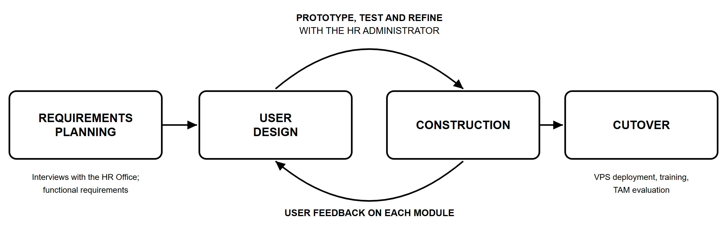
Figure 2. Rapid Application Development
Requirements Planning. The researchers conducted structured interviews and consultations with the ISPSC HR Administrator to identify the current challenges in employee file management and to define the functional requirements of NexHRIS. These requirements included a centralized repository for Personal Data Sheets and leave records, a secure role-based access system, a multi-level leave filing and monitoring feature, the maintenance of the leave and service credit ledger cards, and the faithful reproduction of the official Civil Service forms of the campus.
User Design. A user-centered approach was applied in designing the interface layouts of all modules. The feedback of the HR Administrator guided the design of the Personal Data Sheet review screens, the leave review queue, the ledger card maintenance screen, and the employee account management screens, while the experience of employees was considered in the design of the Personal Data Sheet workspace, the leave filing and tracking screen, and the profile and identification card screens. Each role was given its own navigation menu that shows only the modules it may use. The database was designed as a relational schema, and the design of the system was documented in the use case diagram, the data flow diagrams, the entity relationship diagram, and the flow chart found in Appendices D to I.
Construction. The system was built with the Laravel 12 framework in PHP for the back end; Blade templates with Tailwind CSS and Alpine.js for the interface; Chart.js for the dashboard charts; and MariaDB, a MySQL-compatible relational database management system, for data storage. PhpSpreadsheet reads and validates the uploaded Civil Service workbooks, and LibreOffice converts them to PDF on the server, with a built-in renderer based on PhpSpreadsheet and Dompdf serving as a fallback. Dompdf also generates the printouts of the system itself, namely the approval sheet, the ledger cards, and the management reports. The QR code of the digital identification card is generated with the Simple QrCode library, and the content of HR policies is cleaned with the Symfony HTML Sanitizer before it is displayed. Modules were developed sequentially, and each module was tested and refined before it was integrated with the rest of the system.
Correctness was maintained through an automated test suite executed after every change. At the conclusion of development, the suite comprised 530 automated tests covering sign-in and two-factor verification, role boundaries, the approval chain, the calculation of ledger balances, document conversion, the sanitization of policy content, and the confidentiality of stored personnel records, and all of the tests passed. The automated suite was complemented by browser-based testing of every screen under each of the four roles on desktop and mobile screen widths.
Cutover. The completed system was deployed on a Hostinger KVM 1 virtual private server with one virtual processor, 4 GB of memory, and 50 GB of storage, running Ubuntu 24.04 LTS, the Nginx web server, PHP 8.3, MariaDB, and LibreOffice, with a Let's Encrypt certificate securing every connection over HTTPS. Development was carried out on a local server environment running PHP 8.2 and MariaDB. Uploaded personnel records are stored in the private storage of the server, outside the web-accessible directory, and are released only through the application, so that every request passes the role check; only the blank official forms and profile photographs are served directly. This phase also included user orientation and training for the HR Administrator and the employee-respondents, final adjustments based on evaluation feedback, and the formal administration of the Technology Acceptance Model (TAM) questionnaire.

Project Plan
The development of NexHRIS followed the four phases of the Rapid Application Development model. The project covered the period from June 2026 to September 2026, with each phase assigned specific activities and deliverables to ensure timely and organized system development, as shown in Figure 3.
Activity | June |  |  |  | July |  |  |  | August |  |  |  | September
Activity | 1 | 2 | 3 | 4 | 1 | 2 | 3 | 4 | 1 | 2 | 3 | 4 | 1 | 2 | 3 | 4
Requirements Planning
Interviews and consultations with the HR Office
Analysis of the current process
Definition of system requirements
User Design
Interface design
Database design
Prototype review with the HR Administrator
Construction
Development of system modules
Automated and browser-based testing
Refinement based on user feedback
Cutover
Deployment to the virtual private server
Orientation and training of users
Administration of the TAM questionnaire
Final revisions
Figure 3. Project Schedule
Check the shaded weeks against the actual schedule of the project, adjust them if needed, and delete this note.

Project Assignment
The roles and responsibilities of the project team for NexHRIS: A Smart and Next-Generation Human Resource Information System for Ilocos Sur Polytechnic State College are presented in Table 1. Each member was assigned specific tasks based on his or her skills and area of specialization to ensure the proper development and completion of the system.
Table 1. Project Assignment
Role | Name | Function
Project Manager | Eidref Jake S. Manalansan | Coordinates the project team and maintains open communication with all the members.
System Analyst and Designer | Eidref Jake S. Manalansan  Diana Sofia L. Sta. Ana | Coordinate the efforts of the technical team in resolving challenges and ensure that solutions are practical and consistent.
Programmer and Developer | Eidref Jake S. Manalansan | Manages the planning and design of the system and builds the project.
Quality Assurance and Tester | Diana Sofia L. Sta. Ana  Sheran S. Leal | Test the system for defects, evaluate software needs, and communicate findings to the project team.
Documenter and Technical Writer | Eidref Jake S. Manalansan  Diana Sofia L. Sta. Ana  Sheran S. Leal  Yuri Bib P. Somera  Arvie Keith M. Manzano | Prepare and publish the documents of the project to the respective parties and report the overall status of the project.

Population and Locale of the Study
The study was conducted at Ilocos Sur Polytechnic State College (ISPSC), Tagudin Campus, located in Tagudin, Ilocos Sur. The institution served as the locale of the study, as NexHRIS was developed specifically to address the employee file management needs of its HR Office.
The respondents of the study consisted of two groups. The first group was composed of the two (2) authorized users of NexHRIS within the HR Office, the HR Administrator and the HR Assistant, both of whom operate the system on behalf of the HR Office. Since the HR Office has only two (2) such users, total enumeration was applied to this group.
The second group consisted of the teaching and non-teaching personnel of ISPSC Tagudin Campus, with a total population of 142 employees. Slovin's formula was used to determine the sample size for this group. From a population of 142, a sample of 105 employees was drawn to represent the population at a 5% margin of error.
n = N / [1 + N(e²)]
where n is the sample size, N is the total population, and e is the margin of error. Given N = 142 and e = 0.05:
n = 142 / [1 + 142(0.05)²] = 142 / 1.355 = 104.80 ≈ 105
The 105 employee-respondents were selected through simple random sampling, in which each of the 142 employees had an equal chance of being selected until the required sample size was reached.
Table 2. Distribution of Respondents
Respondents | Sample Size
HR Administrator | 1
HR Assistant | 1
Employees | 105
Total | 107

Table 2 presents the distribution of the respondents. The study involved a total of 107 respondents: two (2) HR Office personnel, the HR Administrator and the HR Assistant, who served as the primary operators of the system, and 105 teaching and non-teaching personnel of ISPSC Tagudin Campus, who served as employee-users of NexHRIS. The respondents were identified based on their direct involvement with the system or their status as its intended users, ensuring that both the administrative and the employee perspectives were represented in the evaluation.

Research Instruments
Data for this study were collected through two methods. First, structured interviews were conducted with the ISPSC HR Administrator before development to determine the current employee file management processes, challenges, and requirements that formed the basis of the feature design of NexHRIS. Second, after the system was deployed, a Technology Acceptance Model (TAM) questionnaire (Appendix B) was administered to all respondents to evaluate the acceptability of the system.
The Technology Acceptance Model, originally developed by Davis (1989), is a widely validated theoretical framework for evaluating user acceptance of information systems. TAM posits that two primary constructs, Perceived Usefulness (PU) and Perceived Ease of Use (PEOU), determine the attitude of a user toward a system and, ultimately, the intention to use it. Perceived Usefulness refers to the degree to which a user believes that using the system will enhance his or her job performance, while Perceived Ease of Use refers to the degree to which a user believes that using the system will be free of effort. The questionnaire used in this study assessed both constructs on a five-point Likert scale, with 1 indicating strong disagreement and 5 indicating strong agreement with each statement, and asked each respondent to rate both the manual process and NexHRIS against the same statements.
The TAM instrument is particularly appropriate for this study because NexHRIS is a new system introduced to users with no prior experience of a digital human resource information system. Evaluating the system through TAM allowed the researchers to determine whether users find NexHRIS useful for their HR transactions and easy to operate, which are the two most critical determinants of system adoption and continued use in institutional settings.

Data Analysis
The researchers used appropriate statistical and qualitative tools to analyze the data gathered for each objective of the study, as follows.
For Objective 1, which aimed to analyze the current employee file management processes of the ISPSC HR Office, the qualitative data gathered through structured interviews with the HR Administrator and the HR Assistant were analyzed using thematic analysis. The responses were systematically organized into recurring themes related to the current HR document management workflow, the challenges and inefficiencies experienced by the HR Office, and the system features and requirements identified by the HR personnel. The resulting themes served as the basis for the system design, the prioritization of features, and the functional requirements of NexHRIS.
For Objective 2, which aimed to determine the system requirements for the development of NexHRIS, the functional and non-functional requirements identified during requirements planning were documented and organized into system specifications. These requirements were validated with the HR Administrator and translated into the modules, user roles, and workflows of the system, ensuring that the developed system directly addresses the needs identified in Objective 1.
For Objective 3, which aimed to evaluate the level of acceptability of NexHRIS based on the responses of the HR personnel and the employees of ISPSC Tagudin Campus using the Technology Acceptance Model, the mean and standard deviation were used to analyze the quantitative data gathered from the TAM questionnaire, in terms of Perceived Usefulness and Perceived Ease of Use. Each item of the questionnaire was rated using the five-point Likert scale presented in Table 3.
Table 3. Likert Scale for the TAM Evaluation of NexHRIS
Scale | Verbal Interpretation
5 | Strongly Agree
4 | Agree
3 | Neutral
2 | Disagree
1 | Strongly Disagree

The computed mean scores for each construct were interpreted using the mean ranges presented in Table 4, which determined the level of agreement of the respondents with each construct and the overall acceptability of the system.
Table 4. Mean Range Interpretation for the TAM Evaluation of NexHRIS
Mean Range | Interpretation
4.21 – 5.00 | Strongly Agree
3.41 – 4.20 | Agree
2.61 – 3.40 | Neutral
1.81 – 2.60 | Disagree
1.00 – 1.80 | Strongly Disagree

For Objective 4, which aimed to determine whether there is a significant difference between the existing manual employee file management process and the developed NexHRIS system in terms of perceived usefulness and perceived ease of use, the Wilcoxon Signed-Rank Test was used. This non-parametric test is appropriate for comparing two related conditions—the manual process and NexHRIS—rated by the same group of respondents, particularly when the data are ordinal, as Likert-scale responses are. The respondents rated both the manual process and NexHRIS using the same TAM-based items, and the test was applied to determine whether a statistically significant difference exists between the two sets of ratings. A significance level of 0.05 was used as the decision threshold: if the computed p-value is less than 0.05, the null hypothesis that there is no significant difference between the manual process and NexHRIS is rejected.
Chapter 3

RESULTS AND DISCUSSION
This chapter presents the findings of the study in the order of its objectives: the current employee records management practices of the institution, the system requirements of NexHRIS and the features of the developed system, the acceptability of the system, and the comparison between the manual process and NexHRIS.

Current Process of Employee Records and HR Data Handling
The HR process of ISPSC Tagudin Campus relied entirely on manual, paper-based, and spreadsheet-based procedures. Employee 201 files, including the Personal Data Sheet, leave records, and other personnel documents, were kept and organized physically by the HR Office, with a Personal Data Sheet per employee, a separate form per leave application, and two handwritten ledger cards per person. Whenever employees needed to update their Personal Data Sheet, they had to visit the HR Office, retrieve their physical file, and manually revise the necessary entries before having it filed again.
Leave applications followed a manual route in which a printed form was physically carried to the Dean, then to the HR Office, and then to the Campus Director for signature, and a form returned at any of these offices had to be filled in again by the employee. After final approval, the HR personnel wrote the days taken on the handwritten ledger card, recomputed the balance by hand, and filed the form. Employees were required to check their leave credits and file their requests in person, relying entirely on the HR personnel to locate their records and compute their balances. This process is illustrated in the flow chart in Appendix C.
This reliance on physical filing made records vulnerable to loss, damage, and unauthorized access, while the absence of a centralized digital repository required HR personnel to spend considerable time locating, reproducing, and verifying documents for every transaction. As the number of personnel and administrative responsibilities of the institution continued to grow, the manual method became time-consuming, prone to errors, and increasingly difficult to sustain.

System Requirements of NexHRIS
The requirements identified during requirements planning and validated with the HR Administrator were organized into functional requirements, non-functional requirements, and the hardware and software requirements of the system.

Functional Requirements
Table 5 presents the functional requirements of NexHRIS, grouped by module, together with the roles that use each module.
Table 5. Functional Requirements of NexHRIS
Module | Functional Requirement | User Roles
Authentication | Sign in with email address and password after accepting the Terms and Conditions; verify a six-digit emailed code for privileged roles; lock an account after five failed attempts; reset a forgotten password by email | All roles
Dashboards | Present the figures and pending work relevant to each role | All roles
Employee Accounts | Create and update staff accounts; assign the role, position, college, and department; activate or deactivate an account; export the employee directory | HR Administrator
Colleges and Departments | Maintain the colleges and their Deans, and the departments under each college and their heads | HR Administrator
My Profile | Update one's own name, email address, contact number, photograph, and password | All roles
Form Templates | Upload, preview, and activate numbered versions of CS Form No. 212, CS Form No. 6, and the leave ledger card | HR Administrator
Personal Data Sheet | Download the template; upload and submit the completed workbook; view it as a PDF; approve it or return it with remarks; retain every version | Employee, Dean, Campus Director; HR Administrator (review)
Leave Application | File a vacation or sick leave application with the completed CS Form No. 6; route it through the approval chain; approve it or return it with remarks; resubmit a returned application; print the approval sheet | Employee, Dean, Campus Director; reviewers
Leave Calendar | View and export the leave of a month within the scope of the role | HR Administrator, Dean, Campus Director
Ledger Cards | Post approved leave, monthly credits, adjustments, and service credits; correct or remove a line with every later balance recalculated; view and print the cards | HR Administrator (maintain); Campus Director (view); Employee, Dean (own card)
Management Reports | Export the leave balances of all personnel as PDF and Excel files, the employee directory as a PDF file, and the leave calendar of a month as a PDF file | HR Administrator, Campus Director
HR Policies | Publish policies as formatted text, a file, or a link; require acknowledgment; track compliance; read and acknowledge policies | HR Administrator (publish); all other roles (read and acknowledge)
Announcements and Notifications | Post announcements to the whole campus or to one college; notify users by email and through the notification bell | HR Administrator (post); all roles (receive)
Digital Identification Card | View and print an identification card with a QR code; verify the card on a public page | Employee, Dean, Campus Director
Activity Log | Record and search sign-ins, decisions, and changes to records | HR Administrator

Non-Functional Requirements
Table 6 presents the non-functional requirements of NexHRIS and the manner in which the system satisfies each.
Table 6. Non-Functional Requirements of NexHRIS
Attribute | Requirement | Implementation in NexHRIS
Security and Privacy | Personnel data must be protected in accordance with the Data Privacy Act of 2012 | Role-based access enforced at the query level; hashed passwords of at least eight characters containing letters and numbers; two-factor verification for privileged roles; account lockout; private storage of uploaded records; sanitized policy content; HTTPS
Accountability | Every significant action must be traceable | Activity log recording the account, action, date and time, IP address, and browser, including the previous values of corrected ledger lines
Document Fidelity | Official forms must print exactly as the campus uses them | Conversion of the uploaded workbook itself to an A4 PDF by LibreOffice
Reliability | Approval routing and ledger balances must be correct | Approval chain derived from the role of the applicant; balances recalculated after every correction; 530 automated tests
Usability | The system must be easy to learn for users new to digital HR systems | One interface with a navigation menu per role; consistent, formal layout of screens and email messages; layout that adapts to mobile screens
Accessibility | The system must be reachable from any location | Web-based system hosted on a virtual private server and used through a web browser
Maintainability | The system must be maintainable by future developers | Model-view-controller structure of Laravel; database changes kept as migrations; versioned form templates

Hardware and Software Requirements
Table 7 presents the hardware and software required to operate NexHRIS on the server and on the side of its users.
Table 7. Hardware and Software Requirements of NexHRIS
Component | Server | Client
Hardware | Virtual private server (Hostinger KVM 1) with one virtual processor, 4 GB of memory, and 50 GB of storage | Desktop computer, laptop, tablet, or smartphone with an internet connection
Operating System | Ubuntu 24.04 LTS | Any operating system that runs a current web browser
Web Server and Runtime | Nginx; PHP 8.3 | —
Database | MariaDB | —
Document Conversion | LibreOffice | —
Web Browser | — | Current version of Google Chrome, Microsoft Edge, Mozilla Firefox, or Safari
Spreadsheet Application | — | Microsoft Excel (desktop) or LibreOffice Calc, for completing the official forms
Email | SMTP email service for verification codes, password resets, and notifications | Registered email address
Security | Let's Encrypt SSL/TLS certificate | —

System Design
The design of NexHRIS is documented in the appendices. The use case diagram in Appendix D presents the use cases of each role, named after the modules in the navigation menu of that role; the Dean and the Campus Director are drawn as specializations of the Employee, since they file their own leave and Personal Data Sheet through the same screens. The context diagram in Appendix E presents NexHRIS as a single process exchanging data with its four user roles, and the Level 1 data flow diagram in Appendix F decomposes it into nine processes and ten data stores, both in Gane and Sarson notation. The entity relationship diagram in Appendix G presents, in crow's foot notation, the eighteen tables of the relational database and their relationships. The flow chart in Appendix H presents the sign-in process and the modules available to each role, and the input-process-output chart in Appendix I summarizes the data that the system accepts, the processing it performs, and the outputs it produces.

Features of the Developed System
The following discussion presents the developed system by module and focuses on the functions demonstrated by the system. To keep the results chapter readable, the complete screen-by-screen plate index is placed in Appendix J; representative screenshots may be inserted there as evidence for each module.
NexHRIS moves the HR transactions of the campus online while preserving the official Civil Service forms exactly as the campus uses them. The system is presented below by module; where a module behaves differently for each role, the corresponding screens are shown separately.

Authentication and Role-Based Access
Users sign in with their email address and password and must accept the Terms and Conditions of the system before signing in. Accounts that administer or approve on behalf of others—the HR Administrator, the Deans, and the Campus Director—are further challenged with a six-digit verification code sent to their registered email address. The code expires after ten minutes, a new code may be requested after sixty seconds, and a code is invalidated after five incorrect entries. Employee accounts sign in with a password alone. After five consecutive failed sign-in attempts, an account is locked for fifteen minutes, and both the failed attempts and the lockout are written to the audit trail. A user who has forgotten the password may request a reset link by email.
After signing in, each user is taken to the dashboard of his or her role, and the navigation menu shows only the modules that the role may use. The four roles share one interface and differ only in what they may do. Their data boundaries are enforced in the database query rather than only in the interface, so that a Dean who edits a web address to reach the records of another college receives a refusal instead of data. All email messages sent by the system—verification codes, password reset links, and notifications—follow one formal layout bearing the name of the institution.
Insert Plate 1 here
The sign-in page with the “I agree to the Terms and Conditions” check box
Address: /login
Insert Plate 2 here
The Terms and Conditions page opened from the sign-in page
Address: /terms
Insert Plate 3 here
The code entry page with the expiry countdown, shown to the HR Administrator, Deans, and the Campus Director
Address: /two-factor
Insert Plate 4 here
The email message containing the six-digit code, as received in the mailbox
Insert Plate 5 here
The page on which a user requests a password reset link
Address: /forgot-password
Insert Plate 6 here
The refusal page shown when a Dean opens a record outside his or her college

Dashboards
Each role opens to a different dashboard. The HR Administrator sees the number of employees, the leave applications in review, the approved applications awaiting ledger posting, and Personal Data Sheet compliance, together with a breakdown by college, the leave volume of the last six months, the distribution of leave types, the progress of the latest policy acknowledgment, newly added staff without a Personal Data Sheet, and recent activity. The Dean sees the headcount of his or her college, upcoming leave in the college, and his or her recent decisions. The Campus Director sees campus-wide leave oversight, including the pending approvals by college, the leave volume of the last six months, the personnel on leave for the day, his or her own leave application, and recent decisions. The Employee sees his or her vacation leave, sick leave, and service credit balances, the leave used during the year, the status of his or her latest leave application and records, and the latest announcements.
Insert Plate 7 here
The dashboard of the HR Administrator
Address: /admin/dashboard
Insert Plate 8 here
The dashboard of a Dean
Address: /admin/dashboard
Insert Plate 9 here
The dashboard of the Campus Director
Address: /admin/dashboard
Insert Plate 10 here
The dashboard of an employee
Address: /dashboard

Employee Accounts, Colleges, and Departments
The HR Administrator creates and maintains staff accounts, recording for each employee the employee number, position, role, college, department, first day of government service, and date hired. A department belongs to exactly one college, and the college to which an employee is assigned determines which Dean signs that employee's leave. Accounts are deactivated rather than deleted, so the history attached to a person is preserved after the person leaves the institution. The employee directory can be filtered and exported as a PDF file. From My Profile, every user maintains his or her own name, email address, contact number, photograph, and password, while the employee number, position, college, department, and role remain under the control of the HR Administrator.
Insert Plate 11 here
The list of employee accounts with its filters
Address: /admin/employees
Insert Plate 12 here
The form for adding a staff account
Address: /admin/employees/create
Insert Plate 13 here
The record of one employee
Address: /admin/employees/{employee}
Insert Plate 14 here
The colleges with their Deans and departments
Address: /admin/colleges
Insert Plate 15 here
The profile page of a user
Address: /profile

Publication of the Official Forms
The official blank forms are held in the system rather than circulated by hand. From Form Templates, the HR Administrator uploads the Application for Leave (CS Form No. 6) and the leave ledger card, while the Personal Data Sheet (CS Form No. 212) is published from PDS Requests. Each upload becomes a new numbered version, and activating a version retires the previous one instead of overwriting it, so that every submission remains associated with the version on which it was filled. A published form can be previewed as a PDF before it is issued to staff, and the original workbook remains available for download.
Insert Plate 16 here
The published leave form and ledger card with their numbered versions
Address: /admin/leave-form-templates

Personal Data Sheet
From My Personal Data Sheet, an employee downloads the active CS Form No. 212, completes it in Microsoft Excel or LibreOffice Calc, and uploads the completed workbook. The system accepts only a workbook based on the official template, and the employee may view the converted PDF before submitting it to the HR Office. The HR Administrator reviews each submission from PDS Requests, reads it as a PDF in the browser or downloads the original workbook, and either approves it or returns it with remarks. A returned sheet displays the remarks to the employee, who uploads a corrected version and submits it again, and every earlier version is retained. The employee is notified of each decision by email and through the notification bell. Deans and the Campus Director submit their own Personal Data Sheets through the same screens. Because the exported PDF is a conversion of the workbook that the employee actually uploaded rather than a form rebuilt from stored values, the printed sheet is the official form of the campus, named after the employee and the year it covers.
Insert Plate 17 here
The Personal Data Sheet workspace of an employee
Address: /pds
Insert Plate 18 here
The list of Personal Data Sheet submissions and the published template
Address: /admin/pds
Insert Plate 19 here
A submission under review, with the approve and return actions
Address: /admin/pds/{employee}
Insert Plate 20 here
The first page of a submitted Personal Data Sheet converted to PDF

Leave Application and Approval Chain
From My Leave, an employee views his or her leave balances, downloads the active CS Form No. 6, and completes it. The employee then files the application by selecting vacation leave or sick leave, entering the inclusive dates and the reason, and uploading the completed form as a workbook, a Word document, or a PDF file. The application is routed according to the rank of the applicant, since no user signs his or her own leave: the application of an employee passes through the Dean of the employee's college, the HR Administrator, and the Campus Director; the application of a Dean skips the Dean stage; and the application of the Campus Director is decided by the HR Administrator alone.
Each reviewer finds the applications awaiting his or her stage in a review queue—Awaiting My Review for the Dean and the Campus Director, and Leave Reviews for the HR Administrator—reads the form as a PDF in the browser, and either approves it or returns it with remarks. A Dean sees only the applications of his or her own college. The next reviewer is notified by email and through the notification bell. A returned application displays the remarks to the employee, who uploads a corrected form, and the corrected application restarts from the first stage of the chain. The employee follows the application through a stage-by-stage timeline and, once it is fully approved, prints the approval sheet, on which any skipped stage is marked not applicable.
Insert Plate 21 here
The My Leave page with the balances and the filing form
Address: /leave
Insert Plate 22 here
The stage-by-stage timeline of an application
Address: /leave
Insert Plate 23 here
Awaiting My Review, as seen by a Dean
Address: /admin/leave/review
Insert Plate 24 here
An application under review by the HR Administrator
Address: /admin/leave/review/{application}
Insert Plate 25 here
An application awaiting the final approval of the Campus Director
Address: /admin/leave/review/{application}
Insert Plate 26 here
The return form with the remarks of the reviewer
Address: /admin/leave/review/{application}
Insert Plate 27 here
The approval sheet of a Dean's own application, with the Dean stage marked not applicable

Leave Calendar
The leave calendar shows the approved and pending leave of a chosen month, scoped to the role viewing it. The Dean sees only his or her own college, while the HR Administrator and the Campus Director see the whole campus and may narrow the view to one college. The calendar can be filtered by leave type, and the month displayed can be exported as a PDF file for posting.
Insert Plate 28 here
The leave calendar as seen by a Dean
Address: /admin/leave/calendar
Insert Plate 29 here
The leave calendar as seen by the HR Administrator or the Campus Director
Address: /admin/leave/calendar

Leave and Service Credit Ledger Cards
The campus keeps two ledger cards per employee on the same official form. The leave ledger card records the vacation and sick leave credits earned and used and the resulting balances, while the service credit ledger card records credits earned outside regular accrual, such as for election duty, enrolment, or accreditation work, and the days charged against them. Once an application is fully approved, the HR Administrator posts it to the ledger and decides on which card the days are charged. The HR Administrator also posts monthly leave credits to one employee or to all personnel in a single action, in which a period already credited is skipped rather than credited twice, and records adjustments.
Each line stores the balances as they stood after that line, so correcting or removing a line recalculates every balance below it. The leave card is kept to two decimal places and the service credit card to three, as the forms of the campus require, and every correction is written to the audit trail together with the values that the line previously held. The HR Administrator maintains all cards, the Campus Director views the card of every employee through Employee Ledgers, and each employee reads his or her own through My Leave Ledger. The cards print on A4 paper in the layout of the official form.
Insert Plate 30 here
The list of employees with their balances and the monthly credit posting
Address: /admin/leave
Insert Plate 31 here
The ledger card of one employee with the correction form
Address: /admin/leave/{employee}/ledger
Insert Plate 32 here
The posting of an approved application to the leave or service credit card
Address: /admin/leave/review/{application}
Insert Plate 33 here
The read-only ledger card of an employee
Address: /leave/my-ledger
Insert Plate 34 here
The printed leave ledger card and service credit ledger card

Management Reports
In addition to the documents of individual employees, the system produces campus-wide reports: the leave balances of all personnel as a PDF file or an Excel workbook, the employee directory as a PDF file that respects the filters on the screen, and the leave calendar of a chosen month. Every generated document is named after the person or the period it covers, so that a saved file can be identified without opening it.
Insert Plate 35 here
The leave balances of all personnel exported as a PDF file
Insert Plate 36 here
The employee directory exported as a PDF file

HR Policies
The HR Administrator publishes policies as formatted text written in a rich-text editor, as an uploaded file, or as a link, with an effective date and, optionally, an expiry date. A policy may be marked as requiring acknowledgment, pinned to the top of the list, and published or withdrawn. Policy text is sanitized before it is displayed, so that no script embedded in a policy can run in the browser of a reader. Employees, Deans, and the Campus Director read the published policies and acknowledge those that require it, and the system records when each person viewed and acknowledged a policy. The HR Administrator sees who has and who has not acknowledged each policy, and the progress of the latest policy is shown on the dashboard.
Insert Plate 37 here
The list of policies with their publication status
Address: /admin/policies
Insert Plate 38 here
The policy form with the rich-text editor
Address: /admin/policies/create
Insert Plate 39 here
The acknowledgment status of each employee for one policy
Address: /admin/policies/{policy}/compliance
Insert Plate 40 here
A policy as seen by an employee, with the acknowledgment button
Address: /policies/{policy}

Announcements and Notifications
The HR Administrator posts announcements to the whole campus or to the personnel of one college. Users are notified of new announcements, of each stage of their leave applications, and of decisions on their Personal Data Sheets by email and through the notification bell, and the Notifications page lists every notice with the option to mark it as read.
Insert Plate 41 here
The page on which the HR Administrator posts announcements
Address: /admin/announcements
Insert Plate 42 here
The announcements as seen by an employee
Address: /announcements
Insert Plate 43 here
The notification bell and the Notifications page
Address: /notifications

Digital Identification Card
Employees, Deans, and the Campus Director are each issued a digital identification card showing the photograph, name, position, college, and employee number of the holder, together with a QR code. The card can be printed, and the QR code resolves to a public verification page that confirms the name, position, college, and account status of the holder, so that a card presented outside the campus can be checked without an account and without revealing any other personal information.
Insert Plate 44 here
The digital identification card of an employee
Address: /my-id
Insert Plate 45 here
The page opened by scanning the QR code of the card
Address: /verify/{token}

Activity Log
Every sign-in, failed sign-in, lockout, decision on a leave application or Personal Data Sheet, publication of a form template or policy, change to an account, and correction of a ledger card is recorded together with the account, date and time, IP address, and browser behind it. The HR Administrator searches the log by keyword, action, user, and date range, giving the HR Office a reliable trail for accountability.
Insert Plate 46 here
The activity log with its filters
Address: /admin/activity-logs

Data Security
To protect personnel data, NexHRIS applies role-based access control that distinguishes the permissions of the HR Administrator, the Campus Director, the Dean, and the Employee, and enforces these boundaries at the query level. Uploaded personnel records—completed Personal Data Sheets, filed leave forms, and policy attachments—are held outside the web-accessible directory and are released only through the application, so each request is checked against the role of the person making it; only the blank official forms, which contain no personal data, and profile photographs are served directly. Passwords are stored hashed and must contain at least eight characters, including both letters and numbers, and every connection to the system is encrypted over HTTPS. With these measures, NexHRIS enhances the security, accessibility, and efficiency of employee records management at ISPSC Tagudin Campus.

Acceptability of the Developed System
This section presents the results of the Technology Acceptance Model evaluation of NexHRIS in terms of Perceived Usefulness and Perceived Ease of Use, as rated by the 107 respondents.
Table 8. Perceived Usefulness of NexHRIS
Indicator | Mean | SD | Interpretation
1. Using NexHRIS enables me to accomplish HR transactions more quickly.
2. Using NexHRIS improves my performance in managing employee records.
3. Using NexHRIS increases my productivity in HR-related tasks.
4. Using NexHRIS makes it easier to track leave applications and leave balances.
5. Using NexHRIS makes it easier to keep the Personal Data Sheet up to date.
6. I find NexHRIS useful in my work.
Overall Mean

Discuss the results in Table 8: state the overall mean and its interpretation, identify the highest- and lowest-rated indicators, and explain what they show about the usefulness of NexHRIS.
Table 9. Perceived Ease of Use of NexHRIS
Indicator | Mean | SD | Interpretation
1. Learning to operate NexHRIS is easy for me.
2. I find it easy to get NexHRIS to do what I want it to do.
3. My interaction with NexHRIS is clear and understandable.
4. I find NexHRIS flexible to interact with.
5. It is easy for me to become skillful at using NexHRIS.
6. I find NexHRIS easy to use.
Overall Mean

Discuss the results in Table 9: state the overall mean and its interpretation, identify the highest- and lowest-rated indicators, and explain what they show about the ease of use of NexHRIS.

Comparison Between the Manual Process and NexHRIS
This section presents the results of the Wilcoxon Signed-Rank Test comparing the ratings given by the respondents to the existing manual process and to NexHRIS in terms of Perceived Usefulness and Perceived Ease of Use, tested at the 0.05 level of significance.
Table 10. Wilcoxon Signed-Rank Test Results
Construct | Mean (Manual) | Mean (NexHRIS) | Z | p-value | Decision
Perceived Usefulness
Perceived Ease of Use

Discuss the results in Table 10: state whether the null hypothesis is rejected for each construct and what the difference between the manual process and NexHRIS means for the HR Office and the employees.

REFERENCES
Abaci, & Medeni. (2022). Complete this entry: full author names, title of the study, journal or source, volume and issue, pages, and DOI or URL.
Angala et al. (2023). Complete this entry.
Bulong et al. (2025). Complete this entry.
Davis, F. D. (1989). Perceived usefulness, perceived ease of use, and user acceptance of information technology. MIS Quarterly, 13(3), 319–340. https://doi.org/10.2307/249008
Department of Information and Communications Technology. (2023). Complete this entry.
Dres, & Rabut. (2025). Complete this entry.
Encarnacion et al. (2024). Complete this entry.
Kosie, & Lew-Williams. (2022). Complete this entry.
Orioque et al. (2024). Complete this entry.
Pagayonan. (2022). Complete this entry.
Panfilova et al. (2024). Complete this entry.
Pressman, R. S., & Maxim, B. R. (2020). Software engineering: A practitioner's approach (9th ed.). McGraw-Hill Education.
Purcia, & Velarde. (2022). Complete this entry.
Rabulan, & Glina. (2025). Complete this entry.
Regional Development Council. (2023). Ilocos Regional Development Plan 2023–2028. Complete this entry.
Republic Act No. 10173. (2012). Data Privacy Act of 2012. Official Gazette of the Republic of the Philippines.
Sebucao-Orias. (2023). Complete this entry.
Taguiam. (2024). Complete this entry.
Wahdaniah et al. (2023). Complete this entry.

APPENDICES

Appendix A. Letter of Permission to Conduct the Study
Insert the signed letter requesting permission to conduct the study at ISPSC Tagudin Campus.

Appendix B. Technology Acceptance Model Questionnaire
Part I. Respondent Information
Name (optional): __________ Date: ______
Respondent group: ☐ HR Administrator ☐ HR Assistant ☐ Teaching personnel ☐ Non-teaching personnel
Part II. Evaluation
Directions: Rate each statement twice—first for the manual process of the HR Office, then for NexHRIS—by checking the box that corresponds to your answer: 5 – Strongly Agree, 4 – Agree, 3 – Neutral, 2 – Disagree, 1 – Strongly Disagree. In each statement, “the system” refers to the manual process when rating the Manual Process columns and to NexHRIS when rating the NexHRIS columns. The statements are adapted from Davis (1989).
No. | Perceived Usefulness | Manual Process |  |  |  |  | NexHRIS
No. | Perceived Usefulness | 5 | 4 | 3 | 2 | 1 | 5 | 4 | 3 | 2 | 1
PU1 | Using the system enables me to accomplish HR transactions more quickly.
PU2 | Using the system improves my performance in managing employee records.
PU3 | Using the system increases my productivity in HR-related tasks.
PU4 | Using the system makes it easier to track leave applications and leave balances.
PU5 | Using the system makes it easier to keep the Personal Data Sheet up to date.
PU6 | I find the system useful in my work.

No. | Perceived Ease of Use | Manual Process |  |  |  |  | NexHRIS
No. | Perceived Ease of Use | 5 | 4 | 3 | 2 | 1 | 5 | 4 | 3 | 2 | 1
PEOU1 | Learning to operate the system is easy for me.
PEOU2 | I find it easy to get the system to do what I want it to do.
PEOU3 | My interaction with the system is clear and understandable.
PEOU4 | I find the system flexible to interact with.
PEOU5 | It is easy for me to become skillful at using the system.
PEOU6 | I find the system easy to use.

Appendix C. Flow Chart of the Manual Process
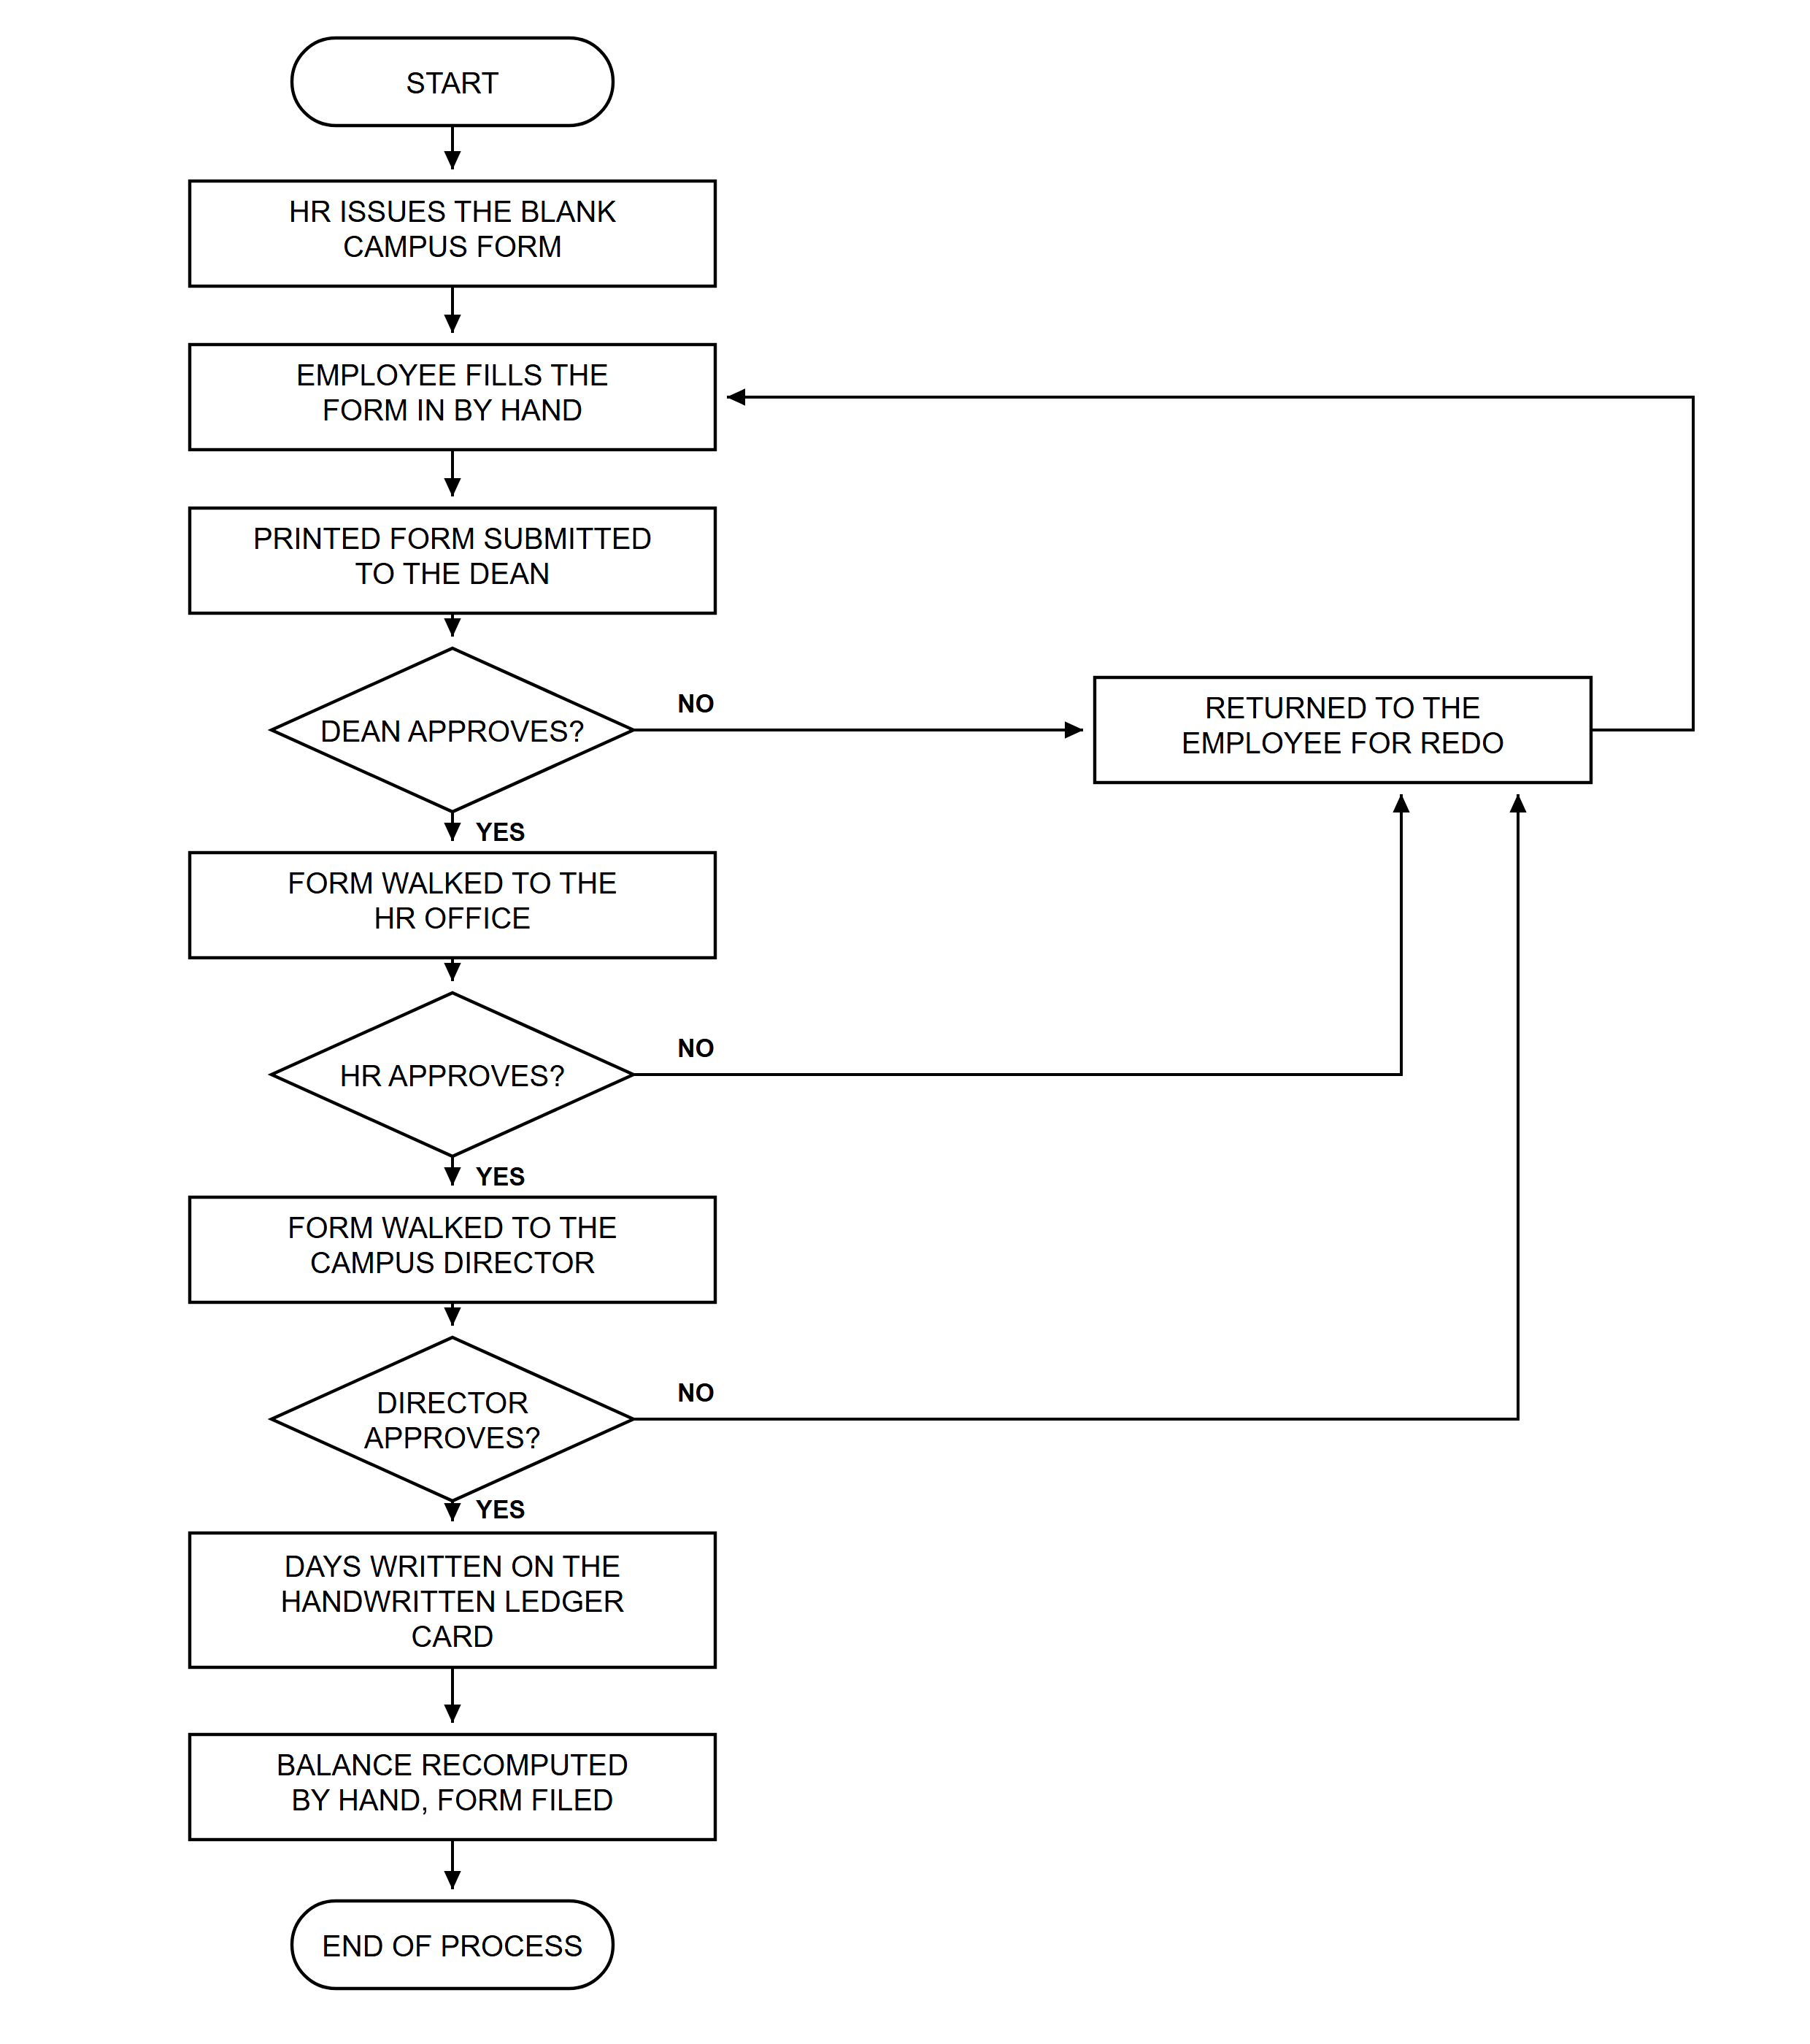

Appendix D. Use Case Diagram
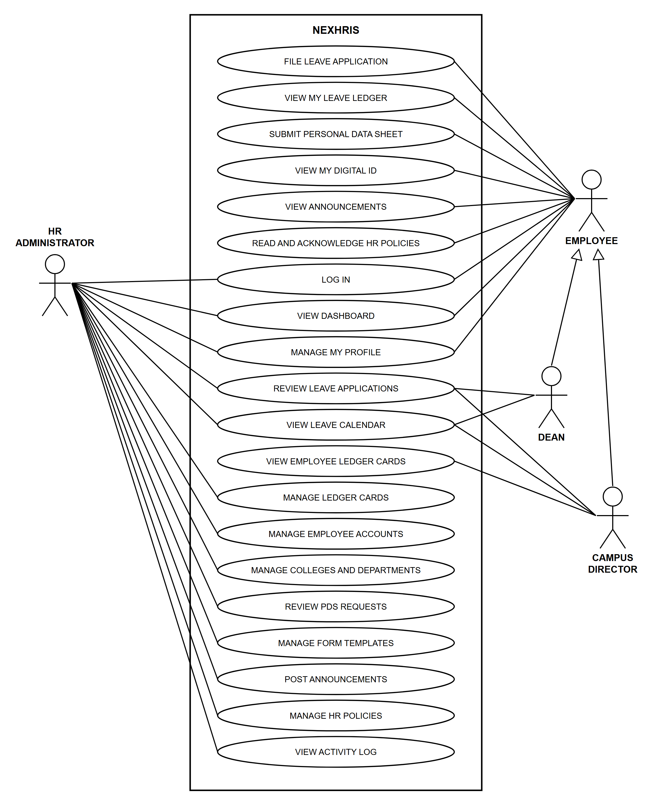

Appendix E. Context Diagram (Level 0)
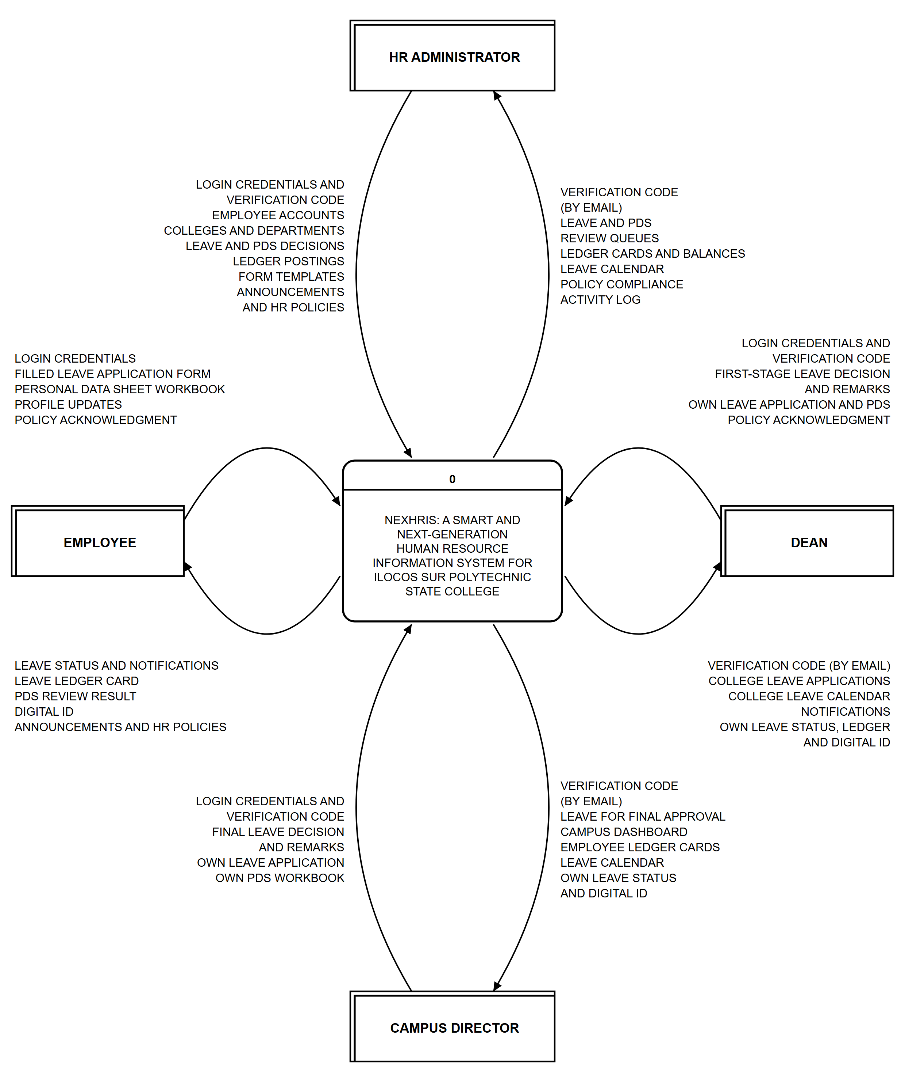

Appendix F. Data Flow Diagram (Level 1)
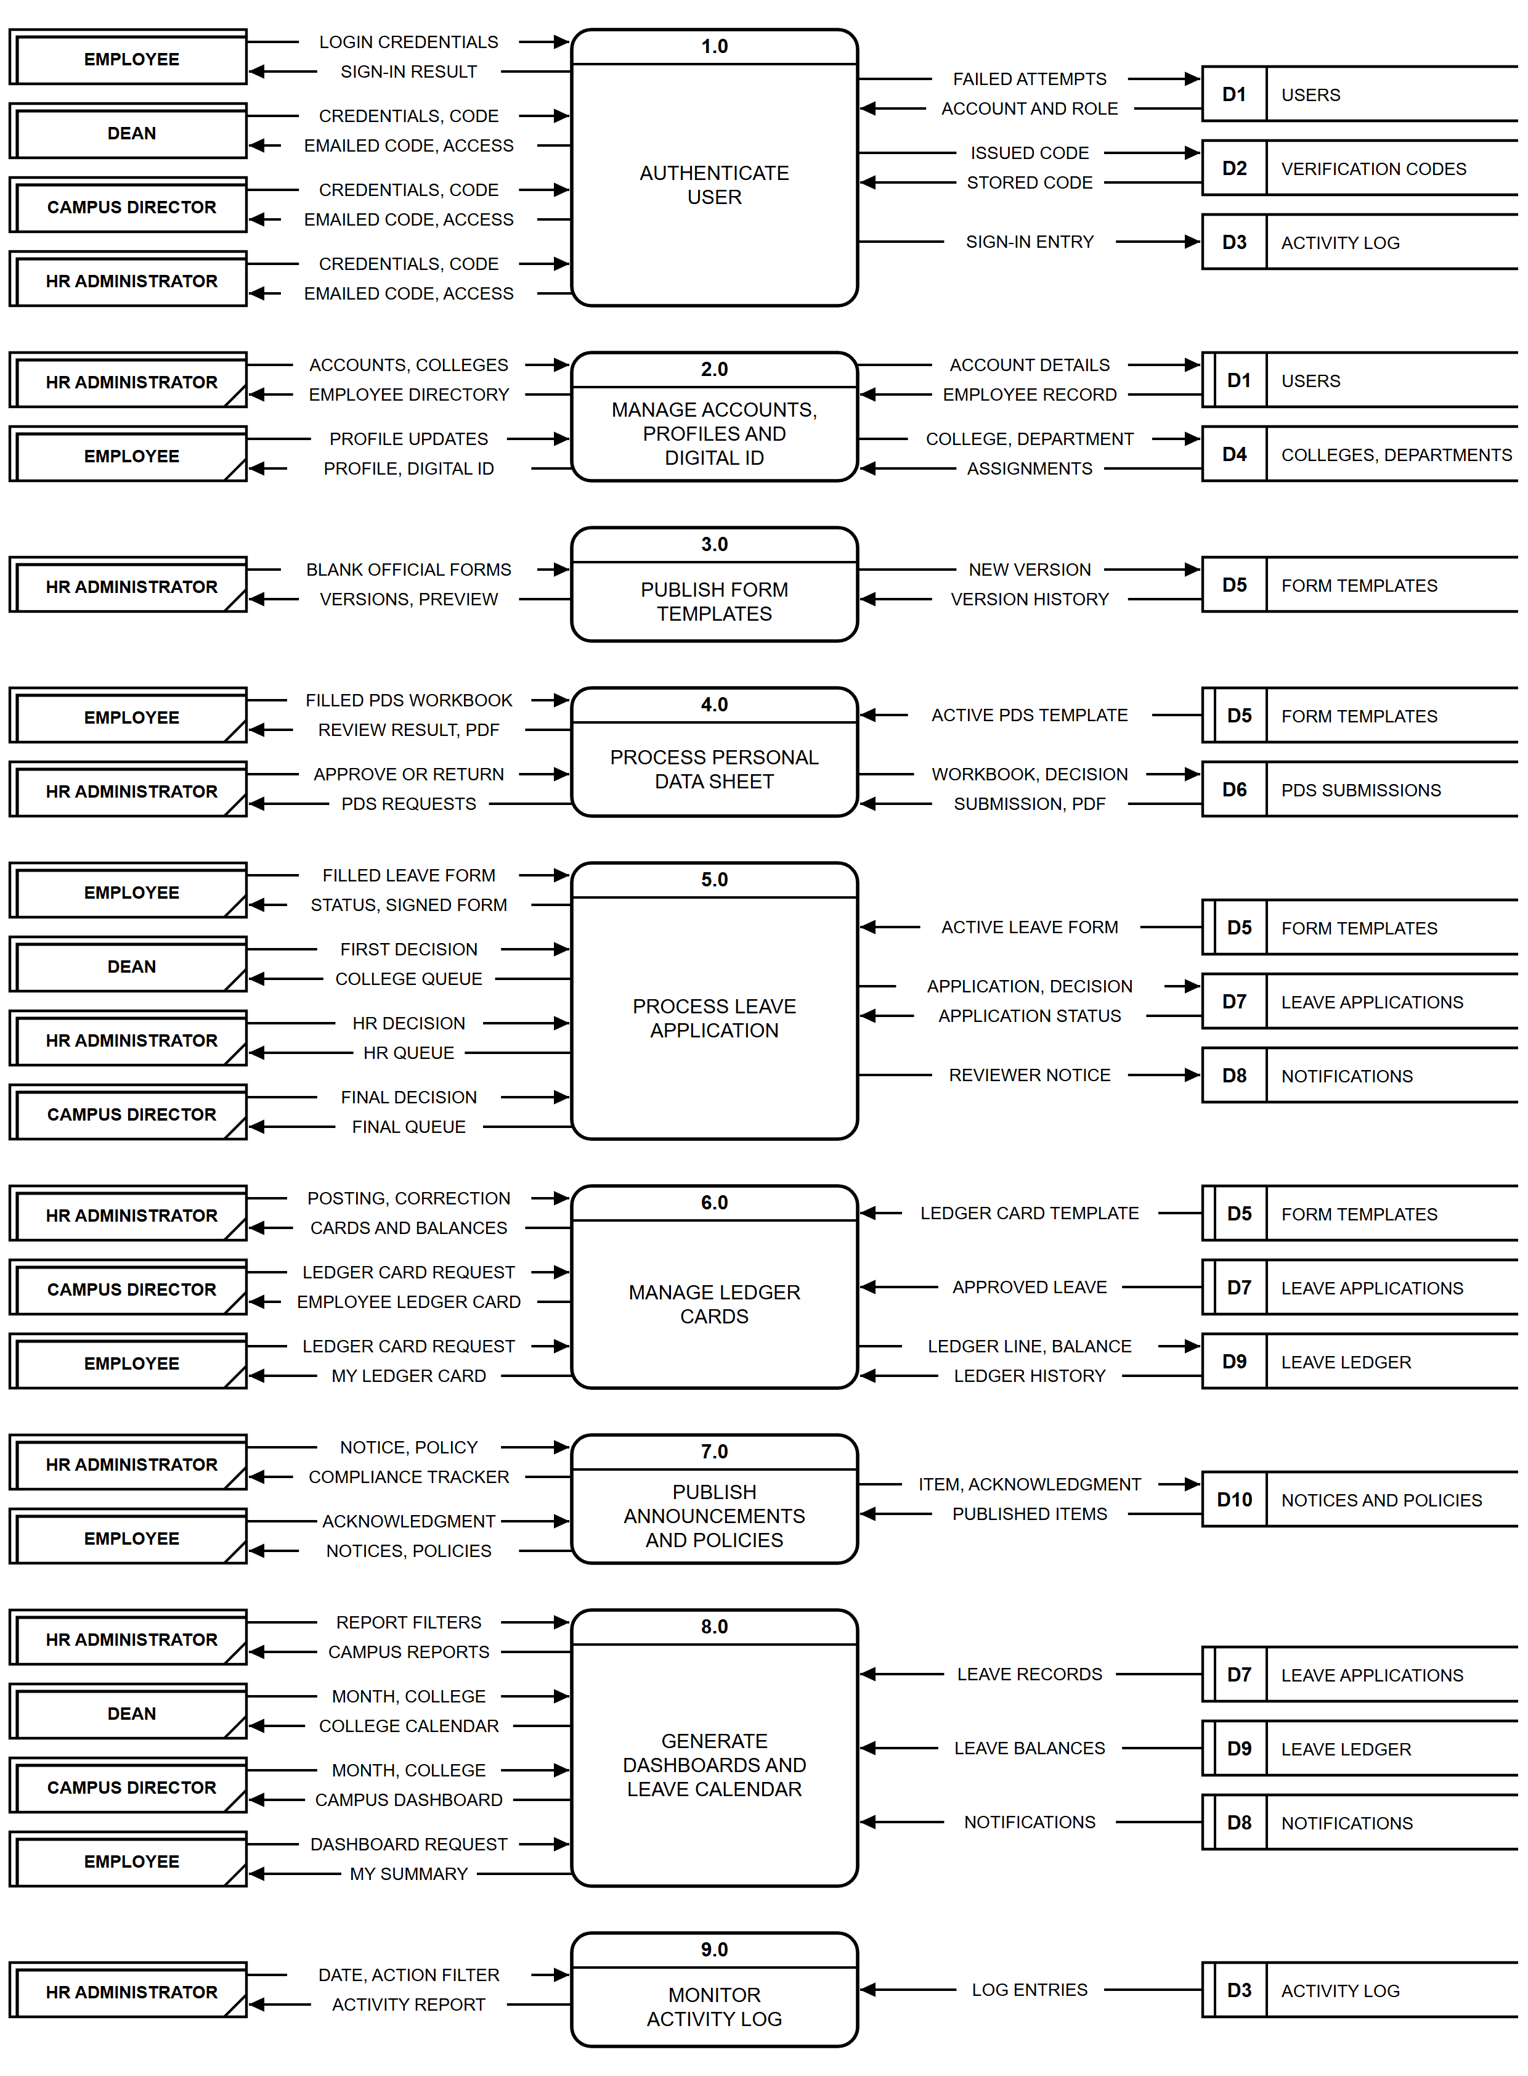

Appendix G. Entity Relationship Diagram
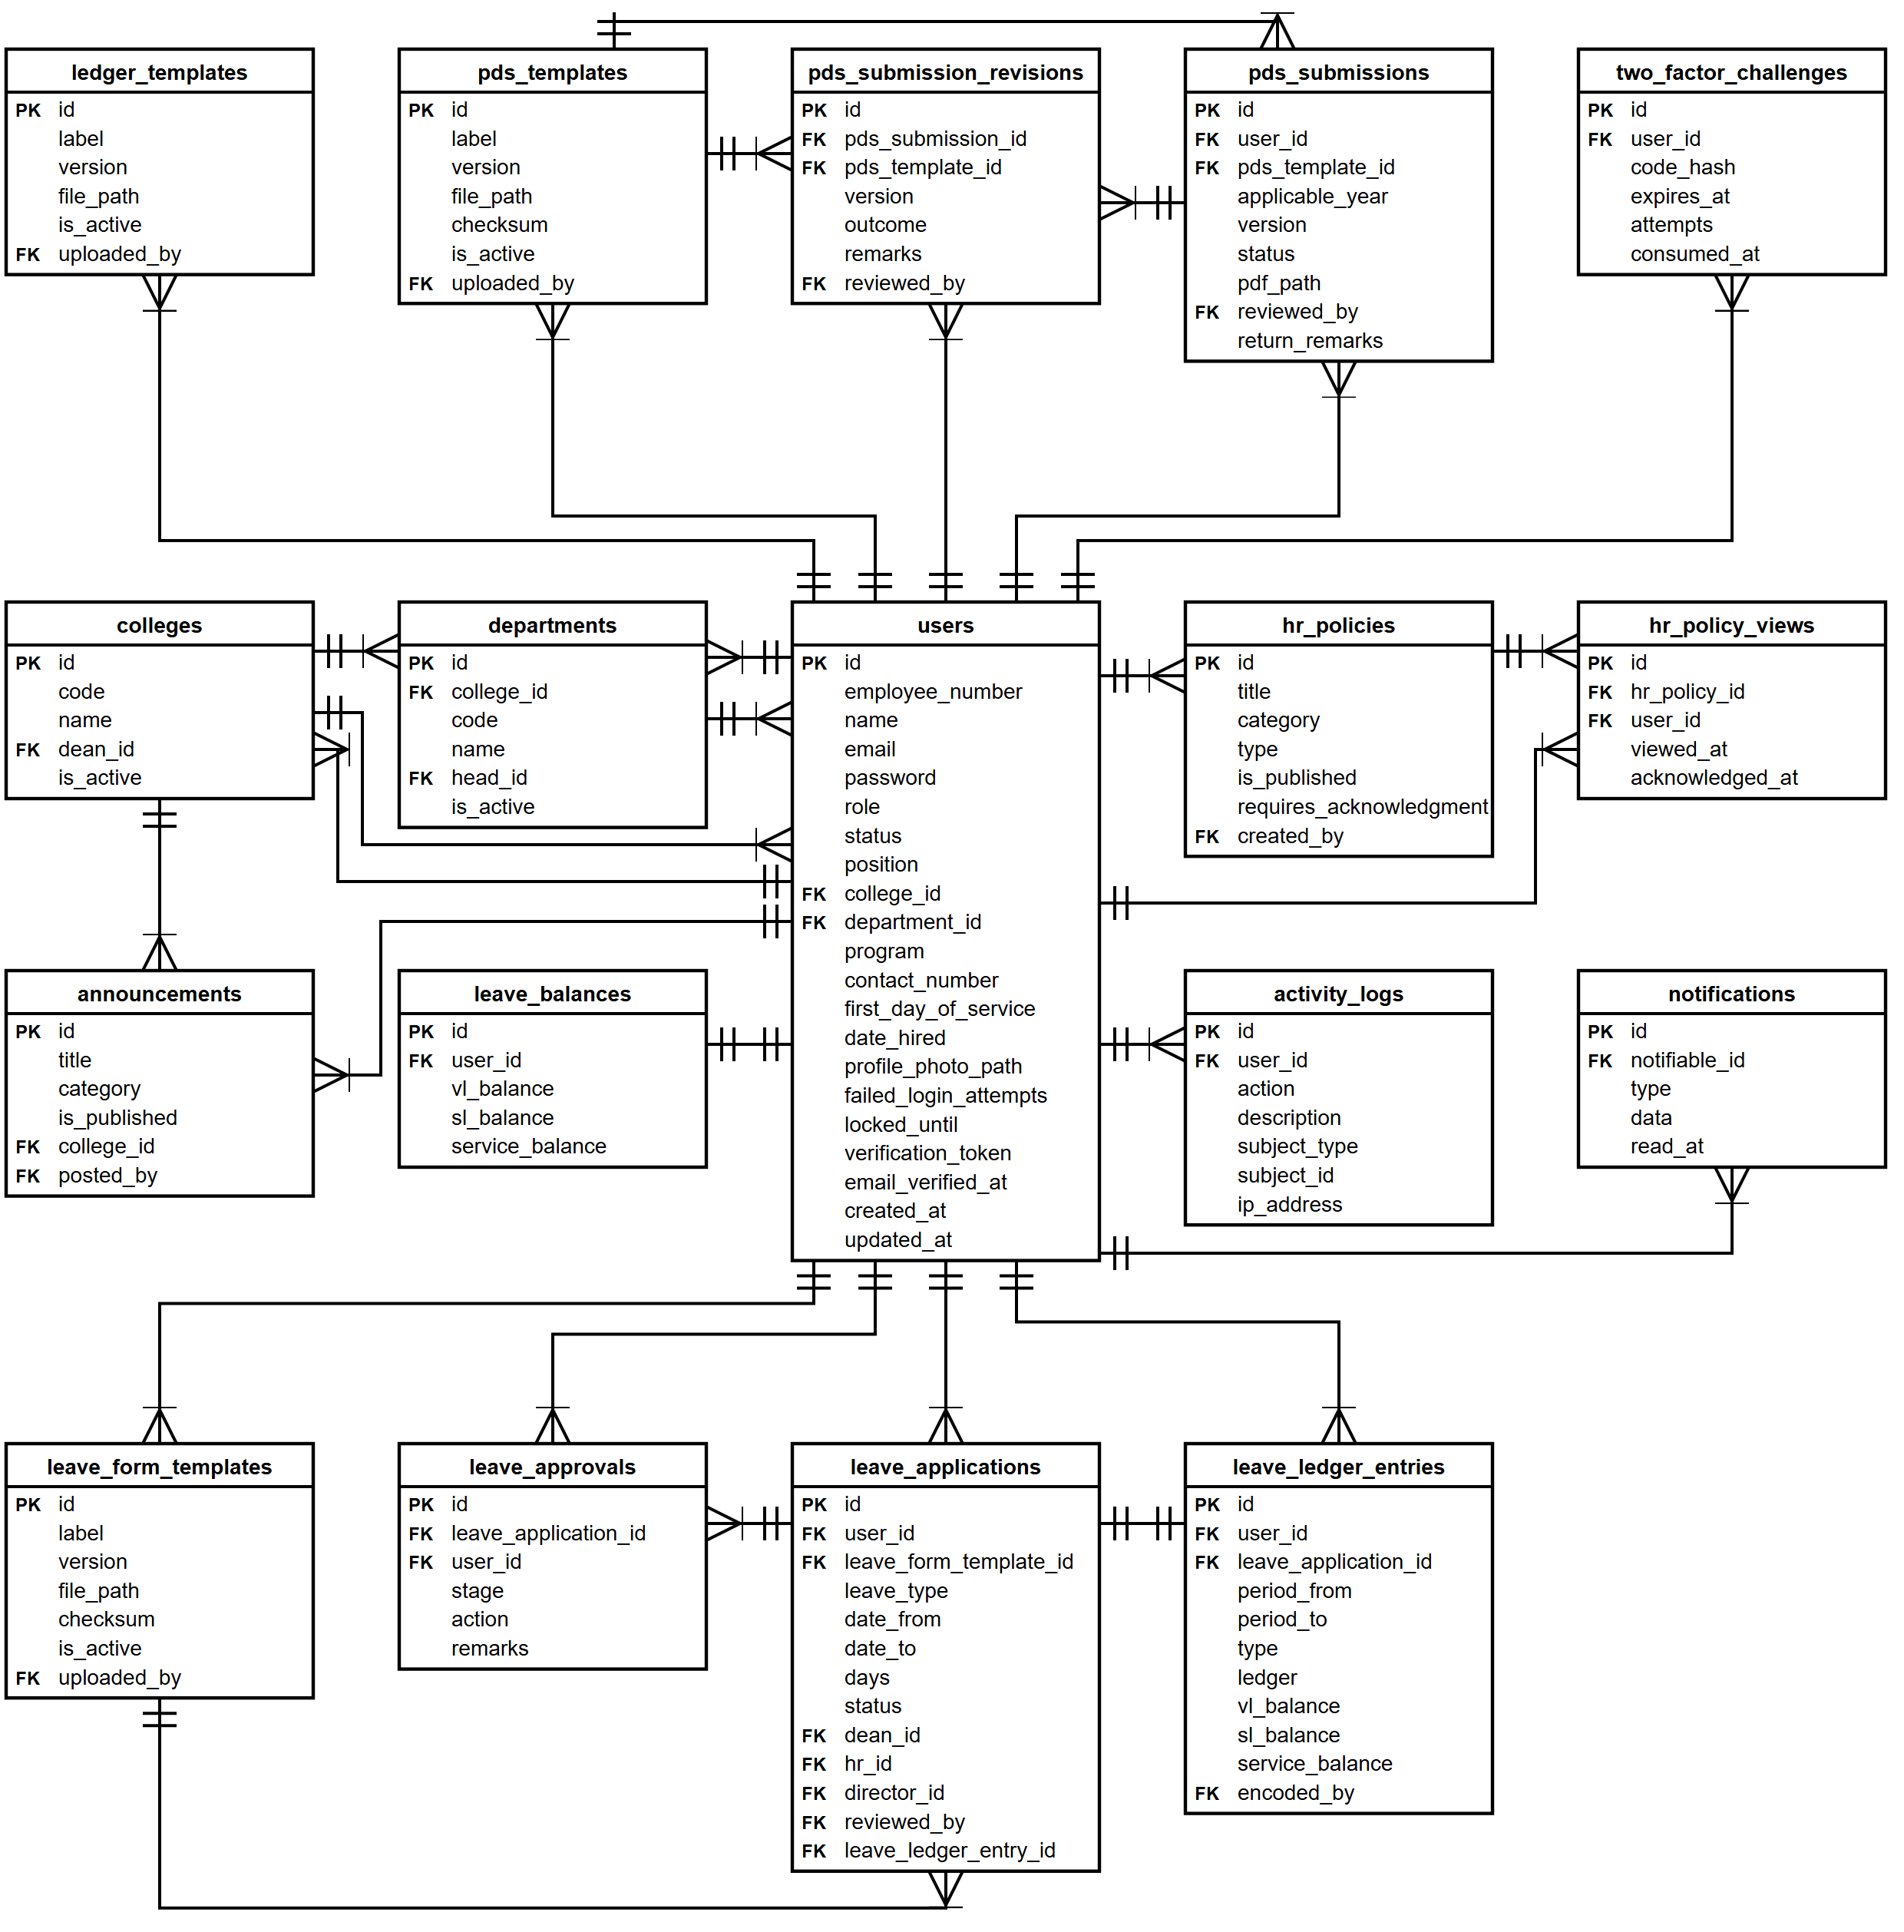

Appendix H. Flow Chart of the Developed System
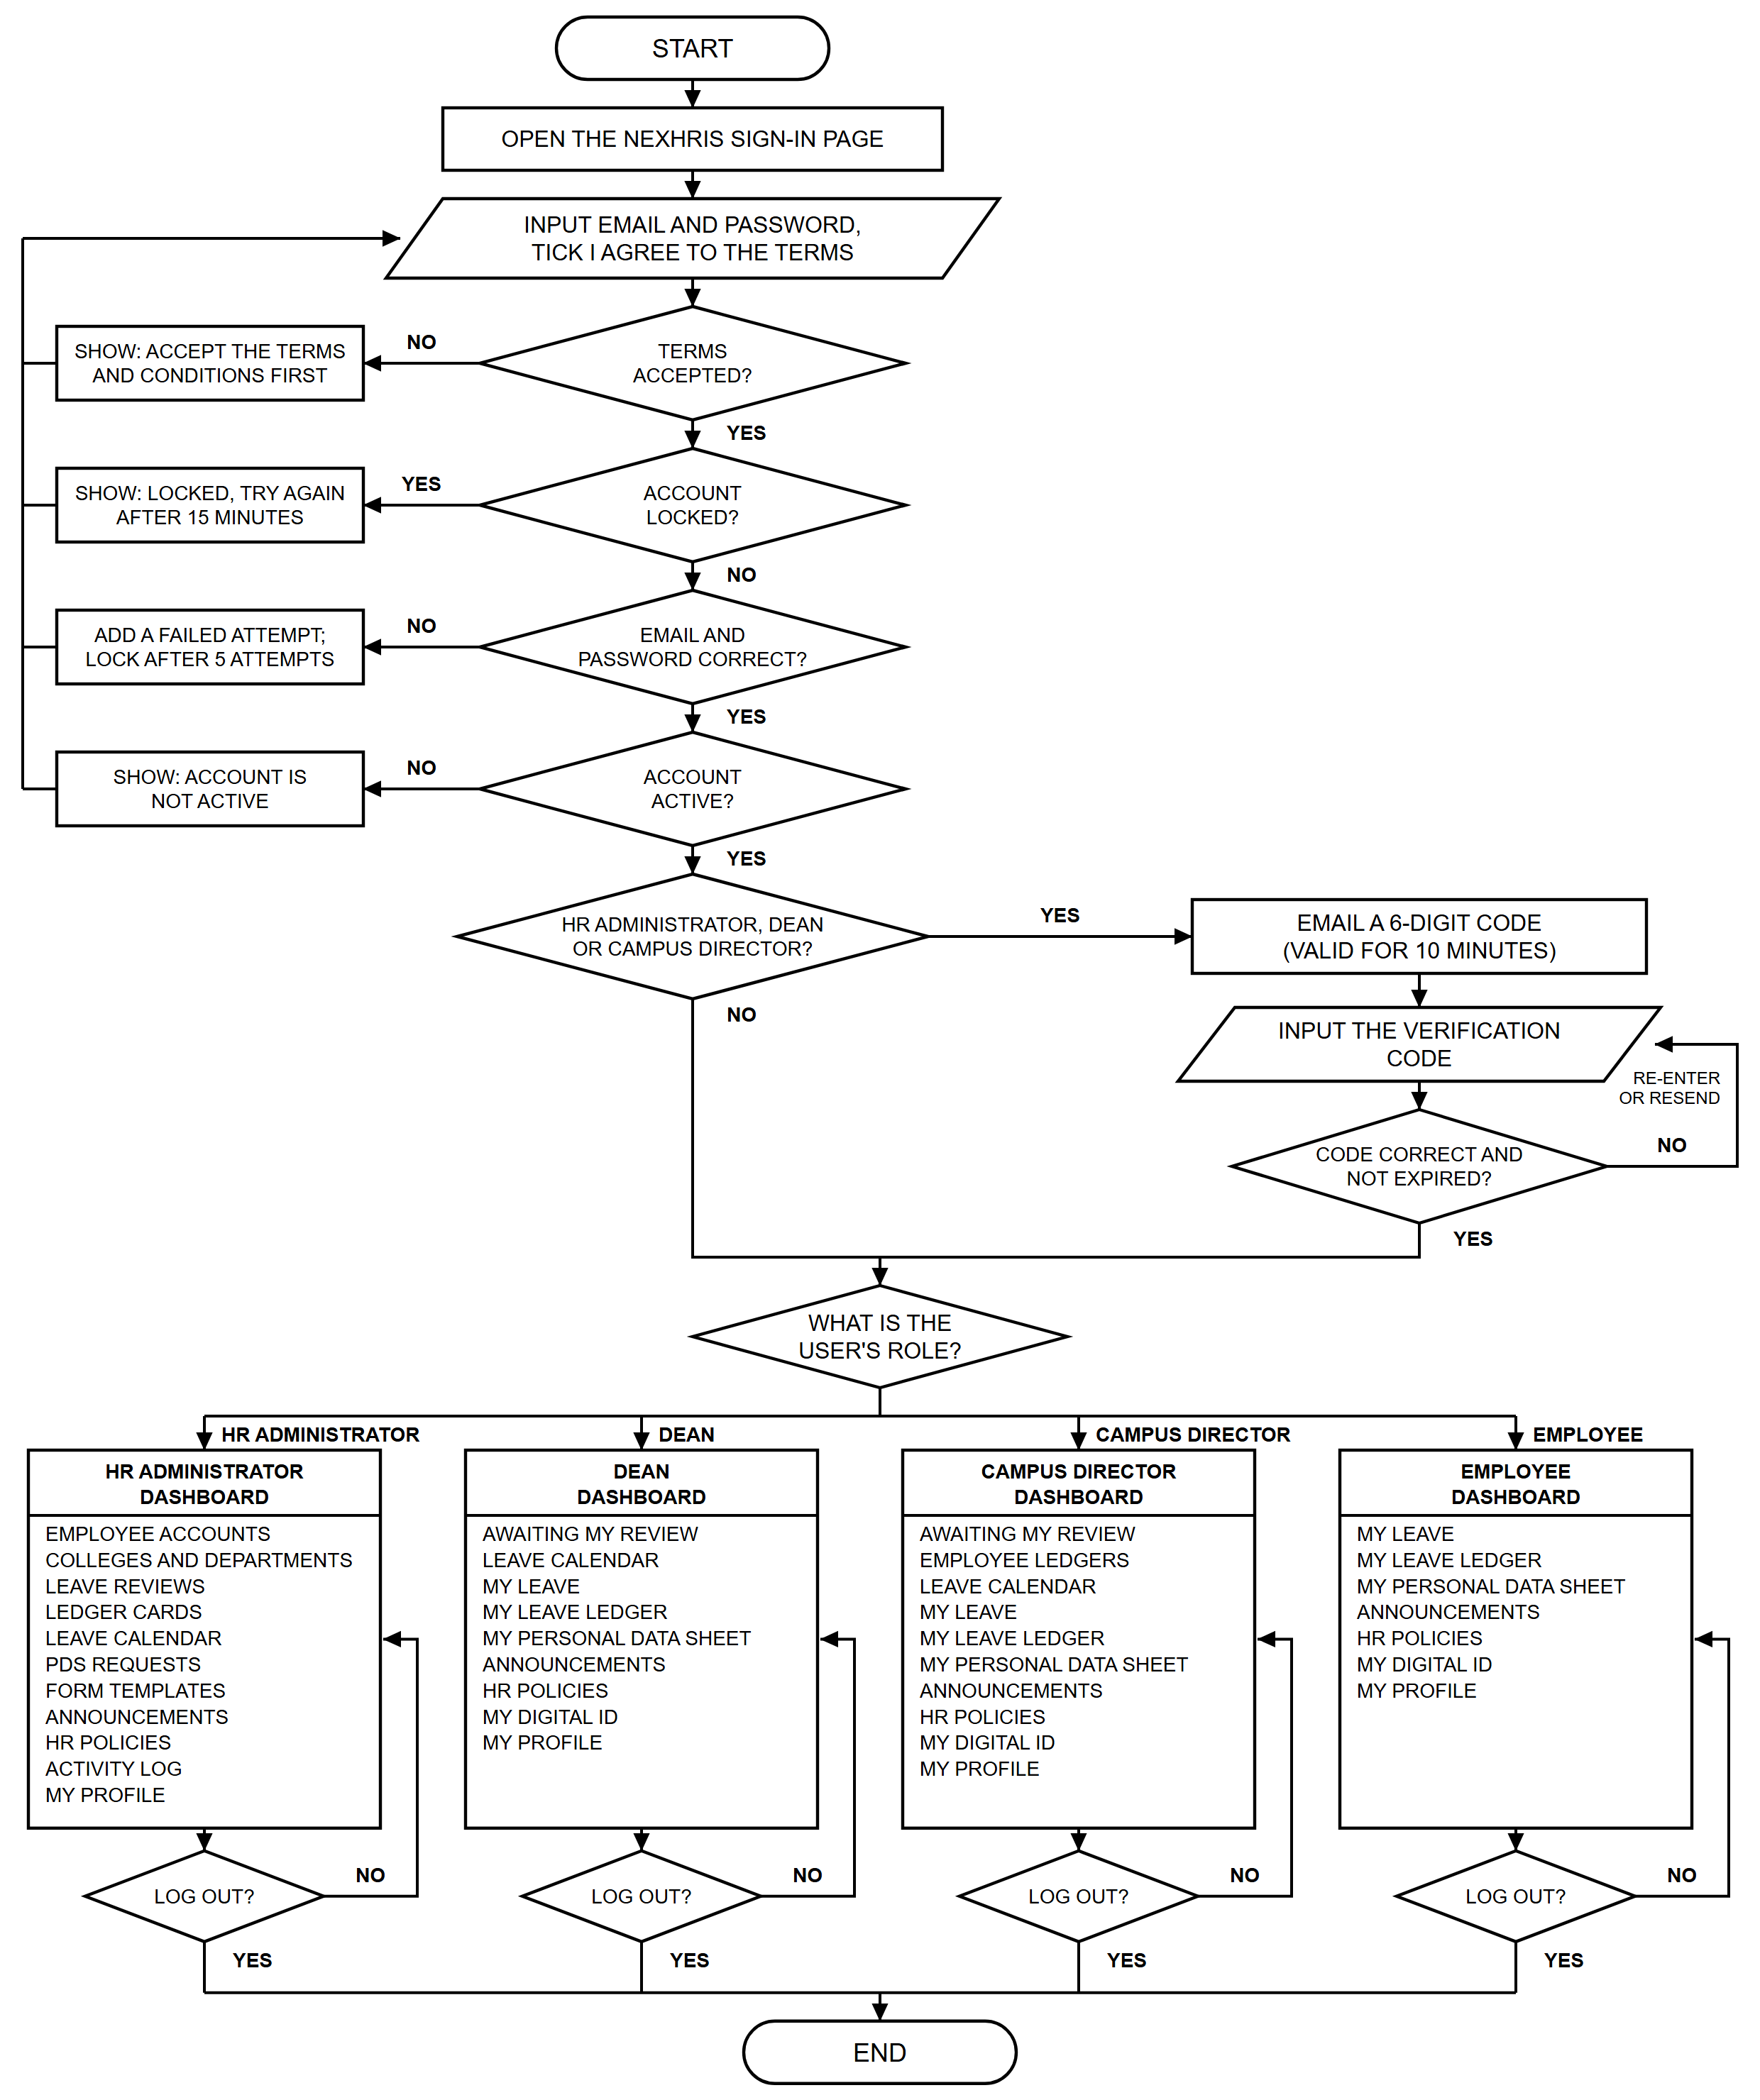

Appendix I. Input-Process-Output Chart
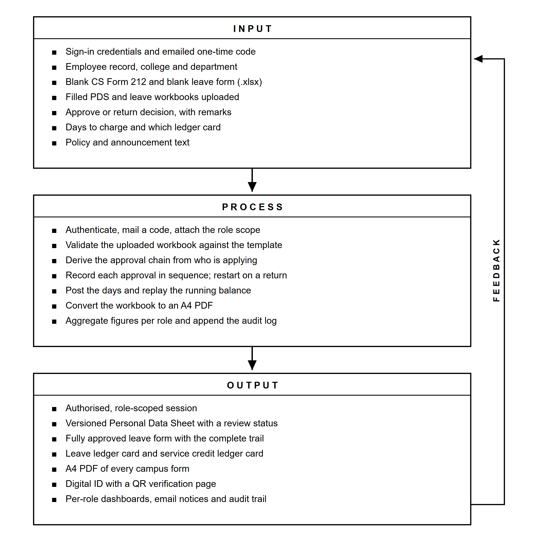

Appendix J. Complete System Plate Index
This appendix contains the complete index of interface screenshots for NexHRIS. Insert each captured screen below its corresponding caption. The order follows the module discussion in Chapter 3.
Plate 1. Sign-in Page with the Terms and Conditions
[Insert screenshot here]
Plate 2. Terms and Conditions
[Insert screenshot here]
Plate 3. Two-Factor Verification
[Insert screenshot here]
Plate 4. Verification Code Email
[Insert screenshot here]
Plate 5. Password Reset Request
[Insert screenshot here]
Plate 6. Refusal of Unauthorized Access
[Insert screenshot here]
Plate 7. HR Administrator Dashboard
[Insert screenshot here]
Plate 8. Dean Dashboard
[Insert screenshot here]
Plate 9. Campus Director Dashboard
[Insert screenshot here]
Plate 10. Employee Dashboard
[Insert screenshot here]
Plate 11. Employee Accounts
[Insert screenshot here]
Plate 12. Creating an Employee Account
[Insert screenshot here]
Plate 13. Employee Record
[Insert screenshot here]
Plate 14. Colleges and Departments
[Insert screenshot here]
Plate 15. My Profile
[Insert screenshot here]
Plate 16. Form Templates
[Insert screenshot here]
Plate 17. My Personal Data Sheet
[Insert screenshot here]
Plate 18. PDS Requests
[Insert screenshot here]
Plate 19. Reviewing a Personal Data Sheet
[Insert screenshot here]
Plate 20. Converted Personal Data Sheet
[Insert screenshot here]
Plate 21. Filing a Leave Application
[Insert screenshot here]
Plate 22. Tracking a Leave Application
[Insert screenshot here]
Plate 23. Dean Review Queue
[Insert screenshot here]
Plate 24. HR Administrator Leave Review
[Insert screenshot here]
Plate 25. Campus Director Final Approval
[Insert screenshot here]
Plate 26. Returning an Application with Remarks
[Insert screenshot here]
Plate 27. Printed Approval Sheet
[Insert screenshot here]
Plate 28. Leave Calendar of a College
[Insert screenshot here]
Plate 29. Campus-Wide Leave Calendar
[Insert screenshot here]
Plate 30. Ledger Cards
[Insert screenshot here]
Plate 31. Maintaining a Ledger Card
[Insert screenshot here]
Plate 32. Posting Approved Leave to the Ledger
[Insert screenshot here]
Plate 33. My Leave Ledger
[Insert screenshot here]
Plate 34. Printed Ledger Cards
[Insert screenshot here]
Plate 35. Leave Balances Report
[Insert screenshot here]
Plate 36. Employee Directory Report
[Insert screenshot here]
Plate 37. HR Policies Management
[Insert screenshot here]
Plate 38. Creating a Policy
[Insert screenshot here]
Plate 39. Policy Acknowledgment Tracking
[Insert screenshot here]
Plate 40. Reading and Acknowledging a Policy
[Insert screenshot here]
Plate 41. Announcements Management
[Insert screenshot here]
Plate 42. Announcements
[Insert screenshot here]
Plate 43. Notifications
[Insert screenshot here]
Plate 44. My Digital ID
[Insert screenshot here]
Plate 45. Public Verification Page
[Insert screenshot here]
Plate 46. Activity Log
[Insert screenshot here]

CURRICULUM VITAE
Insert the curriculum vitae of each researcher: photograph, personal information, educational background, and relevant training or experience.

