NexHRIS Use Case Diagram
Login and role-based navigation for the HR Administrator, Dean, Employee, and Campus Director
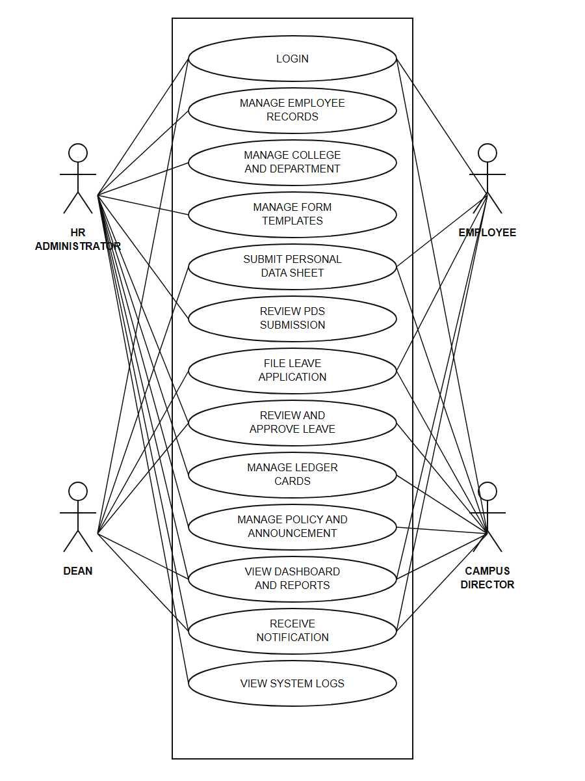
The system requires the user to log in first. After authentication, the dashboard and navbar expose functions according to the assigned role.

