

Bachelor Thesis
GeoTwit – Analysis

Miguel Santamaria
Table of contents
Introduction 3
Twitter API 3
Technologies 3
OAuth 4
REST / Streaming APIs 4
Introduction 4
Streaming API 6
REST API 11
Search of interesting subjects 16
Twitter4J 19
Geolocation's features 19
Google Maps 19
OpenStreetMap 20
Data grouping 20
Analysis of the existing 21

Introduction
This document contains various analysis I have done during the conception of the project. It especially details the possibilities the Twitter API offers, relating to the work to be performed.
Many links are given in this document, providing listings related to the API (requests' parameters, received messages' formats, etc.) or additional explanations, which would be useless to copy in this document.

Twitter API
Before starting notice that all the content of this chapter comes from the documentation of the official Twitter's development web site: https://dev.twitter.com/overview/documentation. Thus, many diagrams contained in this document are taken from this documentation.
Please also notice that Twitter offers a “Best Practices” page, which will be very helpful during the conception of the application, both to the security and the optimization: https://dev.twitter.com/overview/general.
To create a new application using the Twitter API, you have to go there: https://apps.twitter.com/.

Technologies
Twitter offers many tools to developers to facilitate the use of their technologies within applications, which include:
- Fabric: mobile development tool used to easily interact in a stable way with the social features of Twitter (sharing, connexion, etc.).
- Twitter for Websites: widgets collection, which easily integrates Twitter's widgets (Tweet and “Follow” buttons, Tweets displaying, etc.) in a web site.
- OAuth: an authentication way used with the Twitter API for securing and authorizing the different executed requests. Notice that this is not a technology developed by Twitter but a free protocol. You can find more details about the this in the following chapter.
- REST APIs: provide a read and write access to the data of Twitter as a JSON format or via OAuth to use them in programming. They work like most of the APIs provided by services of this kind.
- Streaming APIs: those APIs continually send responses to the requests of the REST APIs trough a persisted HTTP connexion. They can be useful to continually display Tweets linked to a given hashtag and thus to automatically show new Tweets matching with the filter.Fabric: mobile development tool used to easily interact in a stable way with the social features of Twitter (sharing, connexion, etc.).
- Twitter for Websites: widgets collection, which easily integrates Twitter's widgets (Tweet and “Follow” buttons, Tweets displaying, etc.) in a web site.
- OAuth: an authentication way used with the Twitter API for securing and authorizing the different executed requests. Notice that this is not a technology developed by Twitter but a free protocol. You can find more details about the this in the following chapter.
- REST APIs: provide a read and write access to the data of Twitter as a JSON format or via OAuth to use them in programming. They work like most of the APIs provided by services of this kind.
- Streaming APIs: those APIs continually send responses to the requests of the REST APIs trough a persisted HTTP connexion. They can be useful to continually display Tweets linked to a given hashtag and thus to automatically show new Tweets matching with the filter.
The various technologies I listed above are the ones, which are potentially interesting within the project. After a quick analysis it turns out that the tools, which will be useful and helpful are the REST API and the Streaming API, together with the OAuth for the security. It is indeed currently (at least in the first instance) not planned to use mobile technologies and the widgets option is not wide and complex enough to allow us to use it.

OAuth
The current version of the Twitter API (v1.1) uses the version 1.0A of the OAuth protocol. The developer can choose between two ways of authentication within his application:
- Application-User authentication: the most common form of resource authentication with APIs of this kind (Instagram, Facebook, Twitter, etc.). Signed requests both identify the identity of our application as well as the end-user we make API calls on behalf of.
In terms of being specific, the user using the application must have a Twitter account and have to connect it, then accept the access right of the application to his account (according to the rights asking by the developer: Tweets reading, Tweets posting, etc.) in order to get an access token. Later, all executed requests will be signed by this token linked to the current application and user.
In order to use this method, the user must therefore have a Twitter account and trust enough the application to grant reading and/or writing rights on the Twitter's data.
- Application authentication only: the application executes the requests of the API on its own behalf without a user context. This method could at the first sight seem interesting but is unfortunately limited in the list of possible calls to the API. It is indeed possible to search for Tweets and get users information, but we cannot use either geographic data or streaming components...
Despite the ergonomic issues the first method (application-user authentication) could create, we will still keep it. Indeed, the second method does not allow us to use either geolocation or streaming, which is essential to the real-time visualization of Twitter's activities.

REST / Streaming APIs

Introduction
As a reminder, the REST API identifies the Twitter applications and the users by using OAuth and by providing JSON-formated responses. It allows us, among other things and according to the granted rights, to read and post a new Tweet, read the profiles of the users, etc. The last released version (namely v1.1) works in the following manner:
In a nutshell, the user makes request executed by the server, which receives responses and forwards them to the client.
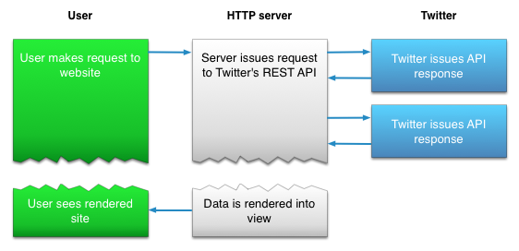Illustration 1: Use case of the REST API within a web application.
Now let's have a look at the Streaming API working (which also use OAuth and JSON), used to dynamically show results of search in real-time:
The operation is here a little more complex: the code maintaining the Streaming is executed in a separated process while another one is processes the HTTP requests.
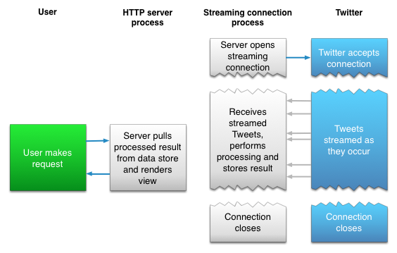Illustration 2: Use case of the Streaming API within a web application.
There is 3 types of endpoints:
- Public streams: stream of the public data flowing through Twitter, which can be filtered by keywords, users, etc.
- User streams: single-user stream, containing roughly all of the data corresponding with a single user's view of Twitter.
- Site streams: the multi-user version of the user streams.
For obvious reasons the public stream is the endpoint we will use.
For following the specifications of the project we will mainly use the Streaming API, in the sens that it has been asked to be able to visualize the activities of the Twitter's subjects in real-time. We though won't set aside the REST API, because it could be useful for the comprehension of the Streaming, which search algorithms' are based on it.

Streaming API
To initialize a stream based on a filter we just have to execute a specific HTTP request (detailed above), indicating the Twitter's servers we want to connect. We then only need to maintain the connexion open so the servers will send us data at regular intervals.
To know we are still connected, the Twitter's servers send us each 30 seconds a message indicating that the connexion is still active (in case where there would be no new actualities). If no confirmation is received after 90 seconds we need to connect again to the stream.
Since there is no other way to test the Streaming API than developing a little application, I won't come to the question here. Notice that search examples are though presented in the “REST API” part of this document, which you can find above.
Limitations
In order to prevent the Twitter's servers to be overloaded by “churns” (a large number of connexions' opening and closing requests), Twitter restricts the possible number of connexion requests in a in a time frame. Once a client exceeds this number, it will receive a HTTP response containing the 420 error code; for unclear reasons Twitter privately keep the maximum number of possible connexions as well as the time frame value. Notice that if the limit is regularly exceeded, Twitter will block our IP address for a while so we have to take this problem into account.
Please also notice that the Streaming is ill advised with mobiles using cellular network, because of the disconnection → connection risk, which is high and can so create “churns”.
For more information about the connexion methods, you can go here: https://dev.twitter.com/streaming/overview/connecting.
Subscription to Twitter's subjects
As stated above, it is necessary to make a HTTP request to indicate the servers of Twitter we want to subscribe to a particular stream. This request must/can have several parameters, which notably allow to give various minor parameters to the server, the wanted language of the Tweets, the filters (keywords, hashtags, etc.), the desired location, etc. Those parameters are detailed here: https://dev.twitter.com/streaming/overview/request-parameters.
Regarding to the location, the Streaming API uses bounding boxes. In other words, it is a rectangular area defined by a pair of geographic coordinates (a longitude and latitude pairs; be aware of the fact we are more used to see coordinates in the “latitude,longitude” format), with the southwest corner of the bounding box coming first, followed by the northeast coordinate. It is possible to have many bounding boxes in one request, separated by commas.
For example, if we want to search Tweets in Switzerland, we have to give the following coordinates: 5.956085,45.817851 and 10.489254,47.808454.
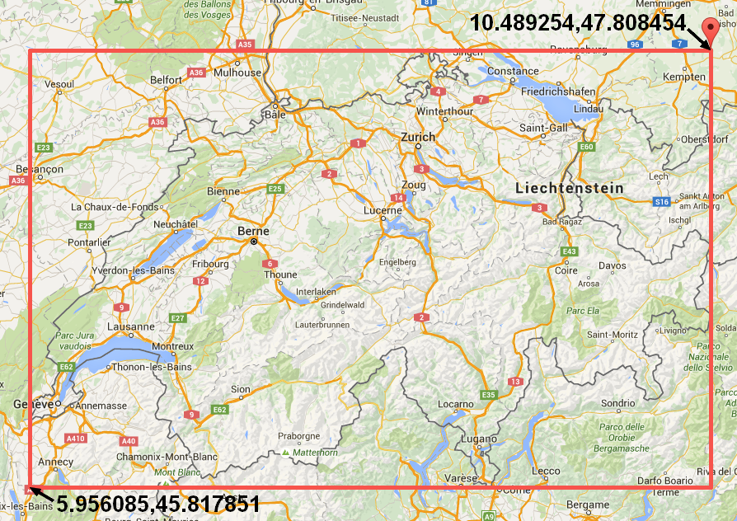Illustration 3: Graphical representation of the coordinates pair bounding Switzerland.
Beware however, the location does not act as a filter for the other filters, which means the request “track=twitter&locations=5.956085,45.817851, 10.489254,47.808454” will search Tweets containing the “twitter” keyword OR located in Switzerland. To better understand the operation of the location “filter”, I conducted several tests. It is important to notice that those tests has been realized with the “twitter4jDesktop” test-application and with the Streaming API; the used keyword was “michel” and to location was a rectangle bounding the USA ({-124.411668, 24.957884}, {-66.888435, 49.001895}). This tuple of keyword/location was used to avoid getting too much results and to (unsuccessfully) isolate information

- Search with keyword only → the obtained results are correct and correspond to the keyword:
However they are coming from all around the word, which restrict the use cases within the application…
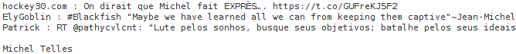Illustration 4: Search of Tweets with keyword only.
- Search with the location only → we're obtaining anything and everything here: indeed, most of the returned Tweets don't have geographic coordinates. This can be explained by this “OR” applied on the search: the application is going to display all Tweets coming from the location area OR the Tweets corresponding to the keyword (namely an empty keyword so any Tweet). In summary, absolutely all Tweets are displayed...
- Search with keyword AND location → at first sight we expect this method to provide good results, but no… It is indeed a simple application of the logical operator OR: the application is going to display all Tweets having the keyword “michel” OR written in the USA (without taking in account the keyword…), which will give incongruous results again.
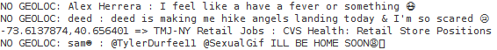Illustration 5: Search of Tweets with location only.
Illustration 6: Search of Tweets with keyword and location.
The Tweets don't necessary having a geolocation tag (I did some tests and obtained a rate of about 20-30% of Tweets having geographic data), we also want to filter the received results on-the-fly to only accept those which have one.
None of these search methods gave appropriate results… This would be a huge problem, because we wish to search Tweets by a keyword AND a location. Therefore, I will have no option but code my own location filter, which will be applied to the results of a search by keywords. In this example I used the “job” keyword in the USA:
Illustration 7: Search of Tweets with keyword and a manual filtering of the location.
Two different approaches are possible here:
- Search Tweets by keywords and (in reality OR) geolocation, and thereafter apply a manual filtering by keywords AND geolocation for countering the logic filter OR. Here are the results I got in two periods of 5 minutes with the “job” keyword and in the USA (by around 15:30, Swiss time zone):
“I received 8061 Tweets in 300 seconds, including 314 ones WITH geolocalion tags and 284 ones with the wanted geolocation.
This means 3.9 % of the received Tweets with the "job" tag(s) owned a geolocation tag and 3.52 % contained the desired location.
I received 6980 Tweets in 300 seconds, including 225 ones WITH geolocalion tags and 215 ones with the wanted geolocation.
This means 3.22 % of the received Tweets with the "job" tag(s) owned a geolocation tag and 3.08 % contained the desired location.”
Results are here disappointing with only about 3-4% of Tweets having a geolocation tag.
- Search Tweets by keywords, and then apply a manual filtering of the geolocation.
“I received 2290 Tweets in 300 seconds, including 548 ones WITH geolocalion tags and 516 ones with the wanted geolocation.
This means 23.93 % of the received Tweets with the "job" tag(s) owned a geolocation tag and 22.53 % contained the desired location.
I received 2774 Tweets in 300 seconds, including 571 ones WITH geolocalion tags and 535 ones with the wanted geolocation.
This means 20.58 % of the received Tweets with the "job" tag(s) owned a geolocation tag and 19.29 % contained the desired location.”
Results are way more convincing here, with about 20% of Tweets having the desired geolocation tag. Even if we received about 3 to 4 times less Tweets than before, we still received more interesting Tweets. Thus, this solution will be the one I will keep.
In addition of receiving JSON messages containing Tweets' data (formated in the following way: https://dev.twitter.com/overview/api/tweets), it is also possible to receive other kind of messages from the servers of Twitter. For example, to indicate a deletion of Tweets or of geolocation tags, a disconnection, a limit reached, etc. All messages' types are available right here: https://dev.twitter.com/streaming/overview/messages-types.
Optimizations
In order to reduce the bandwidth, it is possible to ask servers compressed Gzip data with the following HTTP header: “Accept-Encoding: deflate, gzip”.
Twitter also warns us about the fact that it is possible to receive a huge amount of data during worldwide or important cultural events. It is thus advisable to make tests in order to control if our application can carry this massive flow and take measures in consequences.
Also, for optimization reasons, the servers use the “Chunked transfer encoding” data transfer mechanism, which means they start to send data in a series of "chunks" without knowing the length of the content before starting transmitting a response to the receiver. Our client must so be compatible with this type of transfer.
Be finally aware of the fact the received messages are not necessarily ordered and can be received many times.

REST API
Here is some analysis below about the REST API, which can be useful in the future of the project.
Limitations
First of all, it should be noted than the API have some limitations to ensure the security of the platform, and to avoid the Twitter's server to be overloaded by requests. Limitations are mainly used on the number of requests, which can be performed by periods of 15 minutes by window. Notice that if our application is too regularly limited it may be put on black list, which will forbid the access to the API and therefore to make other requests. For this reason we will need to properly optimize the number of sent requests.
When an application exceeds the rate limit of authorized requests, the Twitter's API send back a “429: Too Many Requests” HTTP response code, which allows us to indicate the user he reached the limit of requests imposed by Twitter for the current type of request.
The HTTP headers contain, among other things, information concerning the current rates of made and remaining requests:
- X-Rate-Limit-Limit : indicate the rate limit of requests for the type of given request.
- X-Rate-Limit-Remaining : indicate the number of remaining requests for the type of given request and for the current period of 15 minutes.
- X-Rate-Limit- Reset : the remaining time before the reset of the next period of 15 minutes.
The limit of each type of request can be accessed here: https://dev.twitter.com/rest/public/rate-limits.
Tweets search
The search API belongs to the Twitter's REST API. It allows us to search Tweets by various criteria (latest or popular Tweets containing or not keywords or hashtags, filtered by language and by geolocation, etc.). Due to the massive quantity of data to process and therefore for performances reasons, search only takes in account Tweets published during the 7 last days preceding the request.
Regarding the location, this API directly uses the geolocation. First thing first, it is strictly speaking not possible to search near a specific location: we have to use a specific geocode in the “latitude,longitude,radius” format, where radius is the search radius in miles (mi) or in kilometers (km), having for center' point the given latitude and longitude.
The API will firstly try to get Tweets containing information about the wanted latitude, longitude and radius, and then in a second time if there is no result, will search for Tweets whose users' profiles match with the desired geolocation parameters.
For example, if we want to search Tweets in a radius of 50 kilometers around the main station of Yverdon-les-Bains (whose coordinates have been found on Google Maps), the parameters will have the following values: “46.783177,6.640630,50km”.
Within the project, this parameters need a more in depth analysis: ideally, the user should just point a location on a map and indicate the radius he wants, resulting an automatically getting of the longitude and latitude associated to this location in the background. It could also be possible to propose default locations (for example “in the German part of Switzerland”, which would point a little on the East of Switzerland with a pre-calculated radius; we could also imagine default locations by country or states). Many libraries/API exists and allows us to easily get coordinates by a pointed location. The most well known of them undoubtedly is Google Maps, but other alternatives like OpenStreetMap exists and will be analyzed below.
Many search filters exists and are accessible on the following web page: https://dev.twitter.com/rest/public/search. Most of these parameters are also compatible with the Streaming API. Among them, we will mainly be interested about the ones regarding the search of keywords and hashtags. Be aware of not forgetting to properly encode search in order for them to be valid in an URL!
In addition of these filters, there is other parameters – allowing a better control on the search – such as the type of results (the latest and/or most popular Tweets), the geolocation, the language of the Tweet or even parameters allowing to iterate on Tweets in an easily way (count, until, since_id, max_id).
Notice that it is also possible to search for Tweets by the ID of locations. For example, the Tweets emitted from the Twitter's headquarters can be found due to the “place%3A247f43d441defc03” parameter. More information can be found here: https://dev.twitter.com/rest/public/search-by-place. This parameters will certainly be less useful than the geolocated search, but still deserves to be on this documentation.
Examples
For the purpose of easily generate search requests, the advanced search tool was used for the coming couple of examples: https://twitter.com/search-advanced. Whenever a search is made, we are redirected on a web page containing a URL, which is built on a particularly format. For example, with a search about the @twitterapi user, we get the following redirection's URL: https://twitter.com/search?q=%40twitterapi. One done we can get the valid URL to use in the API by replacing “https://twitter.com/search” by “https://api.twitter.com/1.1/search/tweets.json” (in our example: https://api.twitter.com/1.1/search/tweets.json?q=%40twitterapi).
In addition, the various tests have been conducted with the API console tool provided here by Twitter: https://dev.twitter.com/rest/tools/console. Beforehand and in order to be able to make requests, we have to authorize the console to access our own Twitter account. It is automatically asked as soon as we try to make a first request.
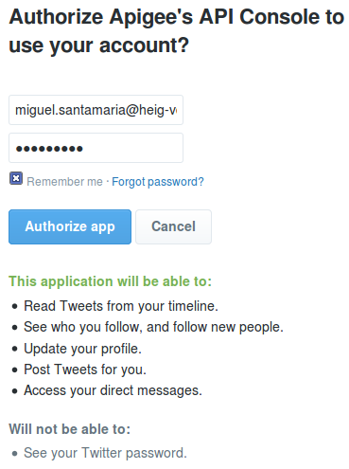Illustration 8: Authorization of the API console through our Twitter account.
Here is a list containing a few examples, and which can turn out to be subsequently useful:
- Search of the latest French Tweets having “yverdon” as keyword and (in reality OR, like we saw before) being located in a radius of 10 kilometers from the Yverdon-les-Bains' main station.
- Request: https://api.twitter.com/1.1/search/tweets.json?q=yverdon&geocode=46.783177,6.640630,10km&lang=fr&result_type=recent
- Results:
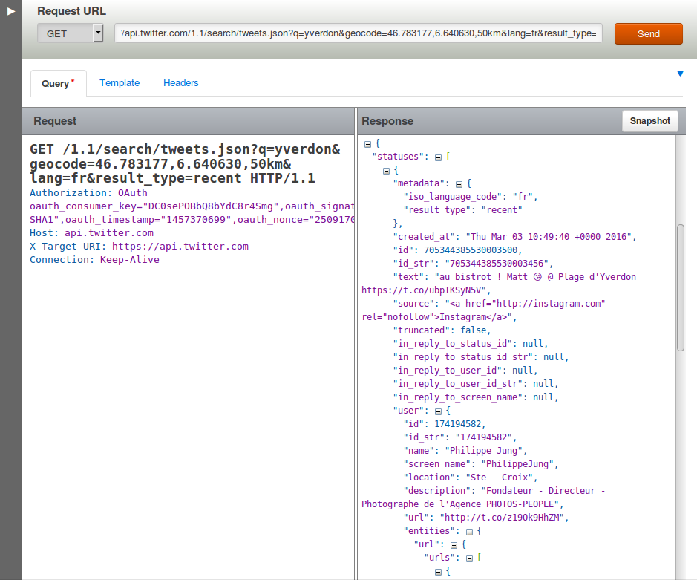Illustration 9: Result in the API console of the latest French Tweets containing the “yverdon” keyword and being located near Yverdon-Les-Bains.
- Results on Twitter (by changing the beginning of the URL):
Illustration 10: Result on Twitter of the latest French Tweets containing the “yverdon” keyword and being located near Yverdon-Les-Bains.
- Search of popular and positive (containing a happy “:)” smiley) Tweets, having the “#pizza” hashtag and (OR) being located in a radius of 100 kilometers from the center of Rome (without taking care of the language)
- Request: https://api.twitter.com/1.1/search/tweets.json?q=%23pizza%20%3A%29&geocode=41.894143,12.495479,100km&src=popular
- Results on Twitter:
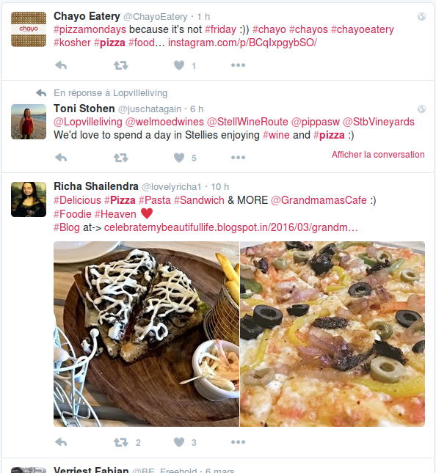Illustration 11: Results on Twitter of the popular and positive Tweets, having the “#pizza” hashtag and being located near to Rome.

Search of interesting subjects
This section contains various Twitter's subjects, which can be interesting in the project. These tests have been conducted with the “twitter4jDesktop” application between 16:30 and 18:30, Swiss hours, and during April 25th 2016. All tested subjects are noted in the following table; notice that it is possible to start only two instances of the same application following a Twitter streaming at the same time.
Subject | Geolocation (location, coordinates) | Nb. of new Tweets in 5 min.
zurich | Switzerland, {5.956085, 45.817851}, {10.489254, 47.808454} | 0
fondue | Switzerland, {5.956085, 45.817851}, {10.489254, 47.808454} | 0
logitech | Switzerland, {5.956085, 45.817851}, {10.489254, 47.808454} | 0
nestlé | Switzerland, {5.956085, 45.817851}, {10.489254, 47.808454} | 1
swatch | Switzerland, {5.956085, 45.817851}, {10.489254, 47.808454} | 0
job | Switzerland, {5.956085, 45.817851}, {10.489254, 47.808454} | 1
sport | Switzerland, {5.956085, 45.817851}, {10.489254, 47.808454} | 0
people | Switzerland, {5.956085, 45.817851}, {10.489254, 47.808454} | 0
containing a 'e' | Switzerland, {5.956085, 45.817851}, {10.489254, 47.808454} | 0
bbc | UK, {-8.306947, 49.696022}, {1.801128, 59.258967} | 0
london | UK, {-8.306947, 49.696022}, {1.801128, 59.258967} | 15
paris | France, {-4.805145263671875, 42.34528267746347}, {8.232879638671875, 51.09052797518529} | 5
roma | Italy, {6.6357421875, 47.09805038936004}, {18.6328125, 36.577893995157474} | 0
pizza |  | 0
pizza | USA, {-124.411668, 24.957884},  {-66.888435, 49.001895} | 3
job | USA, {-124.411668, 24.957884},  {-66.888435, 49.001895} | 618
sport | USA, {-124.411668, 24.957884},  {-66.888435, 49.001895} | 0
people | USA, {-124.411668, 24.957884},  {-66.888435, 49.001895} | 4
vote | USA, {-124.411668, 24.957884},  {-66.888435, 49.001895}
trump | USA, {-124.411668, 24.957884},  {-66.888435, 49.001895}
clinton | USA, {-124.411668, 24.957884},  {-66.888435, 49.001895}
logitech | USA, {-124.411668, 24.957884},  {-66.888435, 49.001895} | 0 or 1
nestlé | USA, {-124.411668, 24.957884},  {-66.888435, 49.001895} | 0 or 1
novartis | USA, {-124.411668, 24.957884},  {-66.888435, 49.001895} | 0 or 1
swatch | USA, {-124.411668, 24.957884},  {-66.888435, 49.001895} | 0 or 1
mcdonald's | USA, {-124.411668, 24.957884},  {-66.888435, 49.001895}
java | USA, {-124.411668, 24.957884},  {-66.888435, 49.001895}
scala | USA, {-124.411668, 24.957884},  {-66.888435, 49.001895}

As regards the recurring themes related to Switzerland, I though about two main categories: the Swiss medias and the active companies. I conducted some bad-resulting tests about companies with the following keywords: “coop”, “glencore”, “logitech”, “migros”, “nestlé”, “novartis” and “swatch”. I deliberately did not put all these words in the table above, because of the insufficient refreshment rate (zero or one Tweet per 5 minutes).
Concerning the medias, I have endeavored to think about recurrent keywords, which could be used in the whole Switzerland (French, German and Italian parts) like “job”, “sport” or “people”, but without success: results were indeed bad again. In a desperate attempt to find Tweets with geolocation in Switzerland, I searched for Tweets containing the 'e' letter (which is pretty common) and received here again zero Tweets, so I decided to move to other countries. I took other Europeans countries first, like UK, France or Italy: most of the tested keyword were still unsuccessful, but I found some of them giving better results, like some of the main European cities.
After all these failures I decided to move to the USA, which are pretty known to use social medias in a stronger way than Europe. I was testing again all the previous keywords when I came across the holy grail: “job”. I received more than 600 results in a 5 minutes period. Surprised, I tested again and received 618 results again! I also tried more typical American subjects – like “vote”, “trump”, “clinton”, “mcdonald's” – and computer subjects like “java” or “scala” but they were way less interesting.
In conclusion, results are pretty bad. We got an average of better results when searching in the USA, especially for the “job” keyword, which is the only keyword giving good results. Switzerland has been quickly eliminated of the interesting countries as well as the other European countries, due to zero rate of Tweets having geolocation tags.
In addition to these few examples, we could think about other interesting cases linked to particularly events: a keyword corresponding to a subject of Swiss votes during the Sunday in which results are given, the name of a candidate in the U.S.A.'s elections during the results day (be careful about the massive flow of data!); the name of a show during its transmission to the TV; the name of a sporting event's winner; etc.
Finally, here is a little “planning” of hot and interesting coming topics until the end of the semester:
Date | Subject
17.03.2016 | Hockey : LHC – HC Ambri-Piotta
17.03.2016 | St. Patrick
27.03.2016 | Easter
21.04.2016 | 90 years of the Queen Elizabeth
23.04.2016 | 400 years of Shakespeare
23.04.2016 au 24.04.2006 | 20KM of Lausanne
08.05.2016 | Football : FC Sion – BSC Young Boys
09.05.2016 | Transit of Mercury in front of the Sun
11.05.2016 au 22.05.2016 | 69th Cannes Festival
14.05.2016 | Eurovision in Stockholm
16.05.2016 au 05.06.2016 | Tennis : Roland-Garros
29.05.2016 | Football : Final of the “Coupe de Suisse”
05.06.2016 | Swiss votes
10.06.2016 au 10.07.2016 | UEFA Euro 2016
29.06.2016 au 04.07.2016 | “Tour de France” 2016
01.07.2016 au 16.07.2016 | 50th Montreux Jazz Festival
19.07.2016 au 24.07.2016 | Paléo Festival Nyon
20.07.2016 | “Independence Day Resurgence” film release
22.07.2016 | “Star Trek Beyond” film release
01.08.2016 | National day of Switzerland
04.08.2016 au 14.08.2016 | “Fêtes de Genève”
05.08.2016 au 21.08.2016 | Olympic Games of Rio de Janeiro
07.09.2016 au 18.09.2016 | Paralympic Games of Rio de Janeiro
25.09.2016 | Swiss votes
29.10.2016 au 30.10.2016 | Lausanne's marathon
08.11.2016 | Elections in the U.S.A.

This non-exhaustive list can be completed with other events during the whole semester.

Twitter4J
Twitter4J (http://twitter4j.org/en/index.html) is a non-official library, which – as its name implies – allows us to easily use the features of the Twitter's APIs with Java. Given that Java classes are fully compatibles with the Scala classes, it turns out that this library is easily usable with the Scala programming language.
It works both with the OAuth technology and the Gzip compression and is 100% compatible with the version 1.1 of the Twitter's API. The advantages of this library lies in the fact that it significantly simplifies the APIs uses (both Rest and Streaming), at the level of both data reading and writing. The documentation of this library have examples of using for each specific case, as well as many useful explainations.

Geolocation's features
In order to make the web site as ergonomic as possible, we will need to use a library to be able to display and work with geographic maps. Two technologies will be analyzed in this section: the unmistakable Google Maps, and one of its main open sourced rival, OpenStreetMap.

Google Maps
The Google Maps API (https://developers.google.com/maps/?hl=fr) seems very intuitive and user friendly, but is however very problematic at the limitations level: if we indeed wish to use the site in a proper way, we will one way or another need to pay for this service, in order to not be limited at the requests rate level, which is hardly practicable within a Bachelor thesis.

OpenStreetMap
OpenStreetMap (currently v0.6) – proposed as an alternative by Mrs. Fatemi – is a direct and free competitor of Google Maps and also have a REST API (http://wiki.openstreetmap.org/wiki/API_v0.6). Although this technology is open sourced, that does not mean that it is obsolete or slower: for example, it also uses the now well known OAuth protocol.
This technology gets very interesting for this project when coupled to a JavaScript library – also open sourced and very light – allowing to easily manipulate maps and add them some effects: Leaflet (http://leafletjs.com/index.html). In our case, the interest of this library – in addition to the main features offered by the map – especially lies in the fact that it allows us to easily communicate with the OpenStreetMap's API. We can also easily draw circles (by a latitude, a longitude and a given radius), rectangles or custom polygons on the map (usable for geolocation features; you can find an example here: http://leafletjs.com/examples/quick-start.html), add annotations as panels. It finally also is fully compatible with the mobile word, which is interesting for scalability issues.
The the above reasons, this technology will be the one used within the project for all the geographic requirements.

Data grouping
We are going to deal with two major big data issues :
- Data sending from our server to our client ; by doing my tests, I sometimes got issues when I lost my Internet connection for a few second : as soon as I got my connection again, the server started to send one by one thousands of Tweets to the client in a very limited time, making my web browser crash… To avoid this case we will have to use an algorithm to group data before sending them to the server.
- Data displaying on the map : since there will be thousands of Tweets to display on a map, we will have to group them again with a clustering algorithm.
I analyzed some existing solutions, and one of the most interesting one was without a doubt the marker-cluster plug-in proposed by Leaflet again (https://github.com/Leaflet/Leaflet.markercluster). This provides a lot of interesting functions, is fully compatible with the Leaflet library (because Leaflet wouldn't develop libraries incompatible with their main library), and can handle up to 50'000 marker in one map! You can find examples here : http://leaflet.github.io/Leaflet.markercluster/example/marker-clustering-realworld.10000.html and http://leaflet.github.io/Leaflet.markercluster/example/marker-clustering-realworld.50000.html.

Analysis of the existing
There is already many existing applications allowing an user to show Tweets on a map, among which :
- One Million Tweet Map (http://onemilliontweetmap.com/): the one million tweet map application approaches what will be done during this project, by displaying real-time Tweets (filtered or not) on a map with grouping methods.
- TrendsMap (http://trendsmap.com/ - found via mashable.com/): this application shows a real-time mapping of Twitter trends across the world. If you click on any word you will see a real-time stream of relevant Tweets. You have to register and / or pay to access more content.
- Tweetping (https://tweetping.net/): shows real-time reception of Tweets all across the world on a map.
- TweetMap (https://worldmap.harvard.edu/tweetmap/): with this tool you can visualize Tweets, which have been written in a given period, and watch some interesting graphs.
- Stweet (http://www.we-love-the.net/Stweet/ found via mashable.com/): this service mashes up Twitter and Google Street View, providing a location-based look at the neighborhood Tweets.
- GeoChirp (http://www.geochirp.com/): this app allows you to search for Tweets in a given location, but only in a static way (no streaming then).
- Tweet To Map (http://tweettomap.com/): this web plug-in allows you to put markers on a map, based on Tweets' data ; as I am writing, it only supports static Twitter content, so I won't use it.

