

Travail de Bachelor
GeoTwit
OpenStreetMap, Leaflet and Mapbox

Miguel Santamaria
Table des matières
Introduction 3
Installation 3
Examples 4

Introduction
This document contains examples and explanations about the using of the OpenStreetMap's API used with the Leaflet library and the Mapbox API.
The Leaflet library (http://leafletjs.com/index.html) provides easy-to-use features to interact with Maps. It uses both OpenStreetMap for the map's data and Mapbox for the map's imagery.
For information OpenStreetMap provides two different APIs : the live-API (http://api.openstreetmap.org/) and another used for tests (http://api06.dev.openstreetmap.org/). This doesn't really matter here, because of the Leaflet library, which acts like a wrapper.
Mapbox (https://www.mapbox.com/) is a platform, which provides map's design as blocks to easy integrate location into online applications.

Installation
Before interacting with all the Leaflet's components you will have to create an account on the Mapbox platform (https://www.mapbox.com/studio/signup/) and then you have to:
- Get the default API's token or create a new one if you want (https://www.mapbox.com/studio/account/tokens/) and write it somewhere.
- Create a MapBox project (https://www.mapbox.com/studio/classic/projects), which will be used by the Leaflet library to provides imagery. Once done you have to get the project's ID and write it somewhere.
Illustration 1: A MapBox project.
Finally, you can create a simple web-application and extract the downloaded Leaflet library into it, then follow the quick-start tutorial (http://leafletjs.com/examples/quick-start.html), which is well explained. Just be careful when you will have to call the map's layer with MapBox; your code must looks like this:
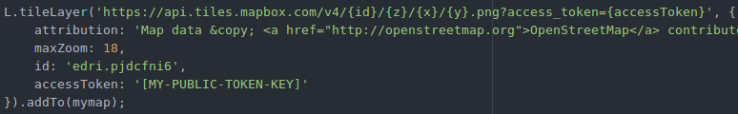Illustration 2: MapBox integration into Leaflet.

Examples
You can find my examples' code in the “/tests/leaflet” repository.
Please notice that there is no inputs controls and the GUI is very poor, because this only is a test-application.
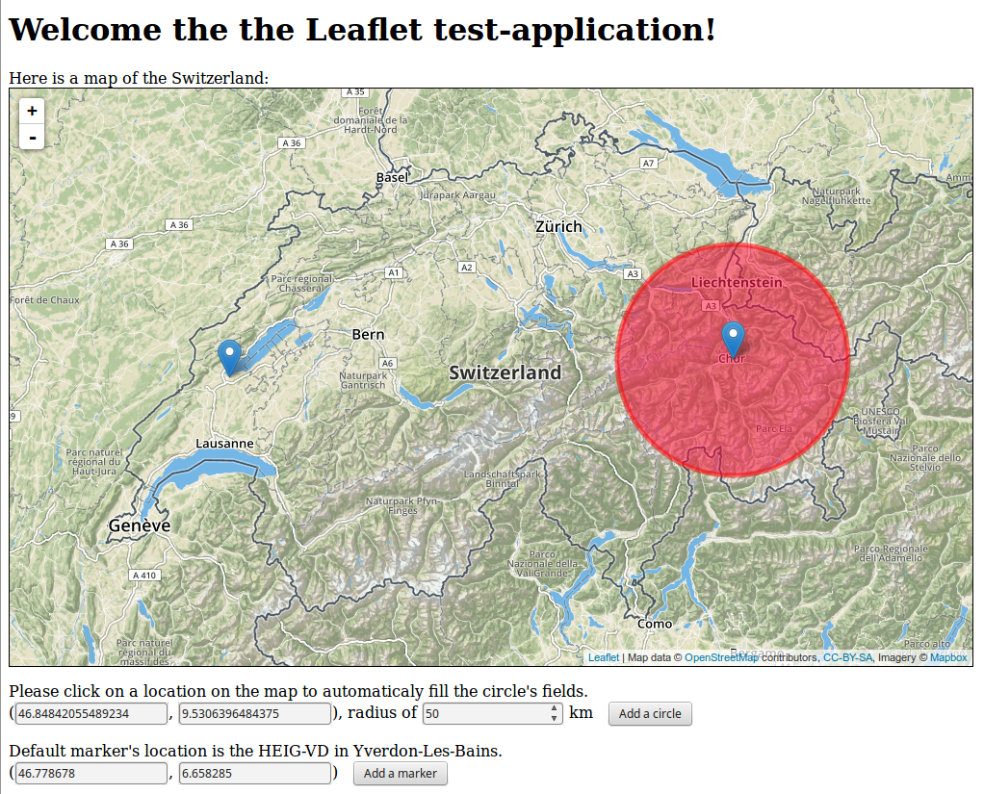Illustration 3: Leaflet test-application.

