

Bachelor Thesis
GeoTwit – Play Framework

Miguel Santamaria
Table des matières
Introduction 3

Introduction
This document contains all documentation related to the GeoTwit application's code.

Behavior of the views
All action's views inherit from one of these two interface templates:
- “mainIndex.scala.html” if the current page is the index one. It contains only the header and footer partials and calls the page's content.
- “main.scala.html” for all other pages; in addition to also containing the page's header and footer, it also contains a page format, which allows us to have the same page format (page's header, content, page's footer, etc.) in all pages.
As said above there is a header (header.scala.html) and a footer (footer.scala.html) partial templates, which are loaded in all templates. They respectively contain all HTML headers (page's title, CSS and libraries loading, ...) and footers (closing tags).

Twitter4J
Twitter4J is used in the “HomeController” controller and is automatically loaded by SBT with the “build.sbt” file. This one indeed contains the Twitter4J's library dependency: "org.twitter4j" % "twitter4j-core" % "4.0.4", where the first string is the library's location, the second one is the library's name and the last one is the library's version.

Connection process
In order to properly connect to the Twitter's APIs the user must click on the “Get Started” button located on the index page.
We he clicks on it the following steps are operated:
- The click calls the “auth” method of the “Home” controller.
- This action uses the Twitter4J library to make an authentication's request in order to get the OAuth token and the authentication URL, which points to the Twitter's authorization page. When doing the request we also give the API a callback URL (/callback => action “callback” of the “Home” controller), which will be called at the end of the authentication.
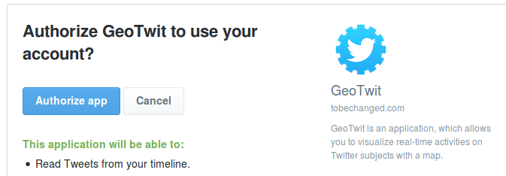
- Redirect the user to the Twitter's authorization page.
- Whatever the user does, he will be redirected on the callback action; if the user successfully authorized the application, the callback will memorize the OAuth token and redirect the user to the “search” action, otherwise he will redirected him on the index page with an error.

