

Bachelor Thesis
GeoTwit – Progress Report

Miguel Santamaria
Table of contents
1. Introduction 7
1.1. Generalities 7
1.2. Work Environment 7
1.3. Project's Objectives 7
1.4. Abstract 8
2. Specifications 8
2.1. Description of the project 8
2.2. Functionalities 9
2.2.1. Tasks 9
2.2.2. Used Technologies 10
2.2.3. Future Extensions 10
3. Analysis 11
3.1. Existing Applications 11
3.2. Technologies 13
3.2.1. Scala 13
3.2.2. Play Framework 13
3.2.3. Twitter's APIs 14
3.2.3.a. Twitter's Technologies 14
3.2.3.b. OAuth 15
3.2.3.c. REST / Streaming APIs 16
3.2.3.d. Interesting Twitter's Subjects 26
3.2.4. Twitter4J 37
3.2.5. Geolocation Features 40
3.2.5.a. Google Maps 40
3.2.5.b. OpenStreetMap 40
3.2.6. Data Grouping 41
3.3. Prototype Applications 41
3.3.1. Leaflet 41
3.3.2. Leaflet – Countries' Borders 43
3.3.3. Twitter4JDesktop 44
3.3.4. Leaflet and Twitter4J 45
3.3.5. Discussion 46
4. The GeoTwit Application 47
4.1. Installation 47
4.2. Mock-Up 47
4.3. UML Diagram of the Application 53
TODO 53
4.4. Anatomy of the Application 54
4.5. Implementation details – Server Side 54
4.5.1. Behavior of the Views 54
4.5.2. Configuration 55
4.5.3. Routes 55
4.5.4. Sessions and Flash Scopes 57
4.5.5. Cache 58
4.5.6. Twitter4J 59
4.5.7. Connection Process 59
4.5.8. Actions Compositions 60
4.5.9. Web Sockets 62
4.5.10. Streaming processes 69
4.5.11. Generation and exportation of the backup files during the streaming mode 69
4.5.12. Importation of a Generated File 73
4.5.13. Retrieving of Static Tweets 77
4.6. Implementation details – Client Side 79
4.6.1. Both Streaming and Static Modes 79
4.6.1.a. Dates Format 79
4.6.1.b. Building of the Twitter's Query String 80
4.6.1.c. Selection of the Language of the Tweets 81
4.6.2. Selection of the Area(s) in the Search Page 81
4.6.3. Grouping of the Tweets on the map 83
4.6.4. Streaming Mode 84
4.6.4.a. Interface of the Streaming's Results 84
4.6.4.b. Reception of Tweets from the Server 86
4.6.4.c. Charts 87
4.6.5. Static Mode 91
4.6.5.a. Selection of the Dates 91
4.6.5.b. Retrieval of Tweets with the Server 91
4.6.5.c. Interface of the Static Mode's Results 92
5. Tests 93
5.1. Functional Tests 93
5.1.1. Subjects Already Analyzed with the Prototype Application 93
5.1.2. Final Match of the Euro2016 Event 95
5.1.3. Pokémon GO 100
5.1.4. Miscellaneous 102
5.2. Security Tests 103
5.3. Load Tests 103
6. Conclusions 103
6.1. Review of the Current State 103
6.2. Encountered Problems 103
6.2.1. Technical Problems 103
6.2.2. Organizational Problems 104
6.3. Final Discussions 104
7. General References and Annexes 105

Table of illustrations
Illustration 1: example of Twitter application's authorization 15
Illustration 2: use case of the REST API within a web application, taken from the documentation of the Twitter's APIs 16
Illustration 3: use case of the Streaming API within a web application, also taken from the documentation of the Twitter's APIs 16
Illustration 4: graphical representation of the coordinates pair bounding Switzerland, taken from Google Maps 18
Illustration 5: search of Tweets with keyword only 19
Illustration 6: search of Tweets with location only 19
Illustration 7: search of Tweets with keyword and location 19
Illustration 8: authorization of the API console through a Twitter account 23
Illustration 9: results of the latest French Tweets containing the “yverdon” keyword and (OR) being located near Yverdon-Les-Bains in the API console 24
Illustration 10: results on Twitter of the latest French Tweets containing the “yverdon” keyword and (OR) being located near Yverdon-Les-Bains 25
Illustration 11: results on Twitter of the popular and positive Tweets, having the “#pizza” hashtag and (OR) being located near to Rome 25
Illustration 12: example of hot trends in the world within trend24 27
Illustration 13: tweets results for the UK-RU match 29
Illustration 14: progression of the EN-RU match, taken from the RTS web site 29
Illustration 15: tweets results for the RO-CH match 30
Illustration 16: progression of the RO-CH match, taken from the RTS web site 30
Illustration 17: tweets results for the AL-FR match 31
Illustration 18: progression of the AL-FR match, taken from the RTS web site (there was two goals at the end) 31
Illustration 19: tweets results for the AL-FR match in the "Stade Vélodrome" of Marseille 31
Illustration 20: tweets results for the EN-WLS match 32
Illustration 21: progression of the EN-WLS match, taken from the RTS web site 32
Illustration 22: tweets results for the DE-PL match 32
Illustration 23: progression of the DE-PL match, taken from the RTS web site 33
Illustration 24: tweets results for the FR-CH and AL-RO matches 33
Illustration 25: progression of the FR-CH match, taken from the RTS web site 34
Illustration 26: progression of the AL-RO match, taken from the RTS web site 34
Illustration 27: tweets results for the IT-ES match 34
Illustration 28: progression of the IT-ES match, taken from the RTS web site 34
Illustration 29: tweets results for the EN-IS match 34
Illustration 30: progression of the EN-IS match, taken from the RTS web site 35
Illustration 31: tweets results for the FR-DE match 35
Illustration 32: progression of the FR-DE match, taken from the RTS web site 36
Illustration 33: tweets results for the FR-DE match with the GeoTwit application 36
Illustration 34: tweets results for the FR-PT match 36
Illustration 35: Twitter application's parameters 38
Illustration 36: Twitter application's authorization's page 39
Illustration 37: PIN code generated from Twitter 39
Illustration 38: output example of a Twitter's desktop application 39
Illustration 39: "Leaflet" prototype application 42
Illustration 40: a MapBox project 42
Illustration 41: MapBox integration into Leaflet 43
Illustration 42: "LeafletCountriesBorders" prototype application 43
Illustration 43: "Twitter4JDesktop" prototype application 45
Illustration 44: deployment of the GlassFish server in the “twitter4JWeb” prototype application 45
Illustration 45: "LeafletAndTwitter" prototype application, using the “job” keyword in the U.S.A. 46
Illustration 46: mock-up – connection process 47
Illustration 47: mock-up – main search page (dynamic mode) 48
Illustration 48: mock-up – streaming process 49
Illustration 49: mock-up – charts of a streaming 50
Illustration 50: mock-up – main search page (static mode) 51
Illustration 51: mock-up – view of the results in the static mode 52
Illustration 52: current UML schema 53
Illustration 53: current anatomy of GeoTwit 54
Illustration 54: injection of a Configuration object in a controller 55
Illustration 55: declaration of JavaScript routes in the Search page's view 56
Illustration 56: inclusion of the implicit request's header in the Search page's view 56
Illustration 57: example of redirection of the user to the Logout page with a JavaScript route 56
Illustration 58: example of addition of a string value in the session 57
Illustration 59: example of use of a flash scope in GeoTwit 57
Illustration 60: injection of a CacheApi object in a controller 58
Illustration 61: example of addition of objects in the cache, for a 2 minutes period 58
Illustration 62: example of reading of a cache object 58
Illustration 63: Twitter's authorization page in the GeoTwit application 60
Illustration 64: pipeline-like process' schema of filters and actions compositions, made with Evolus Pencil 61
Illustration 65: an example of an actions composition 62
Illustration 66: an action using an actions composition 62
Illustration 67: diagram of the web sockets' process is Play Framework, made with Evolus Pencil 63
Illustration 68: opening of a new web socket connection from the client to the server 63
Illustration 69: example of a web socket's sending from the server to the client 64
Illustration 70: example of a rectangle bounding the France's territories 66
Illustration 71: web sockets' operation diagram in GeoTwit, made with Evolus Pencil 68
Illustration 72: format of the generated text file containing a streaming process' data 70
Illustration 73: pop-up asking the user if he wants to export the data as a text file (french buttons are due to the browser's default language) 72
Illustration 74: sample of code used to download the generated file 72
Illustration 75: rendering of a file at the end of an action 73
Illustration 76: progress-bar managed by the jQuery-File-Upload library when the user is uploading a file 74
Illustration 77: Initialization of the automatic Ajax upload process on the "file" input 74
Illustration 78: regex used to match the language in the imported file 75
Illustration 79: matching of the regex used for the language 76
Illustration 80: regex used to validate and get data of Tweets 76
Illustration 81: example of the limitations of the Twitter's REST API 77
Illustration 82: creation of a query for asking the Twitter's REST API with Twitter4J 78
Illustration 83: number of requests executed in one period of 15 minutes before getting an error 79
Illustration 84: selection of a Tweets' language in GeoTwit 81
Illustration 85: drawing of a rectangle on the dynamic map 82
Illustration 86: edition of the rectangle on the dynamic map 82
Illustration 87: creation of the cluster group in GeoTwit 83
Illustration 88: adding of a Tweet in the cluster group, in GeoTwit 84
Illustration 89: first example of speed's color 84
Illustration 90: second example of speed's color 84
Illustration 91: example of an interface of streamings' results (which can change in the future) 85
Illustration 92: example of a Tweet located in the bounding box of the selected country's territories, but not in the territories themselves 86
Illustration 93: example of the graph displaying the total of received Tweets with geolocation tags, by time 87
Illustration 94: example of the graph displaying the reception of Tweets with geolocation tags, by time 88
Illustration 95: example of the graph displaying the parts of the received Tweets with geolocation tags, by subject 88
Illustration 96: example of the graph displaying the total of all received Tweets, by time 89
Illustration 97: example of the graph displaying the reception of all Tweets, by time 89
Illustration 98: example of the graph comparing Tweets having a geolocation and Tweet not having one 90
Illustration 99: loading of the date picker on the dates fields 91
Illustration 100: display of the search button when the user clicked on it in order to search for static Tweets 92
Illustration 101: example of an interface of the static mode' results (which can change in the future) 93
Illustration 102: Tweets map of the FR-PT final match, analyzed with GeoTwit 96
Illustration 103: first zoom on the Tweets map of the FR-PT final match, analyzed with GeoTwit 97
Illustration 104: second zoom on the Tweets map of the FR-PT final match, analyzed with GeoTwit 98
Illustration 105: third zoom on the Tweets map of the FR-PT final match, analyzed with GeoTwit 99
Illustration 106: annotated graphs of the FR-PT final match, analyzed with GeoTwit 100
Illustration 107: graph of the commits I did during the semester 103

Introduction
First note: native French speaker, I decided to write my whole Bachelor thesis in English instead of French, as a personal goal and also for my near future (it can indeed prove to an employer I am comfortable with the Shakespeare language). I tried to be as applied as possible, but it can still remain some grammatical typos, so please excuse me in advance. I would also like to apologize for some weird formatting I had to use in some places containing especially big images and tables: there are indeed some huge blank spaces, but I was not able to properly fix them…

Generalities
- Peers:
  - Student / Developer: Miguel Santamaria
  - Professor / Supervisor: Fatemi Nastaran
- Name of the project: GeoTwit
- Short description: GeoTwit is an application, which allows you to visualize real-time activities on Twitter's subjects with a map.
- GitHub repository: https://github.com/edri/GeoTwit
- Start date: 22 February 2016
- Progress report: 17 June 2016
- End date: 29 July 2016
- Oral defense: 5 September 2016
- Duration: 450 hours

Work Environment
This project is carried out as the final Bachelor thesis within the TIC department of the Computer Engineering sector of the Yverdon-les-Bains's HEIG-VD school, for the IICT institute. The student, supported by his supervisor, works alone on his project, at the level of both development and documentation. Notice that this subject is not confidential.
The project – selected in December 2015 – is spread across various areas, among which the web development as well as the intelligent analysis (data mining) and the data visualization.

Project's Objectives
The Bachelor thesis consists of a personal study of a technical and scientific problem.
It forces a student to work on his own project during a whole semester. The main objectives of this work are to allow the student to develop autonomous and management skills, by analyzing and resolving a problem, and by developing the solution.
In case of problems and to ensure a successful work, the student is supported by a supervisor – generally a professor from the HEIG-VD – who gives him advice and checks the progression of the project. At the end of the work, an external expert will also judge the whole project and will be present during the student's final oral defense.

Abstract
GeoTwit is the application linked to my current Bachelor thesis, which allows a user to visualize real-time activities on Twitter's subjects with a map. As I am writing this abstract, it is the 16th week of the semester. I am thus in the middle of my work and have to produce a progress report about what I currently achieved to prove I properly worked until now. My objectives at the beginning of the semester were to complete all the specifications and the analysis parts of the project, and even to start developing an early of the application until this progress report. Because we had a lot of work during this semester (way more than expected, in fact), I had to use several approaches to reach my goals: firstly, I always worked on this project during Mondays and often during Thursdays, and I also worked in the transports since I spend a lot of time in them. I began with both the specifications and the analysis parts, in particular with the analysis of the Twitter's APIs. To avoid losing a lot of time at the end of the semester, I also mostly kept the documentation up-to-date. I am glad to announce I reached my goals until now: all the specifications and analysis parts are completed, as well as some pages of the application (the home page, the connection process and a basic GUI for the search pages) and various prototypes applications, containing a lot of code I will reuse. For the second half of this project, I am firstly planning to finish the application and the documentation of course, but also to mostly focus on the data analysis since I think I am a little bit early. I will also develop the static mode of the application, which was noted as an application's extension.

Specifications

Description of the project
The goal of this project – GeoTwit – is to set up a web application allowing users to enter two subjects of their choice and to visualize real-time activities for these subjects both on Twitter and on a geographic map. The application could allow many interesting uses; for example, the real-time comparison of the people's inputs in the German and French parts of Switzerland during a time of Swiss votes.

Functionalities
The application will provide the following features:
- The reading of keywords and the selection of geographic areas on the map by the user.
- The retrieval of Tweets, using the Twitter's APIs.
Note that only a certain percentage of these Tweets have geographic information, necessary for the future operations; a first filtering will thus be operated here.
- The analysis and the filtering of Tweets in order to calculate the number of Tweets by areas and by subjects.
- The visualization of the results on a map.
- The interaction (zoom-in, zoom-out, etc.) with the map. The development of this feature will involve the introduction of appropriated algorithms (like Tweet grouping) and libraries, in order to allow an appropriated visualization by the selected zoom level.
- The generation of data charts during the results phase.

Tasks
Here is a chronological list of the various achievements that were operated during this project:
- Use of the Twitter's APIs, including:
  - Retrieval and filtering of Tweets by one or more keyword(s).
  - Retrieval of geographic information attached to a Tweet.
  - Analysis of the percentage of Tweets having geographic information (necessary for further processing) and the search of keywords having good results, in order to determinate the best keywords to use for properly testing the different project's features.
- Use of a cartographic library in order to use geographic maps.
- Development of the Tweet's acquisition and analysis parts.
- Development of the web interface of the application, allowing the user to enter subjects to compare, to choose the geographic areas on the map, to visualize results and to interact with the map.
- Development of a grouping algorithm in order to group Tweets by the map's zoom level.
- Development of charts in order to display interesting information about the results.
- The possibility to export the received data as a text file at the end of a streaming process.
- Tests and validations.

Used Technologies
It was suggested to use the Scala language coupled with Play Framework, while noting other technological choices was quite possible. Due to both the personal interests of the student and a certain curiosity for unknown technologies in general, we decided that these choices will be retained.
By not knowing either of these technologies, the student firstly needed to learn the Scala language as well as the use of Play Framework before starting developing the application.
Note that different web languages (like JavaScript in particular) could be used to complement the application.

Future Extensions
Here is a non-exhaustive list of various extensions, which could be developed if time allows it or in a hypothetical future development:
- Implementation of a user management (inscription, connection) in order to back up the different obtained results.
- Storage of the most successful keywords as well as the areas having the best geographic results within the application.
- Retrieval of the current hot trends on Twitter.
- Importation of the generated text files in the application in order to restore an analyzed streaming process.
- Implementation of two alternatives to display the results:
  - A real-time data refreshment, allowing the application to automatically receive and process new Tweets; this version will be implemented anyway.
  - A static way, which will only display the results once without updating them, and which could even simulate a streaming by analyzing the Tweet's publication dates.
After some discussion with the supervisor, it was decided that these alternatives will be implemented.
- Addition of social features (sharing of results, notes, etc.).
- Addition of a gamification system (allowing users to gain points and trophies by the results rate of their search, implementation of a general ranking, etc.).

Analysis

Existing Applications
There are already many existing applications allowing a user to show Tweets on a map, among which:
- One Million Tweet Map (http://onemilliontweetmap.com/): the One Million Tweet Map application mostly approaches what will be done during this project, by displaying real-time Tweets (filtered or not) on a map with grouping methods.
Though, and unlike GeoTwit, the application does not offer a static search and view of Tweets nor the possibility to export the analyzed data and to access and analyze charts. There is also no possibility to analyze and compare two subjects at the same time nor to filter Tweets by a language or by a particular area. However, this application does not require the users to connect with their Twitter's accounts.
- TrendsMap (http://trendsmap.com/ - found via mashable.com/): this application shows a real-time mapping of Twitter trends across the world. If you click on any word you will see a real-time stream of relevant Tweets. You have to register and / or pay to access more content.
The interesting feature of this application is the display of current trends across the world, which is not currently present in GeoTwit. Users do not seem to have to connect to their Twitter's accounts. However, users have to pay to access more content, and there is no possibility to access static content nor to filter Tweets with more complex filters or to access data analysis tools like charts. Users do not seem to be able to export the analyzed data.
- Tweetping (https://tweetping.net/): shows real-time reception of Tweets all around the world on a map.
Since the application is still in a beta phase, we cannot access every features, but it seems that it can offer data analysis tools like charts as well as a complex filtering process, nearly matching the GeoTwit's features. However, users do not seem to be able to access static features nor to export the analyzed data. Users also need to pay in order to access more interesting functionalities, but don't have to connect with their Twitter's accounts. Note that the GUI of this application is well finalized and pretty.
- TweetMap (https://worldmap.harvard.edu/tweetmap/): with this tool you can visualize Tweets that was written in a given period, and watch some interesting charts.
This application provides interesting tools to analyze static content with a map (complex filters and charts), perhaps more that GeoTwit. Users also do not need to connect. However, there is no possibility to analyze real-time data nor to export the analyzed data.
- Stweet (http://www.we-love-the.net/Stweet/ found via mashable.com/): this service mashes up Twitter and Google Street View, providing a location-based look at the neighborhood Tweets.
This application does not nearly match with GeoTwit, but is still interesting in the sens that it is innovative, since there is only a few applications that allow the user to display Tweets directly in a 3D view of our streets. Of course, it does not offer the other features of GeoTwit.
- GeoChirp (http://www.geochirp.com/): this app allows you to search for Tweets in a given location, but only in a static way (no streaming then).
This application is a basic one, which only allows the user to search for Tweets in a given location, indicating the number of Tweets to display. Like GeoTwit, users have to connect to their Twitter's accounts in order to use the application. However, there is no way to analyze real-time data nor to access analyzing tools like charts.
- Tweet To Map (http://tweettomap.com/): this web plug-in allows you to put markers on a map, based on Tweets' data.
The fact of making a plug-in to use in other application is a pretty good idea, which make this application more innovative than the other. However, the application only supports static content and finally just displays markers in the map. It is thus not used by GeoTwit.
GeoTwit is thus not totally innovative, but still has some interesting features, like the possibility to collect Tweets in both dynamic and static ways and the possibility to access data analysis tools. Here is a little summary of GeoTwit's positive and negative points:
- Data export: none of the analyzed tools seems to allow users to export the real-time analyzed data. GeoTwit allows the user to fully export the analyzed streaming of data.
- Charts: charts is a good way to easily analyze data, but is not provided by a lot of application. In fact, only a few of the analyzed applications had a charts tool.
- More complex filters: in most of the analyzed applications, users can only type a word or a phrase to filter Tweets. In GeoTwit, users can filter Tweets by complex keywords sets (a maximum of 2) with the possibility to add boolean operators like “AND” and “OR” in order to compare subject in a real-time way. It is also possible to filter Tweets by location, by language and by dates (only for the static view).
- Static and streaming search: applications generally offer either a static or a streaming analysis views, but not both of them at the same time. This is one of the strong points of GeoTwit.
- Free: last but not irrelevant advantage, GeoTwit is entirely free, unlike some other applications. In return, users have to connect to their Twitter's accounts and are limited in the number of simultaneous search and in the number of static search per periods.
- Users have to connect: as it was said before, users have to connect with their Twitter's accounts in order to use GeoTwit. Indeed, since the application is free, Twitter imposes some limitations.

- Limitations: speaking of limitations, the users cannot not follow more than two simultaneous streaming processes per account, and have a limitation rate of possible static search per periods. This disadvantage is also due to the fact that GeoTwit uses the Twitter's APIs in a free way.
- Only map displays: some applications provide displays like Google Street View or other original views, unlike GeoTwit. The only possibilities to watch Tweets in a geographic way are the maps.
- No display of current trends: this good idea was seen is some of the analyzed applications, and can guide the users in their choices of filters. Unfortunately, there is currently no other way to access current trends than going to another web site.
- GUI: even if the GUI of GeoTwit is not totally ugly, it can clearly be improved. Indeed, some of the analyzed application had very pretty interfaces.

Technologies
This chapter contains analyses of the main used technologies within this project. Note that many links are given in order to detail things, but you can understand everything without opening them.

Scala
Scala is a multi-paradigm (object-oriented, imperative, concurrent and functional) programming language designed at the EPFL in 2003 by Martin Odersky. It has a strong and static typing discipline and runs on a JVM (Java Virtual Machine). As Scala heavily draws on Java, Java libraries may be used directly in Scala code and vice-versa.
Motivations
Since a lot of people talk about Scala in a good way and since the student particularly enjoyed learning functional languages (like Haskell or Java8) as well as object-oriented ones during his formation, Scala is used in this project.

Play Framework
Play Framework is an open-source and web framework created in 2007 by Guillaume Bort and allowing the developer to write web application with Java or Scala. As it was decided to use Scala in this project, this choice turns out to be the logical continuation, as the framework is compatible with the language, is well-documented and appreciated by the community.
In the following paragraphs, you can find basic instructions about the framework's use, in order to properly understand what was done during the project.
Installation
Since the installation of the framework is quite simple, it will not be rewritten in this documentation, but is explained here instead : https://www.playframework.com/documentation/2.5.x/Installing.
Creation of a New Project
To create a new Play's Scala project, the developer has to type “activator new [APPLICATION-NAME] play-scala”, where [APPLICATION-NAME] is the name of the application to create.
Once done, one has to get in the new created folder and type “activator” to enter the Play console, in which it is possible to compile the code and start the server with the “run” command. Once the server started, the code will automatically compile when the web page is loaded.

Twitter's APIs
Before starting, note that all the content of this chapter comes from the documentation of the official Twitter's development web site: https://dev.twitter.com/overview/documentation. Thus, many diagrams contained in this document are taken from this documentation.
Please also note that Twitter offers a “Best Practices” page, which could be helpful during the conception of the application, both to the security and the optimization parts: https://dev.twitter.com/overview/general.

Twitter's Technologies
Twitter offers many tools to developers to facilitate the use of their technologies within applications, which include:
- Fabric: mobile development tools used to easily interact in a stable way with the social features of Twitter (sharing, connection, etc.).
- Twitter for Websites: widgets collection, used to easily integrates Twitter's widgets (“Post Tweet” and “Follow” buttons, display of Tweets, etc.) in a web site.
- OAuth: an authentication way used with the Twitter APIs for securing and authorizing the different executed requests. Notice that this is not a technology developed by Twitter but a free protocol. You can find more details about this protocol in the following chapter.
- REST APIs: provide a read and write access to the data of Twitter as a JSON format or via OAuth in order to use them in development. They work like most of the APIs provided by services of this kind and are analyzed below.

- Streaming APIs: those APIs continually send responses to the requests of the REST APIs trough a persisted HTTP connection. They can be useful to continually display Tweets linked to a given subject and thus to automatically show new Tweets matching with the filter. This technology is analyzed below as well.
The various technologies listed above are the ones that can potentially be interesting within the project. After a quick analysis, it turns out that the tools that will be useful and helpful are the REST API and the Streaming API, coupled with the OAuth mechanism for the security. It is indeed currently (at least in the first instance) not planned to use mobile technologies and the widgets option is not wide and complex enough.

OAuth
The current version (v1.1) of the Twitter APIs uses the version 1.0A of the OAuth protocol. The developer can choose between two ways of authentication within his application:
- Application-User authentication: the most common form of resource authentication with APIs of this kind (Instagram, Facebook, Twitter, etc.). Signed requests both identify the identity of the application and the end-user it makes API calls on behalf of.
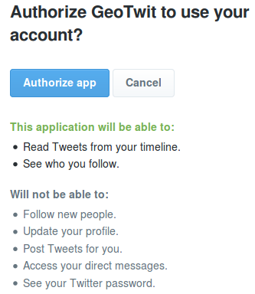Illustration 1: example of Twitter application's authorization
In terms of being specific, the user using the application must have a Twitter account, have to connect and then authorize the application to access data through his account (according to the rights asking by the developer: Tweets reading, Tweets posting, etc.) in order to get an access token. Later, all executed requests will be signed by this token linked to the current application and user.
In order to use this method, the user must therefore have a Twitter account and have to trust enough the application to grant reading and/or writing rights on the Twitter's data.
- Application authentication only: the application executes the requests of the APIs on its own behalf without a user context. This method could at the first sight seem interesting but is unfortunately limited in the list of possible calls to the APIs. It is indeed possible to search for Tweets and get users information, but one cannot use either geographic data or streaming components...
Despite the ergonomic issues the first method (application-user authentication) could create, it will still be kept. Indeed, the second method does not allow the developer to use either geolocation or streaming features, which are essential to the real-time visualization of Twitter's activities.

REST / Streaming APIs
Introduction
As a reminder, the REST API identifies the Twitter applications and the users by using OAuth and by providing JSON-formatted responses. It allows one – among other things and according to the granted rights – to read and post Tweets, read the profiles of the Twitter's users, etc. The last released version (namely v1.1) works in the following manner:
In a nutshell, the user makes requests executed by the server, which receives responses by Twitter and forwards them to the client.
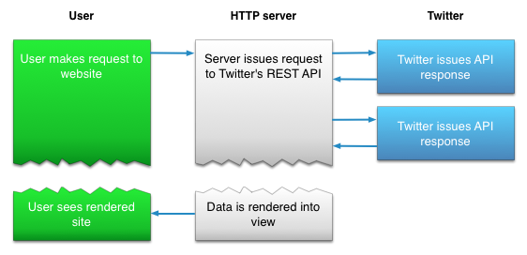Illustration 2: use case of the REST API within a web application,
taken from the documentation of the Twitter's APIs
The Streaming API's operation used to dynamically show results of search in real-time in quite different, but still uses OAuth and JSON:
The operation is here a little more complex: the code maintaining the Streaming is executed in a separated process while another one is processing the HTTP requests.
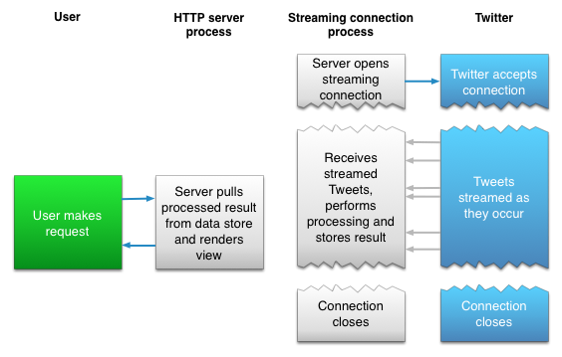Illustration 3: use case of the Streaming API within a web application, also taken from the documentation of the Twitter's APIs
There are 3 types of endpoints:
- Public streams: stream of the public data flowing through Twitter, which can be filtered by keywords, users, etc.
- User streams: single-user stream, roughly containing all of the data corresponding to a single user's view of Twitter.
- Site streams: the multi-user version of the user streams.
For obvious reasons the public stream is the endpoint used within GeoTwit.
The Streaming API is the technology that is mainly used in GeoTwit, because it has been asked in the specifications to be able to visualize the activities of the Twitter's subjects in real-time. The REST API is not set aside, though, because it could be useful for the comprehension of the Streaming whose search algorithms are based on it. After some discussion during the semester, users will also be able to statically search Tweets within GeoTwit with the REST API.
Streaming API
To initialize a stream based on a filter, the developer just has to execute a specific HTTP request (detailed above), indicating the Twitter's servers he wants to connect on. He then needs to maintain the connection opened so the servers will send him data at regular intervals.
To know one is still connected, the Twitter's servers send each 30 seconds a message to the application, indicating that the connection is still active (in case there would be no new actualities). If no confirmation is received after 90 seconds the developer needs to connect again to the stream.
Since there is no other way to test the Streaming API than developing a little application, there is no example in this chapter. You can however go in the “Prototype Applications” chapter, in which the various prototype applications made to to test both Twitter APIs and maps libraries are introduced and explained.. Note that search examples are though presented in the below “REST API” part of this document.
In those prototype application, something important was noticed when doing some tests: Twitter seems to restrict the number of Tweets transiting through the streaming, which means that the Streaming API does not send all posted Tweets. When I indeed tried to post some Tweets when listening to a streaming (in particular during the Euro2016 event), the prototype application did not systematically receive them through the streaming (even if they had geolocation tags, etc.). Thus, the developer only receives samples (which still seems to represent a view of reality) when listening to a streaming.
Limitations
In order to prevent the Twitter's servers to be overloaded by “churns” (a large number of requests of connections' opening and closing), Twitter restricts the possible number of connection requests in a certain time frame. Once a client exceeds this number, it will receive a HTTP response containing the 420 error code; for unclear reasons, Twitter privately keeps the maximum number of possible connections as well as the time frame value. Note that if the limit is regularly exceeded, Twitter will block the IP address of the client for a while, so the developer has to take this problem into account.
Please also note that the streaming is discouraged with mobiles using cellular network, because of the “disconnection → connection” loop's high risk, which can create “churns”.
Finally, note that it is only possible to start two instances of the same application following a Twitter streaming with the same account and at the same time.
For more information about the connection methods, you can go here: https://dev.twitter.com/streaming/overview/connecting.
Subscription to Twitter's subjects
As stated above, it is necessary to make a HTTP request to indicate the servers of Twitter the developer wants to subscribe to a particular stream. This request must/can have several parameters, which notably allow one to give various parameters to the server, like the wanted language of the Tweets, the filters (keywords, hashtags, etc.), the desired location, or other minor parameters. Those parameters are detailed here: https://dev.twitter.com/streaming/overview/request-parameters.
Regarding to the location, the Streaming API uses bounding boxes. In other words, it is a rectangular area defined by a pair of geographic coordinates (a longitude and latitude pair; be aware of the fact that we are more used to see coordinates in the “latitude, longitude” format), with the southwest corner of the bounding box coming first, followed by the northeast coordinate. It is possible to have many bounding boxes in one request, separated by commas.
For example, if one wants to search Tweets in Switzerland, it has to give the following coordinates: 5.956085,45.817851 and 10.489254,47.808454.
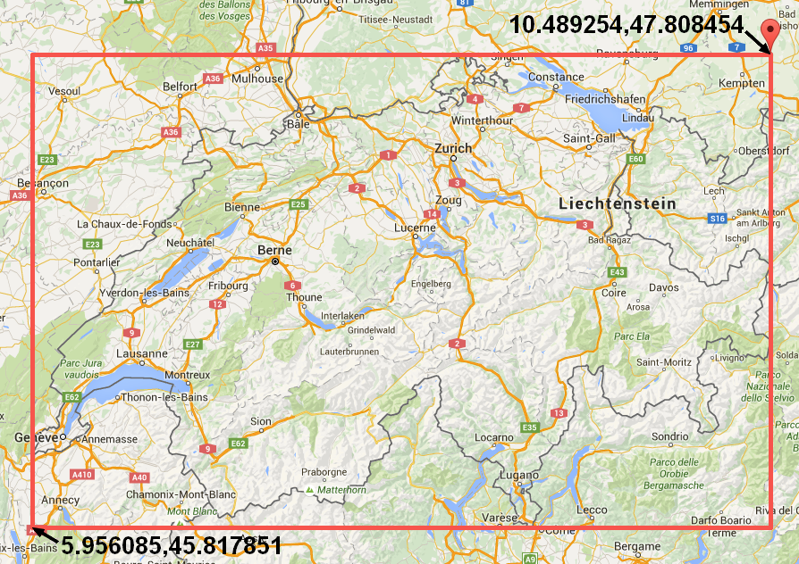Illustration 4: graphical representation of the coordinates pair
bounding Switzerland, taken from Google Maps
Beware however: the location does not act as a filter for the other filters, which means the request “track=twitter&locations=5.956085,45.817851, 10.489254,47.808454” will search Tweets containing the “twitter” keyword OR being located in Switzerland.
To better understand the operation of the location “filter”, several tests were conducted. It is important to note that those tests have been realized with the “twitter4jDesktop” prototype application (detailed on the “Prototype Applications” chapter above) and with the Streaming API. The used keyword was “michel” and the location was a rectangle bounding the U.S.A. ({-124.411668, 24.957884}, {-66.888435, 49.001895}). This tuple of keyword/location was used to avoid retrieving too much results and to (unsuccessfully) isolate information.
- Search with keyword only → the obtained results are correct and correspond to the keyword:
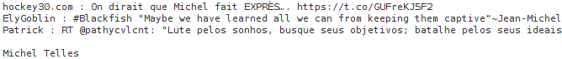Illustration 5: search of Tweets with keyword only
However, they are obviously coming from all around the word, which restrict the use cases within the application…
- Search with the location only → anything and everything was obtained here: indeed, most of the returned Tweets don't have geographic coordinates. This can be explained because of this “OR” operator applied on the search: the application is going to display all Tweets coming from the location area OR the Tweets corresponding to the keyword (namely an empty keyword in this case, so any Tweet...). In summary, absolutely all Tweets are displayed…
- Search with keyword AND location → at first sight one can expect this method to provide good results, but no… It is indeed a simple application of the operator OR: the application is going to display all Tweets having the keyword “michel” OR written in the U.S.A. (without taking in account the keyword…), which will give incongruous results again.
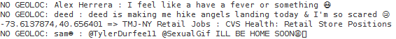Illustration 6: search of Tweets with location only
Illustration 7: search of Tweets with keyword and location
The Tweets don't necessary have a geolocation tag (a rate of about 20-30% of Tweets having geographic data was obtained during tests), so we also want to filter the received results on-the-fly to only accept those which have one.

None of these search methods gave appropriate results… This is a huge problem, because we need to search Tweets by a keyword AND a location in the application. Therefore, we have no other option but to code our own location filter, which is applied to the results of a search by keywords.
Two different approaches are possible here:
- Search Tweets by keywords and (in reality OR) geolocation, and thereafter apply a manual filtering by keywords AND by geolocation for countering the logic filter OR. Here are the results obtained in two periods of 5 minutes with the “job” keyword and in the U.S.A. (by around 15:30, Swiss time zone):
“I received 8061 Tweets in 300 seconds, including 314 ones WITH geolocation tags and 284 ones with the wanted geolocation.
This means 3.9 % of the received Tweets with the "job" tag(s) owned a geolocation tag and 3.52 % contained the desired location.
I received 6980 Tweets in 300 seconds, including 225 ones WITH geolocation tags and 215 ones with the wanted geolocation.
This means 3.22 % of the received Tweets with the "job" tag(s) owned a geolocation tag and 3.08 % contained the desired location.”
Results are here disappointing with only about 3-4% of Tweets having a geolocation tag.
- Search Tweets by keywords, and then apply a manual filtering of the geolocation.
“I received 2290 Tweets in 300 seconds, including 548 ones WITH geolocation tags and 516 ones with the wanted geolocation.
This means 23.93 % of the received Tweets with the "job" tag(s) owned a geolocation tag and 22.53 % contained the desired location.
I received 2774 Tweets in 300 seconds, including 571 ones WITH geolocation tags and 535 ones with the wanted geolocation.
This means 20.58 % of the received Tweets with the "job" tag(s) owned a geolocation tag and 19.29 % contained the desired location.”
Results are way more convincing here, with about 20% of Tweets having the desired geolocation tag. Even if about 3 to 4 times less Tweets were received than before, there was still more interesting received Tweets. Thus, this solution is the one that is developed in the project.
Within GeoTwit, it could also be possible to propose default locations (for example by countries). A prototype application (“Leaflet Countries' Borders” – see the “Prototype Applications” chapter) was made. In this application, you can double-click on countries to draw borders all around them. Many libraries/APIs exist and allow one to easily get coordinates by a pointed location for example. The most well-known of them undoubtedly is Google Maps, but other alternatives like OpenStreetMap exists and will be analyzed below.

In addition of receiving JSON messages containing Tweets' data (formatted in the following way: https://dev.twitter.com/overview/api/tweets), it is also possible to receive other kind of messages from the servers of Twitter, for example to indicate a deletion of Tweets or of geolocation tags, a disconnection, a limit reached, etc. All messages' types are available right here: https://dev.twitter.com/streaming/overview/messages-types.
Optimizations
In order to reduce the bandwidth, it is possible to ask compressed Gzip data to the servers with the following HTTP header: “Accept-Encoding: deflate, gzip”. Twitter also warns the developer about the fact that it is possible to receive a huge amount of data during worldwide or important cultural events. It is thus advisable to make tests in order to control if one's application can carry this massive flow and take measures in consequences.
Also, for optimization reasons, the servers use the “Chunked transfer encoding” data transfer mechanism, which – according to Wikipedia – means they start sending data in a series of "chunks" without knowing the length of the content before starting transmitting a response to the receiver. The client must so be compatible with this type of transfer.
Be finally aware of the fact that the received messages are not necessarily ordered and that a message can be received several times.

REST API
Here are some analyses below about the REST API, which will still be useful in the future of the project, since there will be a static search.
Limitations
First of all, it should be noted than the API has some limitations to ensure the security of the platform, and to avoid the Twitter's servers to be overloaded by requests. Limitations are mainly used on the number of requests that can be performed by periods of 15 minutes and by windows. Note that if one's application is too regularly limited it may be put on black list, which will consequently forbid the access to the API and therefore the possibility to make other requests. For this reason, the developer needs to properly optimize the number of sent requests.
When an application exceeds the rate limit of authorized requests, the Twitter's API send back a “429: Too Many Requests” HTTP response code, which allows one to indicate the user he reached the limit of requests imposed by Twitter for the current type of request.
The HTTP headers contain, among other things, information concerning the current rates of made and remaining requests:
- X-Rate-Limit-Limit: indicates the rate limit of requests for the type of the given request.
- X-Rate-Limit-Remaining: indicates the number of remaining requests for the type of the given request and for the current period of 15 minutes.
- X-Rate-Limit- Reset: the remaining time before the next reset of the 15 minutes' period.
The limit of each type of request can be accessed here: https://dev.twitter.com/rest/public/rate-limits.
Tweets search
The search API belongs to the Twitter's REST API. It allows one to search Tweets by various criteria (latest or popular Tweets containing or not keywords or hashtags, filtered by language and by geolocation, etc.). Due to the massive quantity of data to process and therefore for performances reasons, search only takes in account Tweets published during the 7 last days preceding the request. After some tests, it turns out that some 9-days old Tweets can be received, but not higher.
Many search filters exist and are accessible on the following web page: https://dev.twitter.com/rest/public/search. Most of these parameters are also compatible with the Streaming API. Among them, the interesting ones are the ones regarding the search of keywords and hashtags. In addition of these filters, other parameters allowing a better control on the search exist, such as the type of results (the latest and/or most popular Tweets), the geolocation, the language of the Tweet or even parameters allowing to iterate on Tweets in an easily way (count, until, since_id, max_id).
Regarding the location, this API directly uses the geolocation. First thing first, it is strictly speaking not possible to search near a specific location: one has to use a specific geocode in the “latitude,longitude,radius” format, where radius is the search radius in miles (mi) or kilometers (km), having for center point the given latitude and longitude.
The API will firstly try to get Tweets containing information about the wanted latitude, longitude and radius, and then in a second time if there is no result, will search for Tweets whose users' profiles match with the desired geolocation parameters.
For example, if one wants to search Tweets in a radius of 50 kilometers around the main station of Yverdon-les-Bains, the parameters will have the following values: “46.783177,6.640630,50km”.
Ideally within the project, the user should just point a location on a map and indicate the radius he wants, resulting an automatically acquirement of the longitude and latitude values associated to this location in the background.
Note that it is also possible to search for Tweets by the ID of locations. For example, the Tweets emitted from the Twitter's headquarters can be found with the “place%3A247f43d441defc03” parameter. More information can be found here: https://dev.twitter.com/rest/public/search-by-place. This parameter will certainly be less useful than the search with geolocation, but still deserves to be on this documentation.

Examples
For the purpose of being able to easily generate search requests, the advanced search tool (https://twitter.com/search-advanced) was used for the coming couple of examples. Whenever a search is made, the developer is redirected on a web page containing a URL, which is built on a particularly format. For example, with a search about the @twitterapi user, one will get the following URL of redirection: https://twitter.com/search?q=%40twitterapi. Once done, the developer can get the valid URL to use in the API by replacing “https://twitter.com/search” by “https://api.twitter.com/1.1/search/tweets.json” (in this current example → https://api.twitter.com/1.1/search/tweets.json?q=%40twitterapi).
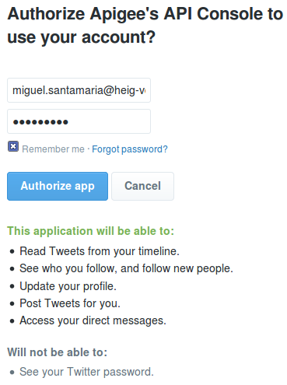Illustration 8: authorization of the API console through a Twitter account

In addition, the various tests have been conducted with the API console tool provided by Twitter right here: https://dev.twitter.com/rest/tools/console. Beforehand and in order to be able to make requests, one has to authorize the console to access its own Twitter account. This access is automatically asked as soon as one tries to make the first request.

Here is a list containing a few examples, which can turn out to be subsequently useful:
- Search of the latest French-written Tweets having “yverdon” as keyword and (in reality OR, like we saw before) being located in a radius of 10 kilometers from the Yverdon-les-Bains' main station.
- Request: https://api.twitter.com/1.1/search/tweets.json?q=yverdon&geocode=46.783177,6.640630,10km&lang=fr&result_type=recent
- Results:
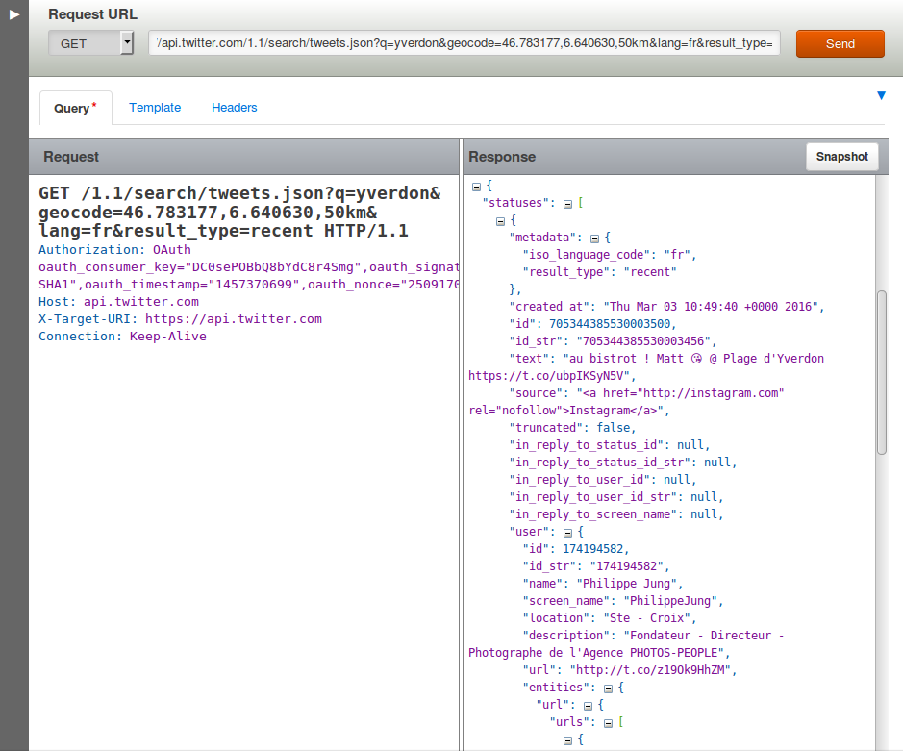Illustration 9: results of the latest French Tweets containing the “yverdon” keyword and (OR) being located near Yverdon-Les-Bains in the API console

- Results on Twitter:
Illustration 10: results on Twitter of the latest French Tweets containing the “yverdon” keyword and (OR) being located near Yverdon-Les-Bains
- Search of popular and positive (containing a happy “:)” smiley) Tweets, having the “#pizza” hashtag and (OR) being located in a radius of 100 kilometers from the center of Rome (without taking care of the language).
- Request: https://api.twitter.com/1.1/search/tweets.json?q=%23pizza%20%3A%29&geocode=41.894143,12.495479,100km&src=popular
- Results on Twitter:
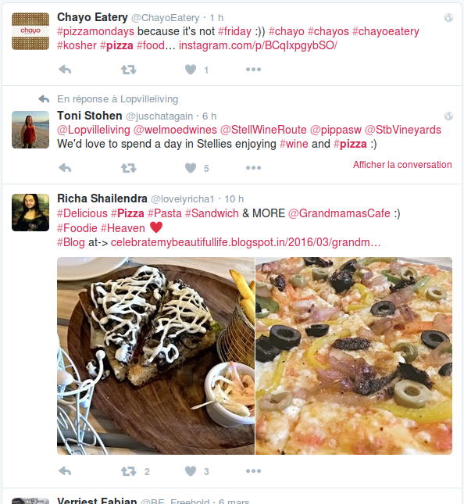Illustration 11: results on Twitter of the popular and positive Tweets, having the “#pizza” hashtag and (OR) being located near to Rome

Interesting Twitter's Subjects
This section contains various Twitter's subjects, which can be interesting in the project. These tests have been conducted with the “twitter4jDesktop” application on April 25th 2016 between 13:00 and 16:30 (Swiss hours) for the Europeans countries and during the next day between 09:00 and 10:00 (still Swiss hours) for the U.S.A.
Subject | Geolocation (location, coordinates) | Nb. of new Tweets in 5 min.
zurich | Switzerland, ({5.956085, 45.817851}, {10.489254, 47.808454}) | 0
fondue | Switzerland, ({5.956085, 45.817851}, {10.489254, 47.808454}) | 0
logitech | Switzerland, ({5.956085, 45.817851}, {10.489254, 47.808454}) | 0
nestlé | Switzerland, ({5.956085, 45.817851}, {10.489254, 47.808454}) | 1
swatch | Switzerland, ({5.956085, 45.817851}, {10.489254, 47.808454}) | 0
job | Switzerland, ({5.956085, 45.817851}, {10.489254, 47.808454}) | 1
sport | Switzerland, ({5.956085, 45.817851}, {10.489254, 47.808454}) | 0
people | Switzerland, ({5.956085, 45.817851}, {10.489254, 47.808454}) | 0
containing a 'e' | Switzerland, ({5.956085, 45.817851}, {10.489254, 47.808454}) | 0
bbc | UK, ({-8.306947, 49.696022}, {1.801128, 59.258967}) | 0
london | UK, ({-8.306947, 49.696022}, {1.801128, 59.258967}) | 15
paris | France, ({-4.805145263671875, 42.34528267746347}, {8.232879638671875, 51.09052797518529}) | 5
roma | Italy, ({6.6357421875, 47.09805038936004}, {18.6328125, 36.577893995157474}) | 2
pizza |  | 0
pizza | U.S.A., ({-124.411668, 24.957884},  {-66.888435, 49.001895}) | 3
job | U.S.A., ({-124.411668, 24.957884},  {-66.888435, 49.001895}) | 618
sport | U.S.A., ({-124.411668, 24.957884},  {-66.888435, 49.001895}) | 0
people | U.S.A., ({-124.411668, 24.957884},  {-66.888435, 49.001895}) | 4
vote | U.S.A., ({-124.411668, 24.957884},  {-66.888435, 49.001895}) | 1
trump | U.S.A., ({-124.411668, 24.957884},  {-66.888435, 49.001895}) | 3
clinton | U.S.A., ({-124.411668, 24.957884},  {-66.888435, 49.001895}) | 0
logitech | U.S.A., ({-124.411668, 24.957884},  {-66.888435, 49.001895}) | 0 or 1
nestlé | U.S.A., ({-124.411668, 24.957884},  {-66.888435, 49.001895}) | 0 or 1
novartis | U.S.A., ({-124.411668, 24.957884},  {-66.888435, 49.001895}) | 0 or 1
swatch | U.S.A., ({-124.411668, 24.957884},  {-66.888435, 49.001895}) | 0 or 1
mcdonald | U.S.A., ({-124.411668, 24.957884},  {-66.888435, 49.001895}) | 0
java | U.S.A., ({-124.411668, 24.957884},  {-66.888435, 49.001895}) | 0
scala | U.S.A., ({-124.411668, 24.957884},  {-66.888435, 49.001895}) | 0
As regards the recurring themes related to Switzerland, the subjects can be separated into two main categories: the Swiss medias and the active companies. Some bad-resulting tests about companies were conducted with the following keywords: “coop”, “glencore”, “logitech”, “migros”, “nestlé”, “novartis” and “swatch”. These words were deliberately not all put in the table above, because of the insufficient refreshment rate (zero or one Tweet per 5 minutes).
Concerning the medias, one endeavored to think about recurrent keywords that could be used in the whole Switzerland (French, German and Italian parts) like “job”, “sport” or “people”. These keywords were unfortunately not successful enough again. Even by searching for Tweets containing the 'e' letter (which is pretty common) in a desperate attempt to find Tweets with geolocation in Switzerland, zero Tweets were received here again.
Regarding to other Europeans countries like UK, France or Italy, most of the tested keyword were still unsuccessful, but some of them gave better results, like some of the main European cities in their respective countries.
After all these failures the U.S.A. were analyzed, because they are pretty known to use social medias in a stronger way than Europe. During the tests, a holy grail was found: “job”. More than 600 results in a 5 minutes' period were received. More typical and current American subjects – like “vote”, “trump”, “clinton”, “mcdonald” – and computer subjects like “java” or “scala” were tried, but they were less interesting.
In conclusion, results are worse than expected. An average of better results was got when searching in the U.S.A., especially for the “job” keyword, which is the only keyword giving good results. Switzerland has been quickly eliminated of the interesting countries as well as most of the other European countries, due to the zero rate of Tweets having geolocation tags.
After some consideration and discussion with the supervisor, it has been decided that it would be better to try these keywords as well as other ones during hours/days instead of minutes. Those tests have been done once the application was developed, because it was be more convenient to do long search and we could have accesses to graphs as well. You can find these tests in the “Test” part of this document.
Another interesting way to find subjects to analyze is to analyze the current trends in the world. Various web sites allow us to watch them, among which “trend24” (http://trends24.in/), which is pretty useful to find hours-by-hours worldwide trends.
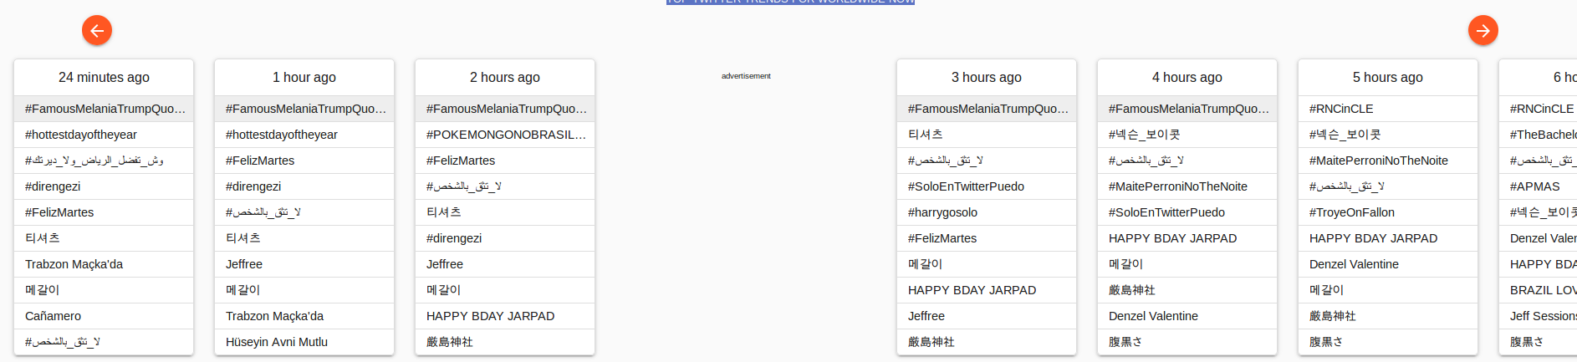Illustration 12: example of hot trends in the world within trend24
In addition to these few examples, other interesting cases linked to particularly events are possible: for example, a keyword corresponding to a subject of Swiss votes during the Sunday in which results are given, the name of a candidate in the U.S.A.'s elections during the results day (be careful about the massive flow of data!); the name of a show during its transmission to the TV; the name of a sporting event's winner; etc.
Finally, here is a little “planning” of hot and interesting topics that occurred during the semester:
Date | Subject
17.03.2016 | Hockey: LHC – HC Ambri-Piotta
17.03.2016 | St. Patrick
27.03.2016 | Easter
21.04.2016 | 90 years of the Queen Elizabeth
23.04.2016 | 400 years of Shakespeare
23.04.2016 to 24.04.2006 | 20KM of Lausanne
08.05.2016 | Football: FC Sion – BSC Young Boys
09.05.2016 | Transit of Mercury in front of the Sun
11.05.2016 to 22.05.2016 | 69th Cannes Festival
14.05.2016 | Eurovision in Stockholm
16.05.2016 to 05.06.2016 | Tennis: Roland-Garros
29.05.2016 | Football: Final of the “Coupe de Suisse”
05.06.2016 | Swiss votes
10.06.2016 to 10.07.2016 | UEFA Euro 2016
01.07.2016 to 16.07.2016 | 50th Montreux Jazz Festival
02.07.2016 to 24.07.2016 | “Tour de France” 2016
19.07.2016 to 24.07.2016 | Paléo Festival Nyon
20.07.2016 | “Independence Day Resurgence” film release
22.07.2016 | “Star Trek Beyond” film release
01.08.2016 | National day of Switzerland
04.08.2016 to 14.08.2016 | “Fêtes de Genève”
05.08.2016 to 21.08.2016 | Olympic Games of Rio de Janeiro
07.09.2016 to 18.09.2016 | Paralympic Games of Rio de Janeiro
25.09.2016 | Swiss votes
29.10.2016 to 30.10.2016 | Lausanne's marathon
08.11.2016 | Elections in the U.S.A.

Euro 2016
I was considered interesting to do data tests on Twitter during the Euro 2016's games. In order to achieve this, the “leafletAndTwitter4J” prototype application (see the well-named “Prototype Applications” chapter for more information) was used and markers were manually removed they do not belong to the analyzed country (this could occur because of the analyzed areas, which were rectangle):
Search information | Results
On 11.06.2016  From 22:00 to 23:00  During the second half of the England-Russia match  Country: UK  Keyword: euro2016 | 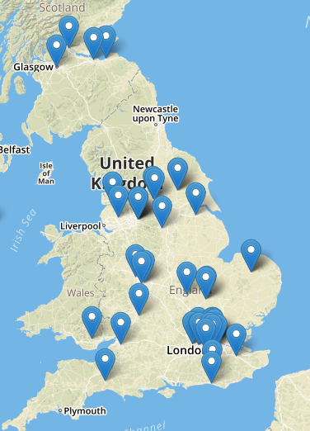Illustration 13: tweets results for the UK-RU match  Score: 1-1  47 Tweets with geolocation tags  Average of 12'000-14'000 Tweets per 10 minutes until the first goal (73'), then 20'000-24'000 after it and until the end  Between 0.01% and 0.07% of Tweets had a geolocation tag (between 2 and 20 Tweets per 10 minutes).  I received a massive flow of 16'000 Tweets in a few minutes after the goal of the 92'.  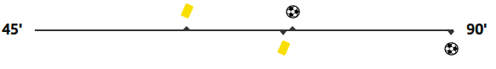Illustration 14: progression of the EN-RU match,  taken from the RTS web site
On 15.06.2016  From 17:55 to 19:55  During the Romania-Switzerland match  Country: Switzerland  Keyword: euro2016 | Score: 1-1  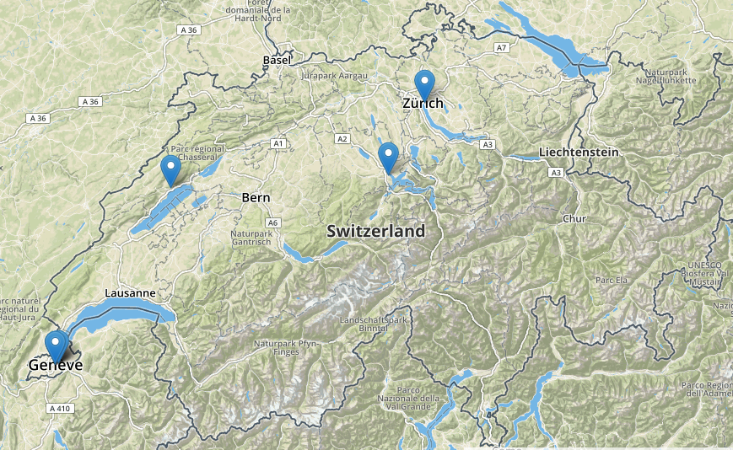Illustration 15: tweets results for the RO-CH match  5 Tweets with geolocation tags  Average of 6'500-8'000 Tweets per 10 minutes, and 10'000-11'000 at the end of the match  Between 0.01% and 0.05% of Tweets had a geolocation tag (between 1 and 4 Tweets per 10 minutes).  Illustration 16: progression of the RO-CH match,  taken from the RTS web site
On 15.06.2016  From 20:55 to 23:10  During the Albania-France match  Country: France  Keyword: euro2016 | Score: 2-0 for France  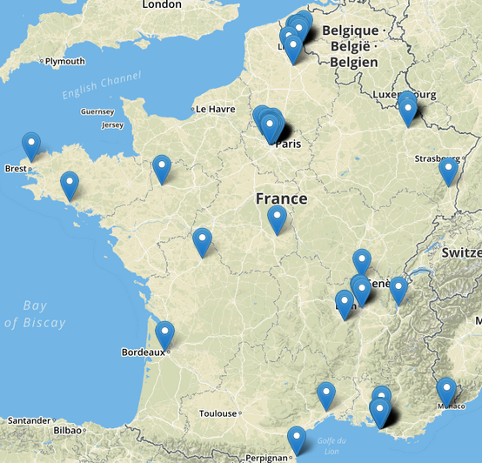Illustration 17: tweets results for the AL-FR match  126 Tweets with geolocation tags  Between 0.01% and 0.09% of Tweets had a geolocation tag (between 5 and 15 Tweets per 10 minutes).  Average of 15'000 / 10 minutes at the beginning of the match, 9'000-12'000 during it, and 24'000-28'000 at the end when the France scored twice.  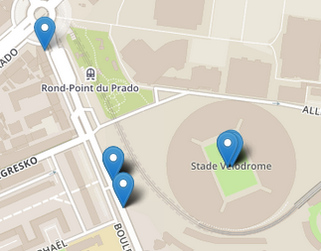Illustration 19: tweets results for the AL-FR match in the "Stade Vélodrome" of Marseille  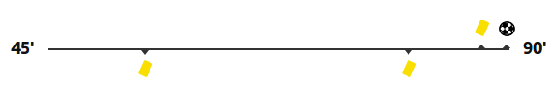Illustration 18: progression of the AL-FR match,  taken from the RTS web site (there was two goals at the end)  There was a lot of Tweets in Lille, Paris and Marseille. Since the match took place in the “Stade Vélodrome” of Marseille, many Tweets were posted there.
On 16.06.2016  From 14:55 to 17:05  During the England-Wales match  Country: UK  Keyword: euro2016 | 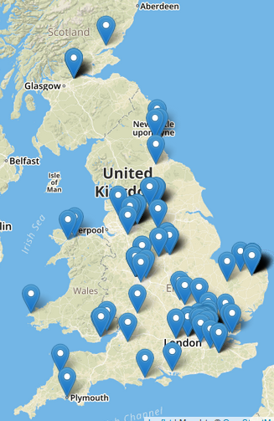Illustration 20: tweets results for the EN-WLS match  Score: 2-1 for England  135 Tweets with geolocation tags  Average of 18'000 Tweets / 10 minutes at the beginning of the match, then 10'000-14'000 until the end and finally 22'000-24'000 each time the England scored (56' and 91').  Between 0.02% and 0.14% of Tweets had a geolocation tag (between 3 and 20 Tweets per 10 minutes).  There was a lot of Tweets in London, Norwich and Manchester, but just a few in Wales.  Illustration 21: progression of the EN-WLS match,  taken from the RTS web site
On 16.06.2016  From 20:55 to 22:55  During the Germany-Poland match  Countries: Germany and Poland  Keyword: euro2016 | 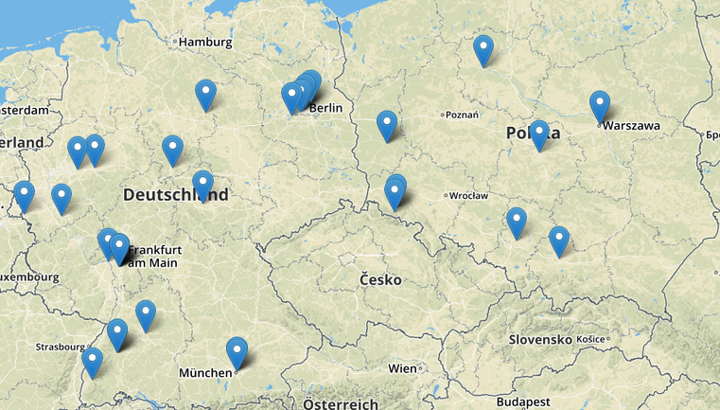Illustration 22: tweets results for the DE-PL match  Score: 0-0  40 Tweets with geolocation tags  Average of 18'000 Tweets / 10 minutes at the beginning of the match, then 11'000-14'000 until the end  Between 0.01% and 0.08% of Tweets had a geolocation tag (between 1 and 6 Tweets per 10 minutes, 15 in the beginning).  Illustration 23: progression of the DE-PL match,  taken from the RTS web site
On 19.06.2016  From 20:55 to 22:55  During the France-Switzerland and the Albania-Romania matches  Countries: France and Switzerland  Keyword: euro2016 | Score (FR-CH) : 0-0  Score (AL-RO) : 1-0 for Albania  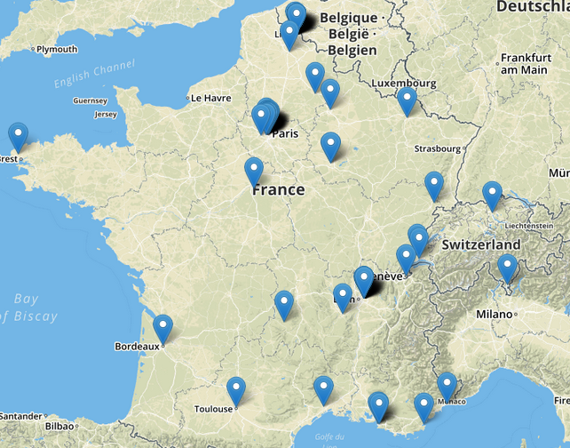Illustration 24: tweets results for the FR-CH and AL-RO matches  90 Tweets with geolocation tags (85 in France, 5 in Switzerland)  Average of 10'000-13'000 Tweets per 10 minutes, and 20'800 at the end of the matches  Between 0.03% and 0.18% of Tweets had a geolocation tag (between 5 and 24 Tweets per 10 minutes).  There was a lot of Tweets in Lyon (the city in where the AL-RO match took place), Paris and Lille (the city in where the FR-CH match took place).  Illustration 26: progression of the AL-RO match,  taken from the RTS web site  Illustration 25: progression of the FR-CH match,  taken from the RTS web site
On 27.06.2016  From 17:55 to 20:00  During the Italy-Spain match  Countries: Italy and Spain  Keyword: euro2016 | Score: 2-0 for Italy  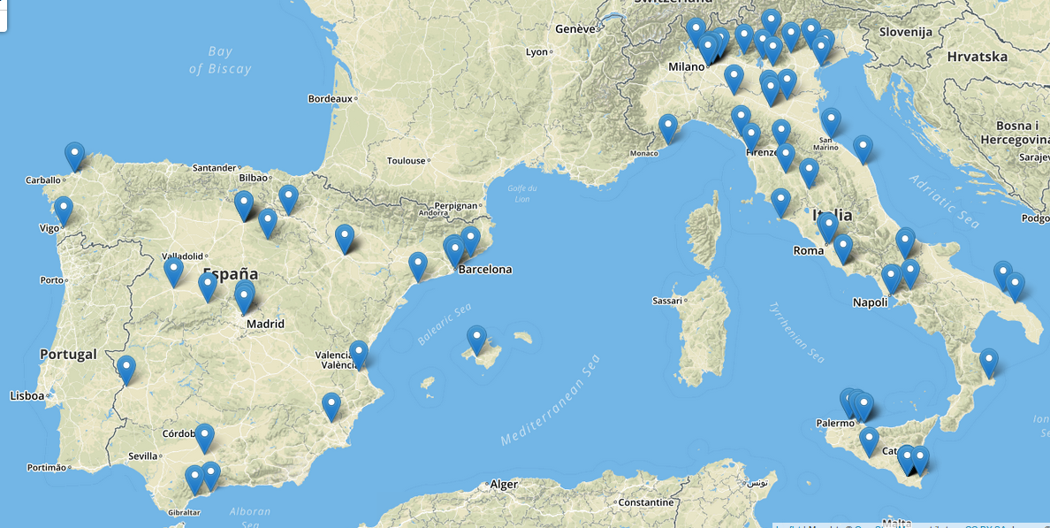Illustration 27: tweets results for the IT-ES match  99 Tweets with geolocation tags  Average of 15'000-18'000 Tweets / 10 minutes during the match, 24'000 during the half-time break, and 26'000 at the end  Between 0.02% and 0.19% of Tweets had a geolocation tag (between 4 and 26 Tweets per 10 minutes). There was a lot of Tweets posted in the North of Italy.  Illustration 28: progression of the IT-ES match, taken from the RTS web site
On 27.06.2016  From 20:55 to 23:05  During the England-Iceland match  Country: Iceland  Keyword: euro2016 | Score: 2-1 for Iceland  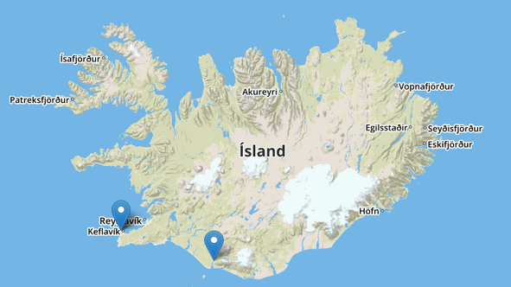Illustration 29: tweets results for the EN-IS match  3 Tweets with geolocation tags  Average of 22'000-26'000 Tweets / 10 minutes during the whole match  I received one Tweet right after the first goal of Iceland, then two Tweets in the same 10 minutes' period after the second one.  Illustration 30: progression of the EN-IS match, taken from the RTS web site
On 08.07.2016  From 21:00 to 22:55  During the France-Germany match  Country: France  Keyword: euro2016 | Score: 2-0 for France  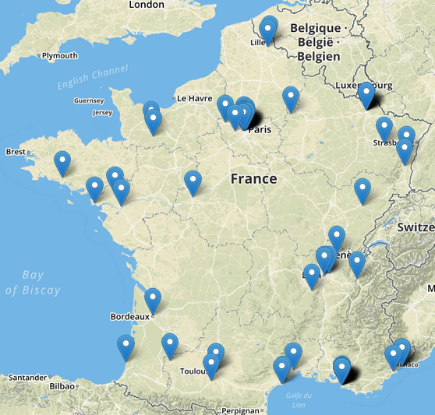Illustration 31: tweets results for the FR-DE match  98 Tweets with geolocation tags  Average of 18'000-21'000 Tweets / 10 minutes during the match, and 26'000-27'000 for each France's goal  Between 0% and 0.08% of Tweets had a geolocation tag (between 0 and 16 Tweets per 10 minutes). There was a lot of Tweets posted from the stadium of Marseilles (the city in where the match took place).  In addition, the GeoTwit application was developed enough to realize the first analyses with it. Here are the results:  Illustration 32: progression of the FR-DE match,  taken from the RTS web site  There was about 90 Tweets with geolocation posted from France (“about”, because of certain groupings that grouped Tweets from several countries; logically, if we manually count them by zooming on the map, the number must be 98, like the prototype application), about 41 from Germany and a total of 178 in the selected area in about 01:54:24, which gives a average speed of 1.56 Tweets per minute.  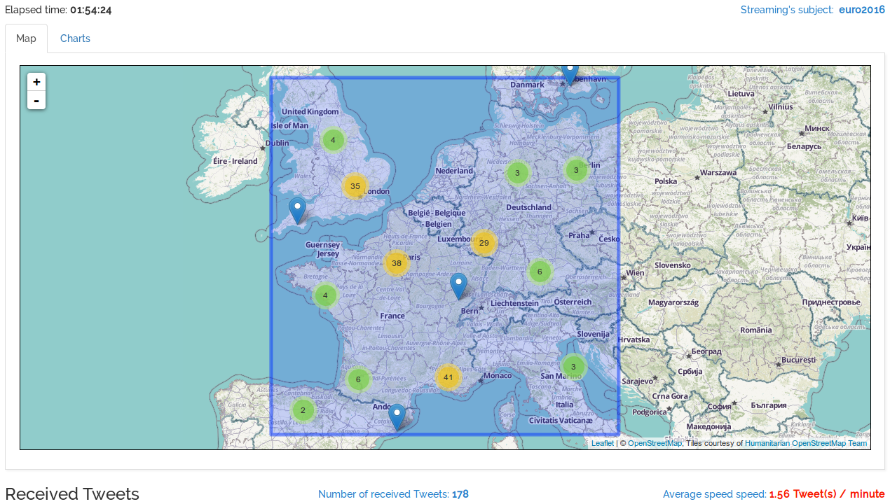Illustration 33: tweets results for the FR-DE match with the GeoTwit application
On 10.07.2016  From 21:00 to 23:35  During the France-Portugal final match  Country: France  Keyword: euro2016 | Score: 1-0 for Portugal  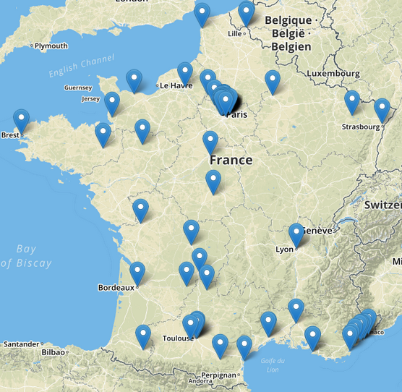Illustration 34: tweets results for the FR-PT match  135 Tweets with geolocation tags  Average of 27'000-28'000 Tweets / 10 minutes during thw whole match  Between 0.01% and 0.08% of Tweets had a geolocation tag (between 3 and 22 Tweets per 10 minutes).
Discussion
After these first results, we can conclude that England and France are the countries whose people post the most Tweets numbers during the Euro2016 event, among all the analyzed countries. The France case can easily be explained: this is the country in which the event takes place, so many people are watching live matches and are twitting. England people just seem to like Twitter and thus post a lot; also, it is the country having the highest percentage level of Tweets having geolocation tags. Concerning Switzerland, there is still too few Tweets for us to be interesting: the application indeed received only 5 Tweets in a 2 hours' period.
Tweets are generally grouped in big cities and in the stadiums in which the matches take place. We can obviously see a certain correlation between the goals moments and the peak of Tweets. These analyses are very pleasant compared to the previous analyses realized in Europe, because of the higher Tweets rate received.

Twitter4J
Twitter4J (http://twitter4j.org/en/index.html) is a non-official library, which – as its name implies – allows one to easily use the features of the Twitter's APIs with Java and which was proposed by the supervisor, Mrs. Fatemi. Given that Java classes are fully compatibles with the Scala classes and vice-versa, it turns out that this library is easily usable with the Scala programming language.
It works both with the OAuth technology and the Gzip compression and is 100% compatible with the version 1.1 of the Twitter's API. The advantages of this library lies in the fact that it significantly simplifies the APIs uses (for both REST and Streaming APIs), at the level of both data reading and writing. The documentation of this library have examples of using for each specific case, as well as many useful explanations.
You can find useful basic instructions about the use of this library in the following paragraphs, allowing you to better understanding what I did in order to develop the prototype applications, as well as the GeoTwit application.
Installation
If you the developer is using a Java or Scala desktop application, he can download the latest stable version of Twitter4J, then add “lib/twitter4j-core-4.0.4.jar” to his application class path. If he wants to use other features (like streaming or asynchronicity), he has to add the other libraries (like “lib/twitter4j-stream-4.0.4.jar” for the streaming), too.
When using Play Framework, the developer just has to add "org.twitter4j" % "twitter4j-core" % "4.0.4" in the library dependencies in the “/build.sbt” configuration file of his application.
Creation of a New Application
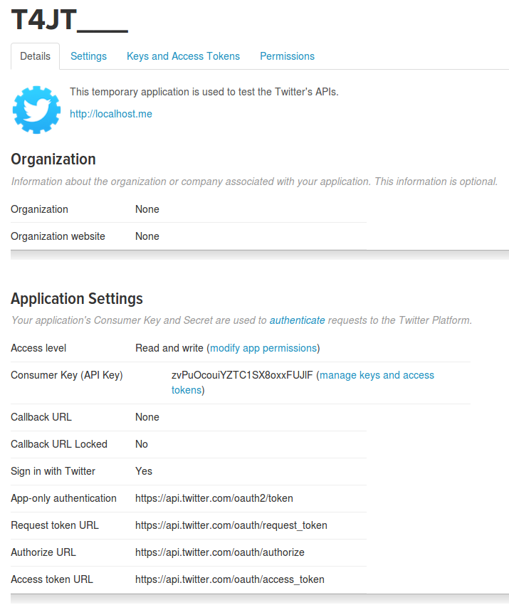Illustration 35: Twitter application's parameters
In order to use the Twitter's APIs on a new application the developer firstly has to create and register a new application on Twitter (https://apps.twitter.com/app/new).

After he did this, he will access a web page, which contains all the parameters of his application.

He has to ensure the access level of the application is the one he wants. Then he can easily get all keys and access tokens in the well-named tab, in order to use them in his application.

Desktop Applications
Desktop applications are a little bit trickier to use with the Twitter's APIs, because the developer has to manually get accesses and he has to indicate the API that he does not want it to redirect the user on a web page after the connection phase. You can find an example in the “GeoTwit/prototypes/twitter4jDesktop” folder.
For the mentioned reasons, the developer has to use the PIN-based OAuth (the user has to give a PIN number generated by Twitter in order to use the API); you can find more information about the ways to do it in these two links: https://dev.twitter.com/oauth/pin-based and https://dev.twitter.com/web/sign-in/implementing. Here is the procedure used in the prototype applications:
- Create a new app on the “Twitter for developers” web site (see “Creating a new application” chapter above).

- Use the Twitter4J library to make a token request and get an access token (http://twitter4j.org/en/code-examples.html, on the “OAuth support” section).
If you're doing it right, you have to ask the current user to grant an access to your application trough a web page's link. Once he clicked on it, he will access an authorization's page:
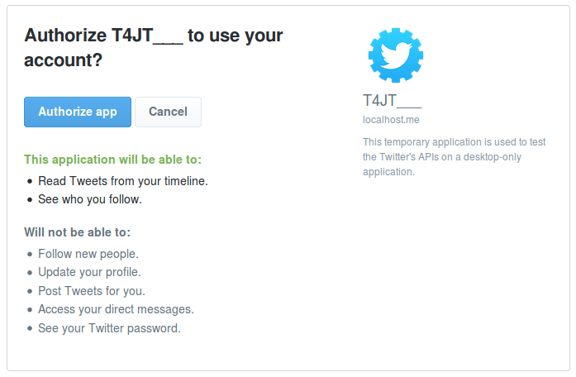Illustration 36: Twitter application's authorization's page
- Once he authorized the app, he will get the PIN to write in the application:
Here is an example of a right output:
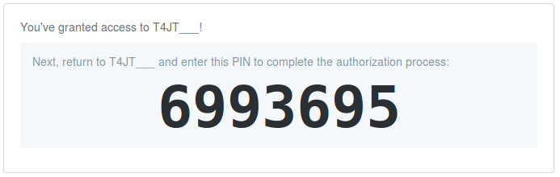Illustration 37: PIN code generated from Twitter
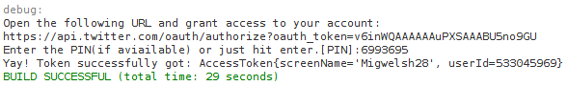Illustration 38: output example of a Twitter's desktop application
- Once you got the token, you can simply use it for your next requests.

Geolocation Features
In order to make the web site as ergonomic as possible and thus to be able to display and work with geographic maps, a library is used. Two technologies were analyzed in this section: the unmistakable Google Maps, and one of its main open-sourced rival, OpenStreetMap.

Google Maps
The Google Maps' API (https://developers.google.com/maps/?hl=fr) is very intuitive and user friendly (as I already used it in the past), but is however very problematic at the limitations level: if one indeed wants to use the site in a proper way, it will needs to pay for this service in one way or another, in order to not be limited at the requests rate level, which is hardly practicable within a Bachelor thesis. For this reason, further analyses will not be drawn on this library.

OpenStreetMap
OpenStreetMap (currently in version 0.6) – proposed as an alternative by Mrs. Fatemi – is a direct and open-sourced competitor of Google Maps, and also have an API (http://wiki.openstreetmap.org/wiki/API_v0.6).
In fact, there is two different APIs : the live-API (http://api.openstreetmap.org/) and another used for tests (http://api06.dev.openstreetmap.org/).
Although this technology is open sourced, this does not mean that it is obsolete or slower: for example, it also uses the now well-known OAuth protocol and is used in a lot of applications, like Leaflet and MapQuest (you can find a short list of these applications right here: http://wiki.openstreetmap.org/wiki/List_of_OSM-based_services).
This technology gets very interesting for this project when coupled to a JavaScript library – also open-sourced and very light – allowing to easily manipulate maps and add effects on them: Leaflet (http://leafletjs.com/index.html). In our case, the interest of this library – in addition to the main features offered by the map – especially lies in the fact that it allows one to easily communicate with the OpenStreetMap's API. One can also easily draw circles (by a latitude, a longitude and a given radius), rectangles or custom polygons on the map (usable for geolocation features; you can find an example here: http://leafletjs.com/examples/quick-start.html) and add annotations as panels. Also, it is fully compatible with the mobile word, which is interesting for scalability issues.
Due to the above reasons, these technologies is the ones that is used within the project for all the geographic requirements.

Data Grouping
Within the project, two major massive data issues were encountered:
- A proper method had to be found when sending data from the GeoTwit's server to the client, because of the massive number of data to send, which can crash the web browser. After some analyses, it turned out that the web sockets technology is one of the best technologies to use in this case, because of the bidirectional connection between the client and the server, and especially because of the fact that we can send floods of data through this route without problems other that some slowness. This technology is detailed in the chapters related to the GeoTwit application itself.
- When displaying data on the map: since there can perhaps be thousands of Tweets to display on the map, we have to group them with a grouping algorithm.
Some existing solutions were analyzed, and one of the most interesting one was without a doubt the marker-cluster plug-in proposed by Leaflet again (https://github.com/Leaflet/Leaflet.markercluster), which allows one to group data by circles on the map. This library provides a lot of interesting functions, is fully compatible with the Leaflet library (because Leaflet wouldn't develop libraries incompatible with their main library), and can handle up to 50'000 markers in one map! You can find examples here:
http://leaflet.github.io/Leaflet.markercluster/example/marker-clustering-realworld.10000.html and here http://leaflet.github.io/Leaflet.markercluster/example/marker-clustering-realworld.50000.html.

Prototype Applications
In order to test various libraries that will be used within the project and as discussed before in this documentation, some prototype applications containing interesting tests were developed (in the “GeoTwit/prototypes” folder). Please note that there are no inputs controls and the GUIs are very poor, because they are only test applications.

Leaflet
This application contains a simple map drawn with Mapbox's imagery and OpenStreetMap's data all together through the Leaflet JavaScript library. In this basic application, you can pin markers and draw rectangles and circles on a map. The "js/map.js" file contains all the map's code.
Just open "index.html" in your web browser and it will work.
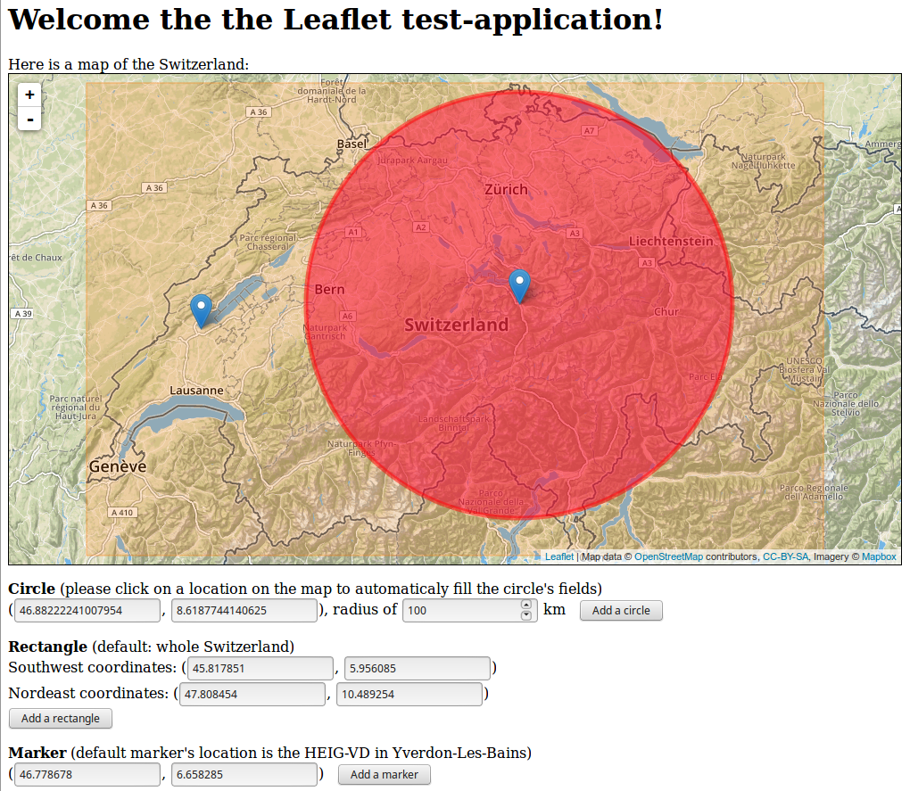Illustration 39: "Leaflet" prototype application
In this application, the Leaflet library uses both OpenStreetMap for the map's data and Mapbox for the map's imagery. The Leaflet library acts like a wrapper on the OpenStreetMap's API. Mapbox (https://www.mapbox.com/) is a platform, which provides map's design as blocks to easily integrate location into web applications. Note that this platform has a limited requests rate, which was noticed too late… In GeoTwit, the OpenStreetMap imagery is directly used.
Before interacting with all the Leaflet's components, the developer has to create an account on the Mapbox platform (https://www.mapbox.com/studio/signup/) and then he has to:
- Get the default API's public token (https://www.mapbox.com/studio/account/tokens/) and write it somewhere.
- Create a MapBox project (https://www.mapbox.com/studio/classic/projects), which is used by the Leaflet library to provides imagery. Once done, the developer has to get the project's ID and write it somewhere.
Illustration 40: a MapBox project

Finally, this simple web-application was created and the downloaded Leaflet library was extracted into it, then the quick-start well-explained tutorial was followed. In order to call the map's layer with MapBox; the code looks like this:
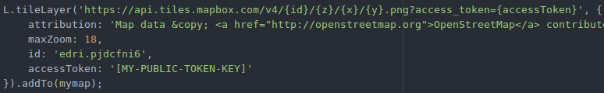Illustration 41: MapBox integration into Leaflet

Leaflet – Countries' Borders
This application provides the same functionalities as the Leaflet one, with the possibility to double-click on a country to draw a polygon all around it. In order to make the application work, please do the following:
- Ensure the JavaScript's packages manager “npm” (https://www.npmjs.com/) in installed on your computer.
- Run “npm install -g browserify” to install “browserify”, which is a library used to use npm's packages within an application without having a Node.js server (https://www.npmjs.com/package/browserify).
- “npm install” to install npm's packages.
- Open the "index.html" file in your web browser.
- Double-Click on any country on the map in order to draw a polygon all around it. Notice that some small countries are not present in the data set so you won't be able to draw a polygon around them.
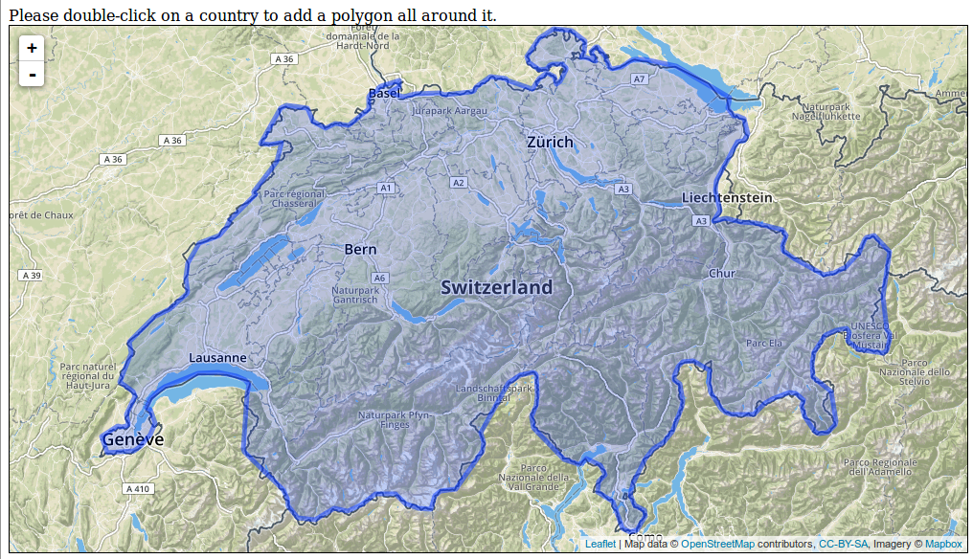Illustration 42: "LeafletCountriesBorders" prototype application

All implementation's details are well commented in the code, but here are the main things to know:
- The data of all the countries' borders are contained in the “/data” folder in a binary format (Shapefile or “.shp” – https://en.wikipedia.org/wiki/Shapefile).
- Since the content of this file is a binary content, JavaScript cannot read it directly and thus has to parse it and convert it to JSON (specifically to GeoJson, which is an agreed format used for encoding a variety of geographic data structures in JSON; more information here: http://geojson.org/).
In order to do this, the calvinmetcalf's shapefile-js library was used (https://github.com/calvinmetcalf/shapefile-js), which was randomly found on Google and which perfectly works by writing “shp('data/TM_WORLD_BORDERS-0.3').then(function(geojson) {...}”.
- Two npm's packages were also used to respectively get a country's ISO (e.g. CH or FR) by a longitude and latitude pair and to get a country's name by its ISO (e.g. CH => Switzerland): which-country (https://www.npmjs.com/package/which-country) and world-countries (https://www.npmjs.com/package/world-countries).
Since these packages are npm packages (which must normally be used in a Node.js server), the amazing “browserify” npm package is used. This one allows the developer to use npm's packages within a simple JavaScript application.
As soon as you updated the “/js/map.js” file (which manages the double-click event on the map), you have to type “browserify map.js -o bundle.js” in a console to generate the “/js/bundle.js” file that contains a working version of the map.js with all the code of the npm's packages included.
- When the user double-clicks on a map, the application first gets the clicked point's coordinates, then search for the clicked country's ISO and name with the coordinates, and finally get the borders' coordinates in the GeoJson data by the country's name in order to draw the polygon with Leaflet.

Twitter4JDesktop
This is a simple Java application in which you can search for Tweets with the REST API or subscribe to the Twitter's Streaming API (by default).
In order to use this application please do the following: uncomment the country in which you want to search Tweets in the “main” of the “Twitter4j.java”, then compile the application, launch "Twitter4j.java" and follow the output instructions.
Note that you may have to provide a PIN for the application if this is the first time you opened it on your computer (see the above “Twitter4J” chapter).
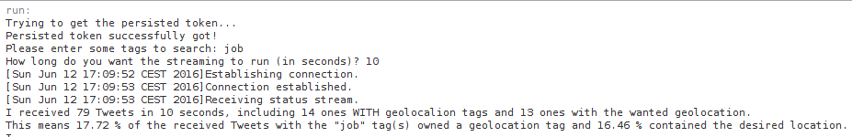Illustration 43: "Twitter4JDesktop" prototype application
All the Twitter4J documentation was used in order to develop this application and everything is well-commented so no other explanations were put here.

Leaflet and Twitter4J
This application receives streams of Tweets and displays them on a map.
It contains two applications: twitter4JWeb, which is a Java application containing the twitter4jDesktop code and a web sockets server used to communicate with the second application leafletAndTwitter. This application is a JavaScript application displaying the received Tweets from the web socket server in a map. The well-named "js/websocket.js" file contains the web socket client part.
Is order to correctly use them, please do the following:
- Uncomment the country in which you want to search Tweets in the beginning of the “readStreaming” method in the “Streaming.java” file of the “twitter4jWeb” application. You can as well change the duration of the analysis below.
- Write the keyword you want to search at the end of the “initializeConfiguration” method in the “Streaming.java” file. Try with the “job” keyword in the U.S.A. to get a lot of results.
- Check that NetBeans and the GlassFish server are properly configured on your computer.
- Run the Java server “twitter4jWeb” in order to deploy and run the GlassFish server.
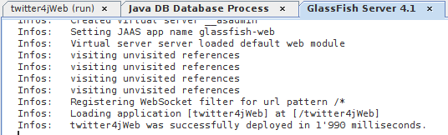Illustration 44: deployment of the GlassFish server in the “twitter4JWeb” prototype application
- Open the "leafletAndTwitter/index.html" file in your web browser when the server is correctly started.
- Then click on the "Start Streaming" button in the web application to start the streaming.
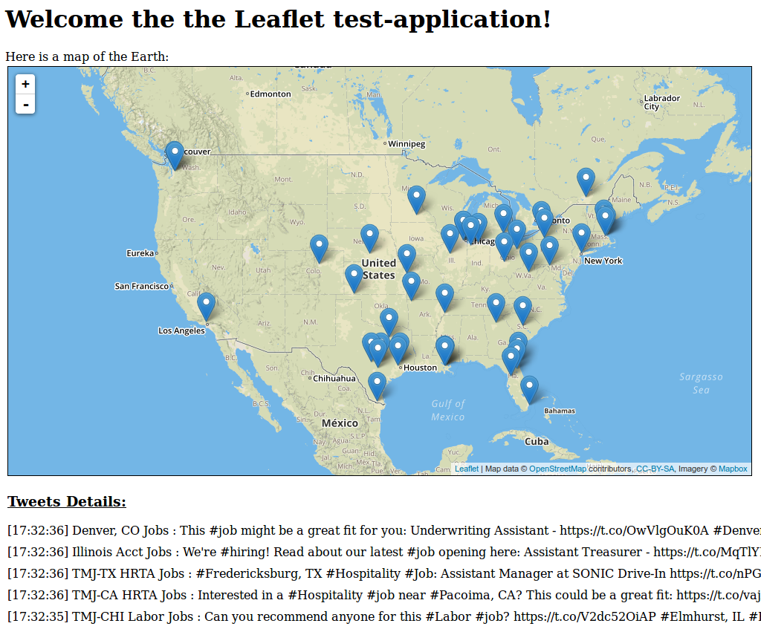Illustration 45: "LeafletAndTwitter" prototype application, using the “job” keyword in the U.S.A.
Like before, the Twitter4J documentation was used in order to develop this application and everything is well-commented so no other explanations were put here.

Discussion
These applications were used to properly test all libraries used within the project, especially the Leaflet and the Twitter4J libraries. By developed them, a huge part of the project's work was already done and they also allowed us to better understand and document these libraries.
Note that the “Leaflet – Countries' Borders” application will perhaps be put on a project apart on GitHub, because some people would need to use it.

The GeoTwit Application
This chapter contains all documentation related to the GeoTwit application's code.

Installation
In order to use the application, please first install the Play framework with activator on your computer (https://www.playframework.com/documentation/2.5.x/Installing). Once done, just go in the “GeoTwit/app/GeoTwit” folder, type “activator run” and open the “http://localhost:9000” URL. The process will take a while the first time you access this page, since it has to download the libraries and compile the application.

Mock-Up
The following mock-up has been produced with the open-sourced Evolus Pencil application. In order to make the mock-up more comprehensible, I spitted it in various parts; you can find the whole mock-up schema in annex.
When the user first accesses the web site, he is redirected on the home page, in which he can connect with his Twitter account.
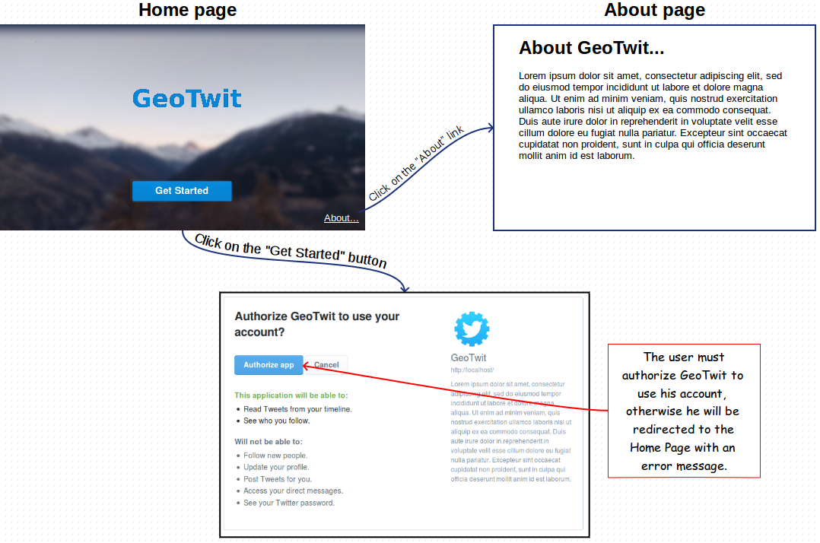Illustration 46: mock-up – connection process
Once the connection is established, the user accesses the search page and can search for Tweets either in dynamic or static mode. First have a look at the dynamic mode, which will use the Twitter's Streaming API.
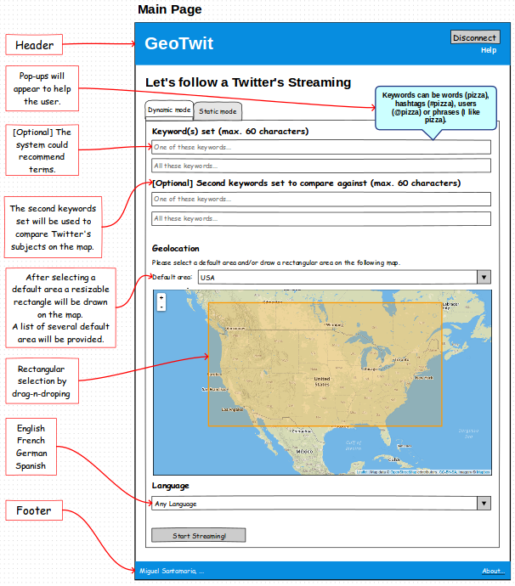Illustration 47: mock-up – main search page (dynamic mode)

The user has to fill the fields, then click on the “Start Streaming!” button to begin the streaming process.
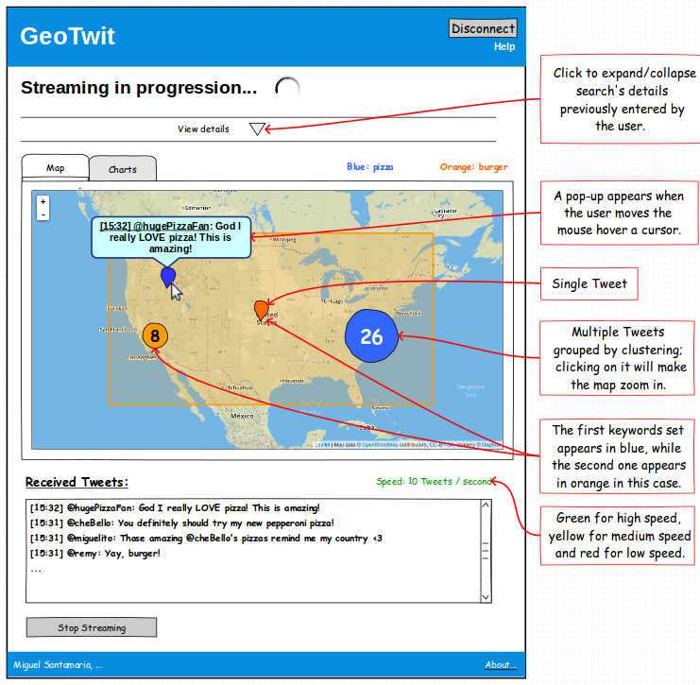Illustration 48: mock-up – streaming process

When watching the results, the user can also access the “Charts” tab, in which he will found interesting charts about the current streaming.
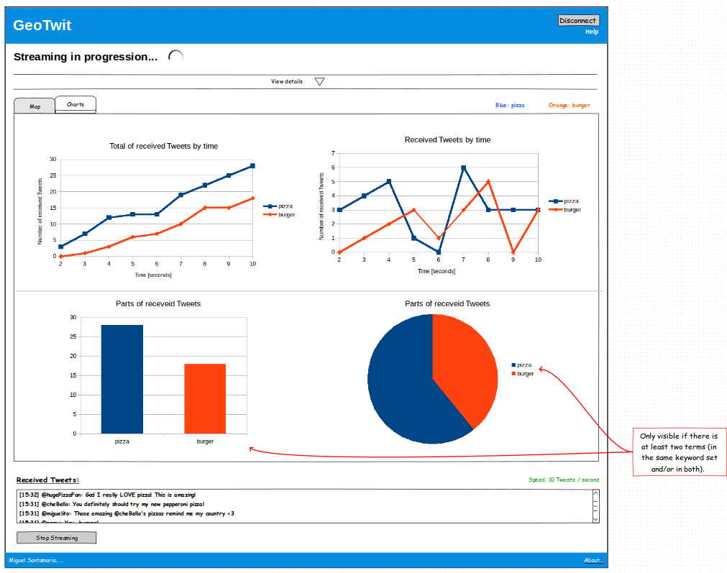Illustration 49: mock-up – charts of a streaming
And now let's have a look at the static mode, which will use the Twitter's REST API.
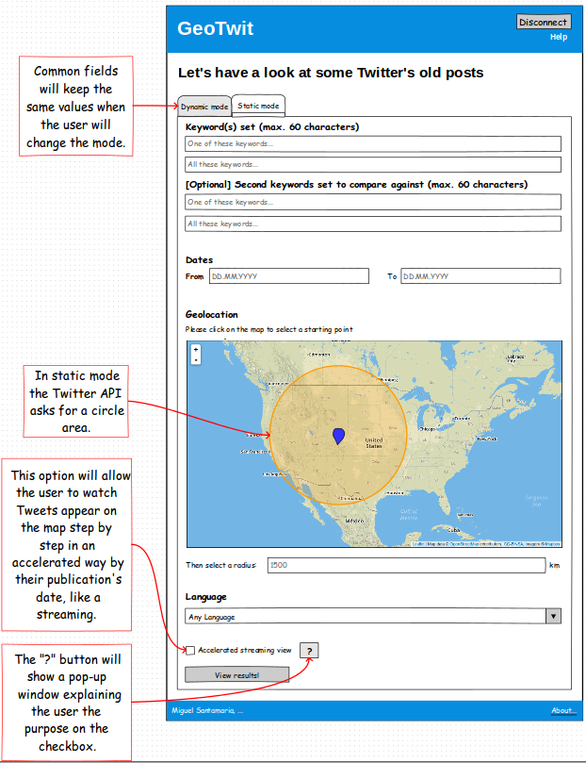Illustration 50: mock-up – main search page (static mode)
Here again the user has to properly fill the fields and click on the “View results!” button to have a look at the results.
In the static mode, you cannot access charts.
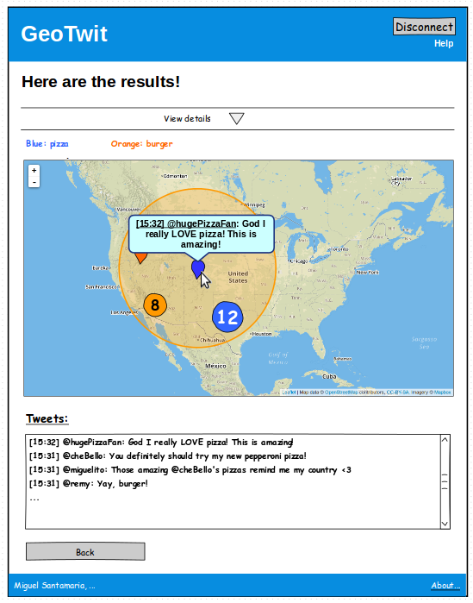Illustration 51: mock-up – view of the
results in the static mode

UML Diagram of the Application
Here is the current version of the UML schema:
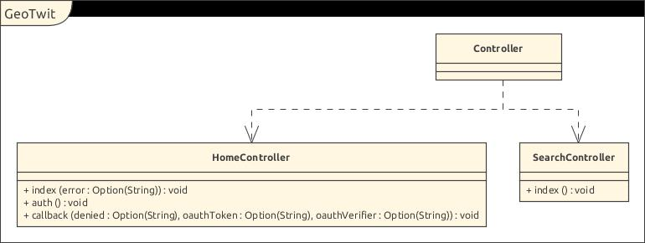Illustration 52: current UML schema
There are currently two controllers: HomeController and SearchController.
HomeController has three actions:
- index(error) → displays the home page and the error if the optional “error” parameter is set.
- auth → occurs when the user clicked on the "Get Started" button of the home page. Redirects the user on the Twitter's connection page, giving it the URL of the callback function, which corresponds to the "callback" action below.
- callback(denied, oauthToken, oauthVerifier) → redirects the user either on the search page if the connection was successful or on the home page if there was an error or the user denied the connection process. The status of the connection process depends on the three optional parameters: if “denied” is set, this means that the user denied the connection process and that the two following parameters are null. If “denied” is not set, this means that the two following parameters must have a value, respectively the token's string value (which will be used for the next requests to the APIs) and the “verifier” of the Twitter's OAuth process as a string (which can be asked by Twitter to verify the requests).
This action is called anyway by the Twitter's API when the user leaves the Twitter's connection page.
SearchController currently has one action:
- index → displays the main search page.

Anatomy of the Application
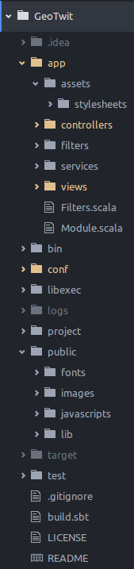Illustration 53: current anatomy of GeoTwit
Here is the current anatomy of the application:
- app: contains all components related to the server, like controllers, views, etc.
  - assets: contains “less” (http://lesscss.org/) files, which are converted to “css” when the server compiles the code.
  - controllers: contains all the application's controllers and actions, which act like standard API endpoints. It also contains actions compositions (see below for more information).
  - filters: can contain filters that will be called before the processing of all the HTTP requests.
  - services: can contain components injected in controllers.
  - views: contains all views and sub-views of the application.
- conf: contains all the application's configurations, in particular the routes' configuration file.
- logs: contains the application's logs file.
- public: contains the client-side components, like fonts, images, JavaScript code (currently: JQuery and the map's code) and various libraries (currently: Bootstrap and Leaflet).
TODO: fichier “search.js”
- build.sbt: this file is used to build the application and contains the application's description, library dependencies, resolvers and a filter used to automatically compile the Less code.
Other files and folders are not important and are in particular used by Activator and SBT to start and compile the application.

As a reminder, you can find more details about the anatomy of a Play application right here:
https://www.playframework.com/documentation/2.5.x/Anatomy.

Implementation details – Server Side

Behavior of the Views
All action's views inherit from one of these two interface templates:
- “mainIndex.scala.html” if the current page is the home page. It contains only the header and footer partials and calls the page's content.
- “main.scala.html” for all other pages; in addition to also containing the page's header and footer, it also contains a page content format, which allows me to have the same page format (page's header, content, page's footer, etc.) in all pages.
As said above there is a header (header.scala.html) and a footer (footer.scala.html) partial templates, which are loaded in all templates. They respectively contain all HTML headers (page's title, CSS and libraries loading, ...) and footers (closing tags).
TODO: ajouter les nouveaux partials (searchContent, searchStreaming, etc.).

Configuration
Configuration files are located in the “/conf” folder. You can found the routes' configuration file in here, as well as the application and Twitter's configuration files.
The Twitter's file contains the consumer's key and secret, used to make requests to the APIs. They are in a file apart in order to avoid security issues: the developer can indeed only push the application's configuration file (which contains non-confidential data) and keep the Twitter's file in local.
In order to be able to read the configuration in the code, the developer has to inject a Configuration object in the controller in which he wants to use it:
Illustration 54: injection of a Configuration object in a controller

Routes
Play Router
Routes are set in the “/conf/routes” file, and are declared with three distinct parameters: the HTTP method (GET, POST, etc.), the URL (“/auth”, etc.) and the controller and action in which the client will be redirected (“controller.HomeController.auth”, etc.) and which can have parameters. They will be used by the server's routing process in order to determinate what to do with the given URL.
Notice that there is also a route configured for the assets files, so the client can access all these files (images, CSS, JavaScript, etc.).
JavaScript Routes
In addition of the Play's main Scala routes and according to the documentation, the Play router is able to generate JavaScript code to handle routing from JavaScript running client side back to the application. The JavaScript router aids in refactoring the application; for example, when an URL or a parameter's name is changed, the JavaScript code will automatically get the new structure.
In GeoTwit, JavaScript routing is used in the Search page of the application. Specifically, JavaScript routes are declared in the “search.scala.html” view and are used in the “search.js” file:
- search.scala.html: JavaScript routes are declared with a helper that generates the JavaScript code of a router named “jsRoutes”. This router contains three routes: the route of the Logout page (in order to redirect the user from the JavaScript code if he is not connected anymore), the one of the “streamingSocket” of the SearchController (in order to initialize a web socket's connection with the server, see the “Web Sockets” chapter below), and finally a router for the assets files (in order to access images, fonts and other public assets).
In order to make the helper work, the developer has to include the request's header as a parameter of the view:
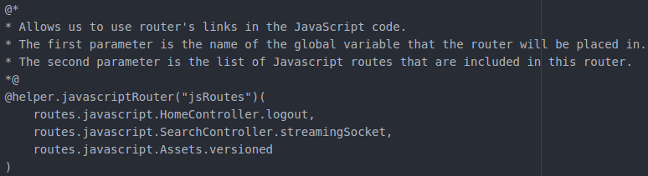Illustration 55: declaration of JavaScript routes in the Search page's view
- search.js: JavaScript routes are used with the “jsRoutes.controllers.[CONTROLLER_NAME].[ACTION_NAME]()” code. If one wants to access an asset entity (like an image or a font), it must replace the controller and action's names by the “Assets.versioned('ASSET_NAME')” code. It is then possible to get the URL of the current entity with the “url” method (which will for example generate the following link: “http://localhost:9000/logout”) or also get a web socket's URL with the “webSocketURL” method (which could generate the following link: “ws://localhost:9000/streamingSocket”).
Illustration 56: inclusion of the implicit request's header in the Search page's view
You can find more information about the JavaScript routing in the Play Framework's documentation: https://www.playframework.com/documentation/2.5.x/ScalaJavascriptRouting.
Illustration 57: example of redirection of the user to the
Logout page with a JavaScript route

Sessions and Flash Scopes
In Play Framework, sessions do not really act like anyone might guess, because of the stateless status of the framework: according to the documentation, data are indeed not stored by the server, but are added to each subsequent HTTP request, using the cookie mechanism. This means that we can only store string values, and not objects. Since this limitation is very annoying, the developer has to use the cache mechanism to store objects (like the Twitter's signed object used to make requests, in GeoTwit), by adding an unique ID related to the current user's session for each cached data (see the “Cache” chapter below).
Each value stored in the session is identified by a string key and have a string value (like a “String → String” map). In order to add a value in the session, the developer has to use the “withSession” method right after the action's result (Ok, Redirect, etc.). Since sessions' data are added in each HTTP request, he has to get the current request's session and put it first in the new request's session in order to keep the older session's data.
If one wants to set a new session, it just have to ignore the current request's session by removing the “request.session” call. In order to discards the whole session (for a disconnection for example), use the “withNewSession” method right after the action's result.
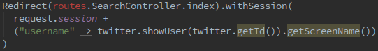Illustration 58: example of addition of a string value in the session
The session timeout's value is set in the “conf/application.conf” configuration file, specifically in the “play.http.session.maxAge” section. The value currently is 7 days.
In GeoTwit, there are several information contained in the session:
- id: an unique ID used to identify the current user and especially cache objects. This ID is indeed used to name and identify these cache objects (since the cache is not related to one user initially). This ID is generated with the Java's UUID generator and is set in the “auth” action of the HomeController.
- username: the username of the connected user, which will be displayed on the header of the search pages and be used to know if the user is connected or not (coupled with the cache – see the “Actions Compositions” chapter below). This value is set right after the Twitter's connection, in the “callback” action of the HomeController.
In addition of sessions, the framework also offers another tool: the flash scope. This mechanism works like sessions, with the difference that data are kept for only one request. It is used in GeoTwit to forward success/errors codes when an action redirect the user to the Home page.
The index action of the HomeController gets the flash message and sends it to the view, which will display (or not) the right message, according to the status. If there is no error, the controller just send a “success” message to the view.
Illustration 59: example of use of a flash scope in GeoTwit
You can find more information about the Play Framework's sessions ans flash scopes right here: https://www.playframework.com/documentation/2.5.x/ScalaSessionFlash.

Cache
As said before, the cache is used to store objects that cannot be stored in sessions. Though, there is one main problem with this method: each time the server compiles a new code, the cache is cleared so the current test user will be disconnected. When the application will be put in production environment, this problem will not often occur.
In order to use the cache, add the “cache” library dependency in the “build.sbt” file (normally already done by default), then inject a CacheApi object in the controller in which you want to use the cache functionalities:
It is then possible to use this “cache” object to read and write the cache.
Illustration 60: injection of a CacheApi object in a controller
When an object is added in the cache, the developer can set a time, which will determinate the period of valid time of this object; once the limit is reached, it will be removed from the cache.
In order to read a cache object, this one must be convert in the right type (a RequestToken object in the example below):
Illustration 61: example of addition of objects in the cache,
for a 2 minutes period
The developer has to think about testing the collected object, in order to ensure it still exists.
Illustration 62: example of reading of a cache object
Here are the different objects that can be stored in the cache, in GeoTwit (“[id]” represents the unique ID generated for the current session, in order to differentiate the cache objects stored on the server side):
- [id]-tmpTwitter (2 minutes' validity)
Contains the Twitter object used to get the request token and the Twitter's authentication URL. This object is stored in the “auth” action of the HomeController and is collected in the “callback” action right after the Twitter's connection. It has to be stored, because it has already been signed with the request token, and still has to be signed with the access token in the callback, in order to be able to make requests to the APIs. This object is thus reused to build the final Twitter object, and since it is not possible to build a new object for security issues, it has to be kept.
If this object timeout before the user reached the callback, he will be redirected to the Home page with an explicit error.
- [id]-requestToken (2 minutes' validity)
Also stored in the “auth” action and used in the “callback” action, this object contains the current user's request token, which will be used to generate the access token. If this object timeout before the user reached the callback, he will be redirected to the Home page with an explicit error.
- [id]-twitter (currently have a 7 days' validity, which is the same value as the session's timeout and is stored in the application's configuration file)
Contains the Twitter final and signed object, which will be used to make requests to the Twitter's APIs in the SearchController. It is set in the “callback” action of the HomeController, right after the two cached object above has been removed from the cache. If this object expired for one reason or another, the user will be considered as disconnected and thus will be redirected and the Home page.
You can find more information about the Play Framework's cache system right here: https://www.playframework.com/documentation/2.5.x/ScalaCache.

Twitter4J
Twitter4J is used in the “HomeController” controller and is automatically loaded by SBT with the “build.sbt” file. As said before, this file indeed contains the Twitter4J's library dependency: "org.twitter4j" % "twitter4j-core" % "4.0.4", where the first string is the library's location, the second one is the library's name and the last one is the library's version. In order to use the streaming API, the file also have to contain the Twitter4J's stream library: "org.twitter4j" % "twitter4j-stream" % "4.0.4".

Connection Process
I based myself on the yusuke's implementation example of a connection process to Twitter with the Twitter4J library in Java (available on GitHub here: https://github.com/yusuke/sign-in-with-twitter) as well as a Qiita's tutorial (http://qiita.com/omiend/items/90163d29b465fb7ab8f0) in order to properly implement my process.
The user must first click on the “Get Started” button located on the index page.
When he clicks on it the following steps are operated:
- The click calls the “auth” method of the “Home” controller.
- This action uses the Twitter4J library to make an authentication's request in order to get the OAuth token and the authentication URL, which points to the Twitter's authorization page. When doing the request, the application also gives the API a callback URL (/callback => action “callback” of the “Home” controller), which will be called at the end of the authentication. This action also stores the temporary Twitter and request token's objects in the cache for 2 minutes, in order to properly use them in the callback action.
- Redirection of the user to the Twitter's authorization page.
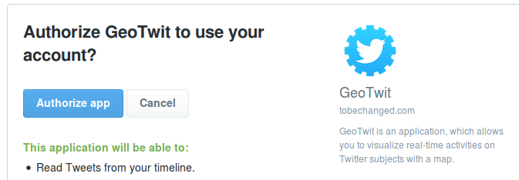Illustration 63: Twitter's authorization page in the GeoTwit application
- Whatever the user does, he will be redirected on the callback action:
  - If the user successfully authorized the application, the callback receives the OAuth token and verifier from Twitter. It will then get and memorize the Oauth access token (according to the temporary Twitter and request token's objects received from the “auth” action, as well as the received verifier from Twitter), add the new Twitter's object in the cache for 7 days (same time as the session timeout) in order to use it in the SearchController to make requests to the APIs, and then finally redirect the user to the “search” action, passing the user's name in the session (in order to display it on the pages' header).
  - If something went wrong, the user will be redirected on the index page with an error.

Actions Compositions
Actions compositions can be interpreted like generic action functionalities, allowing the developer to execute generic code in several actions without writing it again. In summary, this code is executed before the execution of the action itself ; compositions thus act like filters (which contain code executed before any action when a request is made to the Play server), but for specific actions, and can be chained by forwarding the HTTP request through a pipeline-like process.
In the above schema, the client first makes a request to the Play's application server, which sends it to the first filter. This filter executes its code and can perhaps modify the request's content; once done, he forwards the updated request to the next filter, and so on. When the request is finally forwarded to the right controller's action (through the routing process), this one calls the action compositions related to itself, which alternately execute their code and can also update the request. Once the last action composition finished its process, the request is finally forwarded to the action, whose body's code is executed and in which a result (for example the call of the view with the Ok keyword) will be provided.
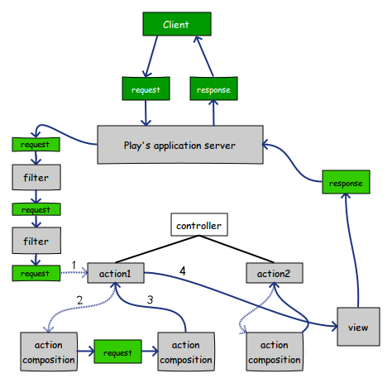Illustration 64: pipeline-like process' schema of filters and actions compositions, made with Evolus Pencil
In GeoTwit, actions compositions are used to check if the user is connected or not, before accessing pages: for all the HomeController's actions (except the “logout” one), the user is redirected to the Search page if already connected; on the opposite, if the user is not connected and tries to access a SearchController's action, he will be redirected to the Home page with an error message. In order to determinate if an user is disconnected or not, the actions compositions check if the “username” value of the session is set and if a “[id]-twitter” object exists in the cache for the current session (where “[id]” represents the unique ID of the current session). If one of these two values does not exist (or if the unique ID is not set), the user is considered as disconnected.
These actions compositions are objects extending the ActionBuilder trait (the NotAuthenticatedAction object in the HomeController, and the AuthenticatedAction object in the SearchController), and implementing a “invokeBlock” method, which is called for every action built by the ActionBuilder.
The “request” parameter of the “invokeBlock” method corresponds to the current HTTP request's object. The “block” parameter will be used to wrap the request, by giving a future result to the HTTP request and thus allowing the request to be chained until the last actor (the action itself).
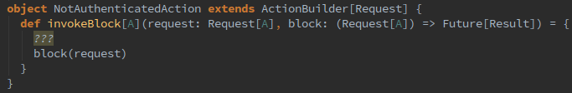Illustration 65: an example of an actions composition
Actions are then defined with these objects, in order to execute the “invokeBlock” method's code before the action itself.
You can find more information about actions compositions in the Play documentation right here: (https://www.playframework.com/documentation/2.5.x/ScalaActionsComposition).
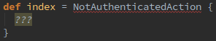Illustration 66: an action using an actions composition

Web Sockets
According to the documentation, web sockets are sockets that can be used from a web browser based on a protocol that allows two way full duplex communication. The client can send messages and the server can receive messages at any time, as long as there is an active web socket connection between the server and the client. In summary, one can use this technology to forward real-time messages from a client to a server and vice-versa; in GeoTwit, web sockets are used to forward data during the streaming process.
In order to make the web socket's communication work, the application thus must have a web socket's client entity and a server one. In GeoTwit, the client is a JavaScript part located in the “search.js” file (modern HTML5 compliant web browsers natively support web sockets via JavaScript), and the server is located in the SearchController. Play provides two different mechanisms for handling web sockets: by using Akka Streams and by using iteratees. Since this second method is deprecated, it will not be explained below and Akka is the one which is used in the application.
Since it would be annoying to split the server and the client parts' explanations, they are both explained here.
In order to be able to send web sockets between a client and the server, a connection firstly has to be initialized:
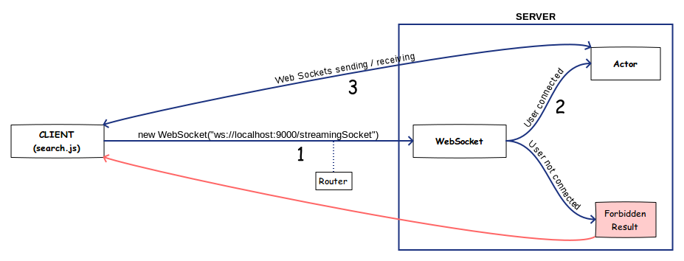Illustration 67: diagram of the web sockets' process is Play Framework, made with Evolus Pencil
- The client has to open a new web socket connection to the server, with the web socket protocol (ws://[URL_OF_SERVER]). A route is declared in the server's router in order to redirect the client's request to the right entity (which is not an action in this case, but a WebSocket object).
- The WebSocket object of the server acted like an action until now. Once it received the client's connection request, it checks that the current user is still authenticated (for security reasons) and if so, it creates a new “Actor” object through an ActorFlow object that allows the developer to access a “out” ActorRef object that will itself be used to send messages to the client. This Actor object acts like a Java Thread, which means it will keep a persistent connection with the client until the expressed closing of this connection (web browser's closing, reload of the current page, expressed web socket message indicating the server that the connection has to end, etc.), and which also means that the server can proceed other processes at the same time. In summary, the WebSocket object acts like a threads manager while the Actor objects act like threads; there can indeed be several current Actor instances running at the same time, but only one WebSocket object, which ends as soon as the Actor is created. In GeoTwit, the WebSocket object also gives the Actor the session's unique ID, so it will be able to access the current user's cache object. Note that the WebSocket object (and thus the Actor one) is configured to only accept and send Json data (in Play: JsValue objects), so it will be easier to identify and deal with web sockets' types.
Illustration 68: opening of a new web socket connection from the client to the server
If the user is not connected anymore when receiving a connection request, the server sends back a Forbidden result that will make the client disconnect the user.
- Once the Actor threaded object is created, it immediately sends a “successfulInit” message to the client, in order to notify it that the connection was successfully opened. As said before, only Json objects can be sent and received in GeoTwit.
You can find more information about ScalaJson objects on the Play documentation right here: https://www.playframework.com/documentation/2.5.x/ScalaJson.
In order to send sockets to the client, the Actor object has to use the given ActorRef (“out”) object:
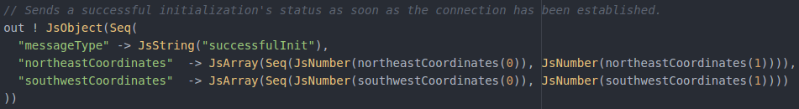Illustration 69: example of a web socket's sending from the server to the client
When a message is sent from the client, the Actor receives it with the “receive” method. This method gets the received Json message's type and process actions depending on it.
Finally, the “postStop” method is triggered when the web socket's connection ended, and is used to properly close the current running streaming.
In order to ends the Actor threaded object, the developer has to send a PoisonPill to the ActorRef (“out”) object with the “out ! PoisonPill” command.
- On the client side, everything is managed with the “socketConnection” object, initialized when the client first sent a connection request to the server. This object contains several methods, among which the “onmessage” one that is triggered when the client receives a message from the socket. Like in the server side, when a message is received, the client first gets the received Json message's type and process actions depending on it.
Here are the messages that can be sent from the server to the client in GeoTwit (the first Json object's attribute is the message type, sometimes followed by various parameters):
- {“successfulInit”}: sent when the client's connection request has been successfully received by the server; when the client receives it, it shows the results page, draws the selected area (rectangle or complex polygon) on the results map and send back a “readyToStream” message to the server.
- {“newTweet”, keywordsSet, internalId, creationDate, longitude, latitude, user, content, nbReceivedTweets}: sent when a new Tweet has been received through the Twitter's streaming process; the client adds the Tweet to the map, displays it in the results panel, and sends a confirmation to the server, indicating that the Tweet belongs to the country's territories (if so and only if the user selected the country in the drop-down menu ; see the client's “readyToStream” and the “tweetLocationConfirmation” web sockets for more information). The “keywordsSet” parameter indicates the keywords set (“first” or “second”) for which the Tweet is (so the client can display Tweet with different colors). “internalId” contains the internal ID of the Tweet, used to identify Tweets in the backup file. “creationDate” contains the creation date of the Tweet, “longitude” and “latitude” parameters are the Tweet's geographic coordinates, “user” contains the name of the user who posted the Tweet and “content” contains the Tweet's content. The “nbReceivedTweets” contains the current number of received Tweets (with or without geolocation tags), used by the graphs.
- {“errorFile”}: sent when an error occurred when the server tried to create/write the backup file. An alert is displayed in order to inform the user, but the streaming process continues.
- {“stopStreaming”, reason}: sent when the server stopped the streaming process (mainly in case of exception); indicates the client that he can indicate the user that the streaming ended. The “reason” is an optional parameter indicating the reason of this stop, that can be:
  - “sessionExpired”: when the server cannot access the Twiter's cached object anymore, which means that the current user's session has expired; the client redirects the user to the Logout page in order to properly disconnect him.
  - “tooManyStreamingProcesses”: when the user ran too many copies of the same application authenticating with the same account name.
  - “queryTooLong”: when the user typed too many characters in one of the keywords sets; the search page is reloaded in order to make a new search.
  - “exception”: when a non-handled exception occurred.
Here are now the messages than can be sent from the client to the server:
- {“readyToStream”, isAreaRectangle, firstKeywords, secondKeywords, coordinates, language}: sent as soon as the client received a “successfulInit” message from the server; when the server receives this message, he starts the Twitter's streaming process(es) with the given user's input parameters. “isAreaRectangle” indicates whether the user manually drew a rectangle on the map (true) or selected a country in the drop-down menu (false); if false, this value indicates that the server must wait for the client to send a confirmation indicating that the received Tweet is in the complex polygon area that represents the country's territories (since the client only gave the bounding box to the server, in order to avoid to overload the connection), in order to only write Tweets belonging to the area in the backup file; if the value is true, the server will automatically write Tweets in the file, without asking the client a confirmation. “secondKeywords” can be empty, since it is an optional input. “language” contains a BCP 47 language identifier (“en”, “fr”, etc.) corresponding to the value of the language the user selected to filter Tweets (if empty, the system will simply not filter Tweets by language). The “coordinates” parameter is an array containing each coordinates of a rectangle; this rectangle can either be the rectangle the user manually drew, or the rectangle bounding all the selected country's territories (since a country can have many of them). Here is an example of a bounding rectangle for the France territories (France and Corsica):
Since it is not possible to send huge amounts of data like the coordinates of all the country's borders through the web sockets system (and even if it was possible, it is really not optimized), the client only sends this bounding rectangle. Once received, the server will search for Tweets contained within this rectangle, and will send them to client client, which will finally check that the Tweet belongs to one of the country's territories (see the Client Side's “Reception of Tweets from the Server” chapter below for more information).
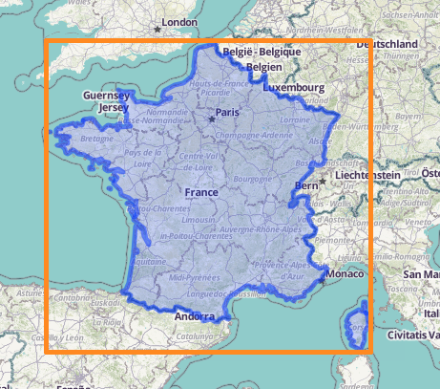Illustration 70: example of a rectangle bounding the
France's territories
- {“currentResults”, elapsedTime, gtrt, grt, gprt, atrt, art, agvw}: sent by the client each second; gives the server the current results (the elapsed time, and the data related to each of the 6 charts: gtrt => Total of received geolocated Tweets; grt => Reception of geolocated Tweets; gprt => Parts of the received geolocated Tweets; atrt => Total of all (with and without geolocation) received Tweets; art => Reception of all Tweets; agvw => Tweets with geolocation tags vs. Tweets without; more information about charts in the “Charts” chapter of the client side section). The server internally saves and overwrites these results, in order to write them as the end of the backup file once the streaming process ended.
- {“tweetLocationConfirmation”, keywordsSet, internalId, creationDate, longitude, latitude, user, content}: sent by the client in order to confirm that the received Tweet (received through the “newTweet” web socket) belongs to the selected country's territories, in order for the server to write it in the backup file. This socket is only sent if the user selected a country in the drop-down menu; indeed, only the bounding box is sent to the server at the beginning of the streaming process, in order to avoid overloading it (see the “readyToStream” web socket). If the Tweet does not belong to the territories, the client simply ignore it. The “keywordsSet” parameters indicates which subject the Tweet-to-confirm belongs to (either “first” or “second”), “internalId” is used to internally differentiate the Tweets to write and results from an internal server's counter, and “creationDate” is the Tweet's creation date, as a “YYYY-MM-DD'T'hh:mm:ss” format. Other parameters are the basic Tweet's parameters.
- {“stopStreaming”}: sent when the user clicked on the “Stop Streaming” button; indicates the server that he can kill the current actor and stop the current Twitter's streaming process.
You can find more information about the web sockets' use in the Play documentation right here: https://www.playframework.com/documentation/2.5.x/ScalaWebSockets.
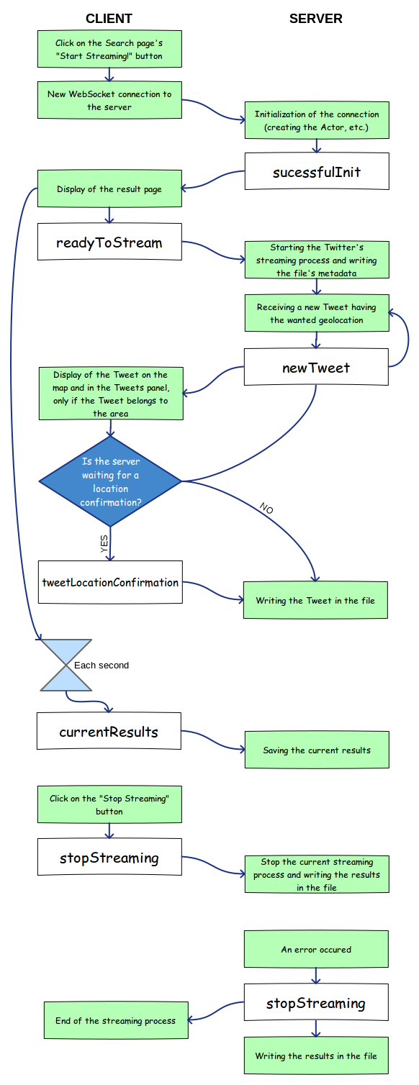Illustration 71: web sockets' operation diagram in GeoTwit, made with Evolus Pencil

Streaming processes
Once the client sent all the data related to the streaming process(es) through the “readyToStream” web socket, the current web socket's actor of the server validates the user's parameters and checks that the user is still connected and if so, it starts the first streaming process through the Twitter's API with the Twitter4J library. If the user filled the second keywords set, the actor starts a second streaming process. As a reminder, the Twitter's API only authorizes two simultaneous streaming per user, so it is not possible to add new keywords sets for now.
The streaming process is located in the “streaming” function of the SearchController, and initializes a listener subscribed to a server of the Twitter's Streaming API with the right query's parameters and a TwitterStream object initialized from the cached Twitter object. Once a Tweet is received, it will trigger the “onStatus” method of the listener object, which will check if the Tweet have a geolocation tag and if so, if it is geolocated in the wanted rectangle. If so, it will send a “newTweet” web socket to the client.
If an exception occurs during the streaming process, the “onException” method of the listener object will be triggered. This one tries to convert the Exception object into a TwitterException object, in order to get the exception's status code and thus to properly inform the client through the “stopStreaming” web socket.
Everything is well commented in the code, so it would be useless to explain everything right here.

Generation and exportation of the backup files during the streaming mode
At the end of a streaming process, the user is asked to export (or not) the backup file of the analyzed subject(s). Both the client and the server take action during this process, but everything is explained here, in order to avoid useless mixes.
First thing first, here is the format of the generated text file:
Spaces and tabulations were added in this example in order to make the file more readable; in real files, there is no spaces and tabulation, in order to gain space.
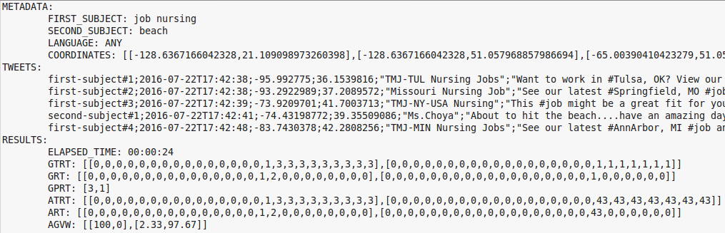Illustration 72: format of the generated text file containing a streaming process' data
- METADATA: this section contains the metadata of the current streaming process and is located at the beginning of the file. The metadata contain:
  - the first subject's search-string;
  - the second subject's search-string, only if the user set a second keywords set; if not, this line does not exist;
  - the language used to filter the Tweets (“ANY” if the user did not select a specific language);
  - the coordinates used to filter the Tweets, as a string-representation of an array of arrays of double (see the illustration above to have an example).
- TWEETS: this section contains the data of all received geolocated Tweets, and is located after the metadata. There is one Tweet per line, and each Tweet contains the following information, separated by semicolons:
  - the identifier of the current Tweet, which is formatted as the following: “[SUBJECT_IDENTIFIER]-subject-#[TWEET_ID]”, where [SUBJECT_IDENTIFIER] corresponds to the string identifier of the subject with which the Tweet has been found (either “first” or “second”), and where [TWEET_ID] corresponds to the local counter value of Tweets received for the current subject until now (in order to identify Tweets of a same subject between them);
  - the date and time representing the creation of the current Tweet, following a “YYYY-MM-DD'T'hh:mm:ss” format, where 'T' is a simple character used to separate the date from the time (and which is used by the Java parser in order to convert this string into a data);
  - the longitude of the Tweet;
  - the latitude of the Tweet;
  - the name of the user who posted the Tweet, bounded by quotation marks (in case the user's name contains a semicolon);
  - the text content of the Tweet, also bounded by quotation marks for the same reason; if a Tweet's content contains line breaks, they are automatically removed.
- RESULTS: this section contains the results of the streaming process, and is located at the end of the file, after the tweets. The results contains:
  - the time the process lasted, formatted as a “hh:mm:ss” format;
  - the graphs' data (one line per graph: GTRT => Total of received geolocated Tweets; GRT => Reception of geolocated Tweets; GPRT => Parts of the received geolocated Tweets; ATRT => Total of all (with and without geolocation) received Tweets; ART => Reception of all Tweets; AGVW => Tweets with geolocation tags vs. Tweets without). All graphs have a two-dimensions array of arrays of numbers, except the GPRT one, which only have an array of numbers. If a chart does not exist (if there is only one subject the GPRT one will not exist, for example) or is empty, an empty array is written (for example: [[],[]] or [] for the GPRT).
During the process, the file is firstly created in the “writeInFile” method of the SearchController, if it is not already existing on the server side. This method writes the given string value in the file whose name corresponds to the given string. For the streaming processes, the files are located in the “/tmp” file and are named as the following: “streaming-[ID].gt”, where [ID] corresponds to the unique ID of the current session of the connected user. Every connected user thus has a file having a unique name for his current session. This also means that there can only be one file per session, which allows the server to not be overloaded by files. “gt” is the self-assigned extension of GeoTwit files, but is just a text file. Note that the file is deleted once it has been downloaded or rejected, but the process is explained later in this chapter.
The first time the “writeInFile” method is called (and thus creates the file) occurs in the “receive” method of the "StreamingSocketActor” class of the SearchController, when the “readyToStream” web socket is received and when the user's inputs have been validated by the server. This first call allows the server to write the metadata of the current streaming process at the beginning of the file.
Then, this method is called each time the server receives a new Tweet from the Twitter's server, either in the “onStatus” method of the listener located in the “streaming” method of the SearchController, or in the “receive” method of the “StreamingSocketActor” class, when the actor received a “tweetLocationConfirmation” web socket (depending if the user respectively manually drew a rectangle on the map or selected a country in the countries' list – more information in the “Web Sockets” chapter above). This call writes the received / confirmed Tweet in the file.
Each second, the client sends the current elapsed time and the charts results to the server (with the “currentResults” web socket), which overwrite them each time. As soon as the streaming process is stopped (either because an exception was thrown or because the user clicked the stop button), the server writes the last received results at the end of the file (still with the same “writeInFile” method). Simultaneously, the client asks the user if he wants to export the generated file, in the “stopStreaming(...)” function of the “search.js” file. If the user says “yes”, he will be able to download the file; if he says “no”, the file will directly be removed from the server, in order to keep it clean at every time. Note that the user is well warned about the results of his decision.
In order to easily download the file and to get a feedback about the download process (either a success or a failure), the johnculviner's “jquery.fileDownload” Jquery's download library (https://github.com/johnculviner/jquery.fileDownload) has been used. It allows the developer to use an Ajax-like file download experience, which is not normally (easily) possible by using the web. The developer just needs to call the library, giving it the URL of the action from which the user can download the file. In GeoTwit, this action is the “fileAction” method of the SearchController, which is used either to download or delete the current user's file (you can find more information below). Here is a sample of code, which is used to download the file:
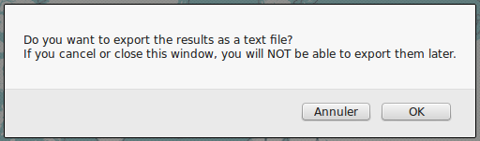Illustration 73: pop-up asking the user if he wants to export the data as a text file (french buttons are due to the browser's default language)
Once the download is done, the file is immediately removed from the server, thanks to the “deleteFile” function of the “search.js” file. If an error occurred, an alert message containing the URL of the download is displayed to the user, so he can download it manually. Note that the next time the user will press the “Start Streaming!” button, the file will automatically be removed (in order to avoid keeping useless files on the server side).
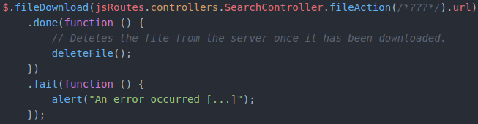Illustration 74: sample of code used to download the generated file
The “deleteFile()” function only sends an Ajax request to the “fileAction” action of the SearchController, in order to delete the file. It does not wait for response from the server.
Regarding the “fileAction” action of the SearchController, this one either download or delete the current user's file, according to its first's string parameter (which can either be “download” or “delete”). This action also needs the string(s) representing the keywords set(s), in order to properly name the file to download. It first gets the file on which the action will be operation, and checks if this file exists. If not, a BadRequest response is returned; if yes, the server performs the wanted action. If the file must be deleted, the server simply execute the “delete” method of the file; if the file must be downloaded, the server has to serve it to the client; in order to accomplish this task, the action must render a file instead of an HTTP result:
The content contains the java.io.File object to send; the file name contains the name of the file that the user will see in the download pop-up, and is formatted as the following: “[SUBJECT_1][_[SUBJECT_2]]_STREAMING_[DATETIME].gt”, where [SUBJECT_1] and [SUBJECT_2] (optional) represent the keywords sets' strings, and where [DATETIME] represents the current date and time, following a “YYYY-MM-DD'T'hh_mm_ss” format; the “inline” parameter indicates if the file must be served as an inline file (which means that he will directly be displayed in the web browser instead of being downloaded through a pop-up). The “Set-Cookie” HTTP header added at the end is used by the “jquery.fileDownload” library in order to receive a confirmation when the file was successfully downloaded (an thus to remove it from the server).
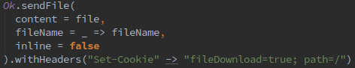Illustration 75: rendering of a file at the end of an action
You can finally find an example of generated file in the “/tmp/EXAMPLE.gt” file and find the related documentation here: https://www.playframework.com/documentation/2.5.x/ScalaStream.

Importation of a Generated File
GeoTwit also allows the user to import a previously generated file, in order to watch the results again (in a static way; the streaming does not resume). Here again, both the client and server sides are explained, in order to avoid mixes.
The user has the possibility to import a generated file by clicking a button located at the beginning of the Dynamic Mode tab's content. In summary, he has to click the button in order send the file to the “uploadAndParseFile” action of the SearchController, which will validate and parse the file, then send back the parsed data to the client as a Json format. You can find more details about this process in the paragraphs below.
The upload process starts as soon as the user chose a file to upload. Firstly, in order to be able to send the file to the action with an Ajax request (for getting Json data back from the server at the end of the process) and to be able to display a progress-bar about the upload, the basic plugin of the blueimp's “jQuery-File-Upload” library (https://github.com/blueimp/jQuery-File-Upload and https://github.com/blueimp/jQuery-File-Upload/wiki/Basic-plugin for the basic plugin) is used.
In order to initialize the automatic Ajax upload, the “fileupload” method is called on the “file” input. The given parameters indicate that the client expects the server to answer with Json data and also provide the refresh function of the progress-bar.
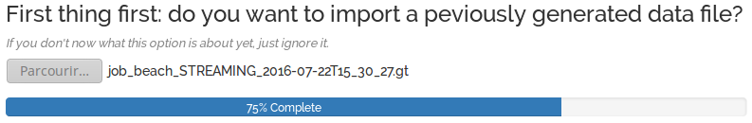Illustration 76: progress-bar managed by the jQuery-File-Upload library when the user is uploading a file
As mentioned in the comment, the URL of the route to which the client sends the file is determined by the input file's “data-url” attribute, which contains the route of the “uploadAndParseFile” action.
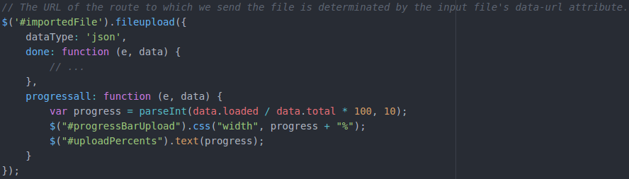Illustration 77: Initialization of the automatic Ajax upload process on the "file" input
The “progressall” function calculates the current progression value of the progress-bar according to the current loaded data, then refresh the HTML component.
The “done” function is called when the upload process is complete: it displays an error if the Json data received from the server contain one, or otherwise calls the “loadFileResultsComponents(...)” function of the “search.js” file, which loads the components (map, charts, HTML components) as well as the received data (display of the metadata, the Tweets and the results).
On the server side, the “uploadAndParseFile” action first validate the file, which must exist and be a text file, and which cannot be empty. If a validation error occurs, the following Json object is returned:
- error: true;
- reason: the reason key of the error, which is either “fileEmpty”, “wrongFormat” or “missingFile”.
If the file is valid, the action call the “validateAndParseFile(...)” method of the same controller, which validates the content of the file. This method returns a Json object containing either an error if there was one or the parsed data of the file if everything was valid:
- The file's content must first have the three sections “METADATA”, “TWEETS” and “RESULTS”.
- The “METADATA” section must have at least the “FIRST_SUBJECT” (string), “LANGUAGE” (string) and “COORDINATES” (array of arrays of doubles) values; the “SECOND_SUBJECT” (string) value is optional. The order of the values does not matter but all of them (except the optional one) have to be in this section.
- The “TWEETS” section can be empty (if there was no received Tweet during the analysis) and is directly followed by the “RESULTS” section in this case; if it contains Tweets, these have to be properly formatted (see the contained data in the “Generation and exportation of the backup files during the streaming mode” chapter above): the date must be in the “YYYY-MM-DD'T'hh:mm:ss” format, the longitude and latitude must be doubles, and the user's name and Tweet's content must be bounded by quotation marks. There must be one Tweet per line.
- The “RESULTS” section must contain the “ELAPSED_TIME” (string) value, and the data linked to the charts (GTRT, GRT, ATRT, ART, AGVW (arrays of two arrays of doubles, which can be empty => “[[],[]]”), and GPRT (array of doubles, which can also be empty => “[]”)). The order does not matter here, as long as every of these values is contained in this section.
- There must not be useless spaces, tabulations or line breaks.
While parsing the file for validating it, the algorithm also simultaneously collects all the data in order to gain time; if a validation error occurs, these data are dropped. The algorithm is split in three parts:
- Validation and collection of the “METADATA” section, and retrieval of the other section's start lines.
- Validation and collection of the tweets if the metadata were valid and if the file contains the two other sections.
- Validation and collection of the results if the two other parts were valid, then return of the Json results.
In order to validate and collect the values, the algorithm uses regular expressions with parentheses (in order to group data and get them as variables) and match cases to validate them. For example, if the algorithm wants to get the language value of the metadata, it will use the following regular expression, which will match a line beginning with “LANGUAGE:” and followed with a value containing at least one character:
The parentheses contained within the regex are used to group the value in order to get it as a variable. The algorithm then tries to match the parsed file's lines with this regular expression, by collecting the group as a “l” variable.
Illustration 78: regex used to match the language in the imported file
The validation of the other metadata and results applies the same principle. Tweets validation is a little more complicated: the regex validates and collect 6 different variables separated by ';'.
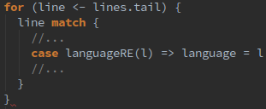Illustration 79: matching of the regex used for the language
These variables must be in the following order and must be formatted as followed:
Illustration 80: regex used to validate and get data of Tweets
- The Tweet's identifier, which must start either by “first” or “second” (the “?>” characters indicates Scala that we do not want to group the character contained in parentheses as a variable), followed by “-subject#”, then by a number. For example: first-subject#2.
- The date, which must contains a string formatted as the following: XXXX-XX-XXTXX:XX:XX, where 'X' is a digit and where 'T' is the 'T' character. For example: 2016-07-22T15:30:14.
- The longitude, which must be a double. For example: -87.9997769.
- The latitude, which also must be a double. For example: 47.8106521.
- The user's name, which must contain at least one character and must be bounded by quotation marks (note that only the bounded content will be taken in the variable). Quotes are used to avoid bugs with a string that would contain a colon. For example: "Speedway Jobs".
- The content, which must follow the same rules as the user's name. For example: “Hello everybody!”.
Once every value of the file are valid and collected, the method send back a Json object, containing the following attributes:
- error: false (indicates that there was no error);
- firstSubject, secondSubject (can be an empty string), language, coordinates;
- tweets => an array containing each Tweet's values: subjectIdentifier (either “first” or “second”), dateAndTime, longitude, latitude, user, content;
- results => an object containing the results: elapsedTime, gtrt, grt, gprt, atrt, art and agvw.
If there was an error, the method sends a Json object containing:
- error: true;
- reason: the reason key of the error, which is “fileNotValid”.
This object is forwarded to the client through the “uploadAndParseFile” action. If everything was valid, the client displays data on the screen.

Retrieving of Static Tweets
Issues due to Limitations
Before explaining the concerned algorithms, more details have to be given about the operation of the Twitter's REST API when a lot of data are available for the current user's request. Indeed, the Twitter's server cannot send the whole amount of data at one time from a certain number of Tweets, because of the problems that this action can cause (mainly slowness). In order to avoid these kinds of problems, Twitter sends the results by “pages”, each page containing a certain amount (up to 100 – configurable with Twitter4J) of Tweets. If there is still too much results, the API also limits the number of pages, which complicates the process: indeed, the developer has to get the lowest ID of the received Tweets set, in order to make a new request collecting a new Tweets set from this ID. Here is an example with a maximum of 3 Tweets per page, and a maximum of 2 pages per results' set:
In this example, the first request collects the Tweets from #12 to #7 (from the highest to the lowest IDs, because Twitter firstly sends the most recent Tweets), by generating two pages. The developer has to manually ask for the next page each time he collected all the Tweets of a page, and have to execute a new sub-request with the new page. Once the first request does not have pages anymore, the developer has to get the lowest ID of the retrieved Tweets (here: #7) if order to make a new request to collect the Tweets from #6, etc.
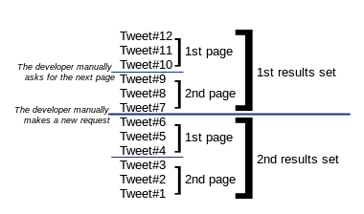Illustration 81: example of the limitations of the Twitter's REST API
This system raises a huge issue: like it was said before in the analysis part of this document, Twitter indeed limits the number of requests that a user can make in a 15 minutes' period. Since every page's sub-request is considered as a request, and since the user may have to do various requests to get all results, the limit can quickly be reached. For this reason, the number of results if limited in GeoTwit.
If this case occurs and the obtained results are limited, the user has to be more specific about his subject(s) and about the range of date. Twitter's REST API unfortunately only supports dates and is incompatible with times, so there is no way to be more specific than days.
Algorithms
When the user clicks on the search button of the static mode, the client makes an Ajax request to the server in order to retrieve the list of static Tweets (see the “Retrieval of Tweets with the Server” chapter in the client's static part below). The server uses the Twitter's REST API to collect Tweets in the “staticResults” action of the SearchController; it first gets and validates the sent parameters, then creates the queries.
The “setCount” method is used to indicate the maximum number of Tweets per page (which can be up to 100). “setSince” and “setUntil” take a “YYYY-MM-DD” date as a string value and are used to filter the Tweets respectively by start date and by end date.
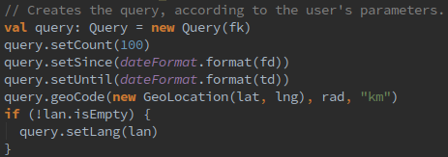Illustration 82: creation of a query for asking the Twitter's REST API with Twitter4J
The action then calls the “getStaticTweets(...)” method for each subject, which gets the Tweets related to the given parameters and builds a Json's array object with them. Specifically, this method applies the algorithm seen above about pages and results' sets in order to avoid limitations as much as possible. Firstly, the “maximumNumberOfRequests” parameters indicates the algorithm the maximum number of requests it can do before risking to reach the Twitter limit. After a few tests, it turns out that the maximum number of requests is close to 175 per account for a laps of 15 minutes (this value may be greater, but it seems to be the minimum value).
In order to keep a margin of error, this number is truncated to 170 in GeoTwit (approximately 17'000 Tweets), which means that if the user entered two different subjects, each search must at at most make about 85 requests (approximately 8'500 Tweets per subject). This calculation is managed by the “staticResults” action: the maximum number is contained in the constant variable “MAXIMUM_NUMBER_OF_REQUESTS”; when the action calls the “getStaticTweets(...)” method, it indicates it the number of requests it can do, according to the number of subjects the user selected.
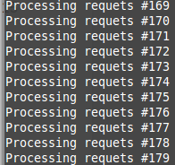Illustration 83: example of the number of requests executed before getting an error in a period of 15 minutes

Implementation details – Client Side

Both Streaming and Static Modes

Dates Format
Since a lot of dates are used in GeoTwit (in the static mode's search page, and in the results pages of both modes) and since they have to be regularly formatted, validated and converted to string objects, the “Moment.js” library (http://momentjs.com/) is used to simplify these processes. This well-known library indeed allows the developer to easily work with dates of both Date and String types.
Since this library normally is a npm package (which must normally be used with a Node.js server), the npm package “browserify” has been used. As a reminder, this package allows the developer to use npm's packages within a simple JavaScript's client application. As soon as the “/public/javascripts/search.js” file is updated, the developer has to type the “browserify search.js -o search-bundle.js” command in a console to generate the “/public/javascripts/search-bundle.js” file that contains a working version of the “search.js” file with all the code of the npm's packages included. The “search-bundle.js” file is thus the one that is read by the web browser.

Building of the Twitter's Query String
In order to filter Tweets with the Twitter API, the developer has to give a query string. It is possible to add AND and OR filter's operator by respectively separating the words with spaces (“ “) and commas (“,”) for the streaming mode or with “ OR “ and “ AND “ for the static mode, since parentheses are not supported by the API. Note that the AND keyword takes priority over the OR one, since comma-separated terms are considered as phrases by the API; here are some examples with the streaming mode (the method is the same for the static mode):
- job → interpreted as “job”
- job engineer → job AND engineer
- job,engineer → job OR engineer
- job engineer,nursing → (job AND engineer) OR nursing
- job,engineer nursing → job OR (engineer AND nursing)
- job,engineer nursing,potato →job OR (engineer AND nursing) OR potato
Once the user filled the keywords sets (with spaces between words) and pressed the search button, the “getAndFormatKeywords(...)” is called. There cases are possible from there:
- The user only filled the AND part (“All these keywords...”) → there is nothing to do here since the words are already separated by spaces.
- The user only filled the OR part (“One of these keywords...”) → the algorithm replaces the spaces with commas.
- The user filled the AND and the OR parts → since the AND takes priority over the OR and we want to search Tweets containing all the AND words and one of more of the OR words (for example: “(dog AND cat) AND (eat OR drink), the algorithm has to manually build the string, by taking each of the OR words and by adding them one by one at the end of the AND words, separating all the possibilities with commas. For example, if the user entered “dog cat” in the AND field and “eat drink” in the OR field, the resulted query will be “dog cat eat,dog cat drink”, which is interpreted as “(dog AND cat AND eat) OR (dog AND cat AND drink)”.
According to the documentation, the text of the Tweet and some entity fields are considered for matches. Specifically, the text attribute of the Tweet, expanded_url and display_url for links and media, text for hashtags, and screen_name for user mentions are checked for matches. Each phrase of the query (terms between commas, like “dog cat eat” and “dog cat drink”) must contain up to 60 character maximum, otherwise the API will generate an error.
In all cases, the function also locally saves a human-comprehensive query (with “AND” and “OR” keywords, and parentheses), in order to display it in the results page. These queries are generated by parsing the query sent to the server.

Selection of the Language of the Tweets
In GeoTwit, the user can choose a language with a drop-down menu, in order to filter the received Tweets by their language.
Since this languages' drop-down menu is located both in the dynamic and static modes, and for scalability issues, the languages list is stored as a Json format, located in the “/public/data/languages.json” file. It is then loaded in the “loadLanguagesList()” function of the JavaScript file. The Json file is composed of an array of languages, in which each element have a “value” (the BCP 47 language identifier (“en”, “fr”, etc.) sent to the Twitter's API) and a “text” (the displayed text) attributes.
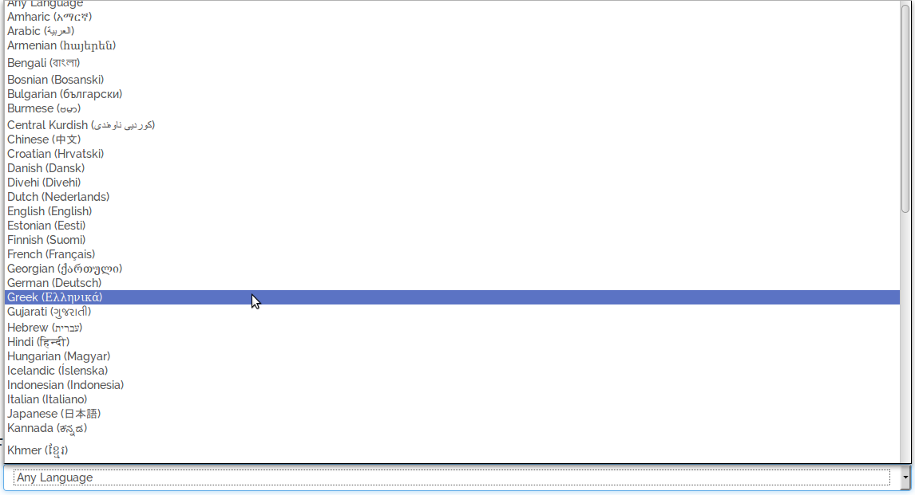Illustration 84: selection of a Tweets' language in GeoTwit

Selection of the Area(s) in the Search Page
In both the streaming and the static modes of the application, the user has to choose an area in where the Tweets will be searched. In the streaming mode, he has the choice to either select a default area in a given list of countries or draw a rectangle area by drag-and-dropping the cursor on the map. For more explanations about the first solution (default areas), please look at the prototype application's “Leaflet – Countries' Border” chapter above and at the end of this chapter. In the static mode, the user can only select a circle area by drag-and-dropping the cursor, since the Twitter's Rest API asks for a circle and since it would be tricky to calculate a bounding circle of the complex polygon representing a country.
The drag-and-drop of a rectangle/circle solution is the one that is mainly explained here; the code is contained in the “/public/javascripts/search.js” file, in the “loadSearchMap()” function.
In order to be able to draw a rectangle/circle on the map by drag-and-dropping it, the w8r's “Leaflet.draw.drag” library (https://github.com/w8r/Leaflet.draw.drag) has been used. This library uses itself the Leaflet's “Leaflet.draw” library (https://github.com/Leaflet/Leaflet.draw), which adds support for drawing and editing polygons on Leaflet maps. Note that these libraries are npm packages, and are thus used with the “browserify” package.
In the code, right after the map's initialization, three objects are set: the first one will contain the drawn items, and the two last ones will contain draw control's objects:
    - drawnItems: this object is added to the map as a feature group and will contain the drawn rectangle.
- drawnControlFull[mapId], where “mapId” is the ID (“streaming” or “static”) of the current results' map: this object represents a toolbar that allows the user to draw a rectangle/circle on the map and which is located on the top-left of the map element. It is the default drawn control that appears when there is no rectangle/circle drawn, and is hidden as soon as the user drew one.
- drawnControlEditOnly[mapId]: this object represents another toolbar that allows the user to update the drawn rectangle/circle. It only appears when the rectangle has been drawn.
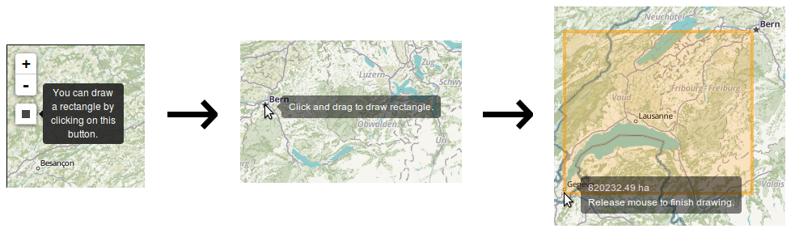Illustration 85: drawing of a rectangle on the dynamic map
As soon as the user draws or edits a rectangle or a circle, the new coordinates are respectively saved in the “boundingRectangleLatLngs” object (the latitude and longitude coordinates of each angle) or in the “circleLatLngRad” (the latitude and longitude of the circle's center' point and radius in kilometers) object, which will be sent to the server.
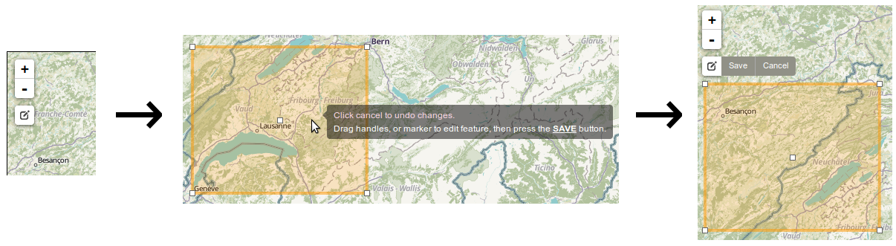Illustration 86: edition of the rectangle on the dynamic map
Concerning the first solution of the streaming mode (default areas) and as a reminder, the country the user selects in the drop-down menu contains a value corresponding to the English name of the country. As soon as a country is selected, the JavaScript code of the “selectCountryOnMap(...)” function reads and converts as the Json format the “TM_WORLD_BORDERS-0.3” Shapefile, which contains all the borders of almost each country of the worlds (note that this file is also read to add the different possible countries in the drop-down menu at the loading of the page, in the “loadCountriesList()” function). Then, the algorithm seeks for the selected country in the Json-converted data, and uses the related coordinates to draws the polygon and the map. The client also sends the server the coordinates of a rectangle bounding the selected country's territories (since a country can have many, like France with the France and Corsica territories) as said before (see the readyToStream web socket's type). The coordinates of this bounding rectangle are calculated in the “selectCountryOnMap(...)” function: if the country only have one territory (like Switzerland), the algorithm just selects the maximum and minimum latitude and longitude points of the polygon representing the country; if it has many territories, the algorithm selects the maximum and minimum coordinates of all the territories. The server will then search for Tweets located inside this rectangle, and send them to the client.

Grouping of the Tweets on the map
Since there can be a lot of displayed Tweets on the map, they have to be grouped by clusters. Fortunately, the Leaflet library offer a plug-in for its library, called “Leaflet.markercluster” (https://github.com/Leaflet/Leaflet.markercluster), and allowing the developer to easily group markers on a map by creating cluster groups.
In GeoTwit, only one cluster group is created (at the initialization of the results maps, in the “loadResultsMap” function:
The developer then just has to add a marker in this cluster group in order to make the library automatically manage the grouping.
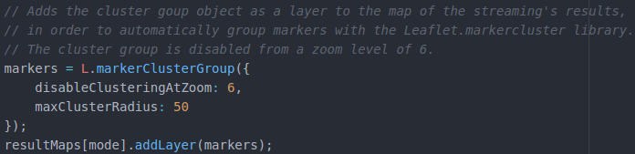Illustration 87: creation of the cluster group in GeoTwit
If the point is in the area, the client adds it; if it is not in the area, the client just ignores it.
Illustration 88: adding of a Tweet in the cluster group, in GeoTwit

Streaming Mode

Interface of the Streaming's Results
During the streaming process, the user can accesses many information, among which:
- The elapsed time since the beginning of the streaming process, updated in the “speedInterval” timer object, which is itself initialized in the “loadStreamingResultsComponents()” function called when the client received the “successfulInit” web socket.
- The human-comprehensive queries (for example “dog AND (eat OR drink)”), generated in the “getAndFormatKeywords(...)” function (see the “Building of the Twitter's Query String” chapter) when the client sent the user's parameters to the server.
- The map displaying all the received Tweets located in the selected area (see the “Reception of Tweets from the Server” chapter below).
- Various charts allowing the user to better analyze the current streaming process and the data related to it (see the “Charts” chapter below).
- The content of the last 100 (this number can change in the future) received Tweets.
- The total number of received Tweets with geolocation tags, which corresponds to the “nbReceivedTweets” variable.
- The average speed of received Tweets per minute, which is calculated each second by the “ speedInterval” timer object (like the elapsed time information). The calculation is very simple and just divides the number of received Tweets by the elapsed time, then multiply it by 60 (in order to obtain minutes) and round it with two decimals.
The tricky part of the algorithm is that it also calculates the color value of the speed text (which is green when the current speed is good, and red when it is not – the goodness of the speed is determined by the “GOOD_SPEED” constant value). The algorithm indeed calculates the hue (between “0 → red” and “120 → green”) and the lightness values (between 50% for the bad speed and 25% for the good speed) of an HSL color (http://www.w3schools.com/colors/colors_hsl.asp), by the calculated speed per minute.
The “speedInterval” timer is stopped when the user clicks on the “Stop Streaming” button.
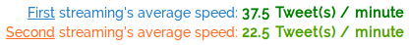Illustration 89: first example of
speed's color
Illustration 90: second example of
speed's color
If the user filled the two keywords sets, the data related to the first one (human-comprehensive query, markers on the map, curves of the charts, number of received Tweets, average speed's label, content of the Tweets, etc.) will appear in blue, while the ones related to the second one will appear in orange. Note that the cluster groups appear in green when there is not a lot of Tweets in them, and in red when there is a lot of Tweets.
Charts are properly explained in the “Charts” chapter below.
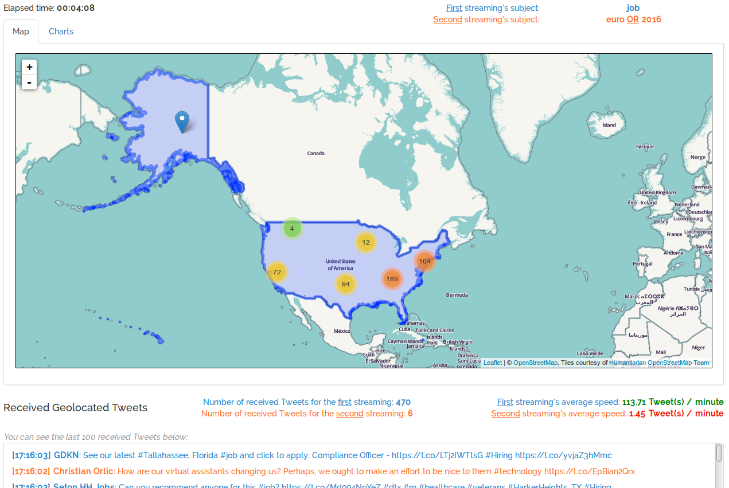Illustration 91: example of an interface of streamings' results (which can change in the future)

Reception of Tweets from the Server
Reception Process
Once the streaming process started, the client first draws the saved selected area (either the rectangle or the complex polygon bounding the area or country). When the server received a Tweet matching the filter, the language and the bounding rectangle, it sends it to the client. Once the client received the “newTweet” web socket message, it first saves the total number of received Tweets (with or without geolocation) contained in the web socket's content, then acts according to the selected location's type (determinated by a boolean variable set when the user selected an area):
- If the user manually selected a rectangle area on the map, it means that the received Tweet necessarily is in the selected area, so the client just displays it on the map and in the received Tweets panel (with the “addTweetOnPage(...)” function). It also increments the local number of received Tweets, in order to properly calculate the average reception's speed.
- It is more complicated if the user selected an default area from the drop-down menu: since the server indeed searched for Tweets within the bounding rectangle, some of the received Tweets may not be in the selected area.
In this case, the client must check that the received Tweet belongs to the complex polygon. In order to properly accomplish this task, the Point Inclusion in Polygon algorithm (PNPOLY - https://www.ecse.rpi.edu/Homepages/wrf/Research/Short_Notes/pnpoly.html) was used with an updated version of the substack's “point-in-polygon” library found on GitHub (https://github.com/substack/point-in-polygon/blob/master/index.js), which allow the developer to determinate if a given point is in a given polygon. Since the PNPOLY algorithm is well explained in the given web site, it will not be totally explained again here. Here is still some of the important points: according to the documentation, the algorithm runs a semi-infinite ray horizontally (increasing x, fixed y) out from the test point, and count how many edges it crosses. At each crossing, the ray switches between inside and outside. This is called the Jordan curve theorem. The case of the ray going thru a vertex is handled correctly via a careful selection of inequalities. The ray is tested against each edge to determinate if the point is in the half-plane to the left of the extended edge and if the point's Y coordinate is within the edge's Y-range.
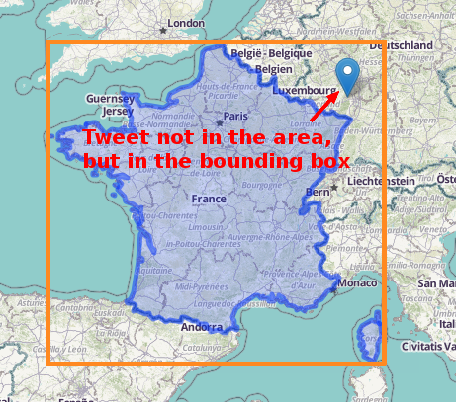Illustration 92: example of a Tweet located in the bounding box of the selected country's territories, but not in the territories themselves

Charts
In order to draw charts in GeoTwit, the Chart.js library is used (http://www.chartjs.org/). There are several other well-known libraries (like D3.js), but they are either too complicated for the simple uses in the application or not as user-friendly and as documented as Chart.js.
In GeoTwit, there are six possible charts, ordered in two categories: Tweets having geolocation tags, and all Tweets (with or without geolocation tags). The following screenshots were taken during a example test made with the “job” (blue) and “euro OR 2016” (orange) keywords sets and located in the U.S.A.
- Charts related to Tweets having geolocation tags:
  - Total of received Tweets, by time: this “line” chart displays the total of received Tweet having a geolocation tag, first by seconds, and then be minutes once 60 seconds elapsed.
  - Reception of Tweets, by time: this “line” chart displays the number of received Tweets during time periods (first by seconds, and then be minutes once 60 seconds elapsed).
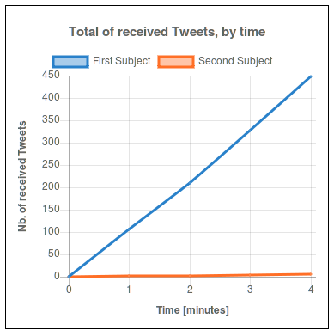Illustration 93: example of the graph displaying the total of received Tweets with geolocation tags, by time
  - Parts of the received Tweets by subject: this “doughnut” chart compares the part of received Tweets for each subject, and is only visible when the user filled the two keywords sets.
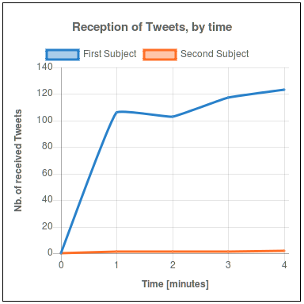Illustration 94: example of the graph displaying the reception of Tweets with geolocation tags, by time
- Charts related to all kinds of Tweets (with and without geolocation tags):
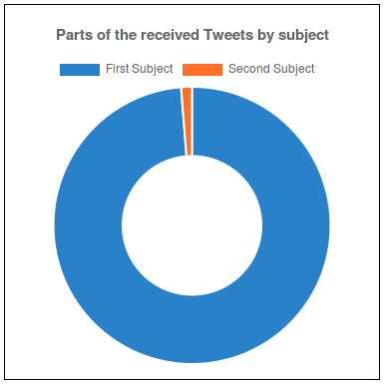Illustration 95: example of the graph displaying the parts of the received Tweets with geolocation tags, by subject
  - Total of received Tweets, by time: this “line” chart displays the total of all received Tweet (having or not a geolocation tag), first by seconds, and then be minutes once 60 seconds elapsed.
  - Reception of Tweets, by time: this “line” chart displays the number of all received Tweets (having or not a geolocation tag) during time periods (first by seconds, and then be minutes once 60 seconds elapsed).
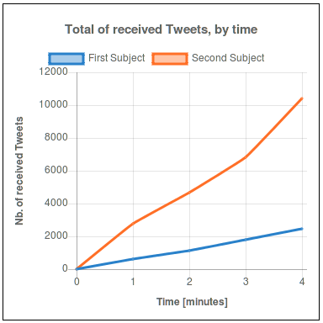Illustration 96: example of the graph displaying the total of all received Tweets, by time
  - Tweets with geolocation vs. Tweets without: this “bar” chart displays the percentage of Tweets having a geolocation tags versus the percentage of those which do not have one.
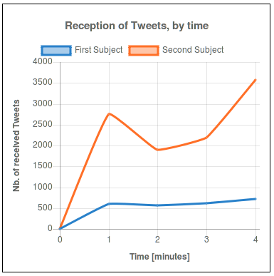Illustration 97: example of the graph displaying the reception of all Tweets, by time
All these charts are responsive and reacts when the user moves the mouse over their elements.
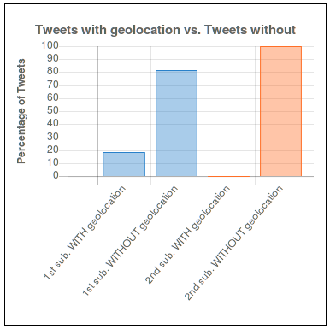Illustration 98: example of the graph comparing Tweets having a geolocation and Tweet not having one
Since the documentation of the library is well documented, everything will not be explained here; the initialization of the charts and the timers related to their refreshment is located in the “loadStreamingResultsCharts(...)” function. Firstly, the contexts of the charts (the HTML elements) are initialized, then the empty datasets of the charts and the charts themselves. The interesting parts of the algorithm concern the refreshment of the charts; there are two timers refreshing the charts each second (and then each minute for the first one):
- lineChartsUpdateInterval: this timer refreshes all the “line” charts (so 4 on the 6 charts) each second, and then each minute when 60 seconds elapsed. All the data are calculated with the “nbReceivedTweets” and “lastNbReceivedTweets” objects, which respectively contain the total number of received Tweets (for the Tweets with geolocation and for all the Tweets) and the last number of received Tweets that were calculated during the last tick of the timer.
- doughnutBarChartsUpdateInterval: this timer refreshed the “doughnut” and “bar” charts each second. All the data are calculated with the “ nbReceivedTweets” object. The bar chart contains two dataset in case of multiple keywords sets (one for each keywords set), in order to display the two subjects' colors. Each data set contains 4 values (2 for the current subject and two null value for the other subject), in order to only display 4 bars (and not 8: 2 subjects x 4 bars).
Once the charts have been initialized, the timers are started. They are stopped when the user clicks on the “Stop Streaming” button.

Static Mode

Selection of the Dates
In the static mode, the user has to select the search's start and end dates in the “YYYY-MM-DD” format. Since the Twitter's REST API only allows the developers to get Tweet from a maximum of 9 days ago, the user cannot select dates that do not fit this filter.
In order to facilitate the selection of dates, the amsul's date picker “pickadate.js” library (https://github.com/amsul/pickadate.js) is used, with the “classic” theme. This library is located in the “public/javascripts” folder in the “picker.min.js”, “picker.date.min.js” and the “legacy.js” (used for older versions of Internet Explorer) files.
The date picker is loaded on dates fields as soon as the Search page successfully loaded.
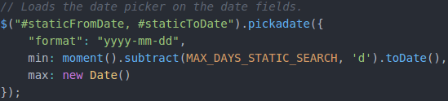Illustration 99: loading of the date picker on the dates fields

Retrieval of Tweets with the Server
Once the user properly filled all the fields, the client sends an Ajax request to the server, in order to retrieve the results. This Ajax request is located in the “getStaticTweets()” method of the “search.js” file. The following parameters are sent in a Json format:
- firstKeywords: the first keywords set filled by the user, formatted with the “getAndFormatKeywords(…) function (see the “Building of the Twitter's Query String” chapter above).
- secondKeywords: the second formatted keywords set filled by the user (it can be empty).
- fromDate, toDate: the “YYYY-MM-DD” formatted date from and to where the Tweets will be searched.
- locationLat, locationLon, locationRad: the latitude and longitude coordinates of the circle's middle point, and the radius of it in kilometers.
- language: the BCP 47 language identifier of the search's language.
Once the server responded to the Ajax request with Ajax, the response message can contain either an error (in this case, the client just displays an error message) or the list of Tweets. Since there can be a lot of Tweets, the data transfer can take a while, so the search button changes its display:
Once the Tweets lists have been received, the client first calculates the numbers of Tweets, then concats the lists (since there is one list per keywords set), sorts the new-created list by the dates and times of the Tweets, then adds each Tweet one by one on the results map (only for the Tweets having a geolocation tag) with the “addTweetOnPage(...)” function.
Illustration 100: display of the search button when the user clicked on it
in order to search for static Tweets
The Tweets also are grouped with cluster groups, like in the streaming mode's results (see the “Reception of Tweets from the Server” chapter).

Interface of the Static Mode's Results
Once the static search is done, the user can accesses many information, among which:
- The human-comprehensive queries (for example “dog AND (eat OR drink)”), generated in the “getAndFormatKeywords(...)” function (see the “Building of the Twitter's Query String” chapter) when the client sent the user's parameters to the server.
- The map displaying all the Tweets located in the selected area. Note that some Tweets can be displayed outside the circle, due to the search algorithm of the Twitter's REST API, which is a little tricky.
- The content of the all the Tweets.
- The total number of received Tweets with and without geolocation tags.
If the user filled the two keywords sets, the data related to the first one will appear in blue, while the ones related to the second one will appear in orange.
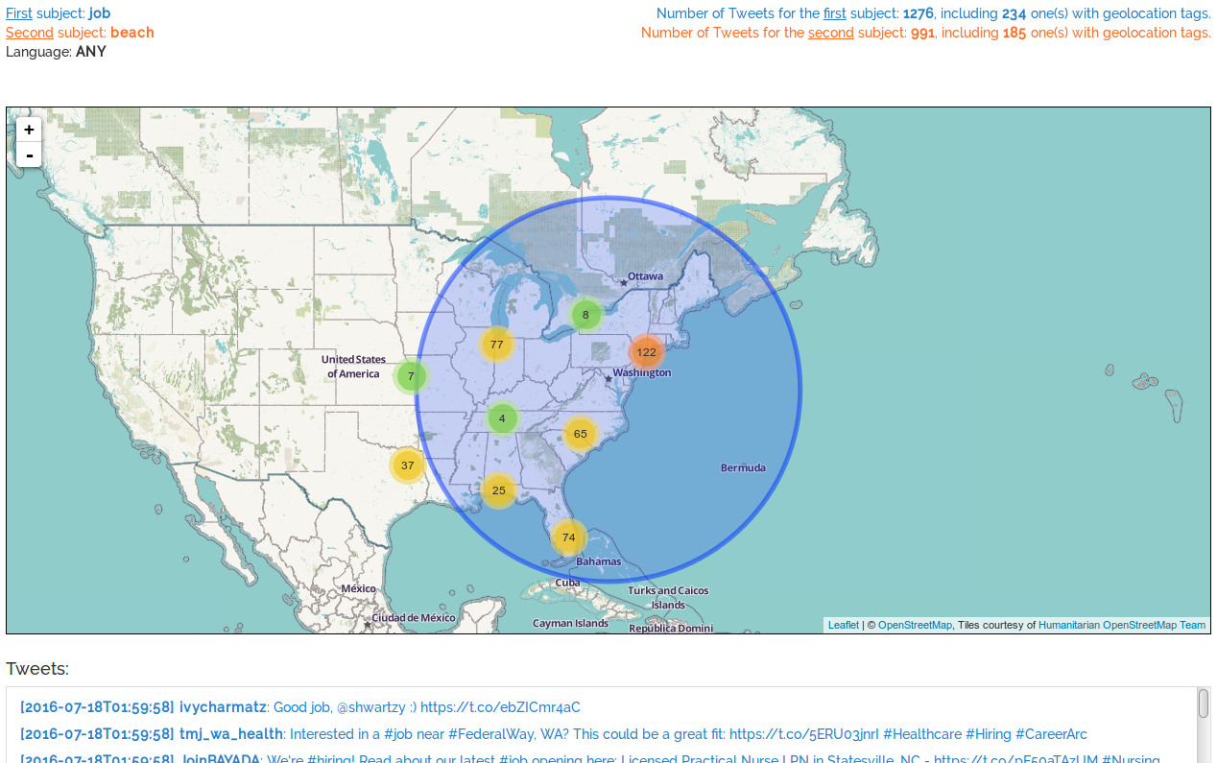Illustration 101: example of an interface of the static mode' results (which can change in the future)

Tests
Tests was done with a Twitter account specially created for this Bachelor work:
TODO: COMPTE

Functional Tests

Subjects Already Analyzed with the Prototype Application
TODO
UK Subjects
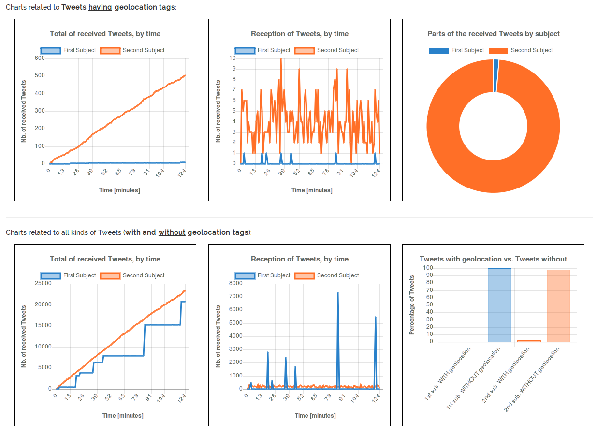
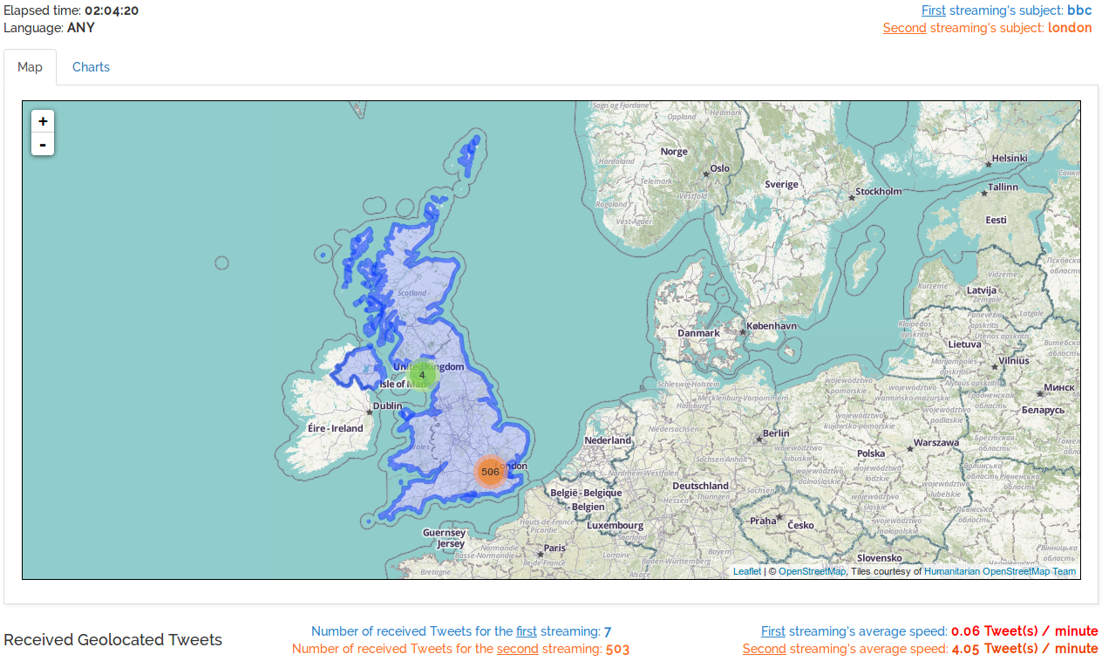
Bbc: 99.97% without geolocation, 0.03% with
london: 97.84% without, 2.16% with
18.07.16 between 15:00 and 17:00
TODO
Italy Subjects
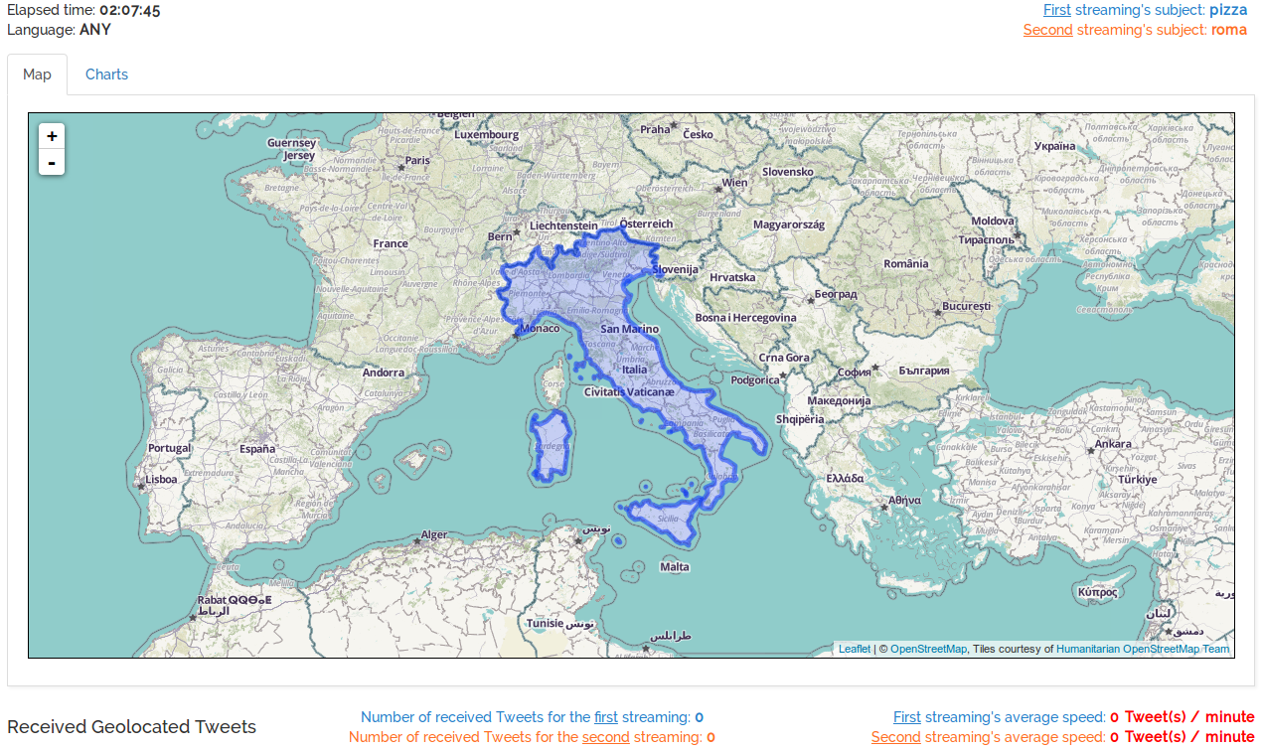
Not a single received Tweet (even without geolocation)
18.07.16 between 17:00 and 19:00

Final Match of the Euro2016 Event
In addition of the analysis of the Euro2016's final match with the prototype application, the GeoTwit application was developed enough to realize the first and complete analysis of an event with it. Two instances of the application was launched with two different Twitter's accounts (since there cannot be more than two simultaneous streaming processes by account), in order to make two different analyses:
- the first analysis concerned the keyword “euro2016” within all Europe.
- the second analysis was composed of two keywords sets (and thus streaming processes), which analyzed the Tweets related to the “euro2016” keyword and either to France or Portugal within all Europe; these keywords sets were respectively “euro2016 AND (france OR fra OR francais OR french OR bleus)” and “euro2016 AND (portugal OR por OR portuguese)”.
Unfortunately, since it was the first large-scale test ever, the first analyzed crashed 30 minutes after the beginning and was unable to properly restart. Fortunately, the prototype application also analyzed the “euro2016” keyword, but only in France though. Because of this issue, only the second analysis' results are presented below.
The duration of the analysis was 02:33:46, and the application received 392 Tweets during it, including 228 (about 1.48 Tweets / minute) related to France and 164 related to Portugal (about 1.07 Tweets / minute). As expected, there were more Tweets related to France, since this country hosted the event. Here are the maps results (note that since the application was still in development, the interface of the following screenshots may be different as the final interface of the application):
The whole Europe posted Tweets, and a lot of them were posted from France and Portugal, as expected. By zooming on the map, more details appears:
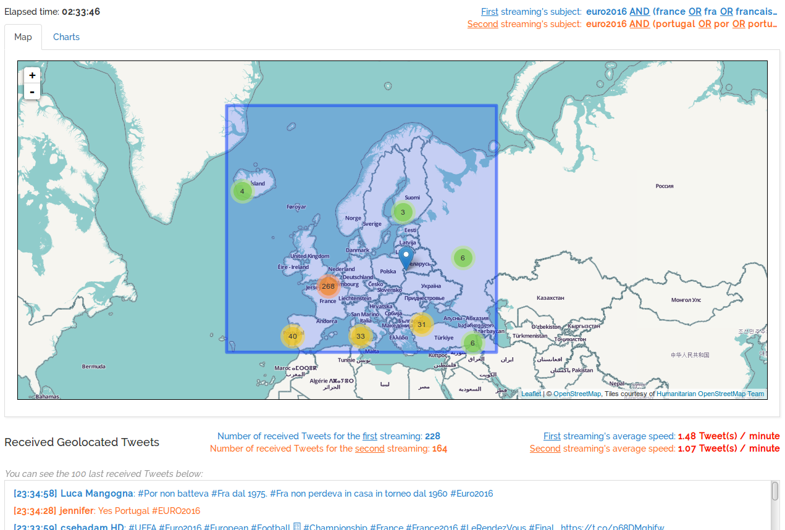Illustration 102: Tweets map of the FR-PT final match, analyzed with GeoTwit
About 215 on 392 received Tweets were posted in the Paris area, where the match occurred.
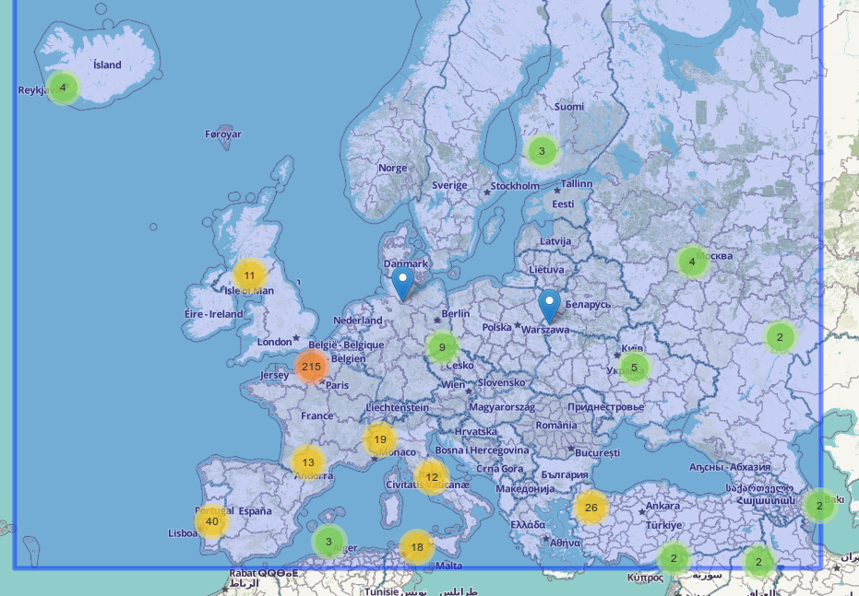Illustration 103: first zoom on the Tweets map of the FR-PT final match, analyzed with GeoTwit
Without France, the distribution of Tweets through Europe was pretty uniform. There still were less posted Tweets from the East part of Europe.
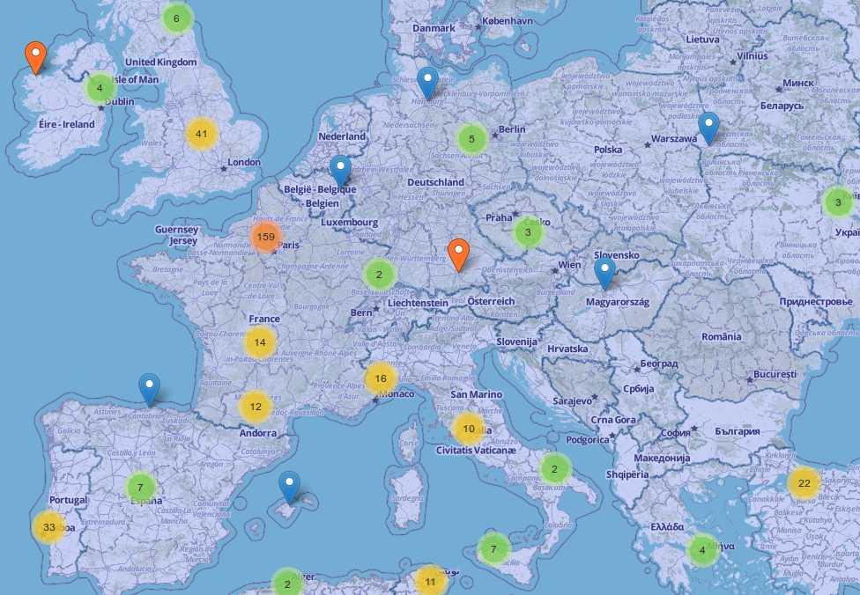Illustration 104: second zoom on the Tweets map of the FR-PT final match, analyzed with GeoTwit
There was no received Tweet from Switzerland. In the opposite, people sent a lot of Tweets from Paris.
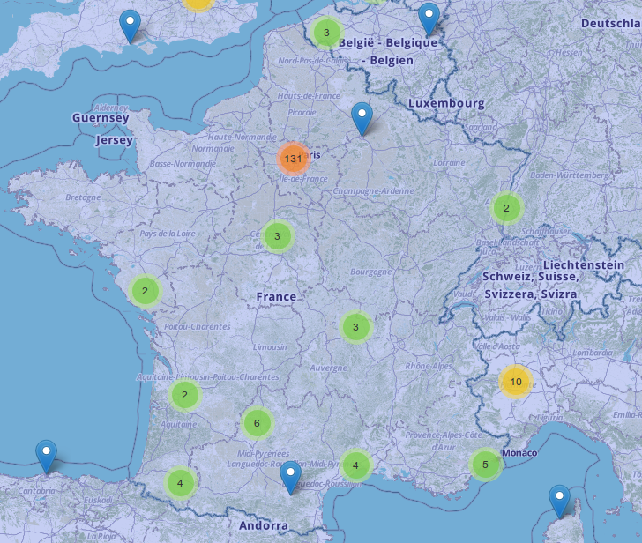Illustration 105: third zoom on the Tweets map of the FR-PT final match,
analyzed with GeoTwit
In addition of the maps results, the application also gave useful graphs about the reception of Tweets. The red annotations was manually added with Gimp:
In the first part of graphs (related to Tweets having geolocation tags), both France-related and Portugal-related Tweets' receptions took a logarithmic form. At the beginning of the match, the application received a lot of France-related Tweets, and then the receptions smoothed.
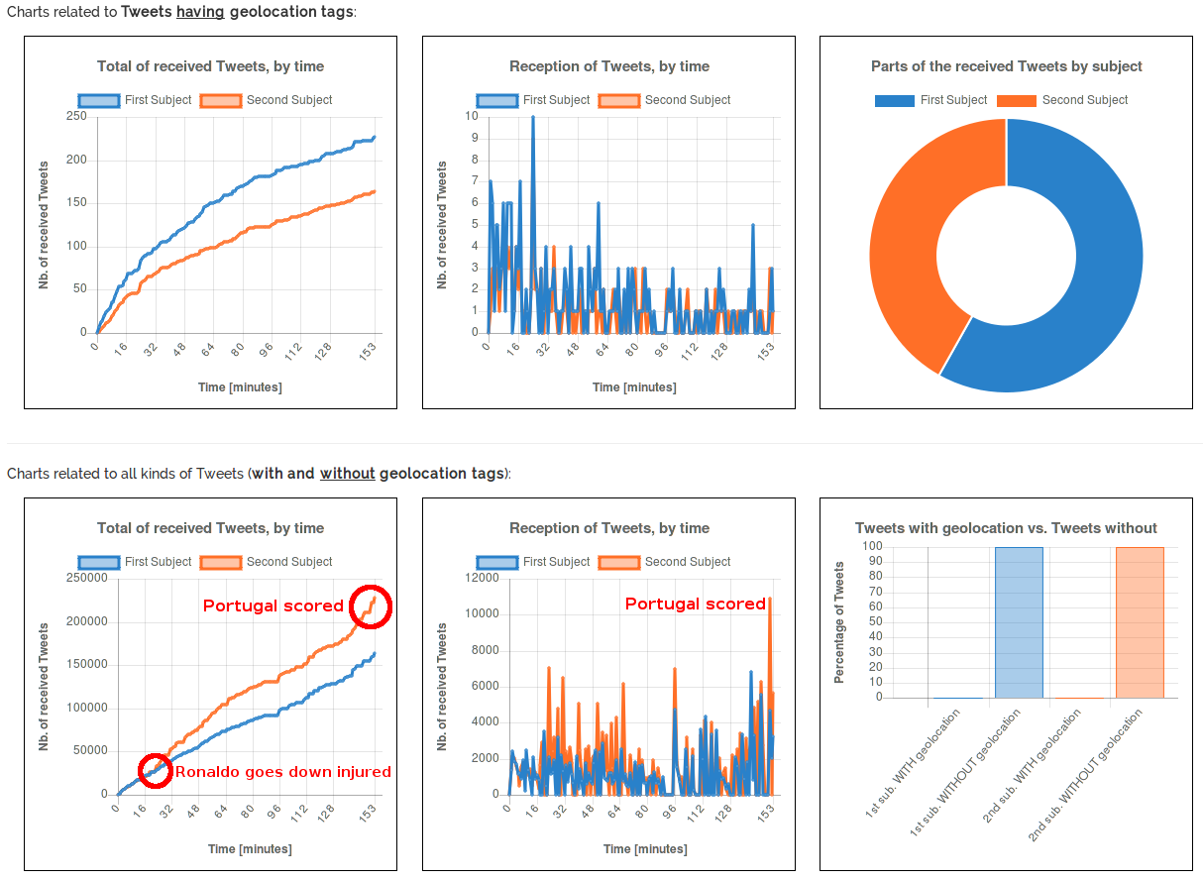Illustration 106: annotated graphs of the FR-PT final match, analyzed with GeoTwit
Concerning the graphs related to all kinds of Tweets (with and without geolocation tags), the curves were more linear than before. The reception of the Portugal's Tweets had two peaks of data, both when the favorite player of Portugal (Cristiano Ronaldo) goes down injured and when the country scored at the end of the match, giving a final reception of 228'165 Tweets related to Portugal, against 164'265 ones related to France. Finally, it should be noted than only a tiny part of posted Tweets had geolocation tags (0.14% for France-related Tweets and 0.07% for Portugal-related Tweets), which seems to follow the average percentages received in the prototype application.

Pokémon GO
One of the not-to-miss events of this semester was without a doubt the Pokémon GO game's release. It indeed created a massive flow of data through the social medias. As a reminder and according to Wikipedia, this application is a free-to-play location-based augmented reality mobile game, which allows players to capture, battle and train virtual Pokémons who appear on device screens as though in the real world. It makes use of GPS and the camera of compatible devices.
This test was a worldwide one and was done between 13:00 and 16:00 (Swiss hours) on the 19.07.2016
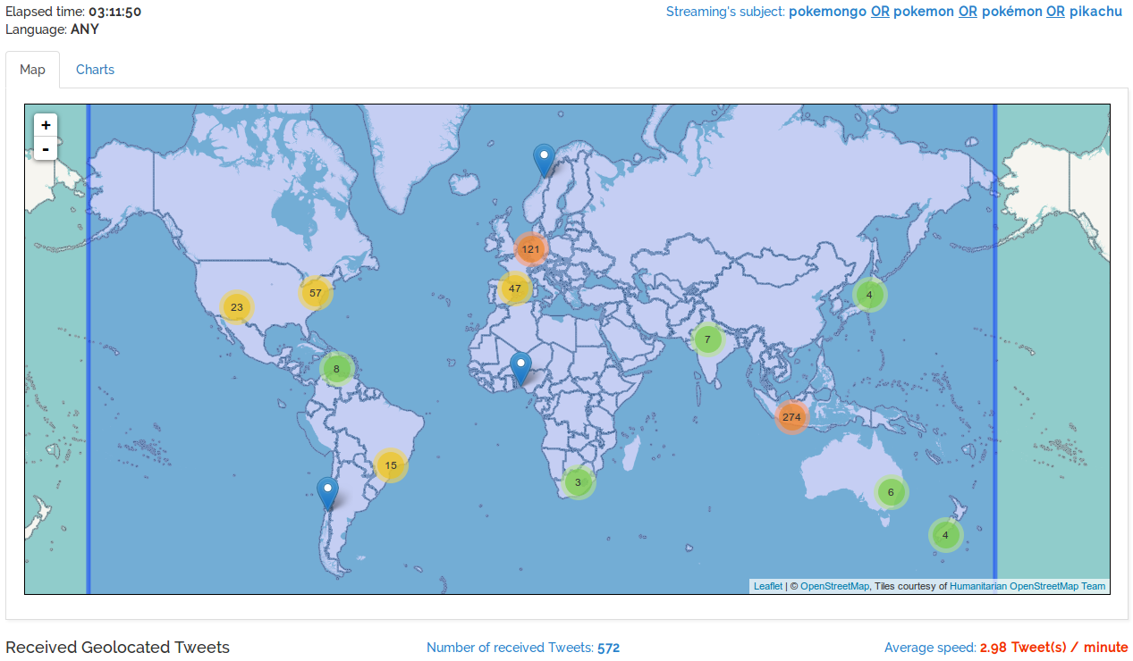
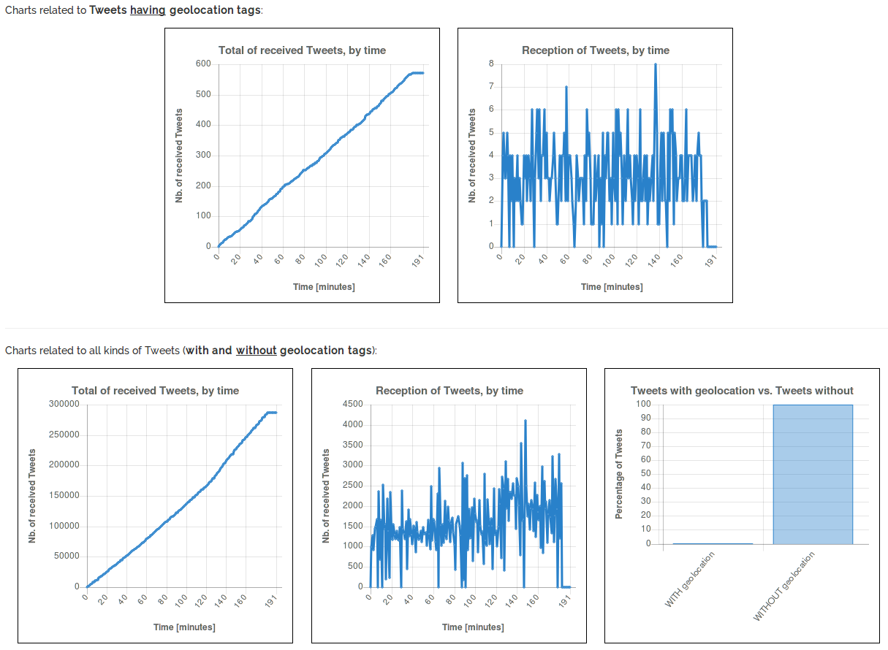

Miscellaneous
Hottest Day of the Summer in the UK
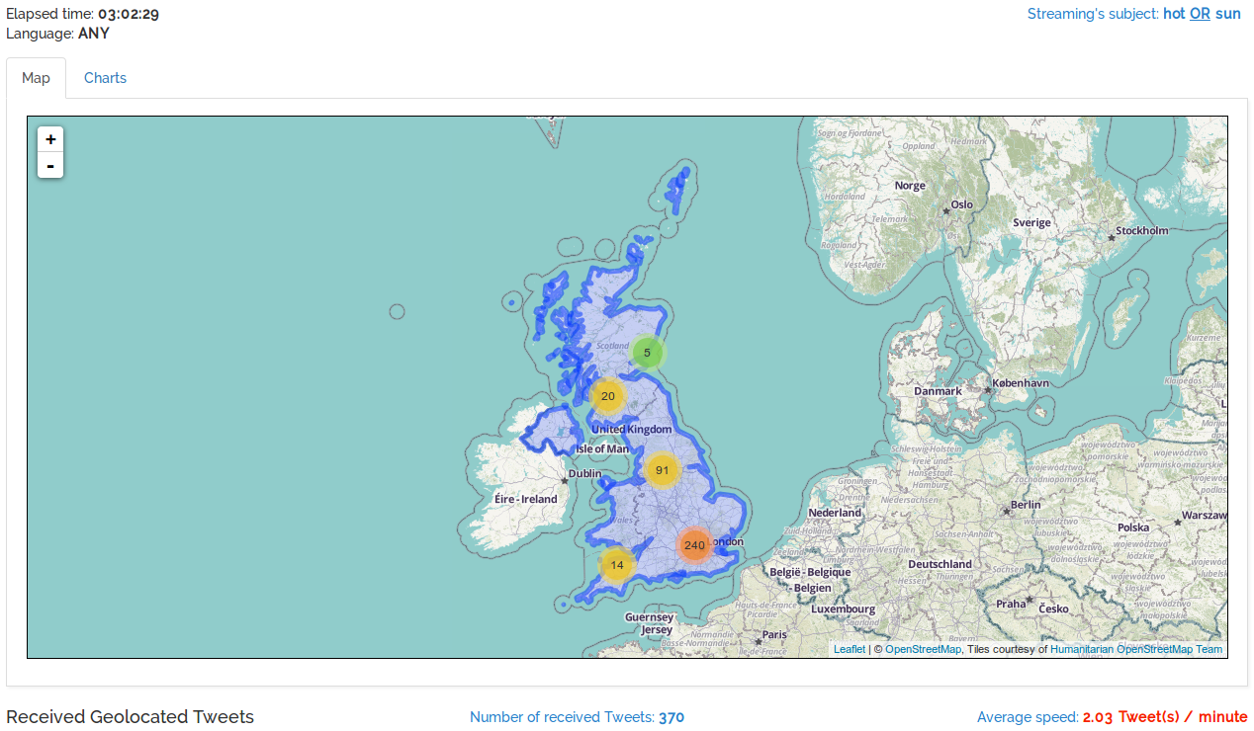
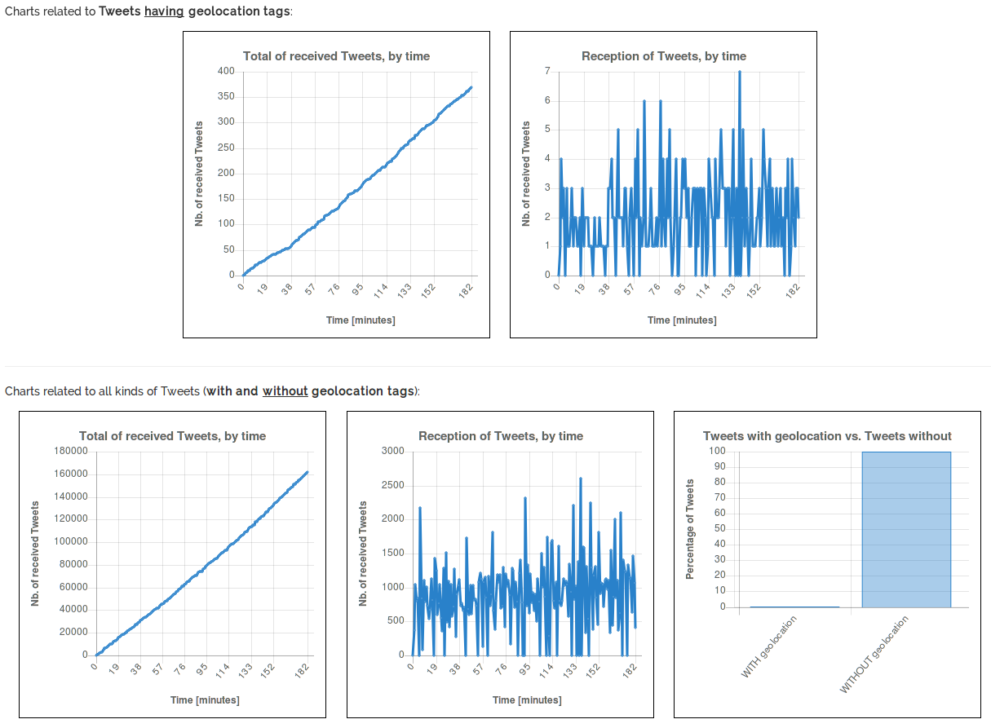
99.77% - 0.23%, 19.07.2016 – 13:00 → 16:00

Security Tests

Load Tests

Conclusions

Review of the Current State
In the beginning of the semester, I planned to complete the specifications and analysis parts of the project. I also planned to develop the basic functionalities of the application (retrieval and analysis of Tweets, basic displays on the map, etc.) as well as the documentation. Notice that this planning changed during the beginning of the semester, but I only updated it a few days ago, because I just forgot...
I succeeded in following this planning. In fact, I think I am even a little bit early: all the specifications and analysis parts of the documentation are finished, and I already created a little bit of the web site (home page, connection process and GUI of the search pages) and almost developed all the functionalities in the prototype applications (display of the Tweets on the map in a dynamical way, selection of the countries on the map, etc.). I also tried and succeeded to work on a pretty regular basis during the whole semester, as you can see in the following GitHub's graph.
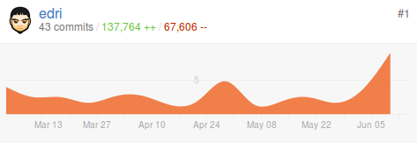Illustration 107: graph of the commits I did during the semester
Everything currently flows smoothly, then.

Encountered Problems
There is two types of encountered problems, like in most of the projects: the technical and the organizational problems.

Technical Problems
Here is the list of technical encountered problems:
- Since the Play Framework is pretty new compared to other older technologies, the documentation of this framework is logically poorer. Due to this little problem, I spent many time on significant things in order to properly use them, for example with all the session management and the protection of the application, trying to prevent a non-connected user to access the web site's content.
In order to solve this problem, I had to search the web a lot and use my knowledge in other programming languages.
- I spent many hours trying to integrate the Twitter4J library in the Play project. It was indeed different when I tried in the pure Java prototype application, where everything was simple. I searched for a while to find the right path to include in the project's build file, and when I finally succeeded, I spent many other hours trying to complete the Twitter's connection process, since it was not properly documented in the library and some things changed with Scala.
- The learning of the different libraries and technologies took some time, but nothing really significant.

Organizational Problems
And here is the list of the organizational problems:
- The main problems until now were the time management and the personal organization: since there was way more work than I thought in the other courses of the semester and since I also worked for an external client on a web site, I never was able to work during the 16 planned hours per week. However, I made myself sure to assiduously work during the free hours I had, to finally be able to follow the planning. I worked during every Mondays, often during Thursdays and sometimes during other days.
- I spend time translating the first documentation from French to English (since it was not planed in the beginning), but it was not a huge problem in the end.

Final Discussions
Even if I was a little bit scared at the beginning of this project, I think it went better than expected. Although my current work is indeed not perfect and I am sure my document should still contain typos, I still think I provided a good work until now. I hope to continue along this path until the end of the project.
For the second half, I am firstly planning to finish the application and the documentation of course, but also to mostly focus on the data analysis, by searching more interesting subjects and by running the application during days instead of minutes. I will also develop the static mode of the application, which was firstly noted as an application's extension.

General References and Annexes
References:
- https://github.com/: the application containing the repository of this project
- http://mashable.com/2010/08/06/twitter-mapping-tools/#yrksT7cG8Sqg: existing Twitter mapping tools
- Wikipedia: description about Scala and the Play Framework, explanations about the “Chunked transfer encoding” data transfer mechanism and the Shapefile file format.
- https://www.playframework.com/: the Play Framework
- https://dev.twitter.com/overview/documentation: documentation of the Twitter's APIs, also used for illustrations
- https://www.google.com/maps: used for illustrations
- http://www.rts.ch/sport/football/euro/2016/resultats/: results of the UEFA Euro 2016's matches
- http://twitter4j.org/en/index.html: Twitter4J Java library
- https://developers.google.com/maps/?hl=fr: Google Maps' APIs
- http://wiki.openstreetmap.org/wiki/API_v0.6: OpenStreetMap's API
- http://leafletjs.com/index.html: Leaflet
- https://github.com/Leaflet/Leaflet.markercluster: Leaflet's marker-cluster algorithm, used to group data by circles on the map
- https://www.npmjs.com/: JavaScript's package manager “npm”
- http://geojson.org/: GeoJson information
- https://github.com/calvinmetcalf/shapefile-js: Shapefile to GeoJson conversion library.
- https://www.mapbox.com/: a platform used to get map's imagery within Leaflet
- http://lesscss.org/: CSS' Less pre-processor
- http://www.w3schools.com/colors/colors_hsl.asp: HSL colors' explanations
- https://www.ecse.rpi.edu/Homepages/wrf/Research/Short_Notes/pnpoly.html: the Point Inclusion in Polygon library's
- https://github.com/substack/point-in-polygon/blob/master/index.js: a JavaScript library using the PNPOLY algorithm.
- http://www.chartjs.org/: the charts library
- http://trends24.in/: a web site in which users can watch current worldwide trends.

Annexes:
- The whole mock-up schema
- Planning:
  - Initial Planning
  - Logbook
  - Hours

