

Travail de Bachelor
GeoTwit – Twitter4J

Miguel Santamaria
Table des matières
Introduction 3
Creating a new application 3
Desktop applications 4

Introduction
This document contains examples and explanations about the using of Twitter's APIs with the Twitter4J library.
The complete analysis of the Twitter's APIs is contained in the “GeoTwit/doc/analysis/analysis.odt” file.

Installation
When using Play Framework, just add "org.twitter4j" % "twitter4j-core" % "4.0.4" in the library dependencies in the “/build.sbt” configuration file of your application.
If you are using a Java or Scala desktop application, download the latest stable version of Twitter4J, then just add “lib/twitter4j-core-4.0.4.jar” to your application class path. If you want to use other features (like streaming or asynchronism) add the other libs too (like “lib/twitter4j-stream-4.0.4.jar” for the streaming).

Create a new application
In order to use the Twitter's APIs on a new application you firstly have to create and register a new application on Twitter (https://apps.twitter.com/app/new).
After you did this you will access a web page, which contains all your application's parameters.
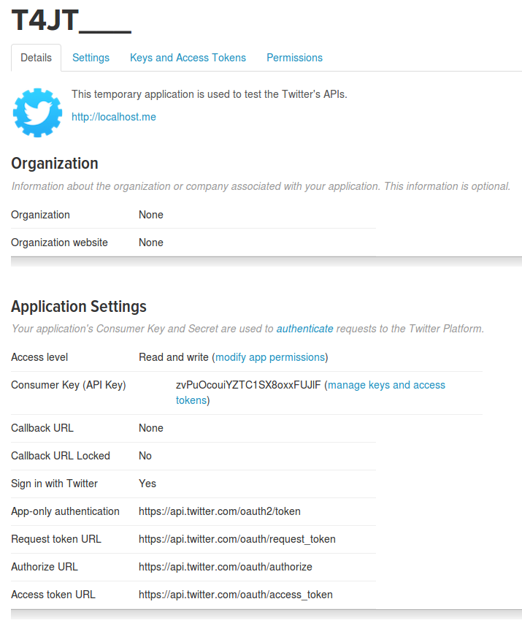Illustration 1: Twitter application's parameters.
First be sure the access level of the application is the one you want. Then you can easily get all keys and access tokens in the well-named tab, in order to use them in your application.

Desktop applications
Desktop applications are a little bit trickier to use with the Twitter's APIs, because you have to manually get accesses and you have to indicate the API that you don't want it to redirect you on a web page.
For the mentioned reasons we have to use the PIN-based OAuth; you can find more information about the ways to do it in these two links: https://dev.twitter.com/oauth/pin-based and https://dev.twitter.com/web/sign-in/implementing.
- Create a new app on the “Twitter for developers” web site (see “Creating a new application” chapter).
- Use the Twitter4J library to make a token request and get an access token (http://twitter4j.org/en/code-examples.html, on the “OAuth support” section).
You can find an example in the “GeoTwit/prototypes/twitter4jDesktop” folder.
If you're doing it right you have to ask the current user to give access to your application trough a web page's link. Once he clicked on it, he will access an authorization's page:
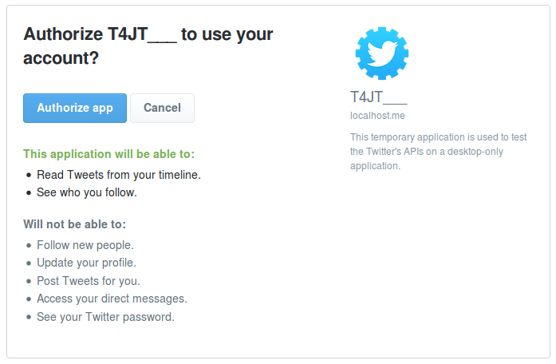Illustration 2: Twitter application's authorization's page.
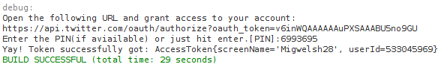
Once he authorized the app, he will get a PIN to write in the application:
Here is an example of a right output:
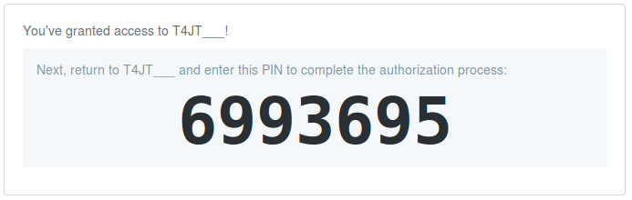Illustration 3: Twitter-generated PIN code.
- Once you got the token you can use it for your next requests!

