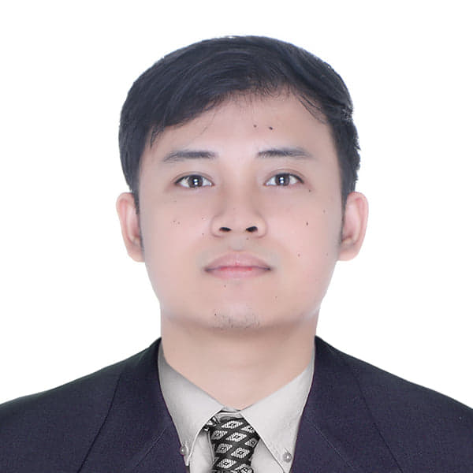**Edrian M. Sawali**

Phone: 0908-2447-247

Email: mr.edrian@gmail.com

Address: Blk 1, Lt 1, Crisanta Homes Subd.,

Brgy., Calingatan Mataasnakahoy Batangas

Date of Birth: May 12, 1996

Seeking a challenging career with a progressive organization that provides an opportunity to capitalize my technical skills & abilities in the field of information technology (IT).

**CAREER OBJECTIVE**

-Hardware troubleshooting

-Basic Programming (C++, C#,Java, Visual Basic, HTML/CSS, PHP, MySQL)

-Microsoft Office (MS Word, Excel, Powerpoint, etc)

-Macromedia Flash 8

-Basic Knowledge in SAP Business I

**TECHNICAL SKILLS**

-Verbal and written communication skills

-Ability to work independently or as part of a team

-Proven leadership skills and ability to motivate

-Fast Learner

**PERSONAL SKILLS**

**Bachelor of Science in Information Technology (2014 – 2018)**

University of Batangas Lipa Campus

Maraouy-Balete Road Balintawak, Lipa City

**Information and Communication Technology (ICT) (2012-2013)**

De Lasalle

Lipa City

**Holy Trinity School (2008 – 2012)**

Mataasnakahoy Batangas Branch

**EDUCATION**

-GET I.T WIN I.T, 2017  
-14th Youth Congress on Information Technology (Y4IT), 2016  
-Tour de’ Creative Visited New Media Services Company, 2016  
-13th Youth Congress on Information Technology (Y4IT), 2015  
-12th Youth Congress on Information Technology (Y4IT), 2014

**SEMINARS**

**ATTENDED**

**Intern - IT Department**  
PAG-IBIG FUND LIPA BRANCH  
*Handled troubleshooting and maintenance as well as monitoring  
and deployment of IT equipment.*

**Web Development III**

MindTech Course Training ( Aug 16 2021 – Sept 8 2021)

**TRAINING**

**EXPERIENCE**

**Service Engineer**  
Philcopy Corporation LIpa Branch  
*Handled troubleshooting and maintenance of field machines as well as monitoring and deployment of IT equipment.*

**WORK**

**EXPERICNE**

-**Mrs. Mayling Capuno**  
Department Head, Information Technology Department  
University of Batangas Lipa Campus

-**Mr. Jerome Fajardo Benigno**  
Faculty, Information Technology Department  
University of Batangas Lipa Campus   
+63917-524-2306

**REFERENCES**

*I hereby certify that the above information is true and correct to the best of my Knowledge and Belief.*

**Edrian M. Sawali**

**Applicant**