Edrian Becerra
CSD310 - Database Development and Use
4/11/2026
Initial database connection
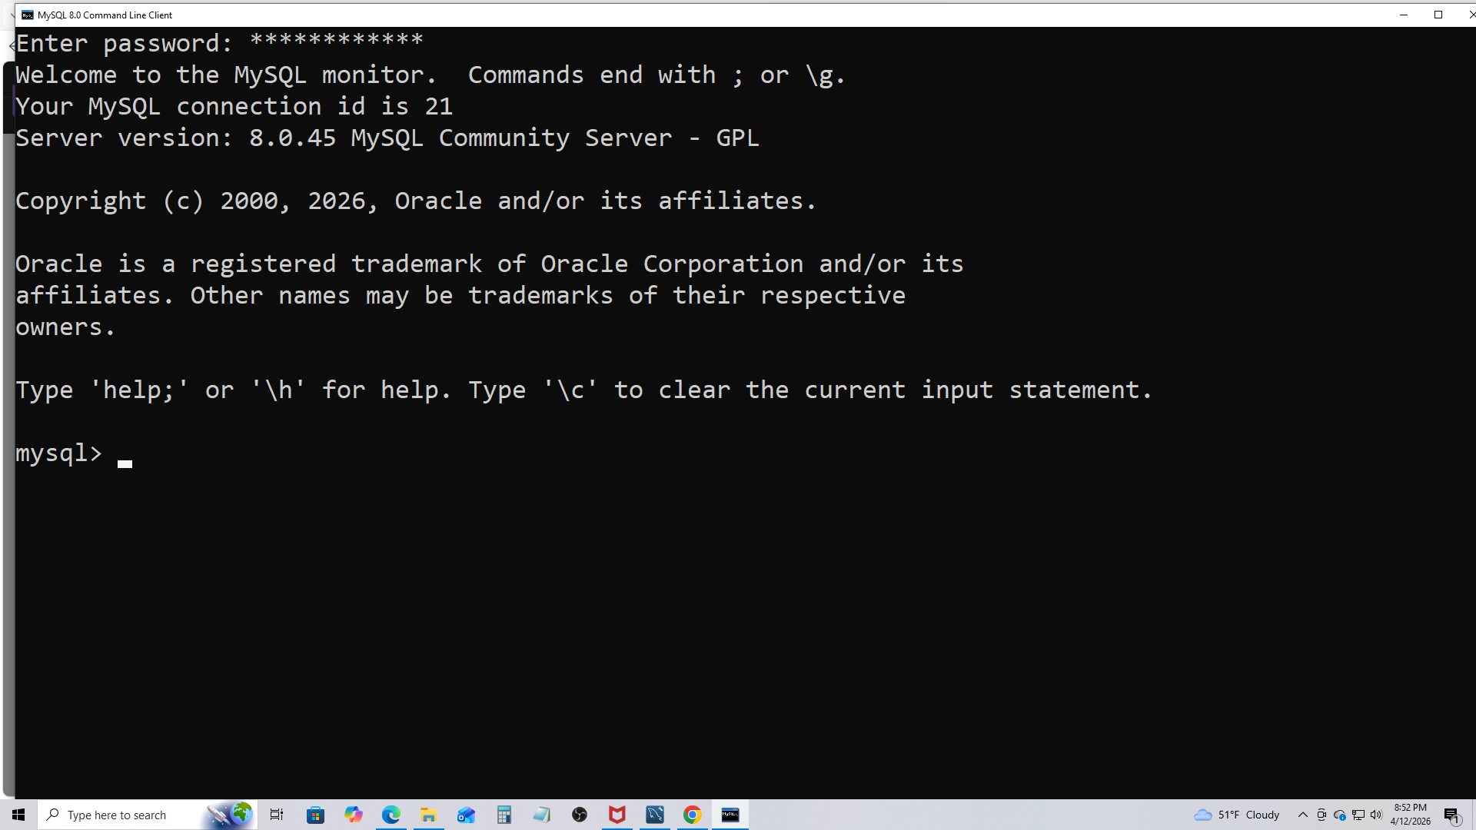
SHOW DATABASES
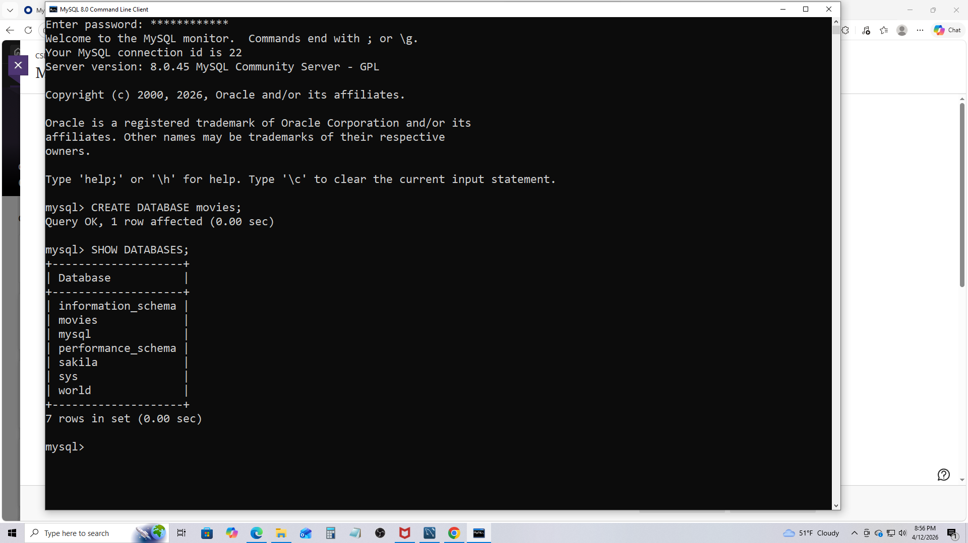
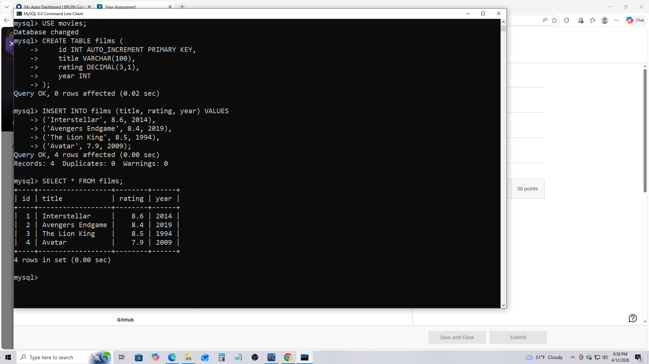
Movies list/table
My 3 functions
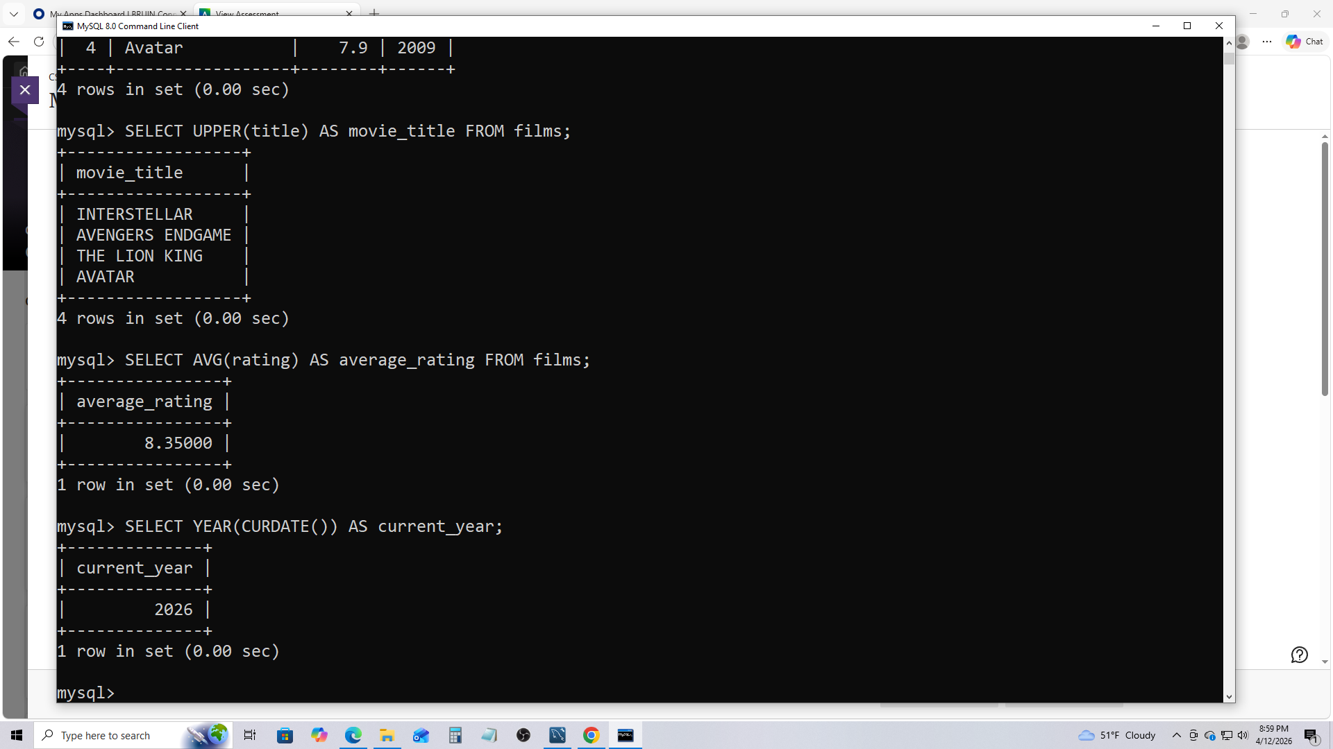
Explanation
In this assignment, I installed and used MySQL to create and manage a database. After logging into MySQL, I created the database named “movies” and verified it using the SHOW DATABASES command. I then selected the database using the USE command and created a table called “films” with columns for id, title, rating, and year. After creating the table, I inserted sample data for four movies: Interstellar (my favorite movie of all time), Avengers Endgame, The Lion King, and Avatar. I then used the SELECT * FROM films statement to confirm that the data was successfully inserted. Finally, I experimented with three MySQL functions to demonstrate different types of operations. I used the UPPER() string function to convert movie titles to uppercase, the AVG() numeric function to calculate the average movie rating, and the YEAR() function combined with CURDATE() to retrieve the current year from the system date. Screenshots of each step and query output were taken and included in this document to demonstrate the successful execution of all required tasks.

