Analyzing The

Employment Insurance

Coverage Survey

(EICS)

**Table of Contents**

**Phase 1**Pages **(3-4)**

IntroductionP.3

MethodologyP.3

Method of Data CollectionP.4

**Phase 2**Pages **(5-10)**

Research Question 1P.5-7

Research Question 2P.8-10

**Appendix** **11**

**References** **12**

**1) Introduction**

The Employment Insurance Coverage Survey (EICS) is a follow up survey conducted to those people sampled in the Labor Force Survey (LFS). Employment Insurance (EI) benefits are given to individuals who lose their jobs through circumstances that are not in their control and also to those who are unemployed. The purpose of this survey is to get a deeper understanding of the relationship between the number of people who receive EI and the number of people unemployed who are in need of EI. Starting in 1997, this survey tried to track the performance of the EI benefits program. This survey outputs the number of people covered by EI, the sample mean of EI benefits received split into groups and the proportion of people who may need EI but do not get access to EI. The data is used to analyze the role of EI benefits to the person or household income during periods of unemployment. The survey also seeks to improve the understanding of the parity between people who receive EI benefits. In this paper, we will answer which characteristics of people receive higher benefits and try to determine the parity of benefits given to different categories of people.

**2) Methodology**

The EICS survey was sampled via a Stratified Random Sampling based on the **Labor Force Survey (LFS) design strata** which grouped samples by provinces and also by wealth. The strata were based on the most recent census information (2011) because the strata becomes less efficient the farther it is from the census source date. The **target population** of this survey everyone belonging in the five groups (or types) of people who are potential employment insurance recipients. This is a follow up to the LFS survey hence its **sampling frame** is the list of all samples in the LFS survey or the list of all households in Canada during the time of data collection. The **sampling unit** is one household in the LFS survey and the **element** here is a person from a noninstitutionalized population who is at least 15 years old. (See fig 2.1 below for distribution of samples per province).

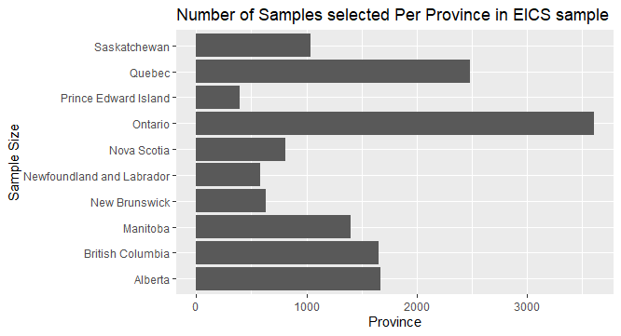

*Fig 2.1 Number of Samples per Province*

**3) Method of Data Collection**

The data was collected via telephone interviews seven weeks after being interviewed for a different survey (Labor Force Survey). The data was collected on members of the household aged 15 or above and are not in the Canadian Armed Forces wherein a maximum of 3 people per household are sampled. In the case that a household moves, the information is obtained from the new household that moved in. Survey results are then inputted by the interviewer, who is a *Statistics Canada Employee (1)*, in a computerized questionnaire. In the case of non-response in the first call, the senior interviewer follows up otherwise they are recorded as no response. *The non-response rate (2)* for this survey is not given, but we estimate it to be similar to the Labour Force Survey Non-response rate which is 10 percent. Although Statistics Canada used proper survey methods with a Stratified Random Sample and a trained interviewer, Non-sampling errors are very hard to avoid. These include errors in inputting the answers, misunderstanding of instructions and non-response. One measure of Sampling Error Statistics Canada uses is the *Coefficient of Variation* (3). The Coefficient Variation of EICS PUMF (estimate of the percentage of people available for employment insurance) is 2.4% which is relatively small, hence we assume that sampling errors are small.

(1)  Interviewers are supervised under senior interviewers to ensure they comply with previous concepts and procedures

(2)  Nonresponse rate: Number of samples who did not respond divided by total number of samples

(3)  Coefficient of Variation: (estimate / standard error of estimate) * 10

**4) Research Questions and Analysis**

**Research Question 1**: **Does the Mean Employment Insurance for those who joined a Union greater than those who did not?**

* For this Research question, we will analyze the parity of Employment Insurance between those who are members of a Union compared to those who are not by comparing their means

**Variables Used**

* Response: Amount of Employment Insurance Received (**benamt**)
  + Type: Quantitative Variable (Numeric)
* Explanatory: Union Status (**union_g**)
  + Type: Categorical Variable, Nominal Scale (Member, Not a Member)

**Assumptions**

* Independence Assumption
  + It is reasonable to assume that the percentage of people who are members of a Union is independent from the percentage of people who are not members this can be strengthened by the Randomization Condition.
* Randomization Condition
  + Based on how Statistics Canada gathered this survey via a Stratified Random Sample, it is reasonable to assume that the amount of Employment Insurance Received is representative of all member and non members of a union
* Nearly Normal Condition
  + We have a large dataset for this research question (1338 samples), by the Central Limit Theorem this would be approximately normal, this holds even if our data is slightly right skewed (see fig 4.1 below).
* Equal Variance Assumption
  + To test this assumption, we conducted a F-test (Appendix A.1) which resulted into not rejection of Null (No evidence that variance are not equal)

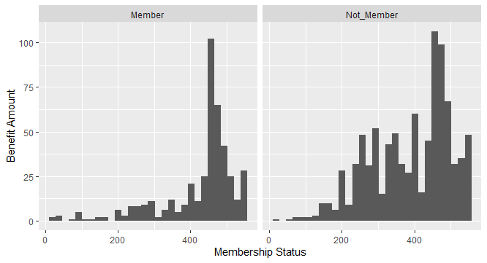

*Fig 4.1 (Histogram of Benefit Amount split into groups)*

**Hypothesis Test**

* H0: *The Mean amount of Employment Insurance Received by people who joined a union is equal to those who did not join a union*
* Ha: *The Mean amount of Employment Insurance Received by people who joined a union is greater than those who did not join a union*

We perform a two sample t-test assuming equal variances because our F-test for equal variances do not show any statistically significant difference (See Appendix A.1). From the output of our t-test (See Appendix A.2), we can see that the p-value is very small (way smaller than 0.05), hence we can conclude that the mean benefits received by people who join a union is **greater** than those who do not join a union. That is, on average people who join a Union receive higher Employment Insurance than those who do not join a Union.

**Confidence Interval and Interpretation**

* We are 95% confident that the mean amount of Employment Insurance Received by people who join a union is about 24 to 48 dollars larger than those who did not join a union (see Appendix A.3 for the output of our t-confidence interval).

**Results and Conclusion**

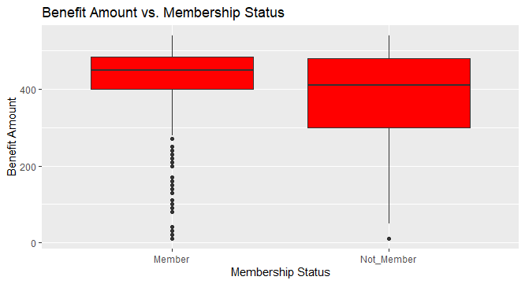

* From the boxplot, we can see that the median benefit amount received by union members is higher than the median benefit amount received by non-members (above by around 50). Also, notice that the 1st Quartile of the boxplot for members is almost the same as the median of the non-members and there is a large skew in the lower tail which means that benefit amount received by the non members who are below the median receive really low benefits. This somehow suggests that the benefits members got is generally more than the non-members. There are lots of lower ‘outliers’ in the lower tail of the benefit amount received by members when applying the 1.5 IQR rule which suggests that the mean might be pulled down by these observations. We can also see that the spreads and range of values for both groups are similar which supports our assumption that they have equal variances (this can also be seen in Fig 4.1 in the previous page). Overall, this suggests that joining a union is beneficial to get a higher EI benefit.

**We recommend people join a Union if they would like to receive a higher Employment Insurance Benefit. On average, the amount of insurance received by Union members are about 24 to 49 dollars larger than those who are non members.**

**Research Question 2**: **Is there an association between receiving Employment Insurance Benefits and Immigration Status?**

**Variables Used**

* Response: Received Employment Insurance Benefits (**benefit**)
  + Type: Categorical Variable with Ordinal Scale (Received or did not Receive EI benefits)
* Explanatory: Immigrant Status (**immigr_g**)
  + Type : Categorical Variable with Nominal Scale(Immigrant or Born in Canada)

**Assumptions**

* We can assume Independence and Randomization because the data was generated via Stratified Random Sampling
* From the table of expected counts below, all values are greater than 5 hence the Chi Square assumption is Satisfied

|  |  |  |
| --- | --- | --- |
| *Table 4.1* | Not Received | Received |
| Canadian By Birth | 7389.21 | 1763.79 |
| Immigrant | 1370.79 | 327.21 |

*Table 4.1 (Expected Counts of Contingency Table assuming independence)*

**Hypothesis Test**

* H0 (Null Hypothesis): *There is no Association between receiving Employment Insurance benefits and immigration status*
* Ha (Alternative Hypothesis): *There is an Association between receiving Employment Insurance benefits and immigration status*

From the output of our Chi Square tests for association (See Appendix B.1), we can see that the p-value is very small (way smaller than 0.05), hence we can conclude that there is an association between receiving Employment Insurance benefit and Immigration Status

**Results and Conclusion**

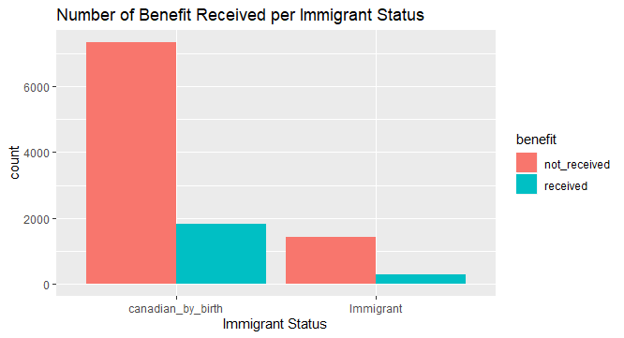

* We can see that the majority of samples in our dataset are Canadian by Birth, we can also clearly see that the number of Immigrants who received EI benefits is very small. On one hand, we can see that around 1812 Canadian by birth who received the benefit while only around 279 immigrants receive the benefit. Although this difference seems really big, part of this is because that most people that were sampled are Canadians by birth (more than 6000 samples greater than Immigrants). Although as we can see from the contingency table below, the conditional probability of receiving benefit given Canadian by birth is still bigger than receiving benefit given Immigrant. This shows that Canadian By Birth are more likely to receive a benefit than Immigrants from our sample.

|  |  |  |  |
| --- | --- | --- | --- |
| *Table 4.2* | Not Received | Received | Sum |
| Canadian By Birth | 7341 | 1812 | 9153 |
| Immigrant | 1419 | 279 | 1698 |
| Sum | 8760 | 2091 | 10851 |

*Table 4.2 (Contingency Table)*

* The proportion of Canadian By Birth who received benefits is equal to 19.7% but the proportion of immigrants who received benefits is only 16.4%. Even by just eyeballing the contingency table, we can clearly see the amount of Canadian By Birth who received Insurance benefit is more than those who are Immigrants.

|  |  |  |
| --- | --- | --- |
| *Table 4.3* | Not Received | Received |
| Canadian By Birth | -3.2294 | 3.2294 |
| Immigrant | 3.2294 | -3.2294 |

*Table 4.3 (Adjusted Standardized Residuals)*

* The adjusted standardized residuals have a magnitude greater than 3, hence we can give a Directional Conclusion. We conclude that Canadians by birth tend to receive benefits more often than we would expect and Canadian Immigrants would receive benefits less often than we would expect if the variables are truly independent.

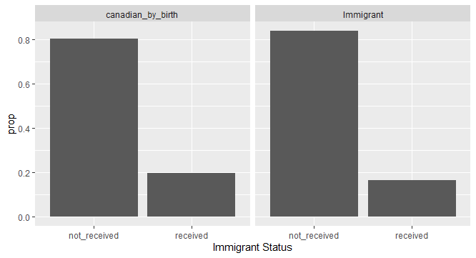

*Fig 4.4 Conditional Probabilities of receiving benefit given Immigrant Status in our sample*

* **Note**: Although we were able to get a statistically significant result, this might not be of practical significance as we can see from the plot of the proportion (Fig 4.4). It seems that the conditional probabilities are very similar to Canadian by birth having a slight edge in probability of receiving a benefit.

**APPENDIX**

**(Note: All codes used to generate the values below and plots are in a separate r script (proj.r) )**

*A.1) F-test to compare variance*

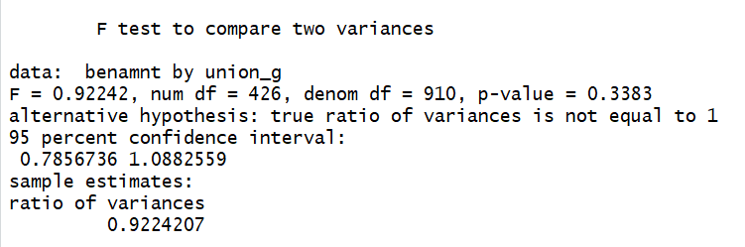

*A.2) Two sample One sided t-test*

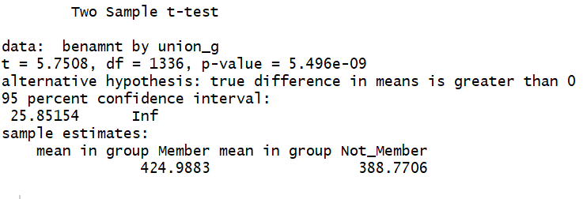

*A.3) Two sided T-test (95% Confidence Interval)*

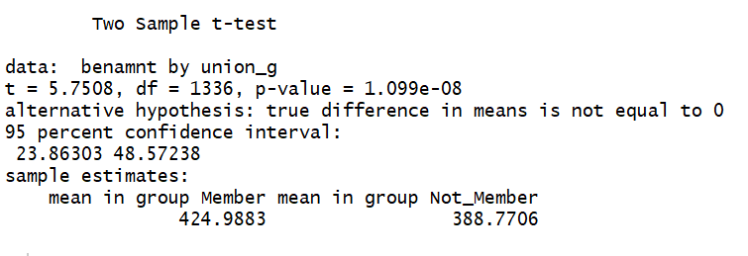

*B.1) Pearson Chi Squared Test*

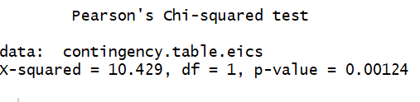

**5) References (SDA CHASS)**

**Link to Data:**

**http://sda.chass.utoronto.ca/sdaweb/html/eics.htm?fbclid=IwAR3I4HQmmBCr23Ur6YQkr6n-wd4zUA1ne-Cn5VgtLwUcDLGffUm1kqHrThY**

**Link to Documentation:**

[**http://sda.chass.utoronto.ca/sdaweb/dli2/eics/eics17/more_doc/EICS2017gid.pdf?fbclid=IwAR1D9YRIUwBQm3af-Ere0cL2_wMCTLA2mZNqr58sp3xs2S1qmOknOsqBgWQ**](http://sda.chass.utoronto.ca/sdaweb/dli2/eics/eics17/more_doc/EICS2017gid.pdf?fbclid=IwAR1D9YRIUwBQm3af-Ere0cL2_wMCTLA2mZNqr58sp3xs2S1qmOknOsqBgWQ)