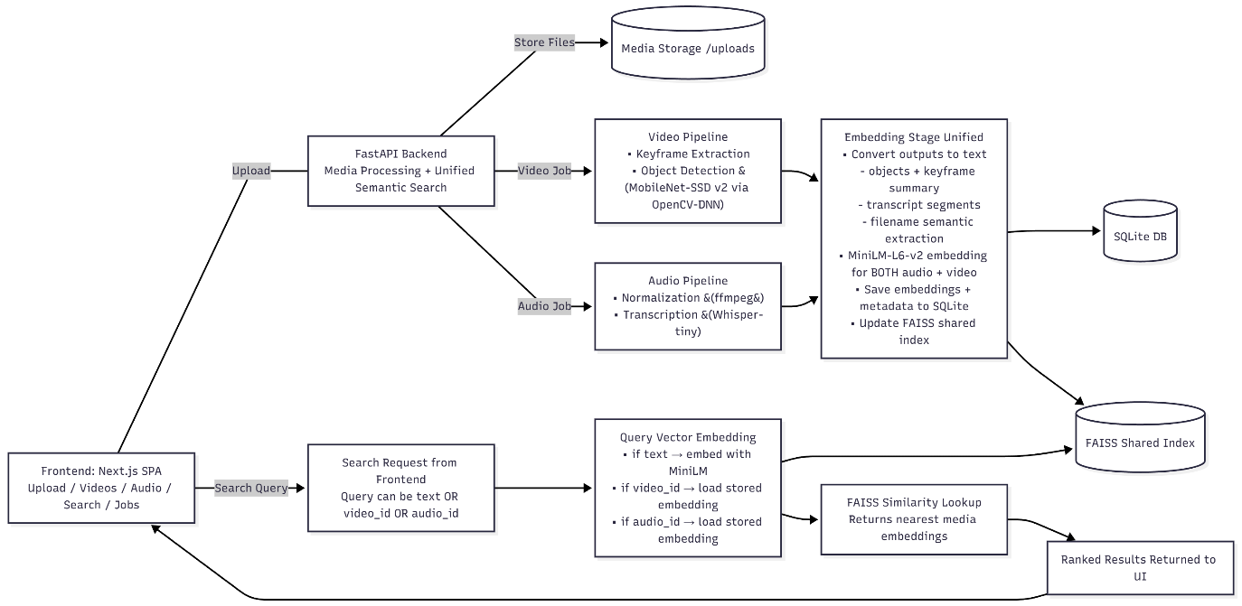
Video Pipeline
- Keyframe Extraction
  - Frames read sequentially with OpenCV (cv2.VideoCapture)
  - Histogram comparison between consecutive frames
  - When hist difference > threshold → keyframe stored
  - Reduces redundant frame processing
- Object Detection (MobileNet-SSD v2 via OpenCV-DNN)
  - Each keyframe passed into cv2.dnn.blobFromImage()
  - Forward pass through MobileNet SSD network
  - Outputs bounding boxes + class predictions + confidence
  - Detected objects converted to text summary
- Text + Metadata Semantic Vectorization
  - Filename + detected object labels + summaries converted to text
  - Encoded with MiniLM-L6-v2 → unified embedding space
  - Embeddings stored in SQLite + indexed in FAISS

Audio Pipeline
- Pre-processing
  - Audio normalized and resampled using FFmpeg
  - Ensures consistent input for transcription model
- Transcription with Whisper-tiny
  - Inference runs in chunks/segments
  - Produces text + timestamps + confidence score
  - Long files handled without memory blowout
- Embedding (Unified with Video)
  - Transcript text + filename embedded via MiniLM-L6-v2
  - Embeddings stored in SQLite + indexed in FAISS

1. Approach for Implementing Vector Similarity Search Across Different Media Types
The system uses unified text-based embeddings to represent both video and audio content in a shared vector space.
- Video is processed → keyframes extracted → objects recognized → converted to descriptive text
- Audio is transcribed to natural language text
- Filenames are also embedded to contribute semantic context
- All text representations are embedded using MiniLM-L6-v2, producing 384-dimensional vectors that map meaning, not raw pixels or waveforms
- Embeddings are stored in SQLite and indexed in-memory with FAISS L2 similarity search
Because both modalities are embedded using the same model, cross-media semantic search becomes possible.
Searching by a phrase like "dog barking" may retrieve videos, audio clips, or both. Searching by video or audio files (already existing ones) will retrieve their saved embeddings and compare them with other files.

2. How the Solution Handles Large Video + Audio Files
The system is designed so large media files do not block request/response processing:
Aspect | Large Video Files | Large Audio Files
Processing Method | Keyframes extracted rather than full-frame processing | Transcribed in segments, not entire waveform at once
Model Used | MobileNet-SSD operates per-frame (scalable) | Whisper-tiny runs chunk-based for streaming
Execution | Process runs in background worker queue | Same async job queue, buffered workloads
Storage | Only embeddings + metadata are stored in DB | Embeddings stored, raw files do not sit in memory
Indexing | FAISS index loads vectors only, not media files | Lightweight RAM footprint

Video and audio are uploaded once, then processed asynchronously, meaning the user isn't blocked — even for long or large inputs. There is however a limitation on the file upload part. Specifically, currently maximum file size is 1GB. To handle more, chunking upload will need to be implemented (backend save chunks and merge).

3. Potential Areas for Improvement With More Compute Resources

Current Approach | Proposed Change | Expected Benefit
MobileNet-SSD | YOLOv8 / DETR | Stronger object detection → richer embeddings
Batch job queue | Celery / Redis / Ray | Better scheduling + distributed scaling
FAISS on CPU | Move FAISS to GPU | Faster retrieval for >1M embeddings
Text-based similarity | Sentence-transformers multimodal model (CLIP) | Enables image similarity without converting to text first

With more hardware, the system could evolve from semantic text-based search into true multimodal embedding reasoning.
4. Trade-offs: Speed vs Accuracy for Video and Audio
Media Type | Faster but Lower Accuracy | Slower but More Accurate
Video | MobileNet-SSD is lightweight and fast; Fewer keyframes → quicker extraction | YOLO / DETR improves recall + complexity; More frames increases accuracy but cost rises
Audio | Whisper-tiny is fast + cheap; Low resource footprint | Whisper-medium/large yield better transcription; Requires GPU + more RAM
Embedding Model | MiniLM fast inference | BERT or large transformer = deeper semantics
Search | FAISS CPU scales quickly | GPU-accelerated FAISS unlocks million-scale index

The system currently favours more on speed and accessibility, while enabling future upgrades if precision becomes the priority.

