Biologically Inspired Computing

# EECS 6180

# Homework 4

# Genetic Programming

# Edris Amin

Mar. 15, 2012

Question:

Determine using genetic programming (GP), the computer program (S-expression) that produces exactly the outputs presented in the table below for each value of x. The following hypotheses are given:

1. Use only functions with two arguments (binary trees)
2. Largest depth allowed for each tree: 4
3. Function set: F = {+, *}
4. Terminal set: T = {0, 1, 2, 3, 4, 5, x}

Table of input data

|  |  |
| --- | --- |
| X | Y |
| -10 | 153 |
| -9 | 120 |
| -8 | 91 |
| -7 | 66 |
| -6 | 45 |
| -5 | 28 |
| -4 | 15 |
| -3 | 6 |
| -2 | 1 |
| -1 | 0 |
| 0 | 3 |
| 1 | 10 |
| 2 | 21 |
| 3 | 36 |
| 4 | 55 |
| 5 | 78 |
| 6 | 105 |
| 7 | 136 |
| 8 | 171 |
| 9 | 210 |
| 10 | 253 |

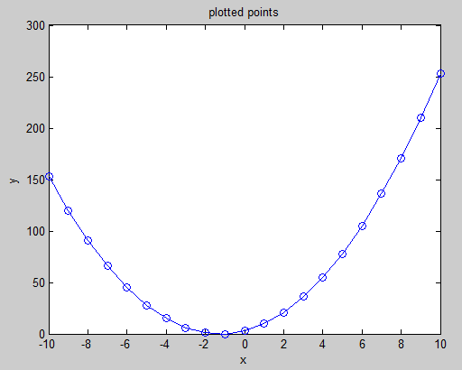

Solution:

The solution for this is to evolve a tree representing an S-expression to find a function which models the relationship between x and y accurately. An example of a suitable S-expression and tree is show below.

Actual equation:

Y = 3*(2+x)*(1+x)

S-expression:

Y = times(times(3,plus(2,x)), plus(1,x))



GPTips, developed by Dominic Searson, is a set of MATLAB functions and scripts designed to evolve a tree of S-expressions to evaluate such problems it is available for download at [ <https://sites.google.com/site/gptips4matlab/> ].

GPTips includes 4 demos and was studied to solve the question posed in this paper. The following new scripts and files were added to the gptips directory: gpED.m, gp_configED, fitnessED. The new files are included in the appendix.

The script gpED.m is the master script to be run first which calls gd_configED.m. The script gp_configED.m contains the configuration parameters for our genetic program. These parameters are:

Population size: 100

Number of generations: 100

Display after 25 generations

Elite selection fraction = 0.25

Elite number: 25

Point to fitnessED

Set fitness to select minimum error

Set termination at Error = 0.01

Set x and y values from table

Set non-x terminal nodes: 0,1,2,3,4,5

Probability of non-x terminal: 0.2

Max tree depth = 4

Not a multigene evolution

Use functions {times, plus}

The fitnessED.m function called the GPTips function evalfitness.m which was not modified by me. The evalfitness.m function evaluates the values of the generated S-expression tree and returns an output array. The fitness of the GPTips generated tree is evaluated in my fitnessED.m script as a difference between the generated S-expression outputs and expected outputs corresponding to the table provided in the problem.

When the 100 generation had been evaluated or the termination was reached gpEd displayed the overall function of x which produced the best y in both algebraic form and S-expression forms. The predicted function was also plotted over the expected. A sample run is shown on the following page.

Sample run 1

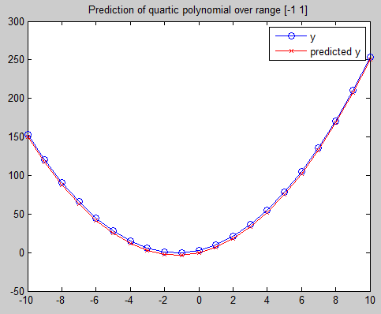

Run parameters

--------------

Population size: 100

Number of generations: 100

Tournament size: 20

Lexicographic selection: False

Max tree depth: 4

Max nodes per tree: Inf

Using function set: TIMES PLUS

Number of inputs: 1

Constants range: [0 5]

Using fitness function: fitnessED.m

Generation 0

Best fitness: 443

Mean fitness: 25770.88

Best nodecount: 7

Generation 25

Best fitness: 63

Mean fitness: 253.92

Best nodecount: 13

Generation 50

Best fitness: 63

Mean fitness: 258.15

Best nodecount: 13

Generation 75

Best fitness: 63

Mean fitness: 530.59

Best nodecount: 13

GPTIPS run complete.

Best fitness acheived: 63

-----------------------------------------------------------

Simplified overall GP expression:

---------------------------------

2.0 x12 + 5.0 x1

plus(plus(times([3],x1),plus(x1,x1)),times(plus(x1,x1),x1))

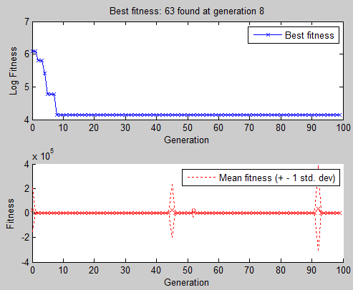

This run didn’t reach the perfect solution after 100 generations. It came up with a function:

y = 2.0 x2 + 5.0 x

Sample run 2

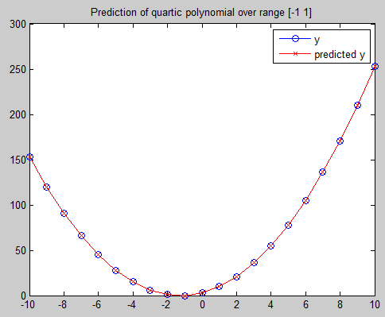

Run parameters

--------------

Population size: 100

Number of generations: 100

Tournament size: 20

Lexicographic selection: False

Max tree depth: 4

Max nodes per tree: Inf

Using function set: TIMES PLUS

Number of inputs: 1

Constants range: [0 5]

Using fitness function: fitnessED.m

Generation 0

Best fitness: 42

Mean fitness: 16655.7

Best nodecount: 15

Generation 25

Best fitness: 21

Mean fitness: 266.84

Best nodecount: 15

Fitness criterion met. Terminating run.

GPTIPS run complete.

Best fitness acheived: 0

-----------------------------------------------------------

Simplified overall GP expression:

---------------------------------

2.0 x12 + 5.0 x1 + 3.0

plus(plus(times(x1,[4]),times(x1,x1)),plus(plus([3],x1),times(x1,x1)))

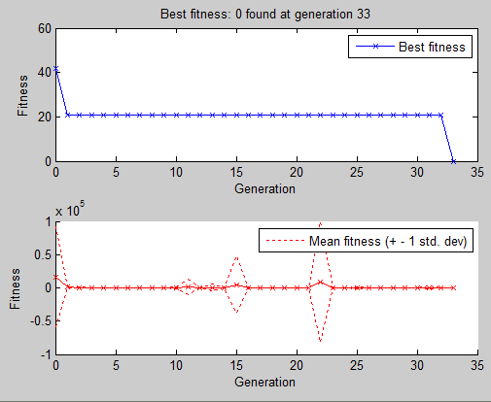

This run did reach the perfect solution after less than 35 generations. It came up with a function:

y = 2.0 x2 + 5.0 x + 3

= 1*(2*x+3)(x+1)

The table below shows solutions, their fitness, and how many generations were required to reach them.

|  |  |  |
| --- | --- | --- |
| Solution | Best Fitness | Generation |
| 1*(2*x+3)*(x+1) | 0 | 4 |
| 1*(2*x+1)*(x+2) | 21 | 100 |
| 2*x2+5*x+4 | 21 | 100 |
| 2*x2+5*x+3 | 0 | 3 |
| 2*x2+5*x+2 | 21 | 100 |

Appendix

gpED.m

%Edris Amin

%GP homework for problem #7 pp117

clc

gp=rungp('gp_configED');

summary(gp);

runtree(gp,'best');

%display equation

gppretty(gp,'best');

expression = gp.results.best.eval_individual{1};

disp(expression);

fitnessED.m

%Edris Amin

%GP fitness function

%code edited from original from (c) Dominic Searson 2009

function [fitness,gp]=fitnessED(evalstr,gp)

% Extract x and y data from GP struct

x1=gp.userdata.x;

y=gp.userdata.y;

% Evaluate the tree (assuming only 1 gene is suppled in this case - if the

% user specified multigene config then only the first gene encountered will be used)

eval(['out=' evalstr{1} ';']);

% Fitness is sum of absolute differences between actual and predicted y

fitness=sum(abs(out-y));

% If this is a post run call to this function then plot graphs

if gp.state.run_completed

figure

plot(x1,y,'o-');hold on;

plot(x1,out,'rx-');

legend('y','predicted y');

title('Prediction of quartic polynomial over range [-1 1]');

hold off;

end

gp_configED.m

%Edris Amin

function gp=gp_configED(gp);

gp.runcontrol.pop_size=100; %population size

gp.runcontrol.num_gen=100; %number of generations = 0:num_gen

gp.runcontrol.verbose=25; %after how many generations to display information

% Selection method options-------------------------

gp.selection.tournament.size=4;

% gp.selection.tournament.lex_pressure=true; % True to use Luke & Panait's plain lexicographic tournament selection

gp.selection.elite_fraction=0.02; % Elitist selection fraction of population to copy directly to next generation without modification.

% Fitness function specification------------------------------

gp.fitness.fitfun=@fitnessED; % fitness function pointer (no need of .m using '@name')

gp.fitness.minimisation=true; % Set to true if you want to minimise the fitness function (if false it is maximised).

gp.fitness.terminate=true; %terminate before num_gen reached

gp.fitness.terminate_value=0.1; %terminate here if termination = true

% Set up user data----------------

xin=linspace(-10,10,21); %generate [-10, -9, -8, ... -1, 0, 1, ... 8 , 9 , 10]

yin=[153 120 91 66 45 28 15 6 1 0 3 10 21 36 55 78 105 136 171 210 253];

gp.userdata.x=xin;

gp.userdata.y=yin;

% Input configuration-------------------

%Define the number of inputs

gp.nodes.inputs.num_inp=1; %inputing one x value per individual

% Constant parameters---------

gp.nodes.const.num_dec_places = 0; %# of dec. places at nodes (integers = 0)

gp.nodes.const.range = [0 5]; %range of values nodes can take if not x

%Probability that a constant node, rather than an input node, will be generated when adding a terminal node to a tree.

gp.nodes.const.p_ERC = 0.2;

% Tree build options------------------

gp.treedef.max_depth=4; % Maximum depth of trees

% Maximum depth of sub-trees created by mutation operator

gp.treedef.max_mutate_depth=4; %same as max_depth after mutation

%Enable multiple gene mode and set max number of genes per individual.

gp.genes.multigene=false; %no multigene used

%Define function nodes

gp.nodes.functions.name{1} = 'times';

gp.nodes.functions.name{2} = 'plus';